[PROGRAM HIGHLIGHT]


Award-winning Korean dark comedy thriller, Parasite, is now available on Viu!

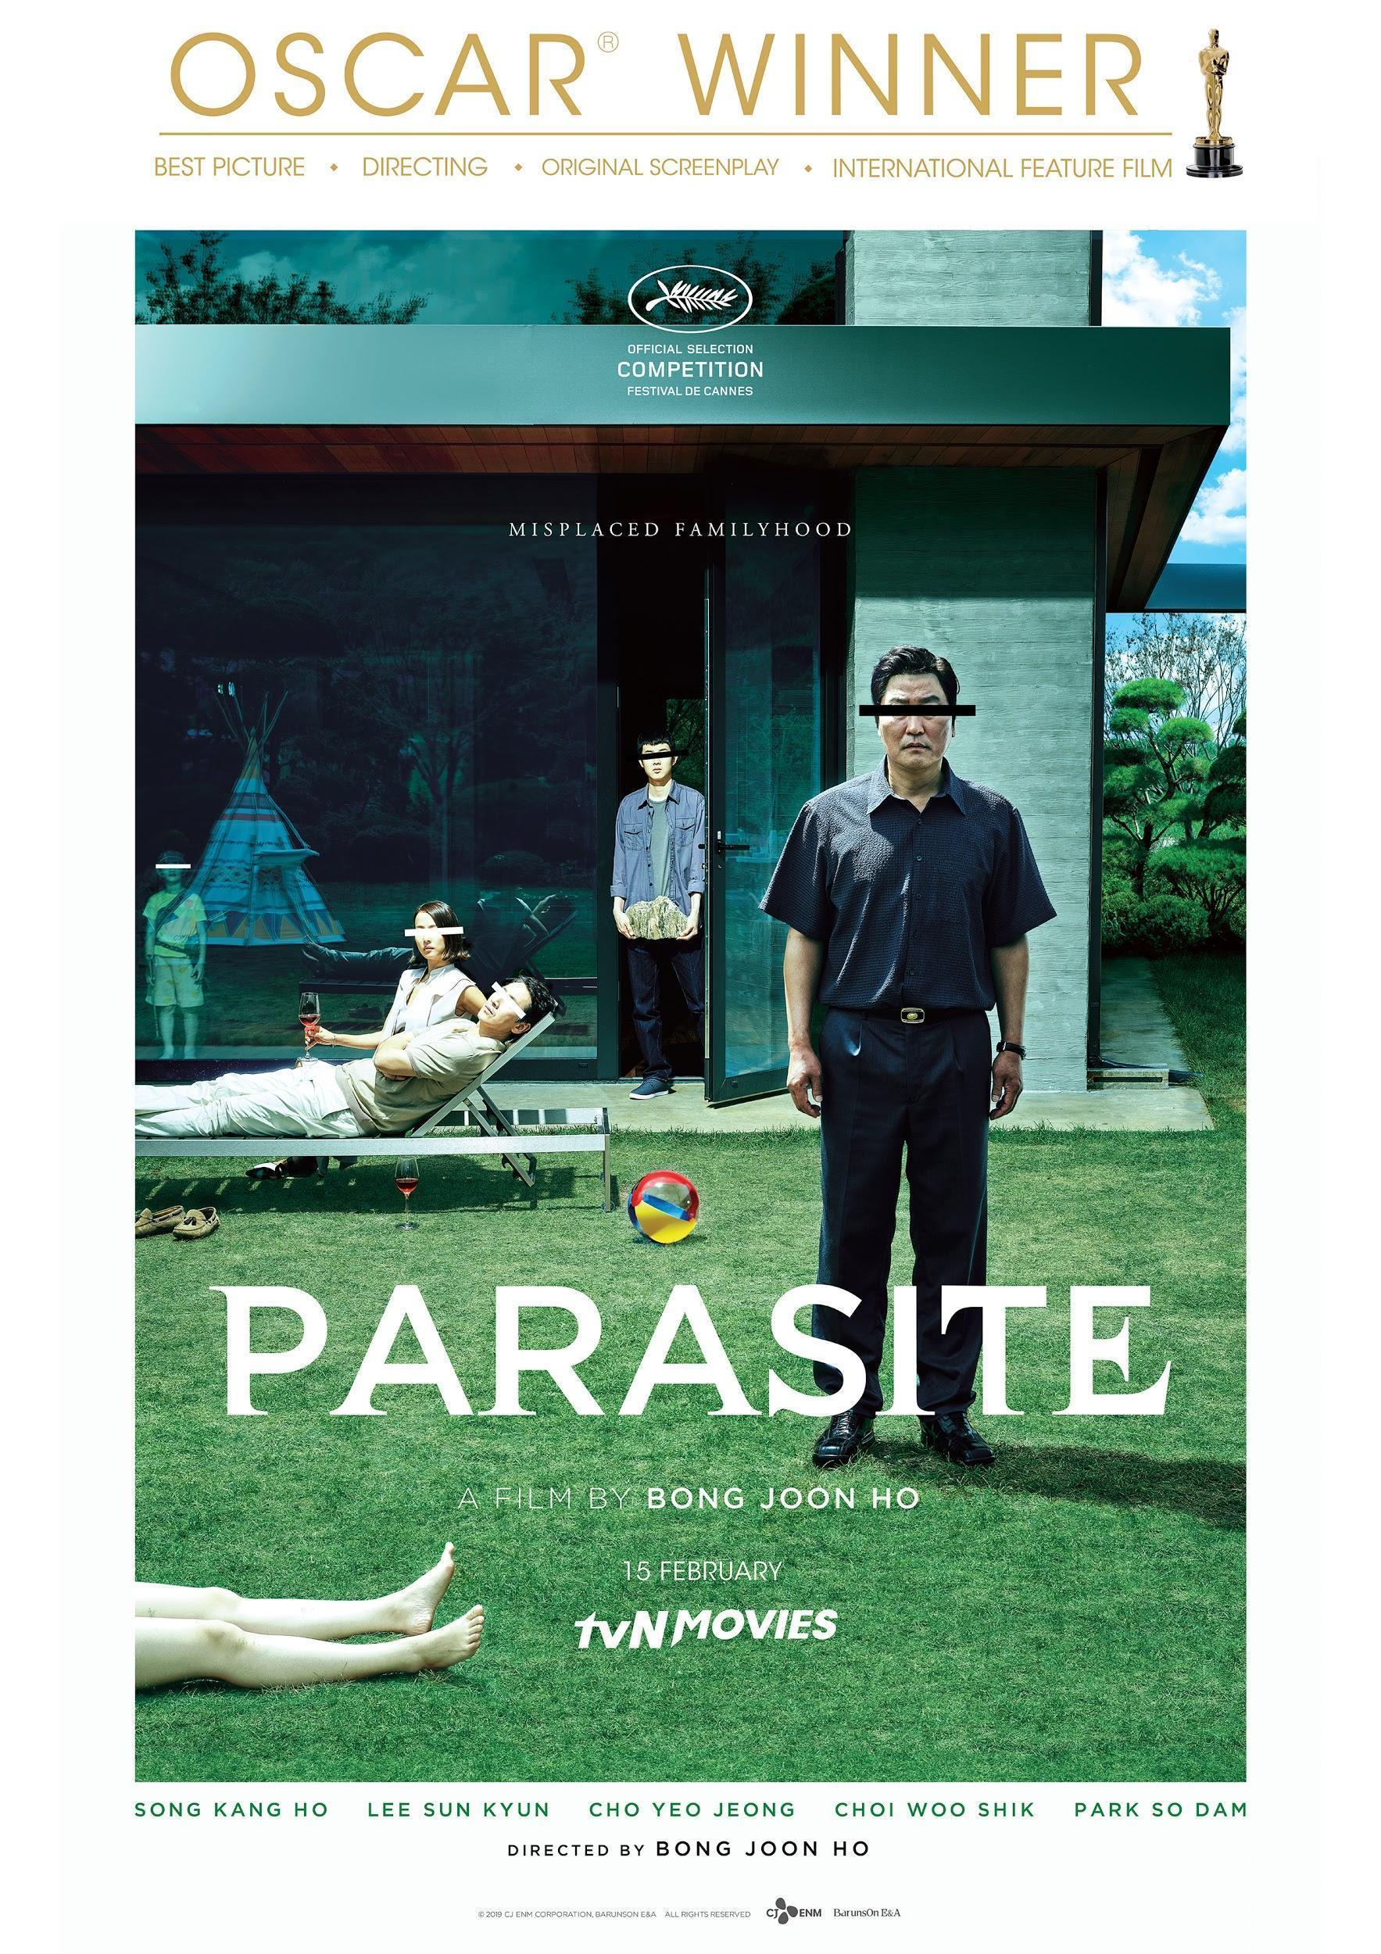

Viu, a leading pan-regional over-the-top (OTT) video streaming service, has added Parasite, an acclaimed 2019 Korean thriller that had recently made its mark in the entertainment industry, to its slate of ever growing content offering.

Critically lauded, Parasite is the first non-English film and first South Korean film to be awarded Best Picture at the 92nd Academy Awards, commonly known as the Oscars, that happened earlier this month. Parasite also bagged the awards for International Feature Film, Best Director and Best Original Screenplay at the Oscars. The Korean dark comedy thriller features a star-studded cast such as Song Kang-ho, Lee Sun-kyun, Cho Yeo-jeong, Choi Woo-shik and Park So-dam.

Revolving around the disparity between social classes, Parasite gives audiences a closer look at the issues faced by each social class and how communities of the lower class race to ascend above the social class chain. The movie begins with a teenager, Kim Ki-woo (played by Choi Woo-shik) who forges a university degree in order to get hired as a tutor for the Parks’ wealthy daughter, Da Hae (played by Jung Ziso). Soon after, the Kims create elaborate new identities and infiltrate the Parks’ household.

Parasite is now available on Viu and users will be able to watch the history-making movie across all of Viu’s platforms which include mobile app, mobile browser, desktop, Android TV and selected LG TVs. Also available in various subtitles such as English, Bahasa Malaysia, Bahasa Indonesia and simplified Chinese, every Viu-er can enjoy Parasite! Subscribe to Viu now for just a low fee of RM10 a month and you can enjoy Parasite, anywhere, anytime!

THE END

About Viu

Viu is a leading pan-regional over-the-top (OTT) video streaming service operated by PCCW Media Group. It is available in 16 markets including: Hong Kong, Singapore, Malaysia, Indonesia, the Philippines, Thailand and Myanmar in Asia; Bahrain, Egypt, Jordan, Kuwait, Oman, Qatar, Saudi Arabia and the UAE in the Middle East; as well as South Africa.

Operating with both an ad-supported tier and a premium subscription tier, Viu delivers premium content in different genres from top content providers with local language subtitles, as well as original production series under the “Viu Original” initiative.

Viu offers users popular and current content with streaming and download features, and localized user interfaces. With the patented Dynamic Adaptive Transcoding technology, Viu can provide the best viewing experience regardless of device or network conditions.

The service can be accessed via Viu app (available for free on App Store and Google Play) on connected devices, e.g. smartphones and tablets, selected smart TVs, as well as on web by logging into www.viu.com.

About PCCW Media

The Media Group of PCCW is a leading, fully integrated multimedia and entertainment group in Hong Kong.

The Media Group operates the leading pay-TV service in Hong Kong under the Now TV brand delivering both self-produced and licensed content to its customers using IPTV technology. Now TV offers more than 160 linear channels and on demand library of local, Asian and international programming. Its premium content can also be accessed via the Now Player app. It is also a leading producer of Chinese language news, financial news and sports programming in addition to Asian infotainment content which complements its wide portfolio of licensed movie and international television content. PCCW Media also offers the Now E entertainment OTT (over-the-top) platform with international and Asian dramas, movies and world-class sports events, which is designed to meet the needs of viewers with Millennial lifestyle.

The Media Group is also engaged in the provision of OTT video service under the Viu brand in Hong Kong and 16 markets in Southeast Asia, the Middle East, India and South Africa. In addition, MOOV is a hugely popular music digital streaming service in Hong Kong.
About PCCW Limited

PCCW Limited (SEHK: 0008) is a global company headquartered in Hong Kong which holds interests in telecommunications, media, IT solutions, property development and investment, and other businesses.

The Company holds a majority interest in the HKT Trust and HKT Limited, Hong Kong’s premier telecommunications service provider and leading operator in fixed-line, broadband and mobile communication services. HKT meets the needs of the Hong Kong public and local and international businesses with a wide range of services including local telephony, local data and broadband, international telecommunications, mobile, and other telecommunications businesses such as customer premises equipment sale, outsourcing, consulting, and contact centers.

PCCW also owns a fully integrated multimedia and entertainment group in Hong Kong, PCCW Media. PCCW Media operates the largest local pay-TV operation, Now TV, and is engaged in the provision of over-the-top (OTT) video service under the Viu brand in Hong Kong and other places in the region.

Through HK Television Entertainment Company Limited, PCCW also operates a domestic free television service in Hong Kong.

Also, wholly-owned by the Group, PCCW Solutions is a leading information technology outsourcing and business process outsourcing provider in Hong Kong and mainland China.

In addition, PCCW holds a majority interest in Pacific Century Premium Developments Limited, and other overseas investments. To learn more about PCCW, please visit www.pccw.com.

For further information, please do not hesitate to contact:
Nicole Aldeth Main Shamani Krishnan
Mad Hat Asia Mad Hat Asia
T: +6012 5670129 T: +6012 9100353
E: nicole@madhat.asia E:shamani@madhat.asia

