

Discovery Channel (Astro Channel 561)

Fast N’ Loud: Demolition Theatre 3

*Image is attached to this email*

Ride along with Gas Monkey Garage as they check out collections of the craziest viral videos.

Premiere Date: Thursday, 1 August 2019
Time: 9.55pm (MY)
Episodes: 6 x 60 mins

Fish or Die

*Image is attached to this email*

Four die-hard anglers are determined to be the first to fish the most remote waters in the world, or die trying. Friends Chris, Thad, Brian and Jay team up to raft, drive, and hack their way to hidden, mysterious waters in search of legendary fish.

Premiere Date: Monday, 12 August 2019
Time: 9.55pm (MY)
Episodes: 10 x 60 mins

---



TLC (Astro Channel 707)

Dr Pimple Popper S2

*Image is attached to this email*

Dermatologist Sandra Lee, aka Dr. Pimple Popper returns to help patients with unique skin conditions reclaim a life free of disguise and embarrassment.

Premiere Date: Monday, 5 August 2019
Time: 8.05pm (MY)
Episodes: 14 x 60 mins

90 Day Fiancé: Happily Ever After S4

*Image is attached to this email*

90 Day Fiancé: Happily Ever After revisits the most memorable couples from previous seasons. The frenzied countdown to the altar may be behind them, but the real drama has just begun to unfold. Returning couples will take us along for their journey as they battle critics, doubters, and obstacles along their road to love – we’ll see whether they truly are living happily ever after. Catch up with couples from the original series who gave up everything for a shot at love and the American dream.

Premiere Date: Friday, 16 August 2019
Time: 9.55pm (MY)
Episodes: 12 x 120 mins, 4 x 60 mins

---



Animal Planet (Astro Channel 556)

Jeremy Wade’s Mighty Rivers
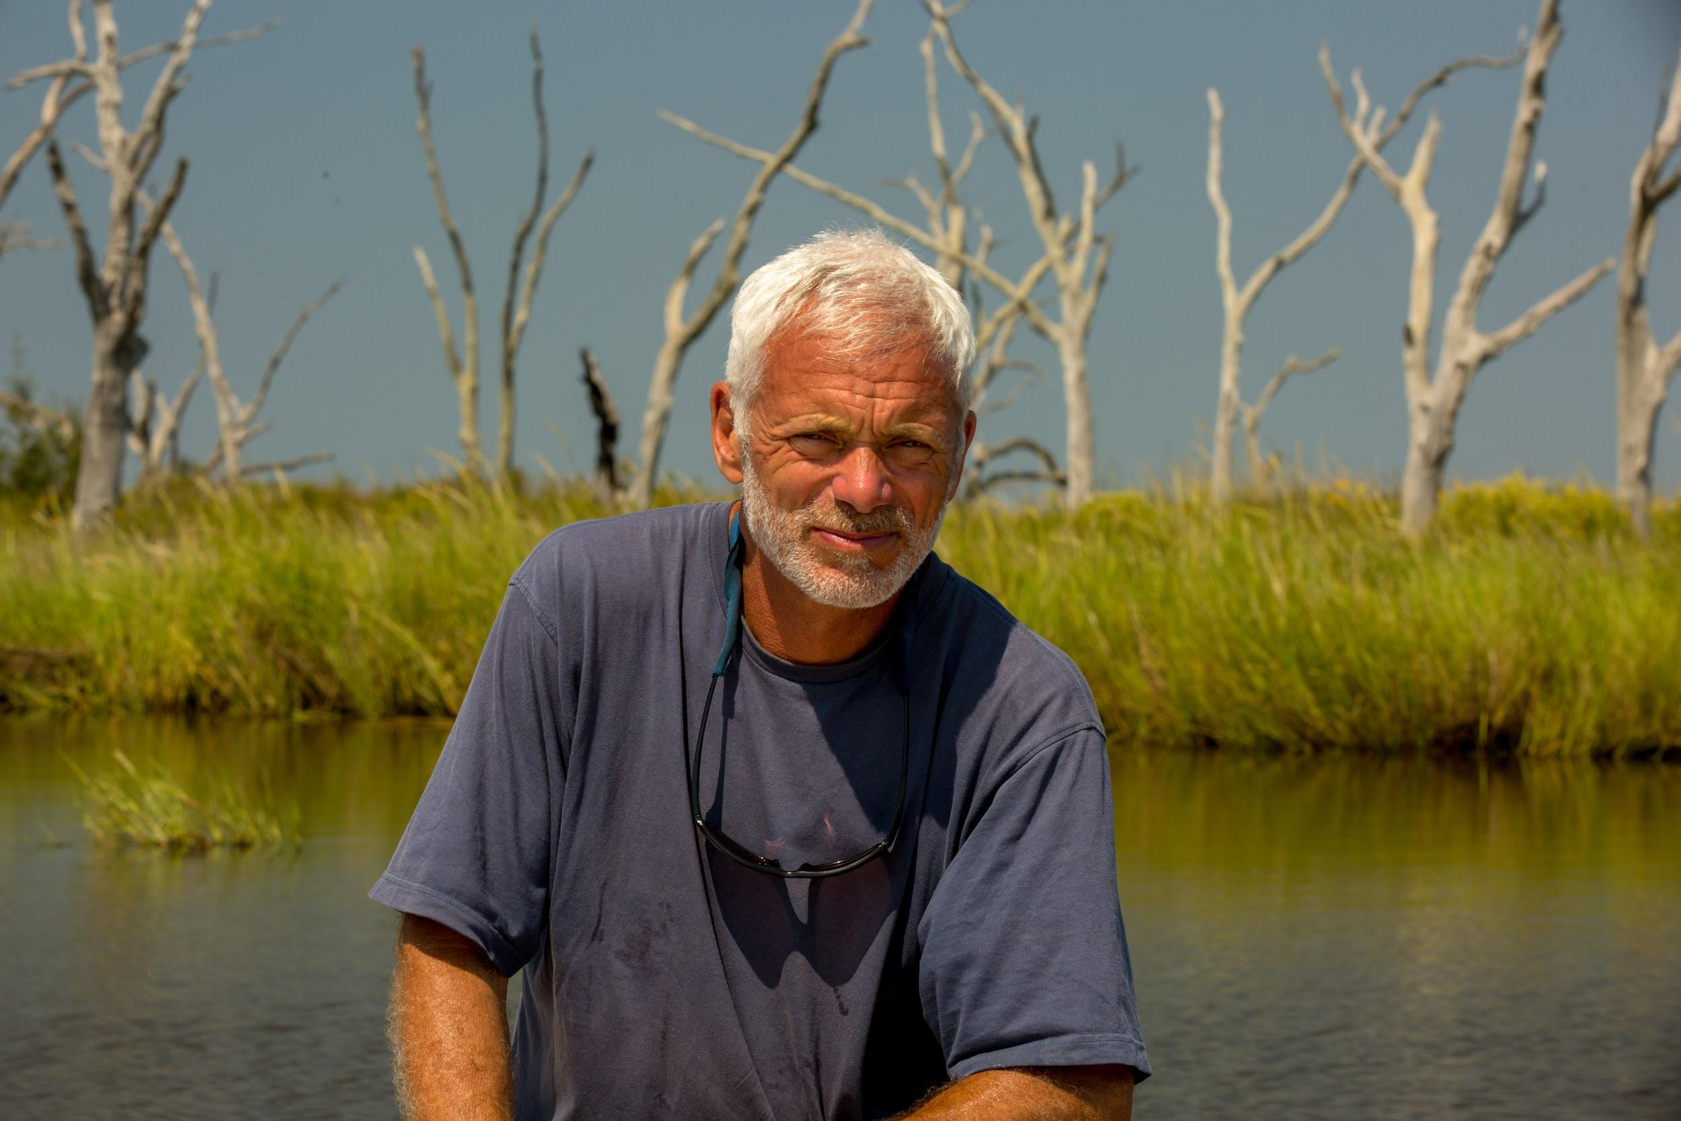
*Image is attached to this email*

Nature’s majestic freshwater giants are disappearing at an alarming rate. For extreme angler and biologist Jeremy Wade, known for investigating stories of monstrous and mysterious fish in Animal Planet’s River Monsters, this is dramatic evidence that some of the world’s most important rivers are in trouble. In Jeremy Wade’s Mighty Rivers, Wade sets out around the world to take the pulse of the Amazon, the Ganges, the Yangtze, the Mississippi, the Danube, and the Zambezi and understand how exploitation and pollution are contributing to the ruin of rivers that were once the lifeblood of communities and home to his bellowed monsters.

Premiere Date: Monday, 5 August 2019
Time: 9.55pm (MY)
Episodes: 6 x 60 mins

Dr Jeff Rocky Mountain Vet S5

*Image is attached to this email*

There’s no such thing as a “regular day” at Denver’s Planned Pethood Plus veterinary clinic. For 80,000-plus clients and their pets, the clinic and its maverick vet Dr. Jeff Young represent one last hope and possibly the difference between life and death.

Premiere Date: Thursday, 22 August
Time: 9.00pm (MY)
Episodes: 3 x 60 mins

---



Discovery Asia (Astro Channel 571)

No Sleep No FOMO

*Image is attached to this email*

No Sleep No FOMO is the travel show for the new generation. Over 60 hours, a host and guest will fly into a new city and attempt to defeat the 60 FOMO lists.

Premiere Date: Friday, 9 August 2019
Time: 9.00pm (MY)
Episodes: 8 x 60 mins

---



Asian Food Channel (Astro Channel 703)

Old Taste Detective

*Image is attached to this email*

Hainanese Chicken Rice is a local national delicacy which was brought along by Hainanese immigrants in early years. This episode, host Yi Fong and Chef Ivan visit famous local chicken rice stalls to learn about the recipe, ingredients and secrets for this dish and attempt to recreate the old taste.

Premiere Date: Tuesday, 6 August 2019
Time: 9.00pm (MY)
Episodes: 11 x 60 mins

---



HGTV (Astro Channel 731)

My Lottery Dream House S5
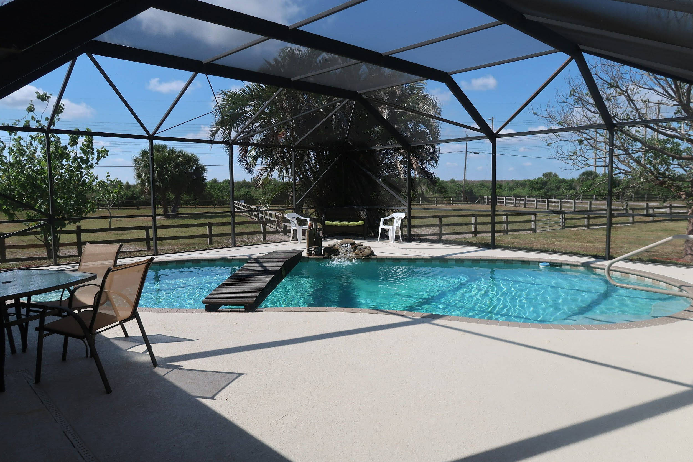
*Image is attached to this email*

David Bromstad takes recent lottery winners on over-the-top house hunts for their new dream homes. Whether they win hundreds of thousands or hundreds of millions, lucky lottery winners everywhere are jumping headfirst into the real estate market. Will they spend all their winnings on an extravagant mansion or settle for a humble sound investment? Find out what happens when average Americans set out to find their Lottery Dream Homes.

Premiere Date: Wednesday, 14 August 2019
Time: 9.00pm (MY)
Episodes: 14 x 30 mins

Christina On The Coast

*Image is attached to this email*

Real estate and flipping expert Christina Anstead helps clients transform their outdated properties into high-end homes in Southern California. She also begins a personal journey as she looks for a new home for her family.

Premiere Date: Friday, 16 August 2019
Time: 9.00pm (MY)
Episodes: 7 x 30 mins

---

