Title: [PROGRAM HIGHLIGHTS] Discovery Networks Asia Pacific - June 2019

Copy:

Dear media



Discovery Channel (Astro Channel 561)

Anthony Bourdain: Parts Unknown S11 & 12

*Image is attached to this email*

The legendary life of Harry Houdini remains as much of a mystery as his death. Modern magicians marvel at his death-defying performances. His breathtaking escapes and astonishing illusions have never been equaled - or fully understood. Now, in this active investigation, magicians and scientists will try to unlock the secrets and mysteries he took with him to the grave.

Premiere Date: 4 June 2019, Tuesday
Time: 9pm (MY)
Episodes: 15 x 60 mins

Murder by Numbers S2

*Image is attached to this email*

Ever wonder how common, everyday objects are made? Science Channel fan favorite HOW IT'S MADE returns for another season of exploring how many of the everyday objects or products we seldom stop to think about are made.

Premiere Date: 8 May 2019, Wednesday
Time: 9.00pm (MY)
Episodes: 26 x 30 mins

---



TLC (Astro Channel 707)

Bakers Vs Fakers S2
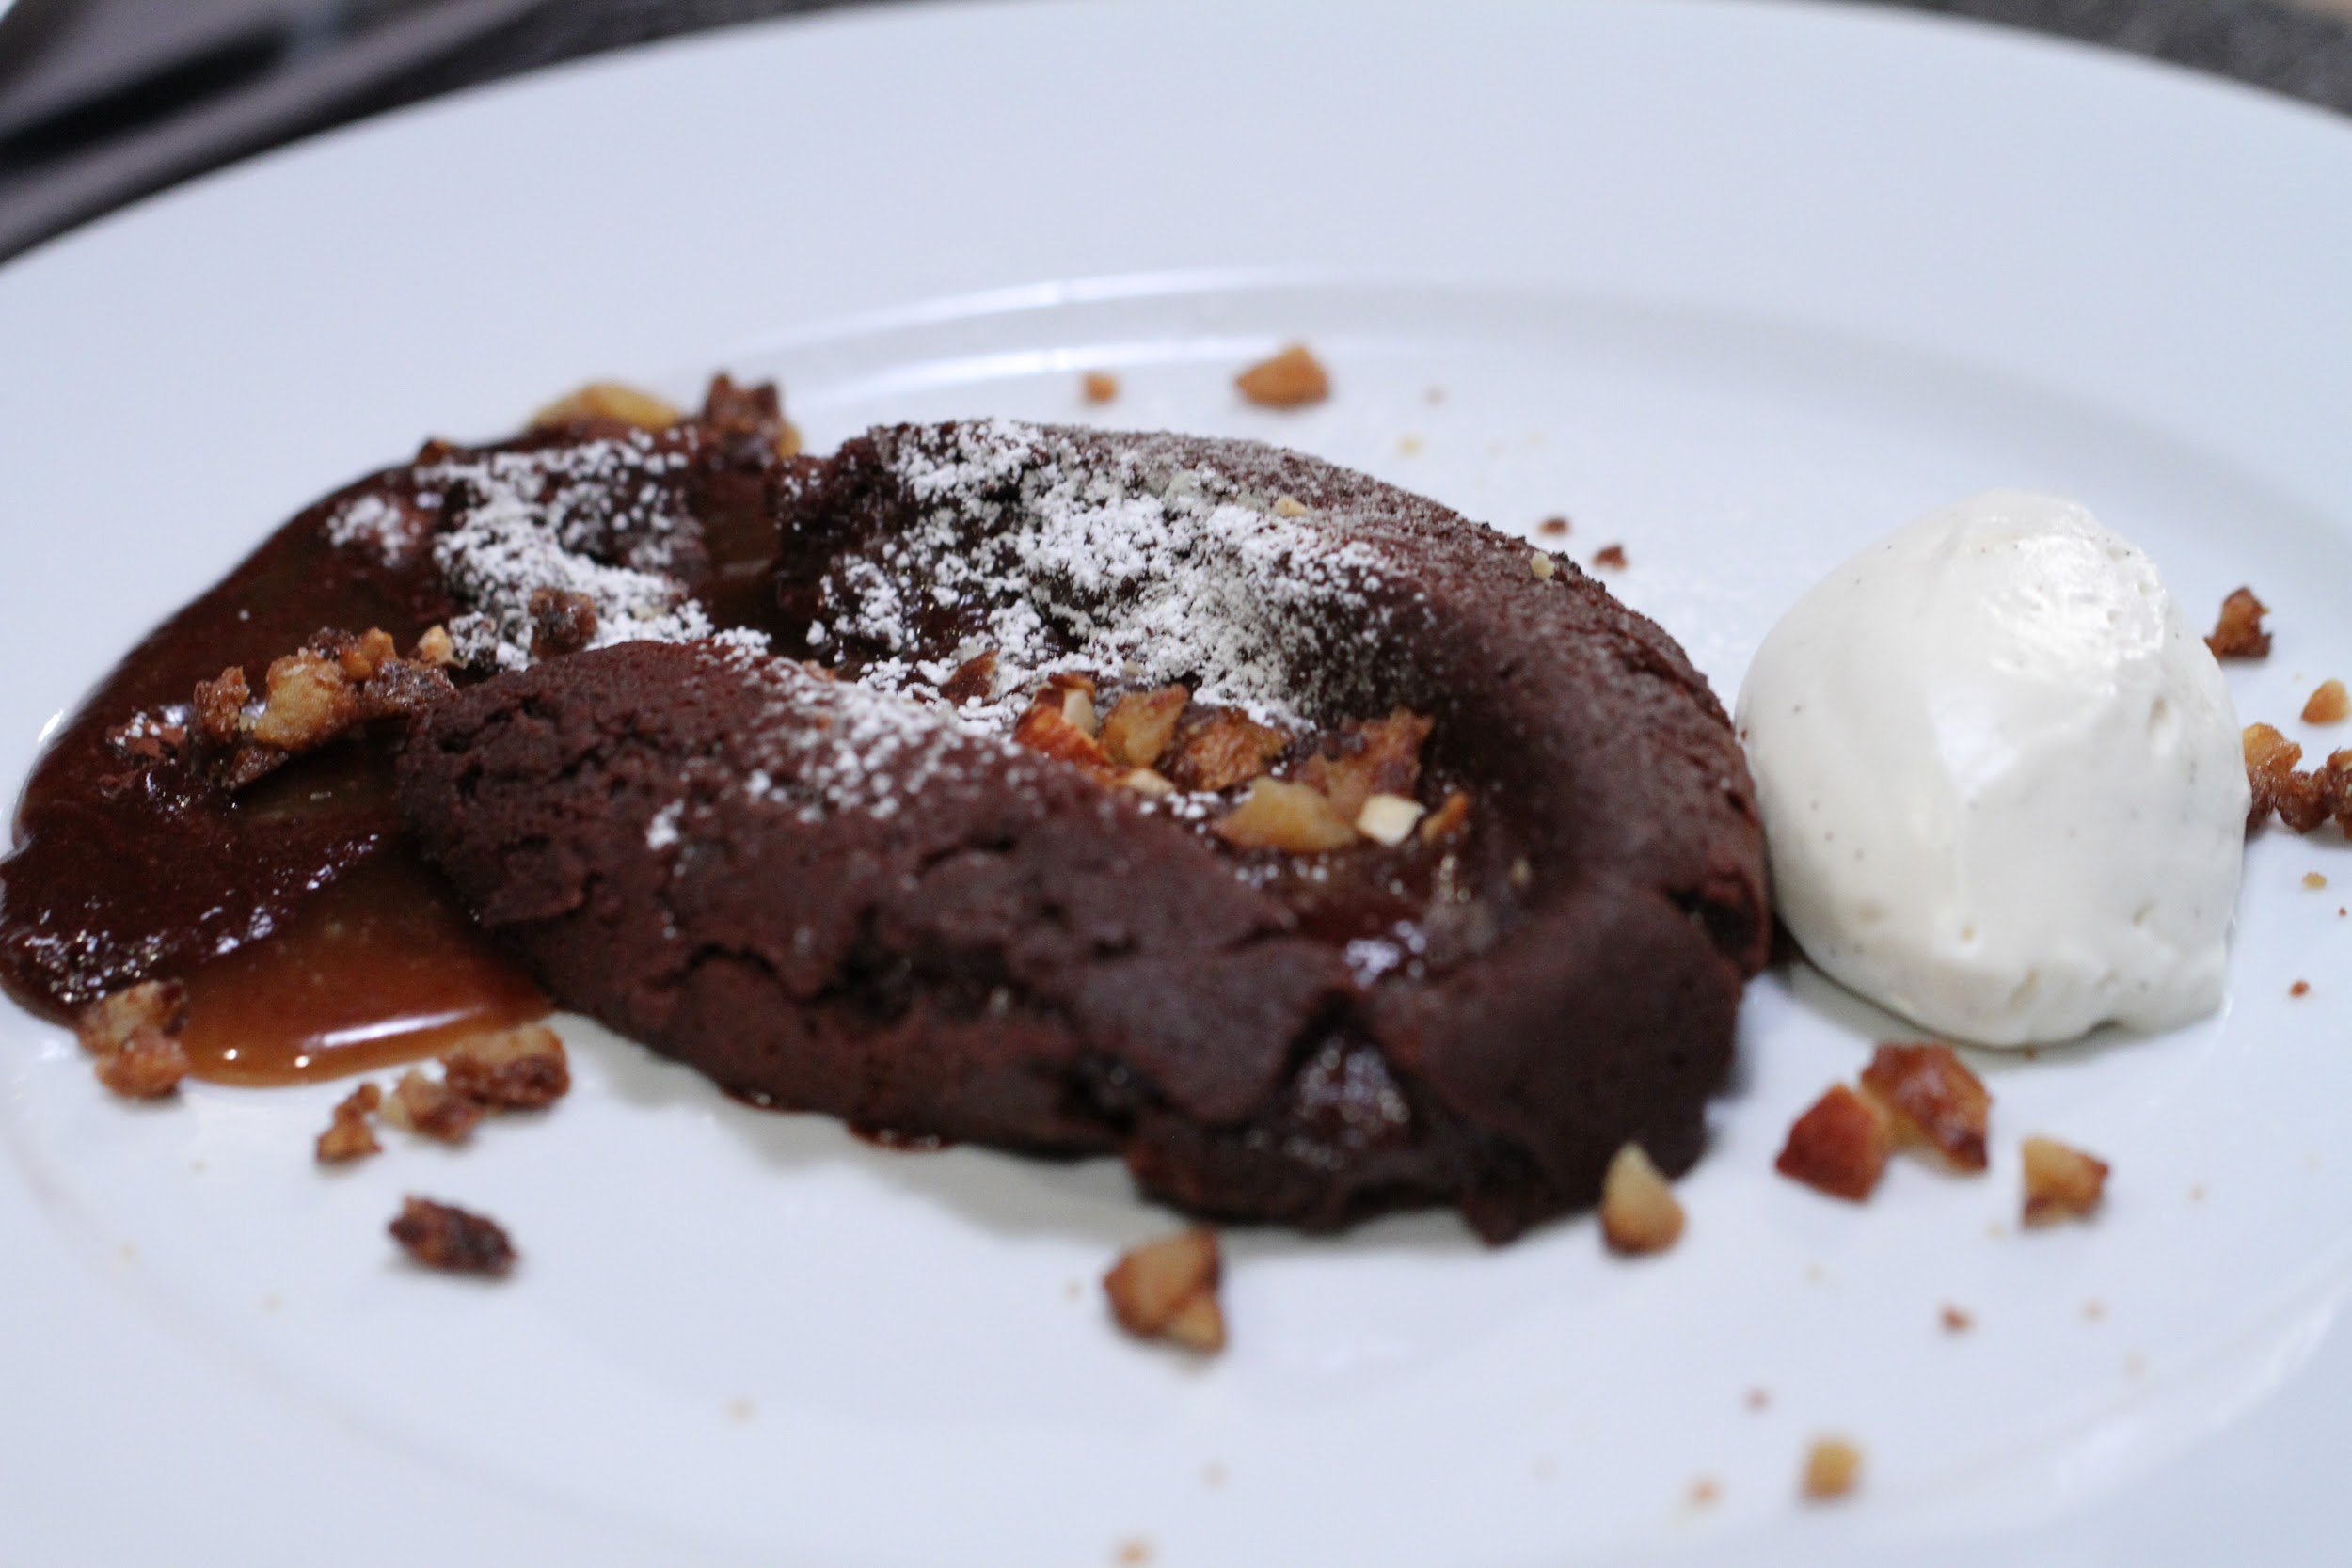
*Image is attached to this email*

Lorraine Pascale hosts this sweet twist on the familiar game: could a talented home baker out-cook a professional, or do true professionals have skills that no amateur could match?

Premiere Date: 19 June 2019, Thursday
Time: 8pm (MY)
Episodes: 14 x 60 mins

---



Animal Planet (Astro Channel 556)

Hanging with the Hendersons

*Image is attached to this email*

Fox Hollow Animal Hospital is run by an endearing family of vets who have it in their DNA to treat and care for animals. Dr. Tony Henderson, his wife Debbie, their sons Dr. Ross, Dr. Ryan, and Cole, and the extended clinic family work hard and play hard.

Premiere Date: 4 June 2019, Tuesady
Time: 9.00pm (MY)
Episodes: 12 x 60 mins

Animal Cribs S2

*Image is attached to this email*

On ANIMAL CRIBS, designer Antonio transforms drab, cramped homes and outside areas into functional, high-style spaces for both pets and the people they love. Antonio's excitement for both design and animals drive him to go the extra mile for his clients and their four-legged, winged, and scaly friends

Premiere Date: 12 June 2019, Wednesday
Time: 9pm (MY)
Episodes: 11 x 60 mins

North Woods Law S6B

*Image is attached to this email*

North Woods Law: New Hampshire (Season 6)- From the White Mountains of the Appalachians, to the rocky shores of the Atlantic Ocean, the Conservation Officers of New Hampshire Fish and Game work endlessly to preserve and protect the natural resources of the Granite Sta

Premiere Date: 28 June 2019, Friday
Time: 9.00pm (MY)
Episodes: 11 x 60 mins

---



Discovery Asia (Astro Channel 571)

John Torode’s Middle East

*Image is attached to this email*

Chef John Torode goes on an incredible journey to track down the best food in the Middle East- hunting down the most inspiring local cooks and discovering the distinctive flavour of each country's cuisine

Premiere Date: 13 June 2019, Thursday
Time: 9pm (MY)
Episodes: 10 x 30 mins

Hualien Earthquake Decoded

*Image is attached to this email*

On Feb 6th, 2018, Hualien County in Taiwan was hit with a 7.0 magnitude earthquake. Although scientific studies still cannot predict precisely when an earthquake will hit; Hualien County Gov. was able to keep the damage to a minimal.

Premiere Date: 6 June 2019, Tuesday
Time: 9.00pm (MY)
Episodes: 5 x 60 mins

---



Asian Food Channel (Astro Channel 703)

Food Producer S1

*Image is attached to this email*

Discover the origins of the food in this eye-opening food programme produced by Jason Yeoh. Learn the relationship between food and nature, and listen to the producers’ beliefs

Premiere Date: 26 June 2019, Wednesday
Time: 9pm (MY)
Episodes: 13 x 30 mins

---



Food Network (Astro Channel 727)

Fast Food Gone Global S1

*Image is attached to this email*

Local flavors are found at American fast food chains around Latin American like empanadas at McDonald's in Cartagena, suspiro donuts at Dunkin' Donuts in Lima, and caramelized goats milk desserts at Baskin Robbins in Mexico City.

Premiere Date: 13 June 2019, Tuesday
Time: 10pm (MY)
Episodes: 10 x 60 mins

Martina’s Table S1

*Image is attached to this email*

With her entire family home for Thanksgiving, country music superstar Martina McBride shares some of her favorite recipes inspired by her Kansas roots. Her holiday menu includes Sausage, Cherry and Cornbread Stuffing, Roasted Cinnamon "Harrisburgs," Romaine Salad accented with Pear, Smoked Blue Cheese and Candied Pecans. The main event of this memorable meal is her unforgettable Roast Turkey with Gravy and the McBride family favorite Fluff Salad.

Premiere Date: 16 June 2019, Sunday
Time: 8pm (MY)
Episodes: 10 x 60 mins

---



HGTV (Astro Channel 731)

Flipping Virgins S3

*Image is attached to this email*

Property expert Egypt Sherrod takes first time house flippers under her wing, teaching them the tricks of the trade when it comes to getting top dollar for smart renovations. Will these Flipping Virgins heed Egypt's advice and make a profit from their first flip -- or will their newbie jitters get the best of them as they risk it all in the unpredictable world of home buying and selling?

Premiere Date: 18 June 2019, Tuesday
Time: 10pm (MY)
Episodes: 13 x 60 mins

One of a Kind S1

*Image is attached to this email*

The very first production line racing Corvette. Only 43 of these racing model cars were produced by Chevy and fewer than half of them exist today. The "airbox" car found was the prototype for all of the subsequent Corvettes in 1957 line.

Premiere Date:17 June 2019, Monday
Time: 9pm (MY)
Episodes: 8 x 30 mins

We would appreciate if you could highlight this in your upcoming issues / online features. You may access hi-res images from this here for your usage.

Should you require further information, do not hesitate to drop me a line at vanesa@madhat.asia / 016 342 5957

You can access the full press kit at <link>

