THE ZALORAYA FASHION SHOW RETURNS THIS 2019 WITH A CLASSIC WAYANG KULIT THEMATIC EXPERIENCE
The highly-anticipated collective runway presentation will also feature a one-day-only #ZALORAYA2019 pop-up event

KUALA LUMPUR, 14 MARCH 2019: ZALORA, Asia’s Online Fashion Destination, in partnership with Boost, is proud to present the return of ZALORAYA, the annual collective runway show this 14 March 2019 at Black Box, Publika. Spotlighting some of the biggest names in the local fashion scene, the #ZALORAYA2019 lineup includes the likes of Tom Abang Saufi, Syomirizwa Gupta, Afiq M, Ezzati Amira, Nurita Harith and many more. This year, there will also be a one-day-only #ZALORAYA2019 pop-up held at the adjacent White Box, allowing shoppers the chance to get up close and personal with ZALORA’s fashion and beauty brands.

For a special offline experience, the ZALORAYA pop-up at White Box, Publika will allow shoppers to immerse themselves into the world of ZALORA. A special beauty market featuring an assortment of top beauty brands available on-site such as Foreo, Laneige and The Face Shop, will be set-up for on-the-spot offline purchases and feature exclusive discounts and promotions. All visitors to the pop-up can also partake in a complimentary beauty passport experience to receive an exclusive #ZALORAYA2019 goodie bag filled with products by selected beauty brands available on ZALORA, including Laneige, Benefit Cosmetics, Pure Theory, and more. Shoppers simply need to visit each beauty vendor, participate in their activations and collect their goodie bag upon completion.

Besides that, shoppers can get a closer look at the brands they love with the curated hijab, Curve lines and Nelissa Hilman displays, and snap cool photos at the many Instagrammable spots located around the pop-up space. Other highlights at the #ZALORAYA2019 pop-up include special guest appearances - including a beauty tutorial featuring founder of LMK Cosmetics, Ameera Khan.

To enhance the shopping experience, #ZALORAYA2019’s main sponsor, Boost will also be offering an exclusive promotion when you shop with the e-wallet app. From 14 March to 30 June 2019, shoppers who spend a minimum of RM250 on ZALORA will receive an extra 25% discount AND RM18 cashback when they pay with Boost. Simply checkout with the code ‘BOOSTZALORAYA’—terms & conditions apply.

“Boost is a proudly homegrown e-wallet and we are very pleased to be associated with the bright lights of the local fashion scene at #ZALORAYA2019. Online fashion shopping in Malaysia is making huge strides and we hope to create a fun and more rewarding cashless experience for ZALORA customers during the upcoming Hari Raya festive season,” said Mohd Khairil Abdullah, CEO of Axiata Digital, Boost’s parent company.
Boost is Malaysia’s leading e-wallet. To date, Boost has over 3.7 million users and more than 66,000 online and offline merchant touchpoints where customers can use their e-wallet.

While the theme for last year’s event was local traditional games, for #ZALORAYA2019, another beloved Malaysian treasure takes center stage instead—the timeless art of wayang kulit. A traditional display of puppet-shadow play, wayang kulit theatre shows, which are commonly found in Kedah and Kelantan, bring together music, light and compelling storytelling to weave an unforgettable performance for the audience. As ZALORA prides itself on celebrating the best of all things local while looking to the future, the wayang kulit theme befits ZALORA’s ethos of telling your own story through style.
“We are proud to host such an array of talented Malaysian designers under our e-commerce roof,” said Giulio Xiloyannis, Chief Commercial Officer of ZALORA. “As an homage to Malaysia’s rich cultural heritage, we chose the wayang kulit theme and the essence of its timeless storytelling format to encourage fashionistas to create, curate and tell their own style story via the endless selection of brands and trends we offer on ZALORA.”

The ZALORAYA 2019 designer presentations will be showcased over three different slots—2PM, 5PM and 8PM respectively—promising a fashion experience unlike any other. #ZALORAYA2019 also marks the first time that Curve collections will be shown, widening the variety of styles available to the ZALORA shopper. In addition, Make Up For Ever will serve as the makeup sponsor for the fashion shows. While the presentations will be invite-only, fashion fans can tune in via live stream on ZALORA’s website and mobile app. Alternatively, to be closer to the action, shoppers at the ZALORAYA pop-up will also be able to watch the show projected on a big screen.

A number of #ZALORAYA2019 collections are already available for purchase on zalora.com.my. Stay up to date with the launches on www.zalora.com.my/women/hari-raya.

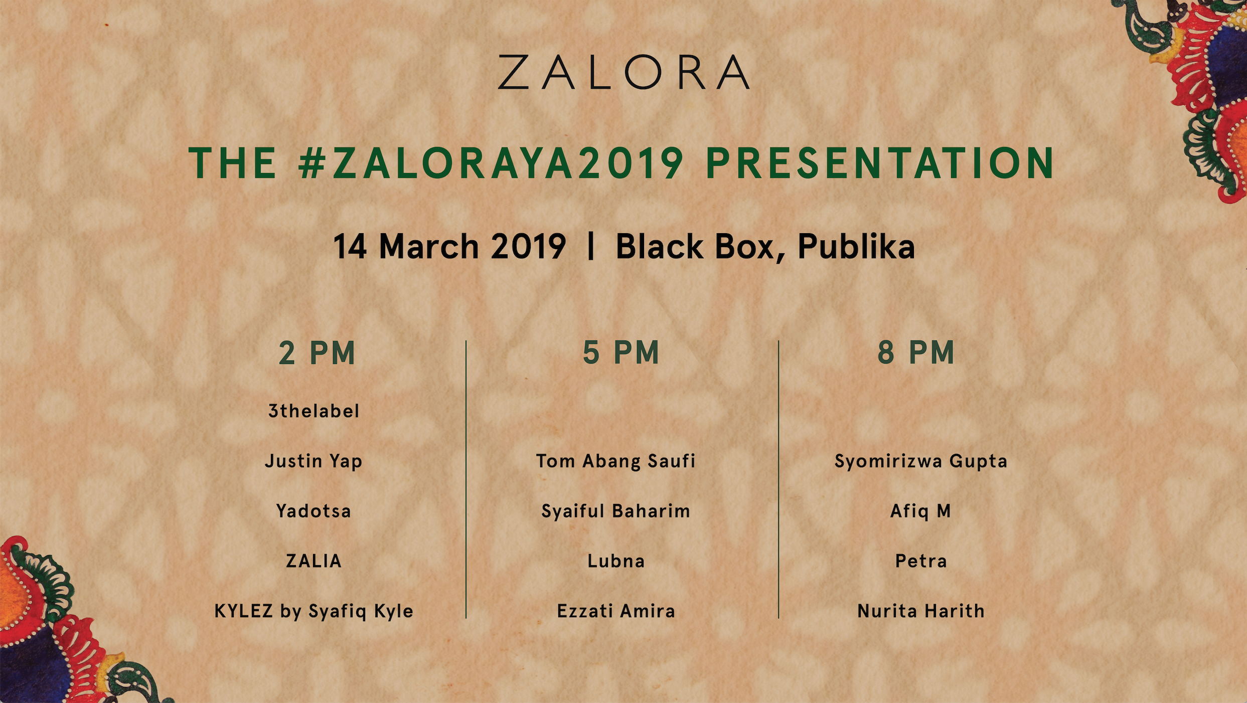

-End-

Press kit available at: http://tinyurl.com/y3yx3s4a

MEDIA CONTACT:
Ira Roslan | PR Manager
ira.roslan@my.zalora.com | +6016 353 8100

ABOUT ZALORA GROUP:
ZALORA is Asia’s online fashion destination. Founded in 2012, the company has a presence in Singapore, Indonesia, Malaysia, the Philippines, Hong Kong, and Taiwan. ZALORA is part of Global Fashion Group, the world's leader in online fashion for emerging markets. ZALORA offers an extensive collection of top international and local brands and products across apparel, shoes, accessories, and beauty categories for men and women. Offering up to 30-day free returns, speedy deliveries as fast as 3 hours, free delivery over a certain spend, and multiple payment methods including cash-on-delivery, ZALORA is the online shopping destination with endless fashion possibilities.

