Viu delves into the underworld with its latest Viu Original series, Black
Adaptation of the popular Korean series of the same name, Black will be aired across Viu’s 17 markets spanning Asia, the Middle East and South Africa

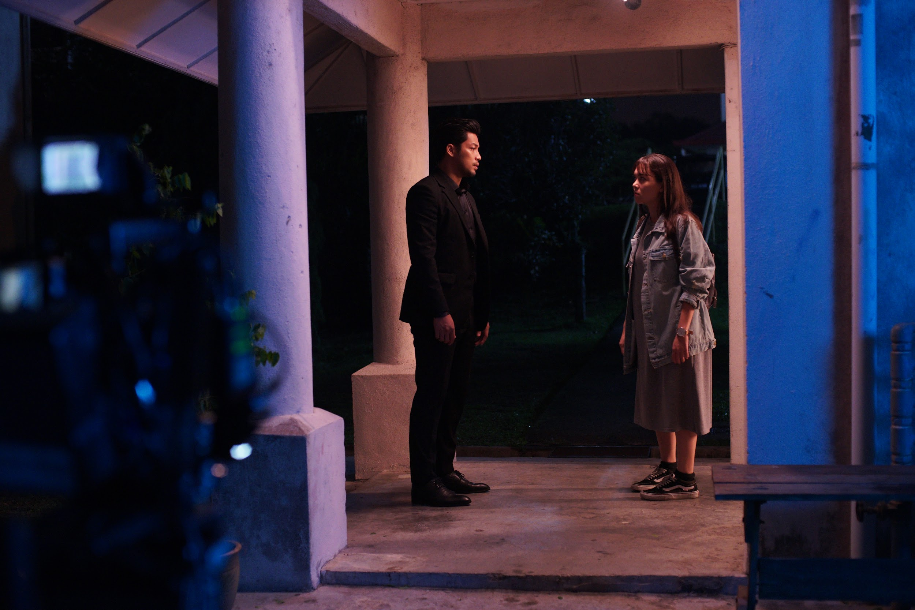

KUALA LUMPUR, December 2019 – Viu, a leading pan-regional OTT video service from PCCW Media Group with more than 36 million monthly active users (MAU), is pleased to unveil its latest Viu Original series, Black. The upcoming series, which is an adaptation of the renowned CJ E&M Korean format of the same name, will be a localized version incorporating Malay mythology. Slated to air exclusively on Viu, the new eight-episode series stars popular artistes such as Kamal Adli, Siti Saleha, Nabila Huda, Zoey Rahman and more.

In the original Korean series, Black is a fantasy thriller romance drama that follows a grim reaper who enters the world of mortals and finds himself falling in love with a woman who can foresee death. All 18 episodes are available on Viu.

Viu’s Malaysian adaptation replaces the concept of grim reaper with Bunian (a supernatural being from another dimension in Malay folklore) and sets Black (played by Kamal Adli) off on a mission to track down his fugitive partner in the human world. Breaking a cardinal rule of his people, Black inhabits the body of Malik, a deceased police officer (also played by Adli) and assumes his identity in order to facilitate his investigation. Despite detesting humans for their “primitive ways”, Black becomes entangled with Sofia (played by Siti Saleha), a woman whose ability to foresee death is key to his mission. Much to his chagrin, he finds himself falling for her – another cardinal sin. Along the way, they become embroiled in a 20-year-old unsolved murder case that leads back to their shared past.

Mr. Kingsley Warner, General Manager of Viu Malaysia, said, “Since we began producing our own Viu Original content, we have received overwhelmingly positive feedback from our Viu-ers and the Malaysian industry alike. Three of our original dramas out of Malaysia have received outstanding recognition at the recent Asian Academy Creative Awards. With a focus on original creative and international formats, Viu Malaysia took the opportunity to bring a localized version of CJ E&M’s powerful and haunting storyline of Black to Viu audiences. We know that the Malaysian remake of Black will be a strong addition to our premium content offering and we are confident it will be well-received by our Viu-ers across all our 17 markets.”

Produced by Kuala Lumpur-based production company, Alpha47 Films, and co-directed by award-winning directors, Razaisyam Rashid and Kroll Azri, Black is set to air with four back-to-back episodes on December 17 and 24. Black will be available exclusively on Viu across its 17 markets spanning Asia, the Middle East and South Africa. Viu-ers can watch the thrilling series on the Viu app which is available for free download on the Apple App Store, Google Play, and selected smart TVs, as well as on the web at www.viu.com.

END

About Viu

Viu is a leading pan-regional over-the-top (OTT) video streaming service operated by PCCW Media Group. It is available in 17 markets including Hong Kong, Singapore, Malaysia, India, Indonesia, the Philippines, Thailand, Myanmar in Asia, the Middle East countries of Bahrain, Egypt, Jordan, Kuwait, Oman, Qatar, Saudi Arabia, the UAE and the newly launched South Africa.

Operating with both an ad-supported tier and a premium subscription tier with more features, Viu delivers premium Asian content in different genres from top content providers with local language subtitles as well as original production series under the ‘Viu Original’ initiative.

Viu offers users express delivery of telecast content, streaming and download features, and localized user interfaces. With the patented Dynamic Adaptive Transcoding technology, Viu can provide the best viewing experience regardless of device or network conditions.

The service can be accessed via Viu app (available for free on App Store and Google Play) on connected devices, e.g. smartphones and tablets, selected smart TVs, as well as on web by logging into www.viu.com.

About PCCW Media

The Media Group of PCCW is a leading, fully integrated multimedia and entertainment group in Hong Kong.

The Media Group operates the leading pay-TV service in Hong Kong under the Now TV brand delivering both self-produced and licensed content to its customers using IPTV technology. Now TV offers more than 160 linear channels and on demand library of local, Asian and international programming. Its premium content can also be accessed via the Now Player app. It is also a leading producer of Chinese language news, financial news and sports programming in addition to Asian infotainment content which complements its wide portfolio of licensed movie and international television content. PCCW Media also offers the Now E entertainment OTT (over-the-top) platform with international and Asian dramas, movies and world-class sports events, which is designed to meet the needs of viewers with Millennial lifestyle.

The Media Group is also engaged in the provision of OTT video service under the Viu brand in Hong Kong and 16 markets in Southeast Asia, the Middle East, India and South Africa. In addition, MOOV is a hugely popular music digital streaming service in Hong Kong
About PCCW Limited

PCCW Limited (SEHK: 0008) is a global company headquartered in Hong Kong which holds interests in telecommunications, media, IT solutions, property development and investment, and other businesses.

The Company holds a majority interest in the HKT Trust and HKT Limited, Hong Kong’s premier telecommunications service provider and leading operator in fixed-line, broadband and mobile communication services. HKT meets the needs of the Hong Kong public and local and international businesses with a wide range of services including local telephony, local data and broadband, international telecommunications, mobile, and other telecommunications businesses such as customer premises equipment sale, outsourcing, consulting, and contact centers.

PCCW also owns a fully integrated multimedia and entertainment group in Hong Kong, PCCW Media. PCCW Media operates the largest local pay-TV operation, Now TV, and is engaged in the provision of over-the-top (OTT) video service under the Viu brand in Hong Kong and other places in the region.

Through HK Television Entertainment Company Limited, PCCW also operates a domestic free television service in Hong Kong.

Also, wholly-owned by the Group, PCCW Solutions is a leading information technology outsourcing and business process outsourcing provider in Hong Kong and mainland China.

In addition, PCCW holds a majority interest in Pacific Century Premium Developments Limited, and other overseas investments. To learn more about PCCW, please visit www.pccw.com.

For further information, please do not hesitate to contact:
Nicole Aldeth Main Shamani Krishnan
Mad Hat PR Mad Hat PR
T: +6012 5670129 T: +6012 9100353
E: nicole@madhat.asia E: shamani@madhat.asia

