For media enquiries, please contact:
Su Zen suzen@madhat.asia +6012 772 5082
Hui Shan huishan@madhat.asia +6012 295 1732
July 2018
FOR IMMEDIATE RELEASE
Sulwhasoo launches Limited Edition
Peach Blossom Spring Utopia Collection
The picturesque collection spreads the message of happiness; a utopian vision of the world filled with peach blossom splendor

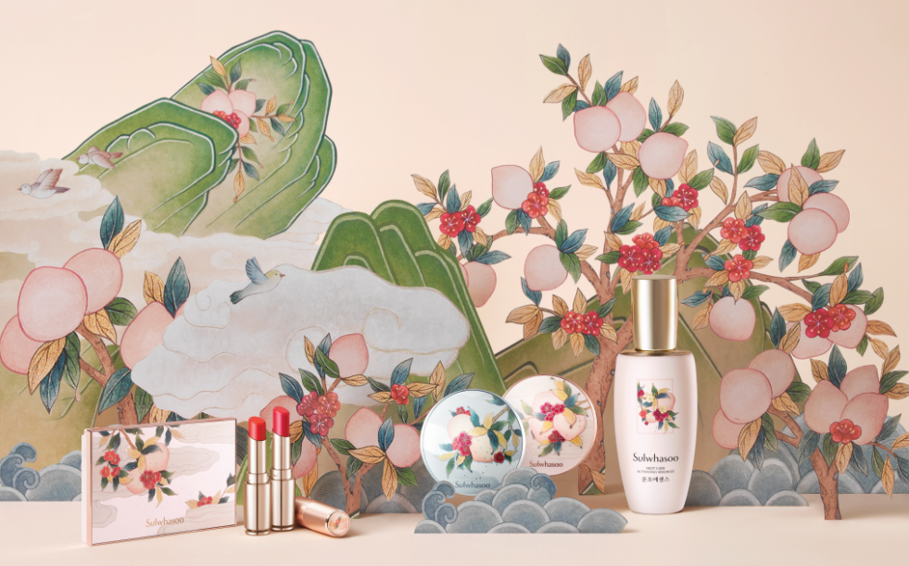
Sulwhasoo Limited Edition Peach Blossom Spring Utopia

KUALA LUMPUR, MALAYSIA - Inspired by the ultimate beauty of plum blossoms blooming in the snow, Sulwhasoo, Korea’s leading luxury beauty brand, launches the Limited-Edition Peach Blossom Spring Utopia collection, carrying only best wishes for their loved ones.

In ancient East, the image of a peach orchard brimming with the vitality of green leaves and peach blossom petals was equated to a utopian vision, called Peach Blossom Spring, where people lived in peace and happiness. The image of the peach, known as the divine fruit of the gods and a sacred symbol of immortality, was incorporated into folk paintings, ceramics and ink stones. It was commonly given out as gifts believing that it’ll bring forth great happiness.
To share the joy and to realize love in the lives of our important ones, Sulwhasoo introduces the Limited-Edition Peach Blossom Spring Utopia collection, a special edition that features a collection of skincare and makeup items altogether, which comprises of First Care Activating Serum EX, Perfecting Cushion, Perfecting Cushion Brightening, Lip Serum Stick, and Makeup Multi Kit.

Sulwhasoo’s Limited Edition Peach Blossom Spring Utopia collection also delivers a heartfelt message, “Wish You Happiness”. Collaborating with contemporary artist, Hana Seo, who interprets traditional folk painting with a modern twist, this Limited Edition collection is a prized collector’s item as well as a perfect gift for your beloved ones.

Moving into the collection, the Limited Edition Peach Blossom Spring Utopia carries none other than Sulwhasoo’s signature product – First Care Activating Serum EX, a first-step serum used right after cleansing to boost the absorption of subsequent products. It addresses dryness, the root cause of all skin troubles, and delivers ultimate radiance to the skin with moisturizing and balance-restoring treatments.

Next is Sulwhasoo’s well-received makeup item, Perfecting Cushion EX. It gives you flawless coverage with Sulwhasoo’s ‘Slim fit high coverage’ formula and skincare technologies that unlocks the moisturizing properties of Schizophyllum commune. By harmonizing the proprietary formula and the moisturizing ingredient, this cushion delivers long-lasting coverage.

On the other hand, the Perfecting Cushion Brightening contains skin-gleaming Magnolia Extract and the translucent Pearlescent Complex to bring out the natural luminosity to the skin. It also uses Sulwhasoo’s proprietary purifying water derived from Licorice Extract – known for excellent skin-clarifying effects. With the Oil Capture System that traps and absorbs excess sebum, Perfecting Cushion Brightening gives a smooth finish without leaving any stickiness.

The rich-textured Essential Lip Serum Stick forms a double layer of oil and water on lips and locks in moisture, leaving them well-nourished and moisturized. Apricot kernel oil and Elastic Complex fill in and smooth out the surface of lips, making them look plump and soft.

Last but not least is the Makeup Multi Kit that consists of Sulwhasoo Powder for Cushion and Multi Blusher with a peach undertone. Multi Blusher is a new addition to Sulwhasoo’s color palette, combining three colors of the season to create a spring-ready natural look. Sulwhasoo Multi Blusher features a mix of the main blusher, which is blendable with other shades to add a subtle flush of color; a point blusher, whose crimson shade creates depth; and a highlighter, which creates highlighting effects. When applied with different brush strokes directions, Multi Blusher helps you achieve different shades of colors and highlighting effects. On the other hand, Powder for Cushion gives a silky finish to the makeup look by reducing the appearance of pores and evening out the surface of the skin with the exquisitely refined powder.

Sulwhasoo First Care Activating Serum EX - Peach Blossom Spring Utopia Limited Edition
■ Volume: 120ml, RM466
■ Price: RM466

Sulwhasoo Perfecting Cushion EX - Peach Blossom Spring Utopia Limited Edition
■ Weight: 15g*2
■ Shade:
No.15 Ivory (Pink)
No.21 Natural (Pink)
No.23 Natural (Beige)
■ Price: RM216

Sulwhasoo Perfecting Cushion Brightening - Peach Blossom Spring Utopia Limited Edition
■ Weight: 15g*2
■ Shade:
No.13 Light Pink
No.21 Medium Pink
No.23 Medium Beige
■ Price: RM216

Sulwhasoo Lip Serum Stick - Peach Blossom Spring Utopia Limited Edition
■ Weight: 3g
■ Shade:
No.4 Rose Red
No.9 Glow Orange
■ Price: RM141

Sulwhasoo Makeup Multi Kit - Peach Blossom Spring Utopia Limited Edition
■ Price: RM299

-END-

About Sulwhasoo

Inspired by the ultimate beauty of plum blossoms blooming in the snow, Sulwhasoo, Korea’s leading luxury beauty brand, presents timeless beauty, conveying the true aesthetics found from the philosophy of harmony and balance, tradition and modernity. The Sulwhasoo brand gains wisdom from the laws of nature, pursues beauty reminiscent of nature with precious natural ingredients and delivers beauty of harmony and balance between the body and the mind by creating beauty from the inside out. Sulwhasoo globally promotes the value of holistic beauty with the legendary ingredient such as the Jaum Balancing Complex™ and Korean ginseng, which contains the wisdom of Asia, with Sulwhasoo’s unique cutting-edge technology. As of 2018, Sulwhasoo has established itself as an authentic global brand, operating in 12 countries around the world such as South Korea, Mainland China, Singapore, Hong Kong (China), Thailand, Indonesia, Malaysia, Taiwan, Vietnam, the US, Canada and France, by conveying Korean traditional beauty and value to all around the world.

