For media enquiries, please contact:
Su Zen suzen@madhat.asia +6012 772 5082
August 2018
FOR IMMEDIATE RELEASE
Sulwhasoo Announces New Additions To Its Signature Ginseng Line
Strengthen skin’s elasticity for youthful definition from every angle

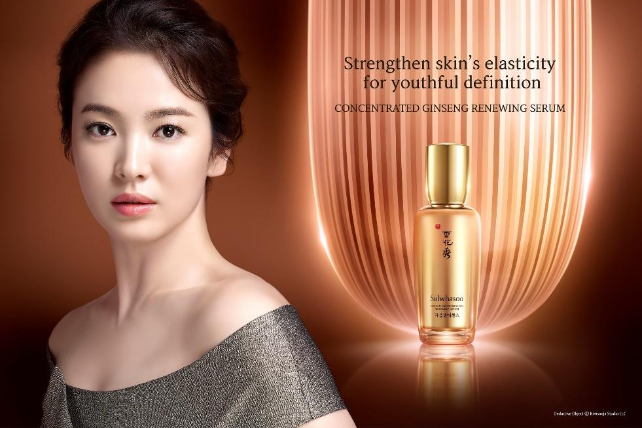

KUALA LUMPUR, MALAYSIA - Known for its holistic beauty that is strongly inspired by Asian philosophy and wisdom, Sulwhasoo offers the beauty of harmony and balance with its Concentrated Ginseng Renewing Line. Formulated with its precious ingredient, Korean Ginseng, the amazing skin care line contains high concentration of nutrition tapped from ginseng, prepping skin with all the moisture and resilience it needs.

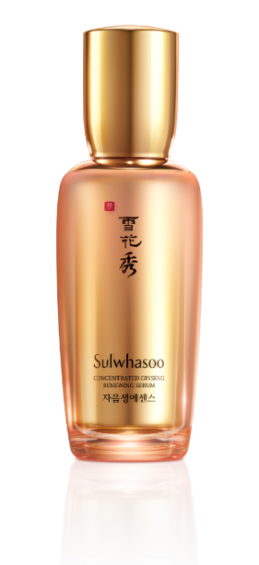
Sulwhasoo Concentrated Ginseng Renewing Serum

Inspired by the ultimate beauty of plum blossoms
blooming in the snow, Sulwhasoo, Korea’s leading
luxury beauty brand, presents the Sulwhasoo
Concentrated Ginseng Renewing Serum. The anti-aging
serum boosts the Derma-Epidermal Junction (DEJ), creating
firm facial contours that look flawless from every angle.

Sulwhasoo believes that firming up the skin requires more
than just quality ingredients. The all-new Concentrated
Ginseng Renewing Serum improves the skin from within
and increases the skin’s elasticity by creating a firm and smooth look. With Ginsenisphere™ technology, the serum contains microcapsules that is imbued with the energy of concentrated ginseng. Infused with precious ginseng seed oil, it automatically forms a creamy textured microcapsule that melts into the skin upon application, giving nourishment to the skin.

The Concentrated Ginseng Renewing Serum is formulated from ginseng leaves, stems and roots - the foundation to skin’s vitality - through Sulwhasoo’s strong commitment in ginseng research and technologies. It enhances the DEJ to plump up the skin from within and improve the appearance of wrinkles, presenting firm facial contours that defy the passage of time.
The serum provides a rich, silky and nourishing feel leaving no sticky residue. The refreshing finish makes it a perfect match with an anti-aging cream especially when paired with Sulwhasoo’s Concentrated Ginseng Renewing Cream EX for firmer skin and a more lifted appearance.

Sulwhasoo Concentrated Ginseng Renewing Cream EX [ Original / Light ]
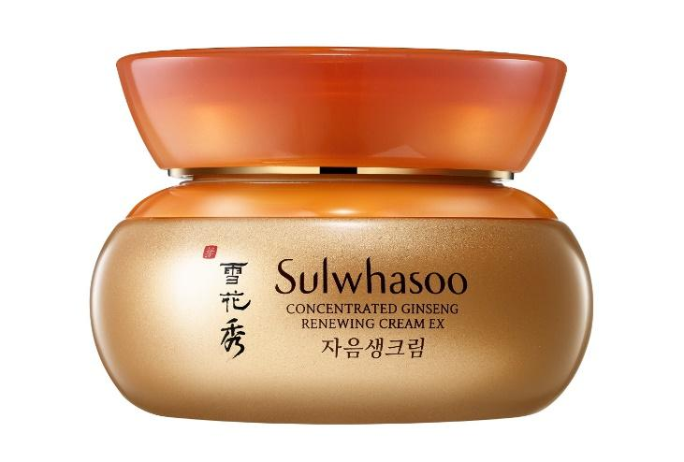
Sulwhasoo’s next must-have product is Concentrated Ginseng Renewing Cream EX. With the culmination of Sulwhasoo’s 50-years of ginseng research, the Concentrated Ginseng Renewing Cream EX helps skin regenerate and reinvigorate with Compound K, a precious anti-aging ingredient found in ginseng roots. This premium anti-aging cream also contains Ginsenoside Re extracted from ginseng flowers - the origin of ginseng energy, to prevent skin damage by enhancing the skin’s defensive power.

The Concentrated Ginseng Renewing Cream EX addresses early signs of aging skin such as dryness, loss of firmness and dullness. It helps recreate youthful beauty by bringing back elasticity, firmness and resilience to the skin, especially at wrinkle-prone areas such as the eyes, mouth and smile lines.

Available in two options, one would be able to select their preferred cream based on the skin’s conditions and needs. The Concentrated Ginseng Renewing Cream EX Original features a nutrition-rich texture with a profound ginseng scent, while the Concentrated Ginseng Renewing Cream EX Light has a soft, refreshing texture and a fresh scent of ginseng flowers.

Sulwhasoo Concentrated Ginseng Renewing Water & Emulsion
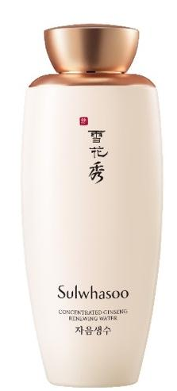
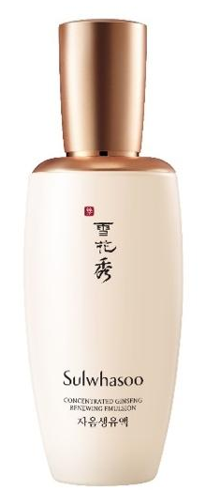

This year, Sulwhasoo is introducing two new products to complement its Concentrated Ginseng Renewing Line - the Sulwhasoo Concentrated Ginseng Renewing Water and the Sulwhasoo Concentrated Ginseng Renewing Emulsion as part of its skincare lineup. Both products contain anti-aging ingredients that prep the skin by moisturizing and firming dry skin with its precious ingredient, Steamed Ginseng Water Concentrate™.

Steamed Ginseng Water Concentrate™ is created by drying steamed ginseng in a vacuum and then recovering the vapors through a cooling process. The painstaking process reflects Sulwhasoo’s commitment to securing precious ingredients, no matter how slow and complicated it is.

Featuring three moisturizing agents, the moisture-rich Concentrated Ginseng Renewing Water glides on as smoothly as oil and makes the skin firm from within, leaving it moisturized and supple, where Concentrated Ginseng Renewing Emulsion spreads on the skin gently and keeps the skin hydrated for a long time with a lightweight and refreshing finish. It delivers greater moisturizing effects, when used together with Concentrated Ginseng Renewing Water and Concentrated Ginseng Renewing Cream EX.

With its bracing scent of ginseng leaves and flowers, the Concentrated Ginseng Renewing Water and Emulsion are perfect for anyone who wants truly healing and calming experiences.

The new additions of Sulwhasoo Concentrated Ginseng Renewing line will be available at all Sulwhasoo counters nationwide, Sulwhasoo Boutiques in Mid Valley Megamall and Sunway Pyramid starting from September 2018.

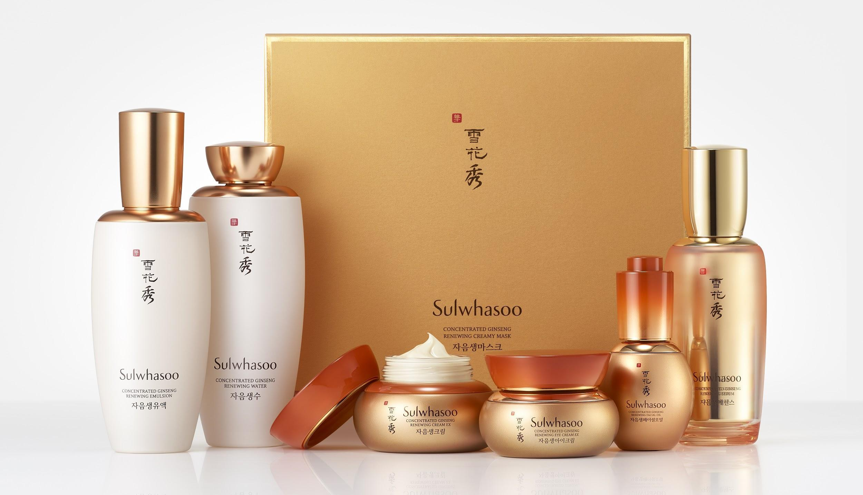

The Complete Sulwhasoo Concentrated Ginseng Renewing Line

Sulwhasoo Concentrated Ginseng Renewing Water
- An anti-aging toner formulated with precious Steamed Ginseng Water Concentrate™ to keep skin firm, moist and supple
■ Size: 125ml
■ Price: RM300

Sulwhasoo Concentrated Ginseng Renewing Emulsion
- An anti-aging emulsion formulated with precious Steamed Ginseng Water Concentrate™ to keep skin hydrated with a lightweight and refreshing finish
■ Size: 125ml
■ Price: RM330

Sulwhasoo Concentrated Ginseng Renewing Serum
- An upgraded anti-aging serum with Ginsenisphere™ technology to strengthen skin’s elasticity for youthful definition from every angle
■ Size: 50ml
■ Price: RM690

Sulwhasoo Concentrated Ginseng Renewing Facial Oil
- An anti-aging facial Oil infused with carefully selected precious ginseng seed oil, to provide radiance and nourishment to dry skin without stickiness
■ Size: 20ml
■ Price: RM452

Sulwhasoo Concentrated Ginseng Renewing Eye Cream EX
- Formulated with a powerful ginseng formula, this eye cream rejuvenates the skin and creates a youthful and smooth look around the eye area
■ Size: 20ml
■ Price: RM594

Sulwhasoo Concentrated Ginseng Renewing Cream EX Original / Light
- The culmination of Sulwhasoo’s 50-years of ginseng research, this anti-aging cream promotes skin regenerate and reinvigorate with Compound K, a precious anti-aging ingredient found in ginseng roots
■ Size: 60ml
■ Price: RM750

Sulwhasoo Concentrated Ginseng Renewing Creamy Mask
- An anti-aging mask with innovative Double Wrapping Sheet™ delivering powerful ginseng energy with a creamy texture, improving skin’s elasticity, firmness and radiance
■ Quantity: 5 sheets
■ Price: RM424

- END -

About Sulwhasoo

Inspired by the ultimate beauty of plum blossoms blooming in the snow, Sulwhasoo, Korea’s leading luxury beauty brand, presents timeless beauty, conveying the true aesthetics found from the philosophy of harmony and balance, tradition and modernity. The Sulwhasoo brand gains wisdom from the laws of nature, pursues beauty reminiscent of nature with precious natural ingredients and delivers beauty of harmony and balance between the body and the mind by creating beauty from the inside out. Sulwhasoo globally promotes the value of holistic beauty with the legendary ingredient such as the Jaum Balancing Complex™ and Korean ginseng, which contains the wisdom of Asia, with Sulwhasoo’s unique cutting-edge technology. As of 2018, Sulwhasoo has established itself as an authentic global brand, operating in 12 countries around the world such as South Korea, Mainland China, Singapore, Hong Kong (China), Thailand, Indonesia, Malaysia, Taiwan, Vietnam, the US, Canada and France, by conveying Korean traditional beauty and value to all around the world.

