MGAC 2019 LAUNCH
PANEL SESSION

PANELIST PROFILES

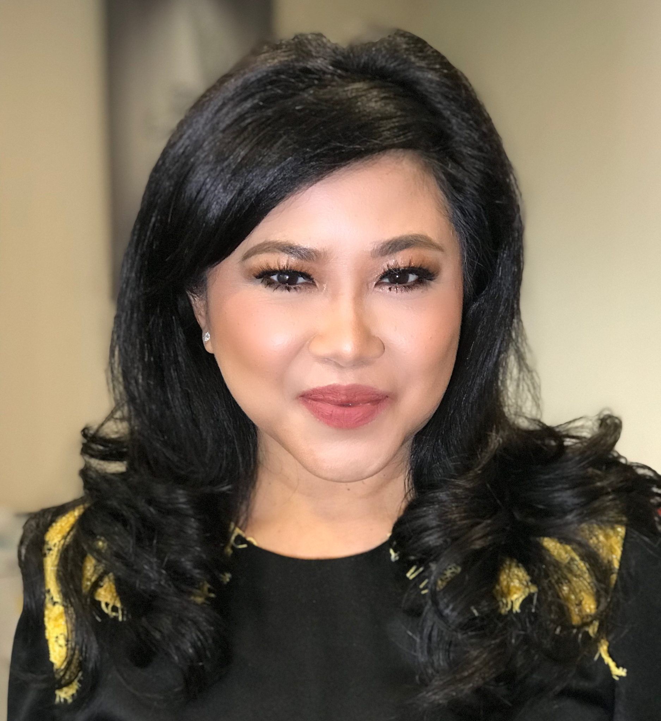 | Nora Abdul Manaf  Group Chief Human Capital Officer, Maybank  In addition to Nora Manaf’s role as the Group Chief Human Capital Officer and member of the Group EXCO of Maybank, Nora chairs several national level committees and holds several Board memberships. Nora is also an Adjunct Professor appointed by the College of Business, Universiti Utara Malaysia (UUM).  Nora is actively engaged in the country’s FI, Employers’ and Education circles via the leadership roles she holds. In 2018, Nora was appointed to the Malaysian Human Resource Minister’s Advisory Group. She is also Chairman of the Malayan Commercial Banks’ Association, Chairman of the Banking Sector HR Networking Group (HRNG), a Council Member of the Malaysian Employers Federation (MEF), a member of the National Labour Advisory Committee (NLAC), Advisory Committee for UUM Master of Science (Finance) and an Advisory Council Member of Yayasan Peneraju Pendidikan Bumiputera as well as for the University-Industry Advisory Council Universiti Utara Malaysia. Nora was recognised as a Global Top50 Human Resource Professional, and was appointed into Talent Compact 4.0, an Industry Talent Advisory Panel of Talent Corporation Malaysia Berhad.  Nora’s Board memberships include the Board of Etiqa General Insurance Berhad, Etiqa Life Insurance Berhad, MBB Labs Private Limited, Bangalore and the Malaysian American Commission on Educational Exchange (MACEE). Nora is also a Member of the Board of Examiners for the Asia Institute of Chartered Bankers (AICB), Member of the Asia Pacific Industry Advisory Panel for the Chartered Institute of Management Accountants (CIMA) and a Qualified Person for Training (QPRT) for the Institute of Chartered Accountants in England and Wales (ICAEW).  Nora is active in her quest to make a difference to empower women. She is the Executive Sponsor for Maybank’s Women Mentor Women Council established in 2013, as well as a Mentor for the ICAEW-TalentCorp Women in Leadership Programme. In 2016, Nora was awarded the “Beacon of Light” award at the National Women in Leadership Summit organised by the Asian Strategy & Leadership Institute (ASLI) in partnership with the Ministry of Women, Family and Community Development. Nora also spoke at a Women in Leadership seminar in Oxford University in 2016. Nora is a qualified Chartered Accountant and is registered with the Malaysian Institute of Accountants (MIA). Nora also holds a post-grad certification in Human Resource Development from Cornell University and is a certified Gallup Strengths finder Coach Level II. She is also a graduate of the Advanced Management Program from Harvard Business School.
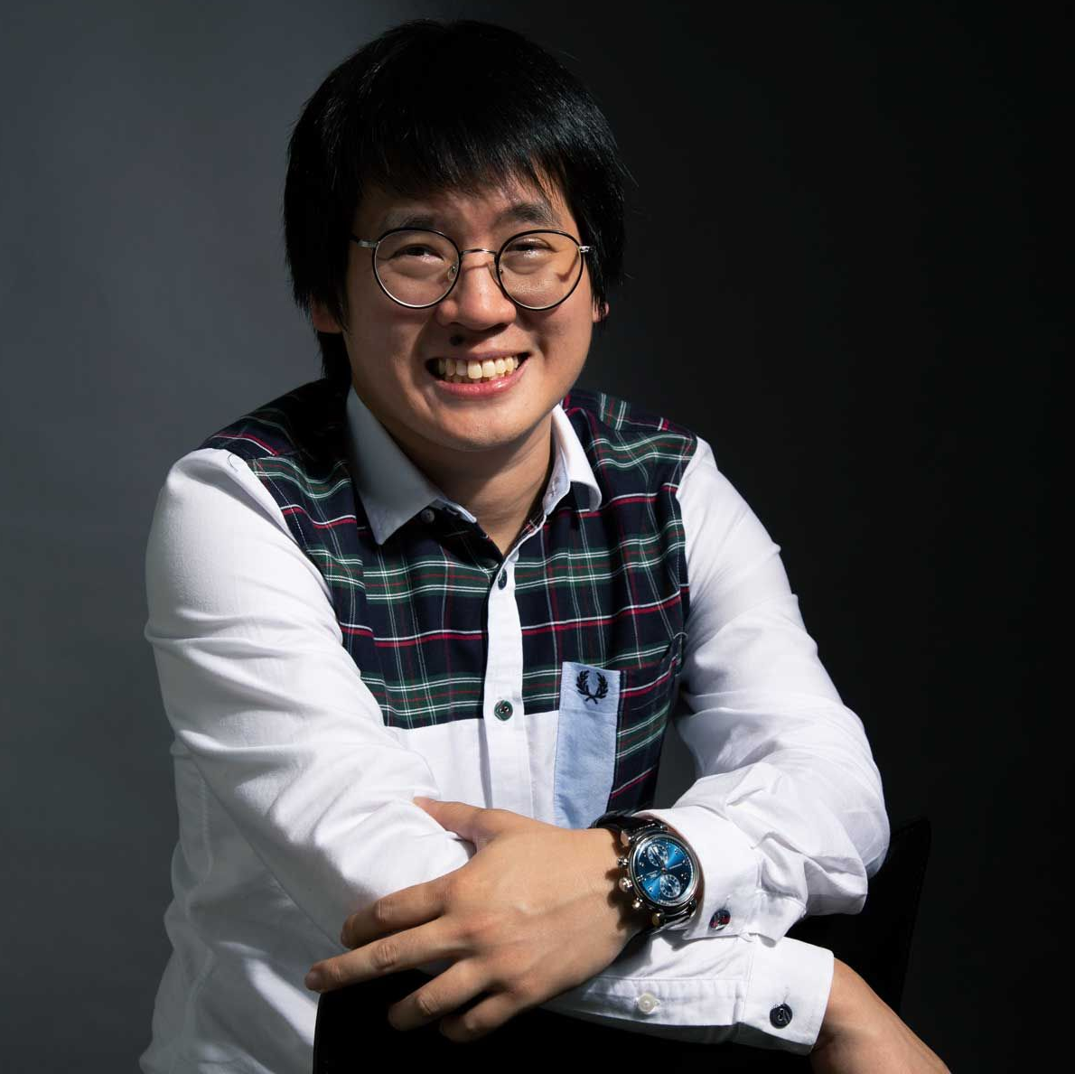 | Timothy Tiah  Founder, Colony CoWorking Space  Timothy after his graduation alongside his business partner established Netccentric together with the launch of a blog advertising company, Nuffnang. Then, after pioneering the social media marketing space, he decided to become the mind behind Colony, which is among the first co-working spaces in KL, boasting luxurious amenities and services. In less than two years Colony is set to open its fourth outlet.
 | Zikry Kholil  Cofounder, Incitement  Zikry cofounded Incitement in late 2011, which started off as a movement aiming to transform people's inspiration into tangible action steps towards their personal growth and helping challenged communities. Zikry is arguably one of the most significant upcoming thought leaders in the social sector. His work with Incitement earned him a listing as Forbes 30 Under 30 Asia 2016, Top 100 World Visionary Leader 2016 and voted as Top 10 Malaysia's Most Innovative Entrepreneurs. He currently sits on the Advisory Board of the SME & Entrepreneurship Business Award Malaysia and is a member of the Grand Jury for the United Nations World Summit Award (WSA).
 | Anabelle Co-Martinent  Founder and Chief Executive Officer, La Juiceria  As the Founder and Managing Director for La Juiceria Sdn Bhd, founded in KL in 2013, she oversees the expansion, business development strategies, marketing and operations for La Juiceria Cold-Pressed Detox bars, Goodness Greens café, La Juiceria Superfoods cafes and Super Saigon Pho Cafes. Anabelle also runs a restaurant called The Gardens (Philippines).  Soxial Status is a boutique social media agency that she started in 2018 to help SME’s. She carved out her marketing experience in the technology sphere during her previous stints with leading global brands like Hewlett Packard, Canon and Nokia in her native Philippines, as well as Microsoft in Kuala Lumpur, where she has spearheaded numerous ambitious product launches.
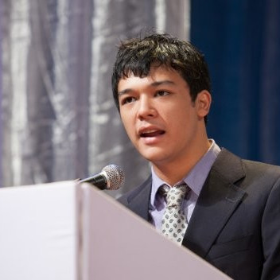 | Moderated by Jonathan Case  Founder, Case Creativity  Jonathan formed Case Creativity in 2014 to address the disconnect between clients and quality writers in Malaysia. Having grown up in Malaysia and studied Philosophy, Politics and Economics in the UK, Jonathan developed a fluent way of communicating across borders and adapting his message to different audiences. Jonathan is also a corporate emcee and voiceover artist with a passion for the stage.

