Hey there media friends!



As Malaysia celebrates 61 years of independence, what better way to spend your day than immersing yourself in shows that ignite the patriotism within us! In commemoration with Merdeka, Viu will be featuring shows that highlight themes of patriotism, courage and bravery. From action films to Asian dramas, Viu has a little something for everyone! Be prepared to experience tears, laughter and national pride with Viu’s selection of shows this ‘Merdeka’ season.

1.THE BATTLESHIP ISLAND (Movie)

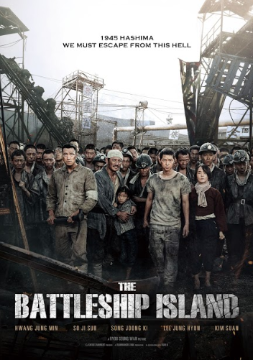

History buffs will enjoy this film, which is loosely based on World War II. The Battleship Island is a harrowing film about the suffering of 400 Koreans during the Japanese occupation and their attempt to escape their labour camp on Hashima Island. This is a moving tale of the hardship faced by the people of Korea and showcases the brutality of the Japanese occupation. It’s a movie that’s bound to leave viewers in tears and evoke a sense of pride for the nation with its inspiring patriotic speeches.

2.THE REBEL (Drama)

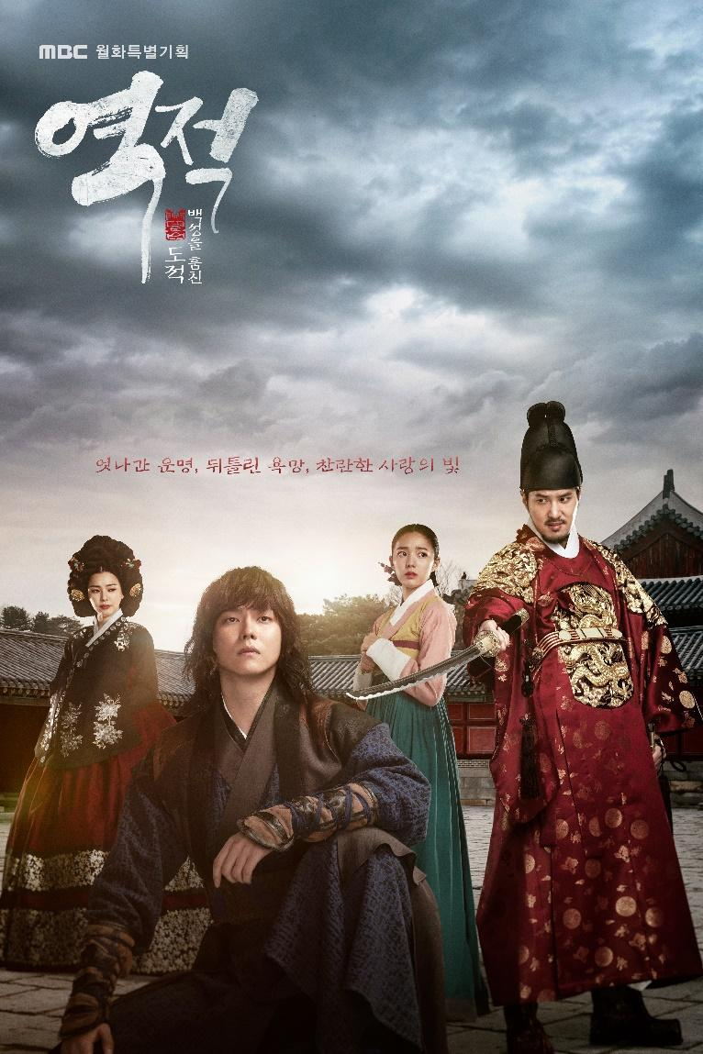
Episodes: 30 Episodes x 60 Mins

If you enjoy Robin Hood, then you’re in for a treat with this drama! It revolves around the story of Hong Gil-Dong’s quest to become the first revolutionary activist in Joseon by stealing from the rich and giving to the poor. However, in his journey to do so, he is challenged by the reign of the oppressive and cruel tyrant King Yeonsangun. Get inspired by Hong Gil-Dong’s tenacity and rebellion in the name of liberty in Korea’s version of Robin Hood.

3.ILJIMAE (Drama)

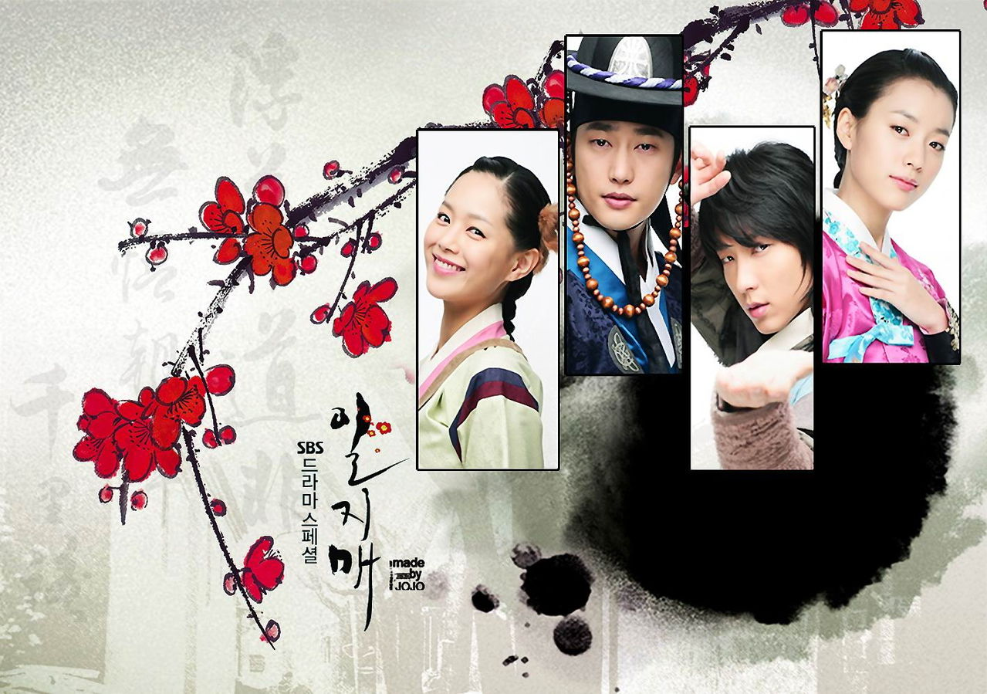
Episodes: 20 Episodes x 22 Minutes

Inspired by a comic strip, Iljimae which means "A single stalk of plum",this is a Korean period drama set during the Joseon dynasty. It tells the story of Geom, who is lazy, good-for-nothing by day but don’t let his laissez faire attitude to life fool you, because when the sun goes down, the rich are his victims and the poor are who he protects.

4. SIX FLYING DRAGONS (Drama)

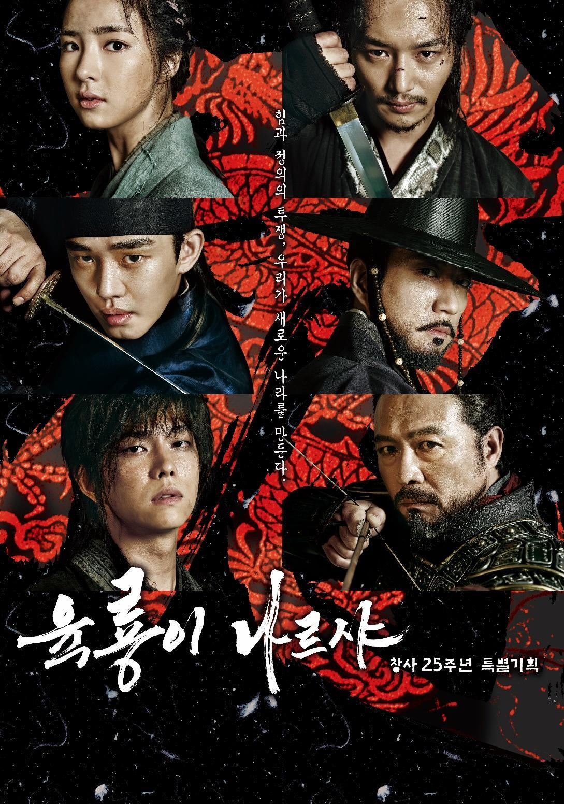
Episodes: 50 Episodes x 60 Minutes

Six Flying Dragons is a gripping tale about ideological and political turmoil that will set your heart racing. It involves Prince Yi Bang Won and Jeong Do-Jeon, a vital instrument in helping the prince father Yi Seong-gye to establish the Joseon nation. Watch as tempers flare and drama unfold due to differences in political opinion as Jeong Do-jeon wants a country ruled by ministers while Taejong wants absolute power.

5. HWARANG: THE POET WARRIOR YOUTH (Drama)

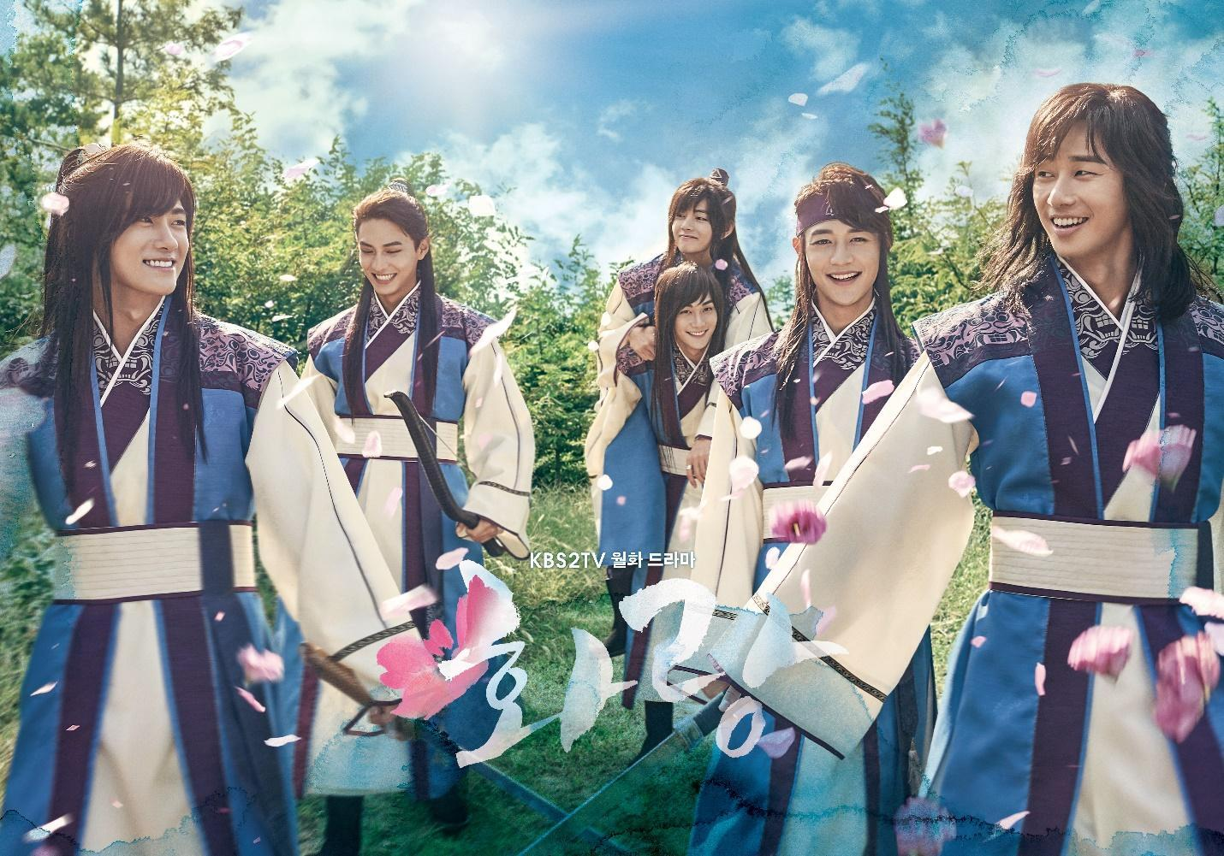
Episodes: 20 Episodes x 60 Minutes

Hwarang is the name of an elite group of young men in Silla, an ancient kingdom of the Korean Peninsula. Viewers will be inspired by the Hwarang as they discover their passion, love and friendship in the midst of turmoil faced by the kingdom.

6. THE DESCENDANT (Drama)

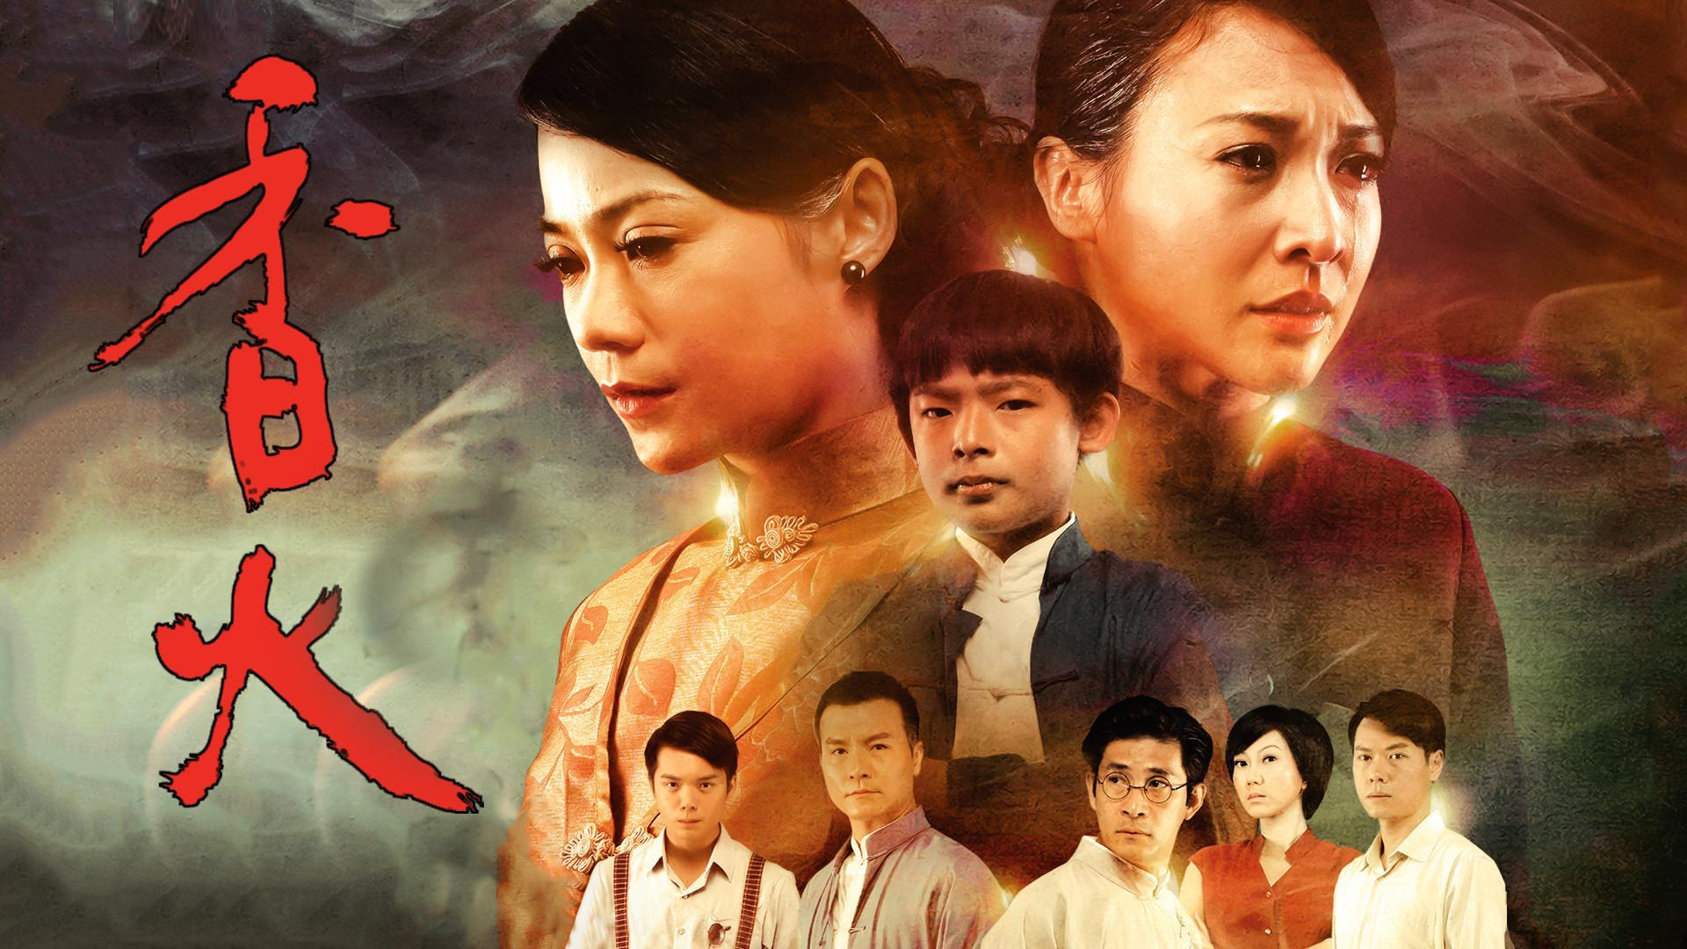
Episodes: 30 Episodes x 60 Minutes

If you have a deep appreciation for colonial architecture from the 20s to 60s era, then The Descendant will take you down memory lane. Shot in locations that are rich in history and beautiful colonial architecture such as Penang, Klang and Kuala Lumpur, this series is bound to make you feel like you are living in that time period. The Descendant is set against the backdrop of the incense-making industry and drama revolves around the conflicts of three generations of a large family, giving viewers of this generation a chance to get a glimpse of life in Malaysia back then.

7.DUS (Movie)



Dus, which translates to ‘Ten’ in Hindi, is a film packed with thrilling action, an all-star cast along with chart topping music and great production value - a movie that will not disappoint. This Hindi action movie is about Special Agents from India who are sent to foil the plans of a terrorist who is about to wreak havoc in Canada when the Indian Prime Minister plans a visit. The catch is that the agents will only have seven days to stop the deadly terrorist attack as it is scheduled to take place on 10 May - the inspiration for the film’s name.

8.KHAKEE (Movie)

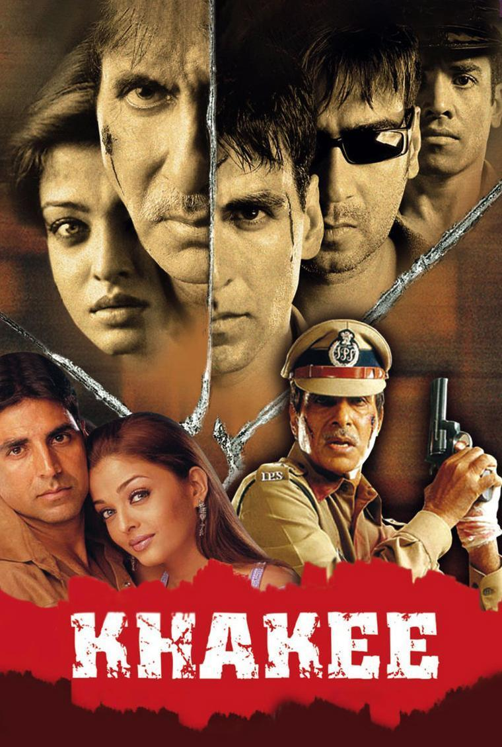

Bollywood movie fans will enjoy Khakee, a film that tells the story of an Indian Police team who are on a mission to escort an accused terrorist from a small town in Maharashtra to Mumbai. The movie also features Bollywood’s famous heartthrobs such as Akshay Kumar and Aishwarya Rai.

9.CITY OF LIFE AND DEATH (Movie)
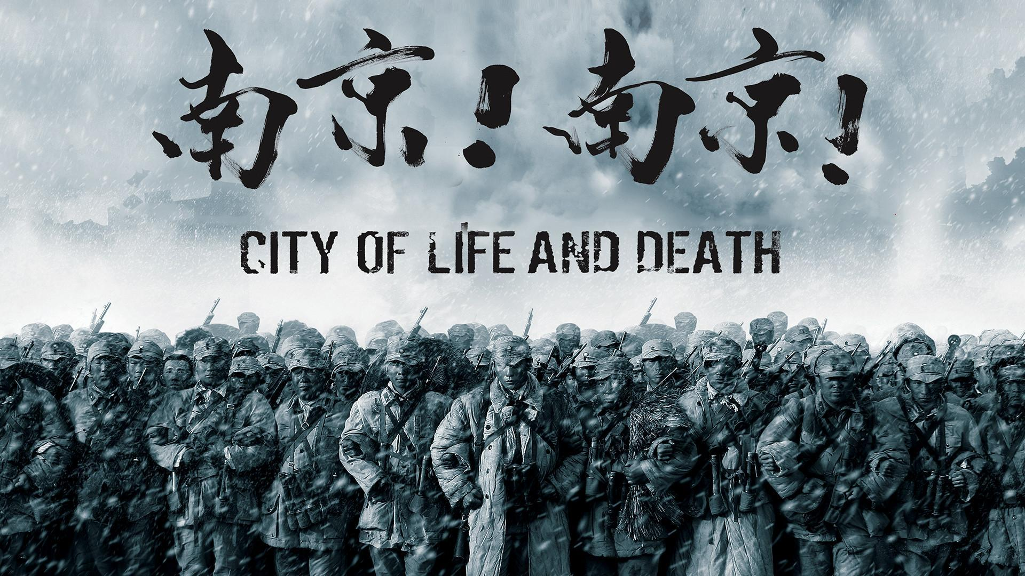

A story about heroism and acts of barbarism, City of Life and Death is a Chinese drama set in the year 1937 when the Japanese occupied Nanjing, a Chinese capital. For several weeks there were a great number of Chinese prisoners-of-war and civilians that were killed by the Japanese military. This is known as the Nanking massacre that resulted in a battle and subsequent atrocities against the inhabitant.

10.ASMARADANA (Drama)



Asmaradana is a drama-filled movie not to be missed during this Merdeka season. The story begins with the mother of the protagonist, Tengku Saiful, who disapproves of his choice of partner because she is not of royal lineage. In the name of love, and despite being disowned by his own mother, Tengku Saiful continues to live his life with Narimah. Unfortunately, Narimah is abruptly left widowed and expecting a child when Tengku Saiful passes suddenly.

---

Get your popcorn ready and tune into www.viu.com or download the Viu app to watch these inspiring shows!

