PRESS RELEASE

SOMETIME BY ASIAN DESIGNERS AND ALIA BASTAMAM LAUNCH BASTA 2 MINI EXCLUSIVELY ON ZALORA

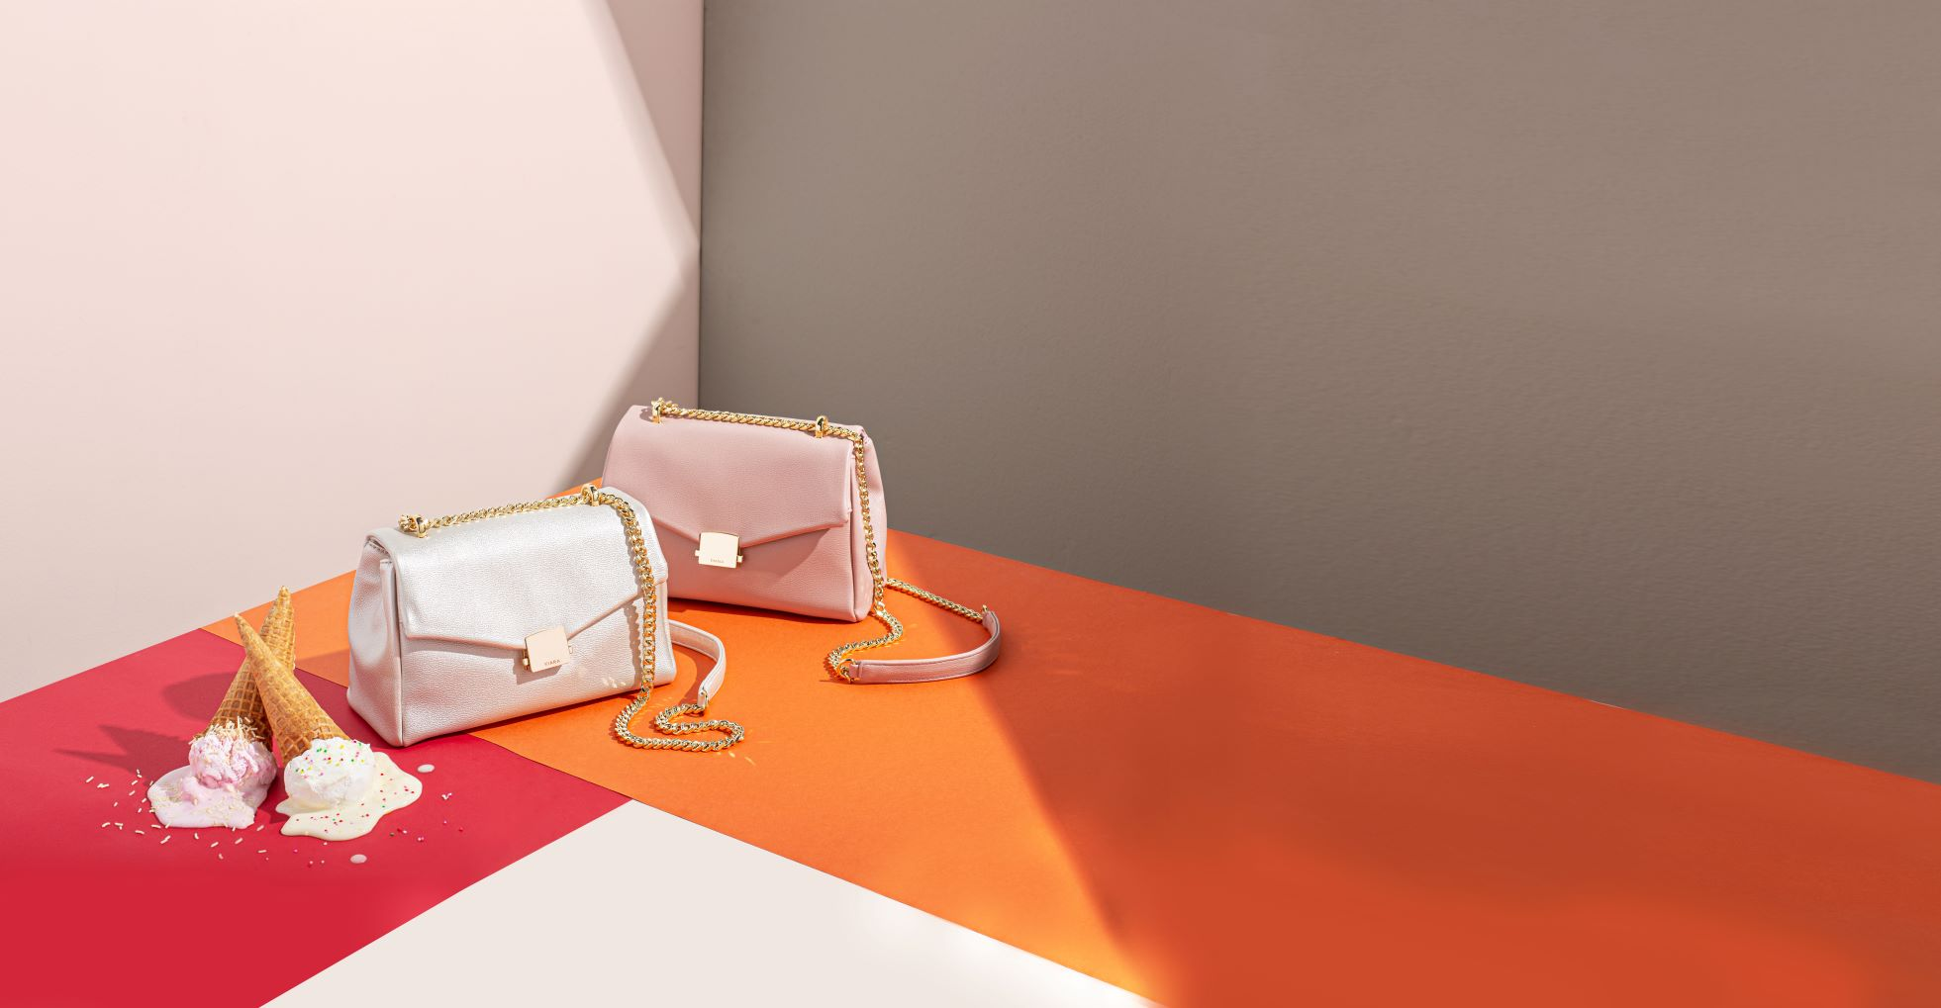

Kuala Lumpur, 26 June 2019; ZALORA, Asia’s online fashion destination will be launching the Basta 2 Mini the latest leather carryall, a collaboration between Asia’s bag specialist brand, Sometime by Asian Designers and Malaysian fashion designer, Alia Bastamam’s diffusion label, Alia B. The collection goes live on ZALORA at 11am tomorrow, 27 June 2019.

This compact installment of the much-loved Basta 2 from 2018, transitions effortlessly from day to night, with its accompanying gold chain strap and elegant hardware. Channeling the easygoing Alia B. girl, the relaxed silhouette can be worn over the shoulder, or as a chic crossbody bag. The design may be petite at only 16cm in height and 24cm in width, but still offers 6 practical compartments, including a secret compartment.
Available in 10 colours, the Basta 2 Mini comes in metallic and solid hues.

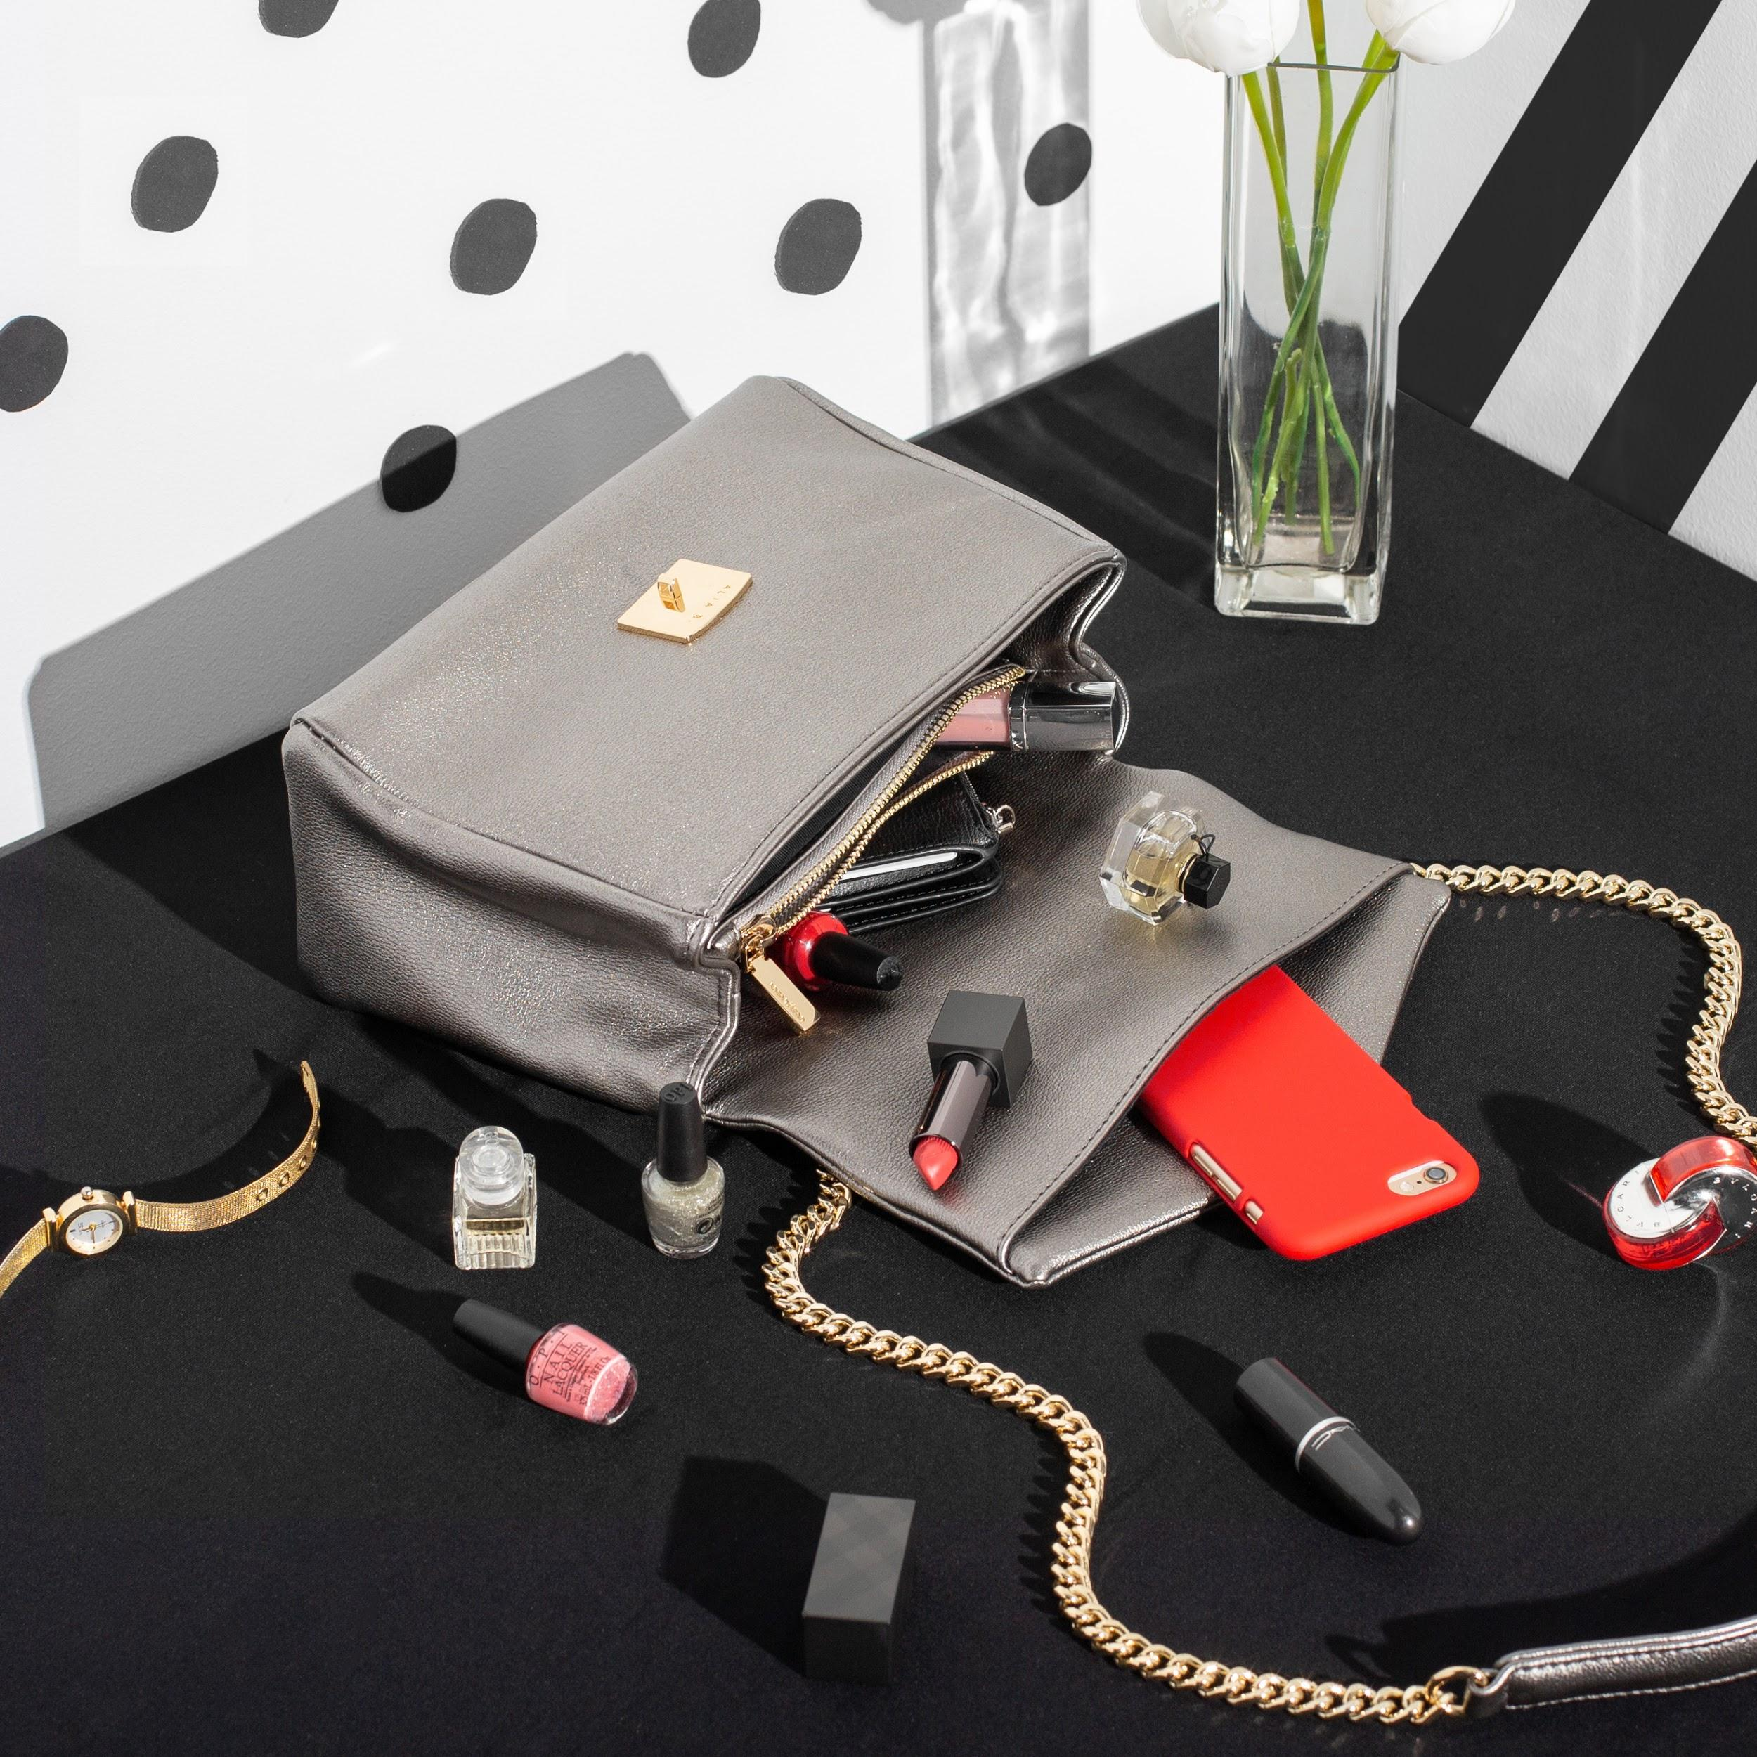

The Basta 2 Mini, co-designed by Alia Bastamam and Sometime by Asian Designers will be available at RM209.00 exclusively on zalora.com.my and zalora.com.sg from tomorrow, 27 June 2019 at 11am.

Press materials are available for download here.

-END-

MEDIA CONTACTS:

Ira Roslan | PR Manager
ira.roslan@my.zalora.com | +6016 3538 100

Lydia Chan | PR Executive
lydia.chan@my.zalora.com | +6012 3140 900

ABOUT ZALORA GROUP:
ZALORA is Asia’s online fashion destination. Founded in 2012, the company has a presence in Singapore, Indonesia, Malaysia & Brunei, the Philippines, Hong Kong and Taiwan. ZALORA is part of Global Fashion Group, the world's leader in online fashion for emerging markets. ZALORA offers an extensive collection of top international and local brands and products across apparel, shoes, accessories, and beauty categories for men and women. Offering up to 30-day free returns, speedy deliveries as fast as 3 hours in some markets, free delivery over a certain spend, and multiple payment methods including cash-on-delivery, ZALORA is the online shopping destination with endless fashion possibilities.

ABOUT SOMETIME BY ASIAN DESIGNERS:
Established in December 2012, Sometime by Asian Designers is a Malaysian bag specialist company that co-designs with selected Asian designers and fashion icons. Produced in-house in its own factory, the passionate team behind the brand has expertise and resources that enables them to offer exclusive designer bags without the conventional retail mark-up to discerning customers.

Celebrating the bag industry and its talents, Sometime by Asian Designers has worked with numerous brands, fashion designers and icons in Malaysia since its inception. An online-focused store, Sometime by Asian Designers’ most coveted collections include the Ribag, Sofina, Niko-Niko and Basta.

For more information on Sometime by Asian Designers, visit https://www.sometime.asia or follow their social media channels, (https://www.facebook.com/sometime.byasiandesigners) or Instagram @sometime_byasiandesigners

