Viu pushes social media engagement to new heights with
Viu Original’s reality travelogue “No Sleep No FOMO”
Viu’s 30 million users embark on a new exciting adventure with celebrity guests
Kim Jong Kook, Eric Nam and today’s hottest Asian social media stars

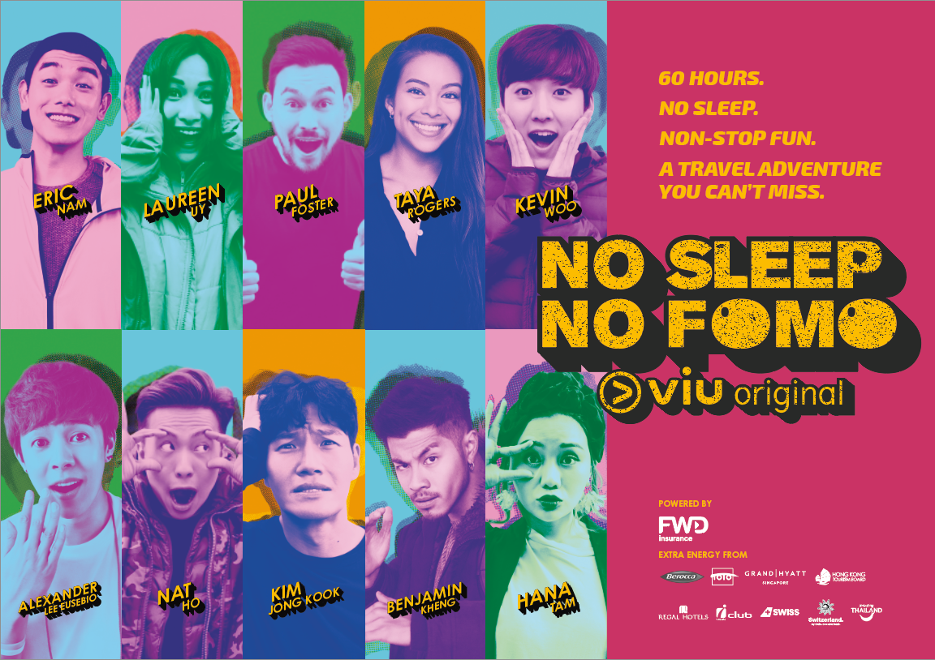

PCCW (SEHK:0008) – HONG KONG / SINGAPORE, March 20, 2019 – Viu, a leading pan-regional OTT video service from PCCW Media Group with more than 30 million monthly active users, today launches a new premium production No Sleep No FOMO. This Viu Original production is the first ever pan-regional travelogue with social media engagement at its heart.

The series rides on the lifestyle phenomenon of FOMO (Fear Of Missing Out) and turns an original YouTube challenge into a new innovative show with high-end production that takes the audience on a comedic and highly energetic journey to Hong Kong, Indonesia, Malaysia, the Philippines, Singapore, South Korea, Switzerland and Thailand.

Members of the cast of No Sleep No FOMO, which features today’s hottest Asian celebrities and social media influencers, are dropped into unexpected destinations and tasked to complete the FOMO list. In each episode, the celebrities are required to complete 60 fun and exciting missions within 60 hours without sleep. The missions include riding a buggy with a facemask on in the Philippines, staying in an abandoned haunted hotel in Indonesia and performing at a standup comedy club in Malaysia.
cont’d …
The protagonists will in each episode discover new adventures, explore interesting locations, experience wild things, encounter new people, indulge in local delicacies and refresh their minds and bodies.

The host, Singapore’s entertainment veteran Paul Foster, is joined by celebrity co-hosts Kim Jong Kook from the hit-show Running Man (South Korea), singer/songwriter Eric Nam (South Korea), and social media stars Hana Tam (Hong Kong), Kevin Woo (South Korea), Alexander Lee Eusebio (South Korea), Benjamin Kheng (Singapore), Nat Ho (Singapore), Laureen Uy (the Philippines) and Taya Rogers (Thailand). Together they reach a remarkable fan base of more than 12 million social media followers.

No Sleep No FOMO is also Viu Original’s first production to include a new interactive element that lets viewers engage directly with the show and its cast members. Dubbed as ‘Viu Engage’, the new element gave social media followers and audience the opportunity to co-create segments in the show. Fans were able to follow and watch No Sleep No FOMO come to life through dedicated hashtags #ViuNoSleepNoFomo and #ViuEngage, as well as to influence the course of the social media stars’ adventures by interacting on their social media channels in real-time. Since the beginning of the production, the social media posts of No Sleep No FOMO have organically reached three million users and generated more than 600,000 social interactions.

Ms. Janice Lee, Managing Director PCCW Media Group, said, “There are more than 3.4 billion active social media users in the world today which represents nearly 80% of all Internet users. The digital generation is constantly and actively engaging on social media, in particular with their social media idols. We want to embrace this phenomenon, and therefore put social media at the heart of No Sleep No FOMO. We have integrated new interactive social media elements into the production and let our fans participate and be a part of their idols’ adventures, turning viewers into active co-creators of the show.”

No Sleep No FOMO is based on a format owned by global content agency The Story Lab. It also marks the first collaboration of The Story Lab, part of Dentsu Aegis Network, with a regional OTT player.

Mr. Michael Iskas, Global President of The Story Lab, said, “We are thrilled to be collaborating with Viu on No Sleep No FOMO for key Asian markets. Audiences across the region are keen to further engage through content of high entertainment value, making this the perfect project to launch on the platform.”

cont’d …
Viu has grown from 16 million users in 2017 to 30 million users in 2018, with high levels of engagement. Ms. Janice Lee added, “Our goal is to grow and build deeper connections with audiences in Asia. No Sleep No FOMO is aimed at achieving that. By bringing the show to selected markets where Viu is a leading OTT service and with the introduction of new interactive elements, we hope to engage with our Viu-ers even more and be locally relevant to them. It will provide brands a unique opportunity to reach such a super-connected and captive digital audience.”

The pan-regional production includes eight episodes and will be available for free from March 22, 2019 on www.viu.com and on the Viu mobile apps across seven markets including Hong Kong, Singapore, Malaysia, Myanmar, Indonesia, the Philippines and Thailand.

- # -

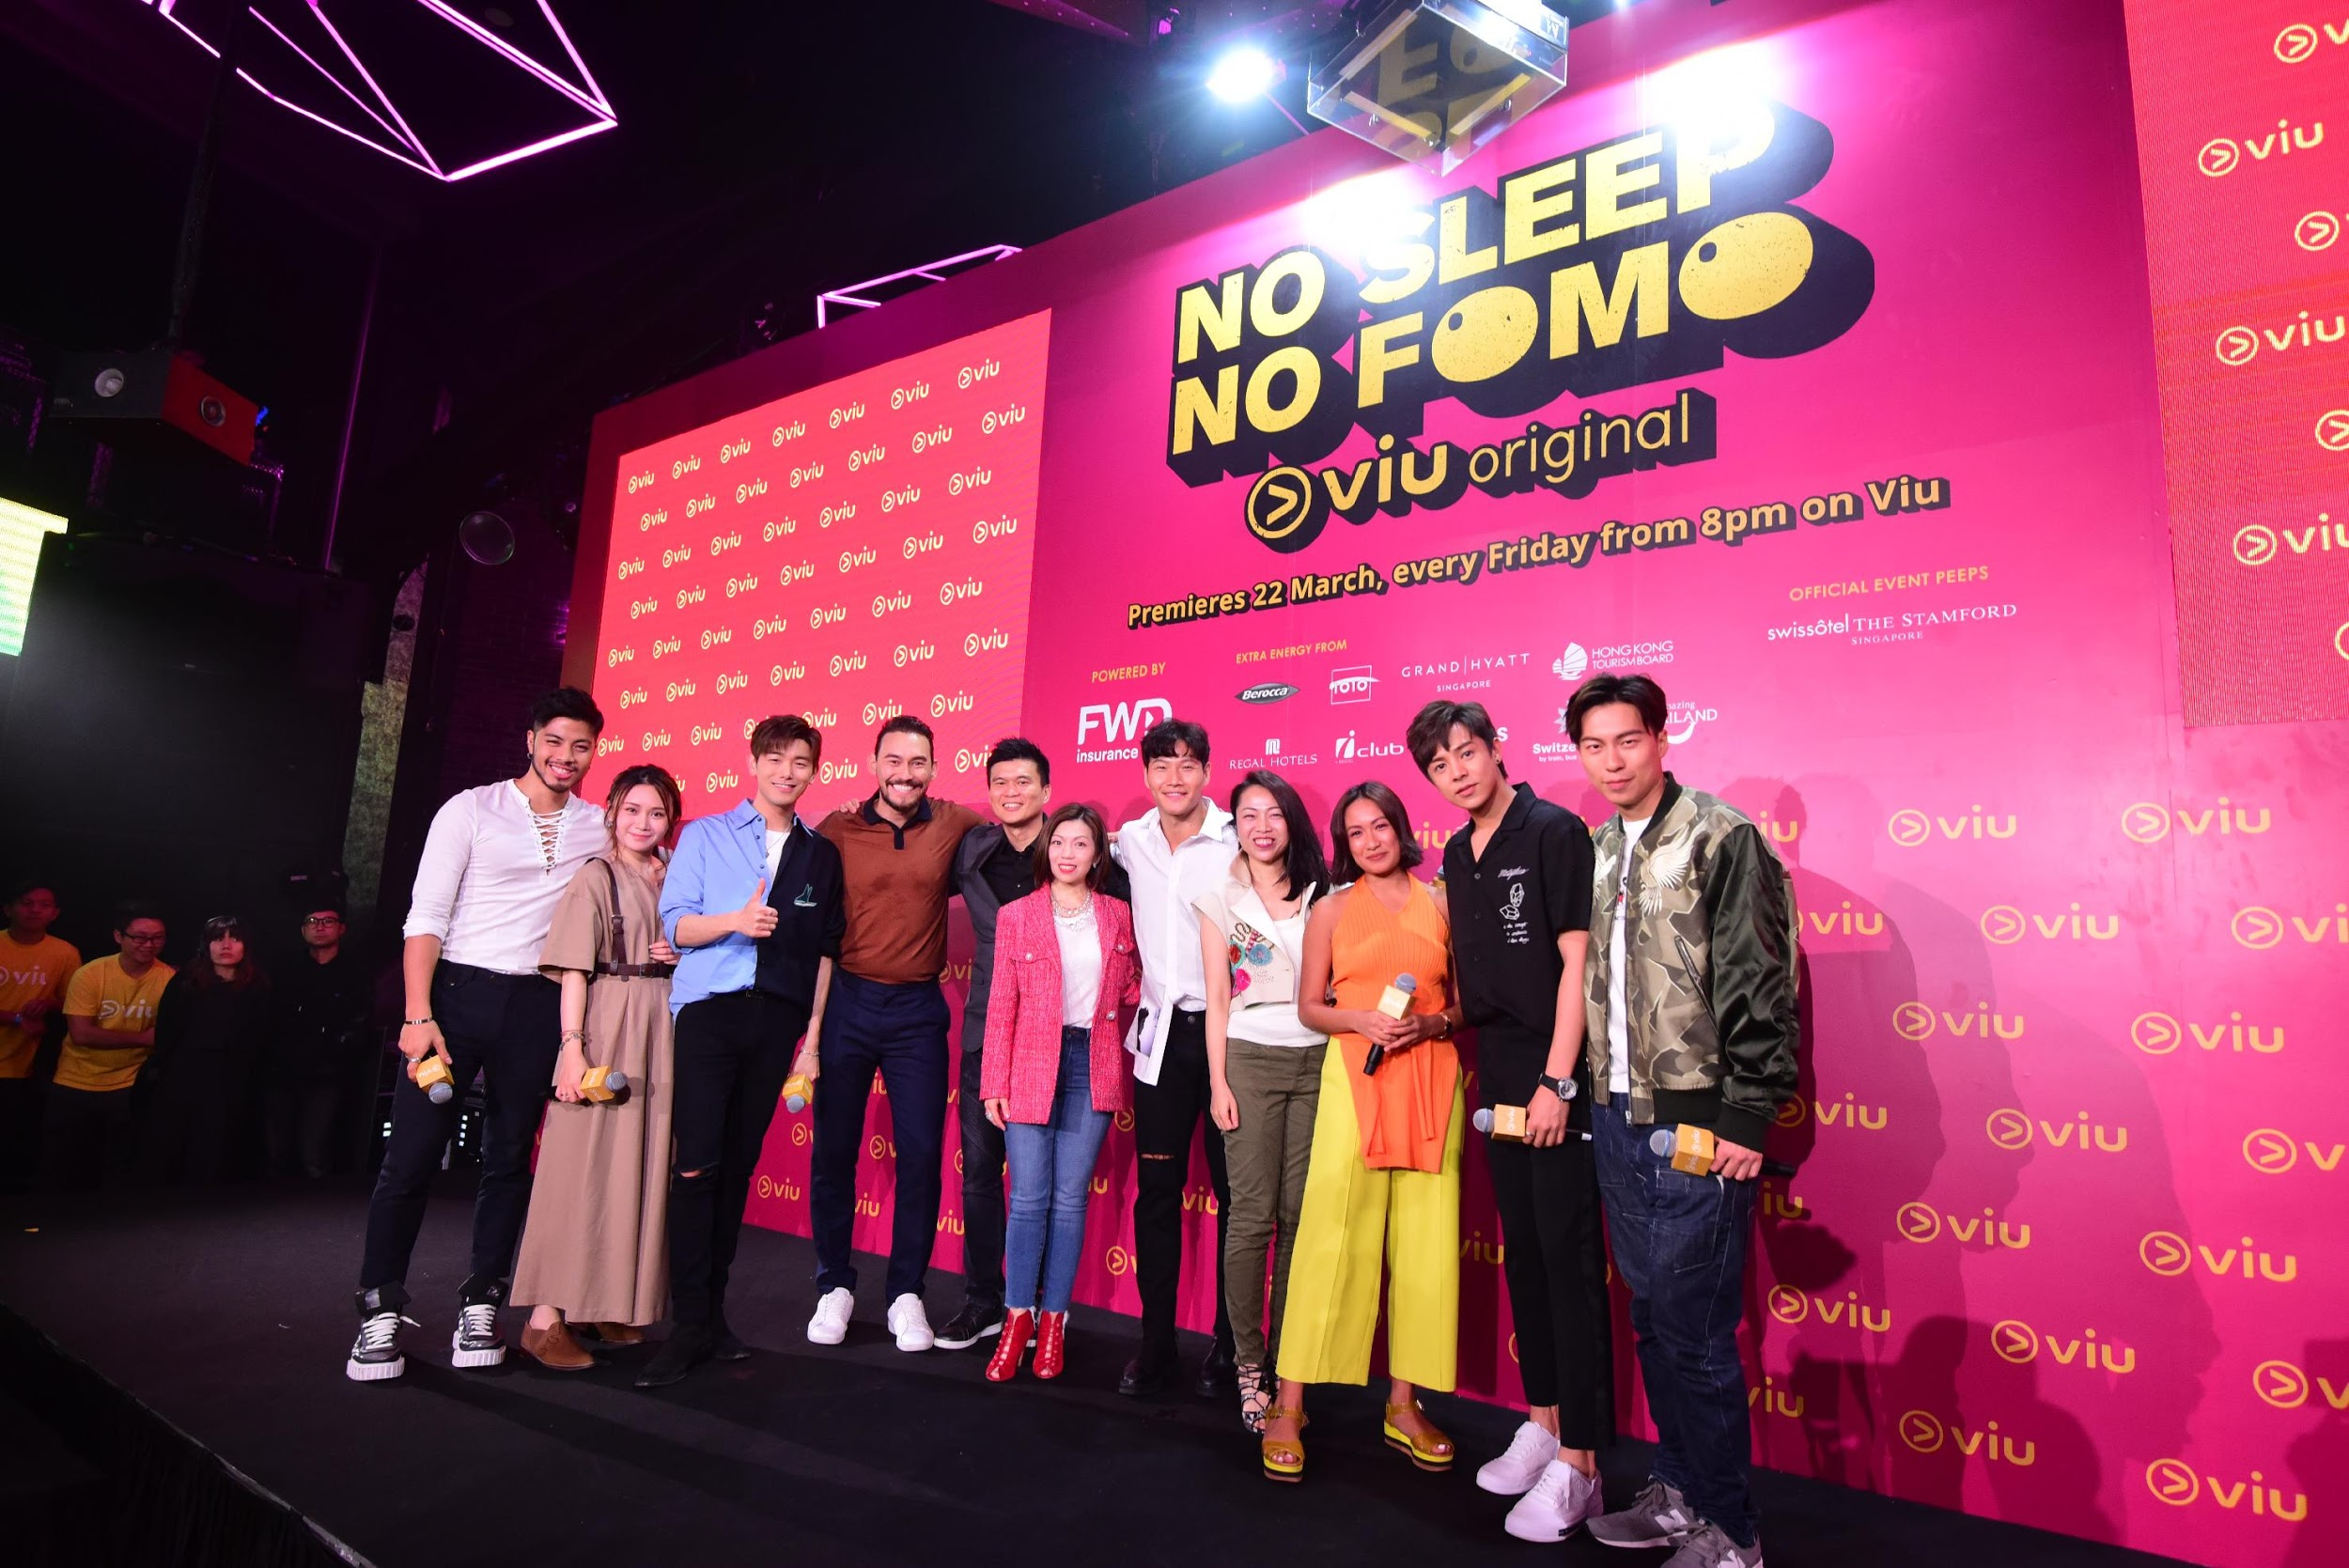

Ms. Janice Lee, Managing Director, PCCW Media Group (center), Helen Sou, Senior Vice President, Digital Media, PCCW Media Group (4th from right) together with the celebrities and social media influencers announce the launch of No Sleep No FOMO

To view/download images of the program, please visit http://bit.ly/ViuNSNF

Please credit all content and information to “Viu”.

cont’d …

About Viu

Viu is a leading pan-regional over-the-top (OTT) video streaming service operated by PCCW Media Group. It is available in 17 markets including Hong Kong, Singapore, Malaysia, India, Indonesia, the Philippines, Thailand, Myanmar in Asia, the Middle East countries of Bahrain, Egypt, Jordan, Kuwait, Oman, Qatar, Saudi Arabia, the UAE and the newly launched South Africa.

Operating with both an ad-supported tier and a premium subscription tier with more features, Viu delivers premium Asian content in different genres from top content providers with local language subtitles as well as original production series under the ‘Viu Original’ initiative.

Viu offers users express delivery of telecast content, streaming and download features, and localized user interfaces. With the patented Dynamic Adaptive Transcoding technology, Viu can provide the best viewing experience regardless of device or network conditions.

The service can be accessed via Viu app (available for free on App Store and Google Play) on connected devices, e.g. smartphones and tablets, as well as on web by logging into www.viu.com.

About PCCW Media

The media group of PCCW is a leading, fully integrated multimedia and entertainment group in Hong Kong.

The media group operates the leading pay-TV service in Hong Kong under the Now TV brand delivering both self-produced and licensed content to its customers using IPTV technology. Now TV offers more than 170 linear channels and on demand library of local, Asian and international programming. Its premium content can also be accessed via the Now Player app. It is also a leading producer of Chinese language news, financial news and sports programming in addition to Asian infotainment content which complements its wide portfolio of licensed movie and international television content. PCCW Media also offers the Now E entertainment OTT (over-the-top) platform with international and Asian dramas, movies and world-class sports events, which is designed to meet the needs of viewers with Millennial lifestyle.

The media group is also engaged in the provision of OTT video service under the Viu brand in Hong Kong and 15 markets in Southeast Asia, the Middle East and India. In addition, MOOV is a hugely popular music digital streaming service in Hong Kong.

cont’d …

About PCCW Limited

PCCW Limited (SEHK: 0008) is a global company headquartered in Hong Kong which holds interests in telecommunications, media, IT solutions, property development and investment, and other businesses.

The Company holds a majority interest in the HKT Trust and HKT Limited, Hong Kong’s premier telecommunications service provider and leading operator in fixed-line, broadband and mobile communication services. HKT meets the needs of the Hong Kong public and local and international businesses with a wide range of services including local telephony, local data and broadband, international telecommunications, mobile, and other telecommunications businesses such as customer premises equipment sale, outsourcing, consulting, and contact centres.

PCCW also owns a fully integrated multimedia and entertainment group in Hong Kong, PCCW Media. PCCW Media operates the largest local pay-TV operation, Now TV, and is engaged in the provision of over-the-top (OTT) video service under the Viu brand in Hong Kong and other places in the region.

Through HK Television Entertainment Company Limited, PCCW also operates a domestic free television service in Hong Kong.

Also, wholly-owned by the Group, PCCW Solutions is a leading information technology outsourcing and business process outsourcing provider in Hong Kong and mainland China.

In addition, PCCW holds a majority interest in Pacific Century Premium Developments Limited, and other overseas investments. To learn more about PCCW, please visit www.pccw.com.

For further information, please contact:

Shamani Krishan  Mad Hat PR PLT  Tel: 03 2742 1361  +60 12 9100 353  Email: shamani@madhat.asia | Joelynn Lee  Mad Hat PR PLT  Tel: 03 2742 1361  +60 12 9098 284  Email: joelynn@madhat.asia

Issued by PCCW Limited.

Source: We Are Social – Digital Report 2019

