For more information, please contact:
Sarah Miranda James | +60 12 246 1506 | sarah@madhat.asia
Yap Hui San | +60 16 377 2723 | yaphuisan@madhat.asia

Lipton Brews Quality Connections Among Malaysians
With New #KawBersama Campaign

Kuala Lumpur, 10 October 2019 - Lipton is back once again to bring Malaysians closer to each other, one cup of tea at a time. In this modern day and age, we tend to get caught up in our fast-paced lives, with the advancement of technology limiting all daily communications within the constraints of our mobile screens, resulting in real-life connections being sidelined.

As a fast-growing country, it comes with no surprise that Malaysia has the highest social media penetration in Southeast Asia. A recent study* showed that 80% of the nation's population spends an average of 8 hours online. This proves that Malaysians dedicate a healthy portion of their daily lives to screens.

These global and local findings led to Lipton's latest campaign, #KawBersama, which aims to encourage Malaysians to foster strong bonds over a strong-tasting cup of tea. Tea time is a tradition that has been practiced from generation to generation in Malaysia, and every family has their own unique rituals surrounding tea time, making it the perfect time to build quality connections.

“At Lipton, we believe that tea is best enjoyed together, and our Lipton Potbags are created with that in mind, ensuring the perfect pot to share with the family. We wanted to ensure that our consumers foster quality connections, be it with friends or family, and feel warm inside and outside with every sip,” said Andreana Mah, Senior Brand Manager of Lipton Malaysia.

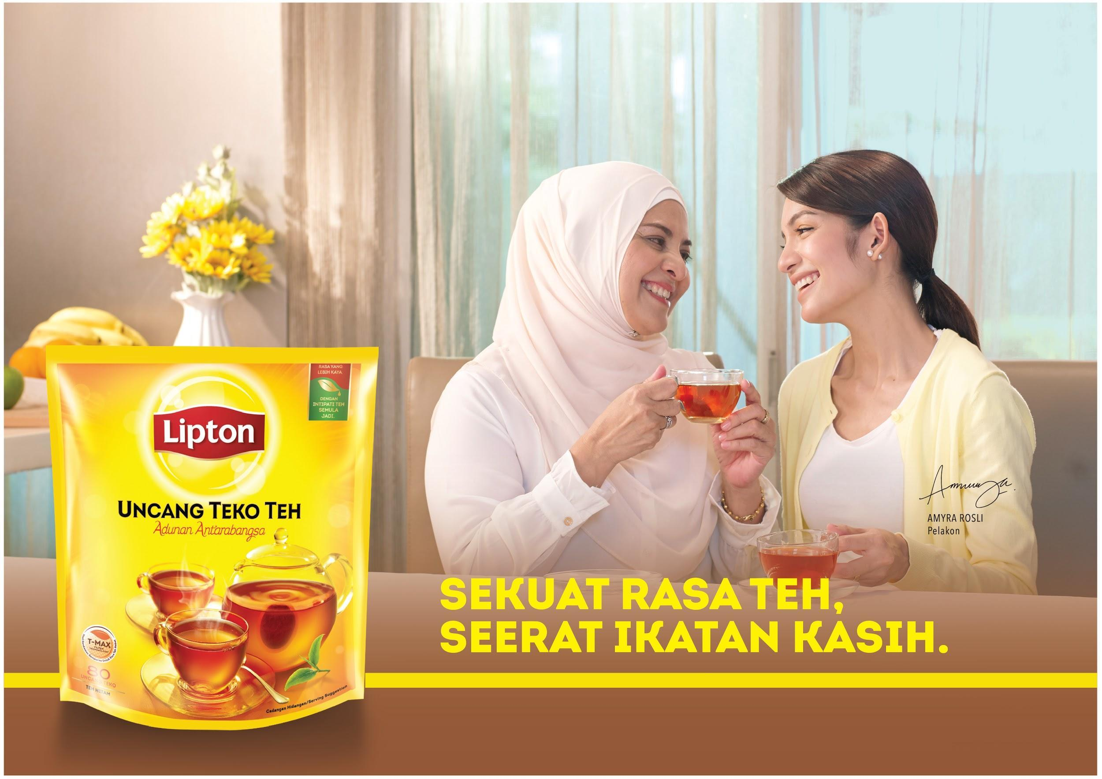

The campaign kicked off earlier this year with popular Malaysian superstar Amyra Rosli in a series of commercials that saw the actress working with her husband and mother respectively to bring the message of #KawBersama to life. “We were very excited to work with Amyra Rosli as we feel that she is the perfect representation of a modern working parent, and together with her family, truly exemplifies the values that Lipton believes in,” continued Andreana.

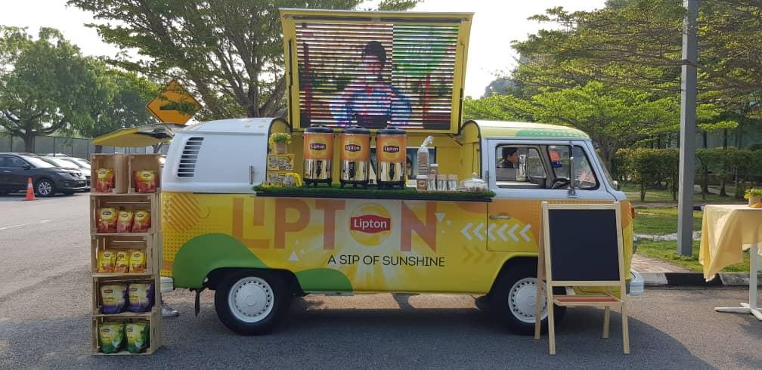

To further embody the spirit of #KawBersama, Lipton rolled out the #KawBersama kombi van in conjunction with Teh Tarik Month this September. The roving kombi van features a pop-up area where consumers can bond over a cup of tea, with snacks and fun activities. The #KawBersama kombi van travelled across Peninsular Malaysia throughout the month of September, reaching approximately 20,000 consumers in total.

Lipton Potbags are available for sale at all major hypermarkets and supermarkets in Malaysia.

*The survey report can be found online at: https://datareportal.com/reports/digital-2019-global-digital-overview

For more information on Lipton and #KawBersama updates, check out https://www.facebook.com/LiptonMalaysia/

###

About Unilever
Unilever is one of the world’s leading suppliers of fast moving consumer goods with operations in more than 100 countries and sales in 180. We have some of the world’s best known and most trusted brands, with leadership positions in many of the home and personal care and food categories in which we compete. With products that are used over two billion times a day around the world, we work to create a better future every day and help people feel good, look good and get more out of life with brands and services that are good for them and good for others. More than 167,000 people worldwide work for Unilever. For more information, visit www.unilever.com

About Lipton
Sir Thomas Lipton founded Lipton in 1871 to deliver the best quality tea for the ultimate experience. Lipton Yellow Label pioneered this dream with the finest international blends from Ceylon and Kenya giving Lipton tea its signature aroma and taste. Since then, Lipton has delivered great innovations bringing vitality and natural goodness into people’s lives.

Lipton renowned as the World’s NO.1 Tea Brand continues to push the boundaries and thus begins embarking on a journey to give tea an exciting twist to brighten every occasion with a cup a refreshingly delicious Lipton Tea!

