[MEDIA ALERT]

IT’S THE SHIP X PESTLE & MORTAR CLOTHING COLLABORATION
Asia’s Largest Festival at Sea teams up with Malaysia streetwear fashion label Pestle & Mortar Clothing for exclusive merchandise collection ahead of 2019 sailing!

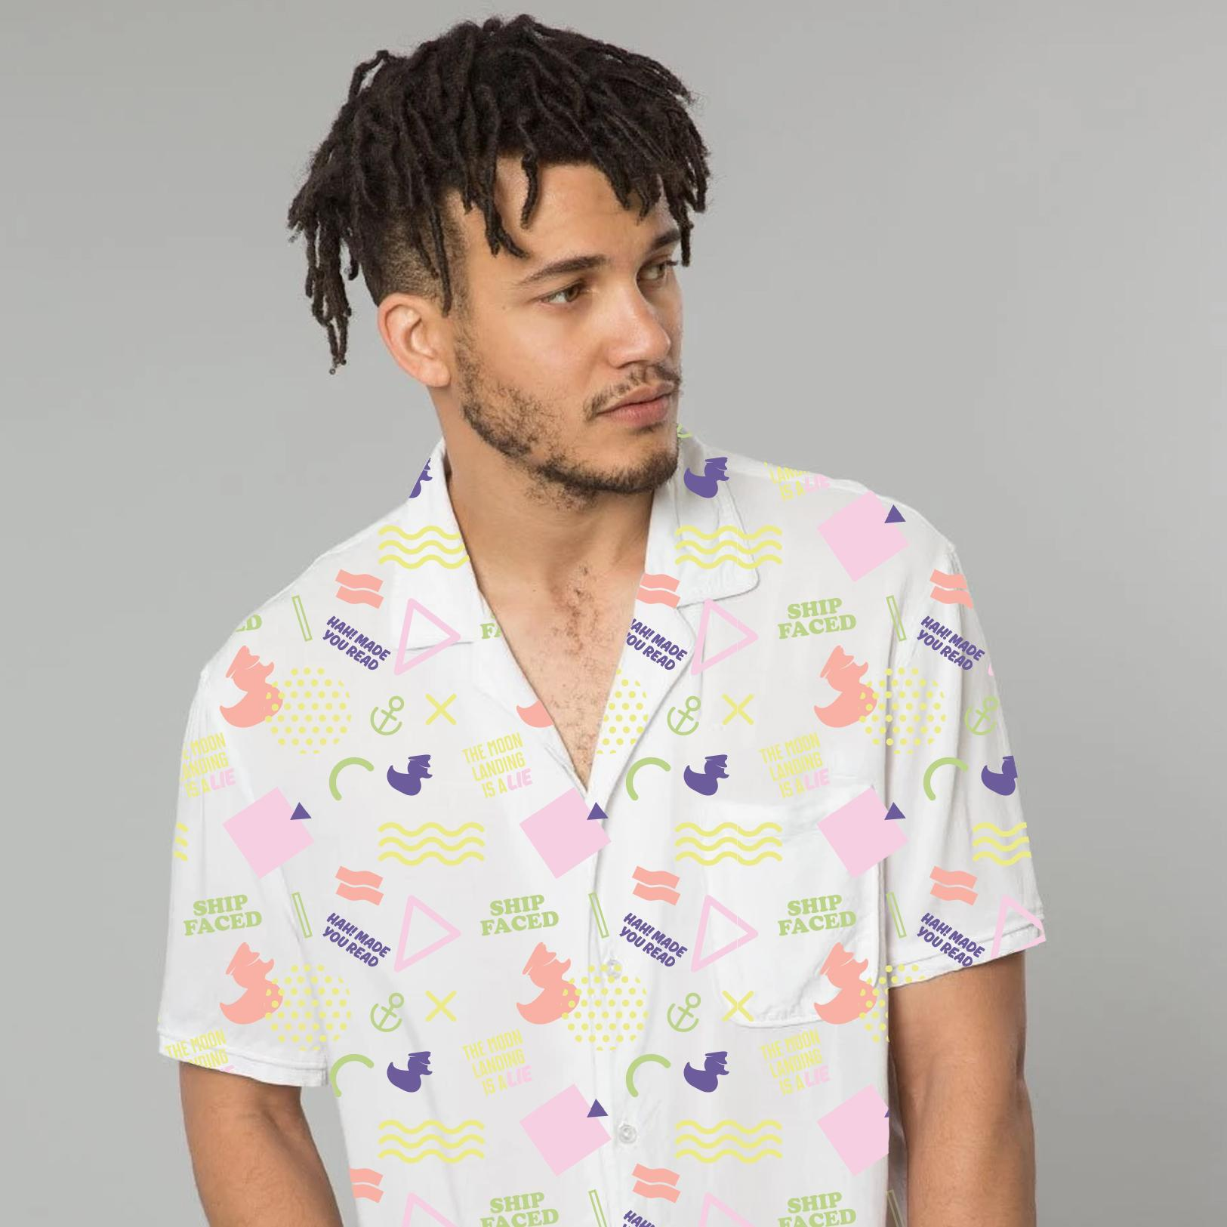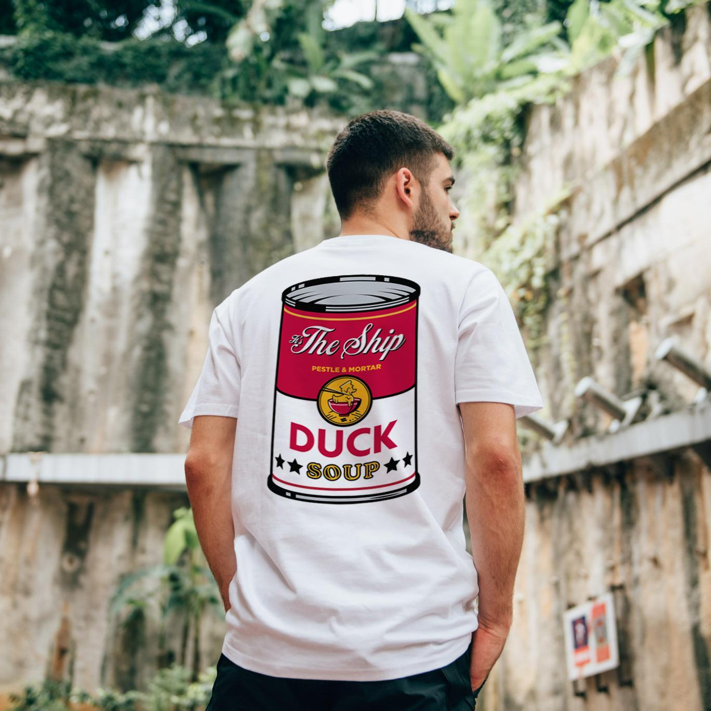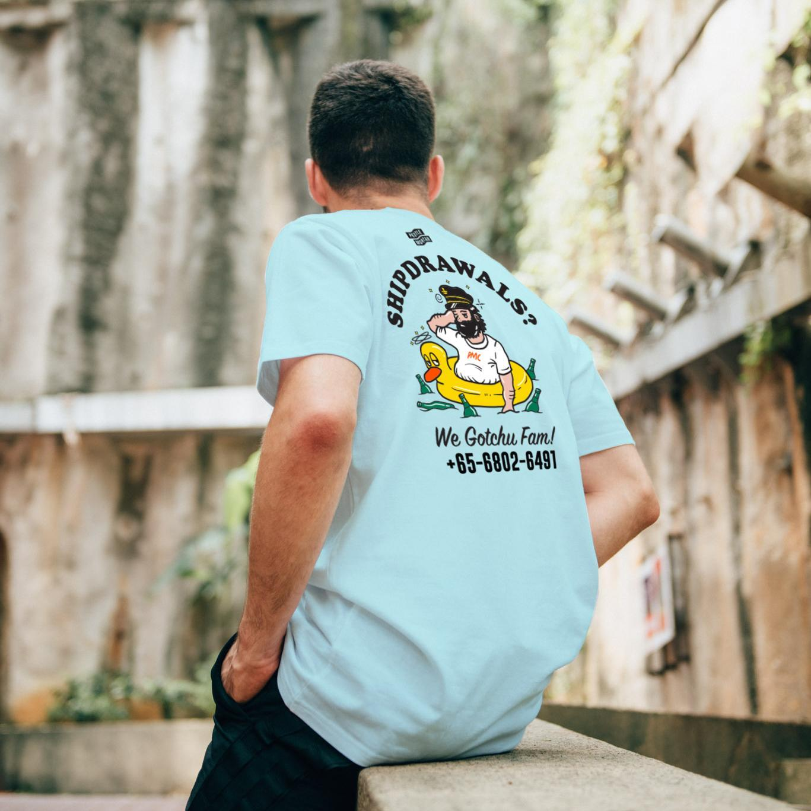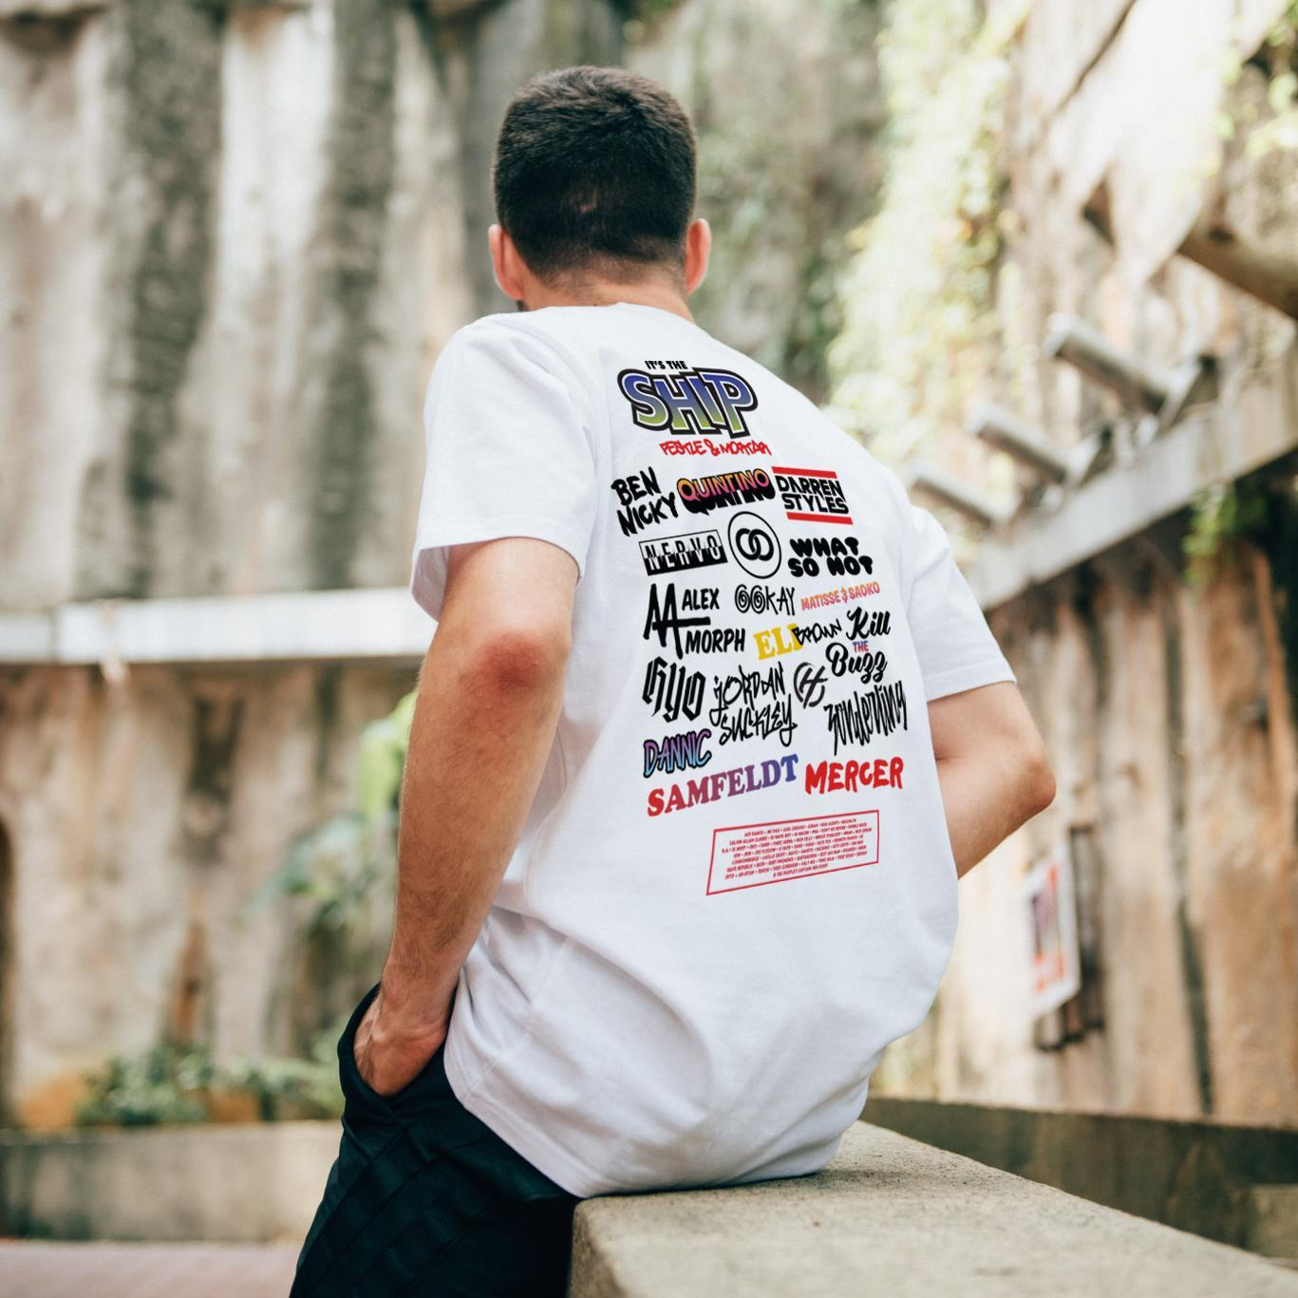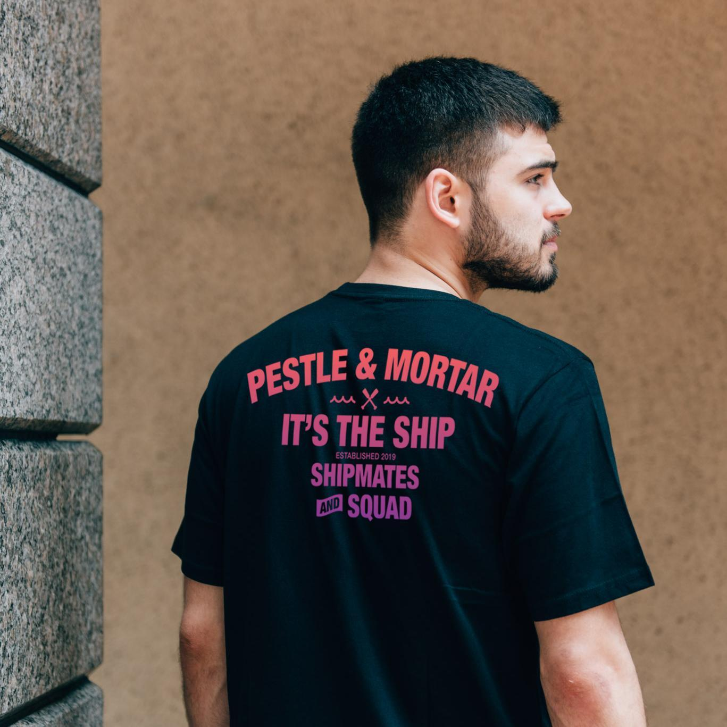

(Singapore) 18 October 2019 – All aboard! Asia’s Largest Festival at Sea IT’S THE SHIP is setting sail from 13 to 15 November! Ahead of the 2019 sailing, IT’S THE SHIP has joined forces with Malaysian street fashion label Pestle & Mortar Clothing to produce exclusive festival merchandise collection PMC x ITSSG.

Now in its sixth edition, IT’S THE SHIP will be taking the open waters by storm with its first ever non-stop, uninterrupted nautical adventure. This year’s acclaimed headliners include NERVO, Darren Styles, Sam Feldt, Quintino, alongside regional and local music acts. Legendary for its array of entertainment experiences, IT’S THE SHIP will be also presenting novel themed pop-up parties such as ONESIE and FYRE FAN CLUB. With such an extensive programme, IT’S THE SHIP’s exclusive merchandise was designed to get its Shipmates ready for the Shipcation that awaits them!

Featuring quintessential festival tees, tank tops and a bum bag, the festival’s limited-edition collection was conceptualised with IT’S THE SHIP’s eccentric and humorous spirit alongside Pestle & Mortar’s youthful street style. The designs borrow visual references from pop art icons, television, and meme culture, along with the classic IT’S THE SHIP motifs like Steve the Duck.

All Shipmates are F.R.I.E.N.D.S
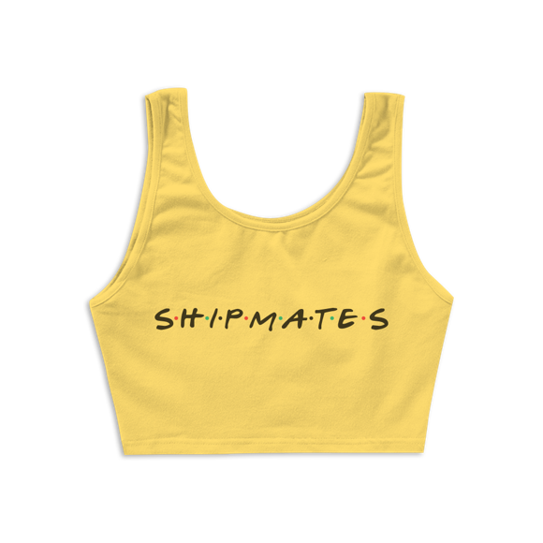
Taking cue from the popular television show, PMC x ITSSG Female Tank Yellow is for the Monica, Phoebes, and Rachels out there!

Put Your Hands Up
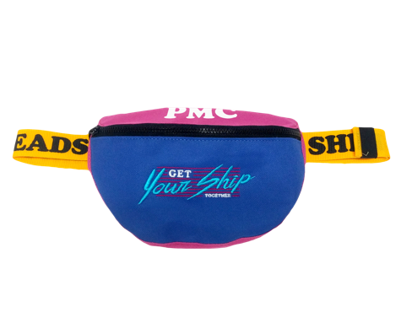
Everybody has to put their hands up on IT’S THE SHIP – can’t do that carrying so many things around! The real rave baes can get their ship together with the PMC x ITSSG Bum Bag.

Were you even on IT’S THE SHIP?

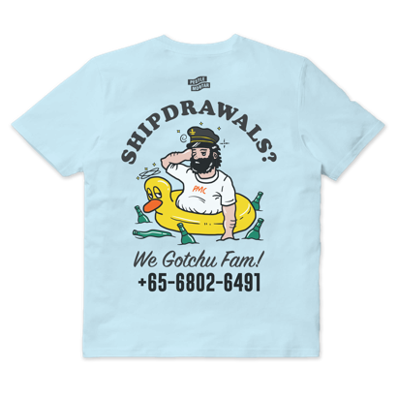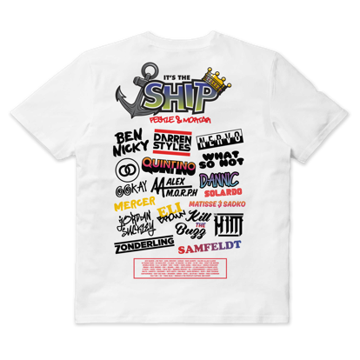

Prove it with a festival T-shirt! Festival-goers can also purchase the classic shirts emblazoned with the artist lineup and cheeky puns because shirts or it didn’t happen!

The collection comes in a wide range of sizes from XS to XXL. Groups of friends looking to be #squadgoals will all be able to find their sizes easily.

Priced from RM160 or SGD$52 onwards, the items will be available online at Pestle & Mortar Clothing’s website as well as onboard IT’S THE SHIP 2019. For 15% off, IT’S THE SHIP fashion fanatics can pre-order using the promo code “SHIPFACED” when they shop online now before boarding the festival cruise at sea.

For shipmates hopping onboard, they will be spoilt for choice with two additional merchandise option. The IT’S THE SHIP x Pestle & Mortar customized iron on patch t-shirt with a choice of either a white or black based t-shirt and a sleek limited edition Captain’s t-shirt.

CUSTOMIZED PMC X ITSSG IRON ON PATCHES
SGD60

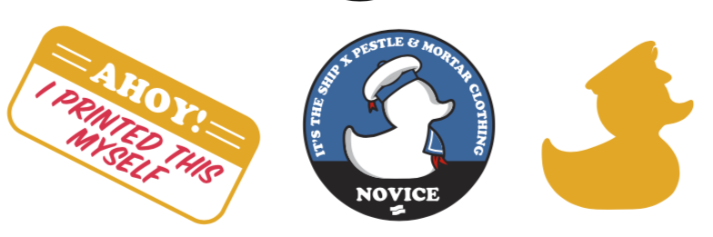

LIMITED EDITION CAP’N SHIRT
SGD115

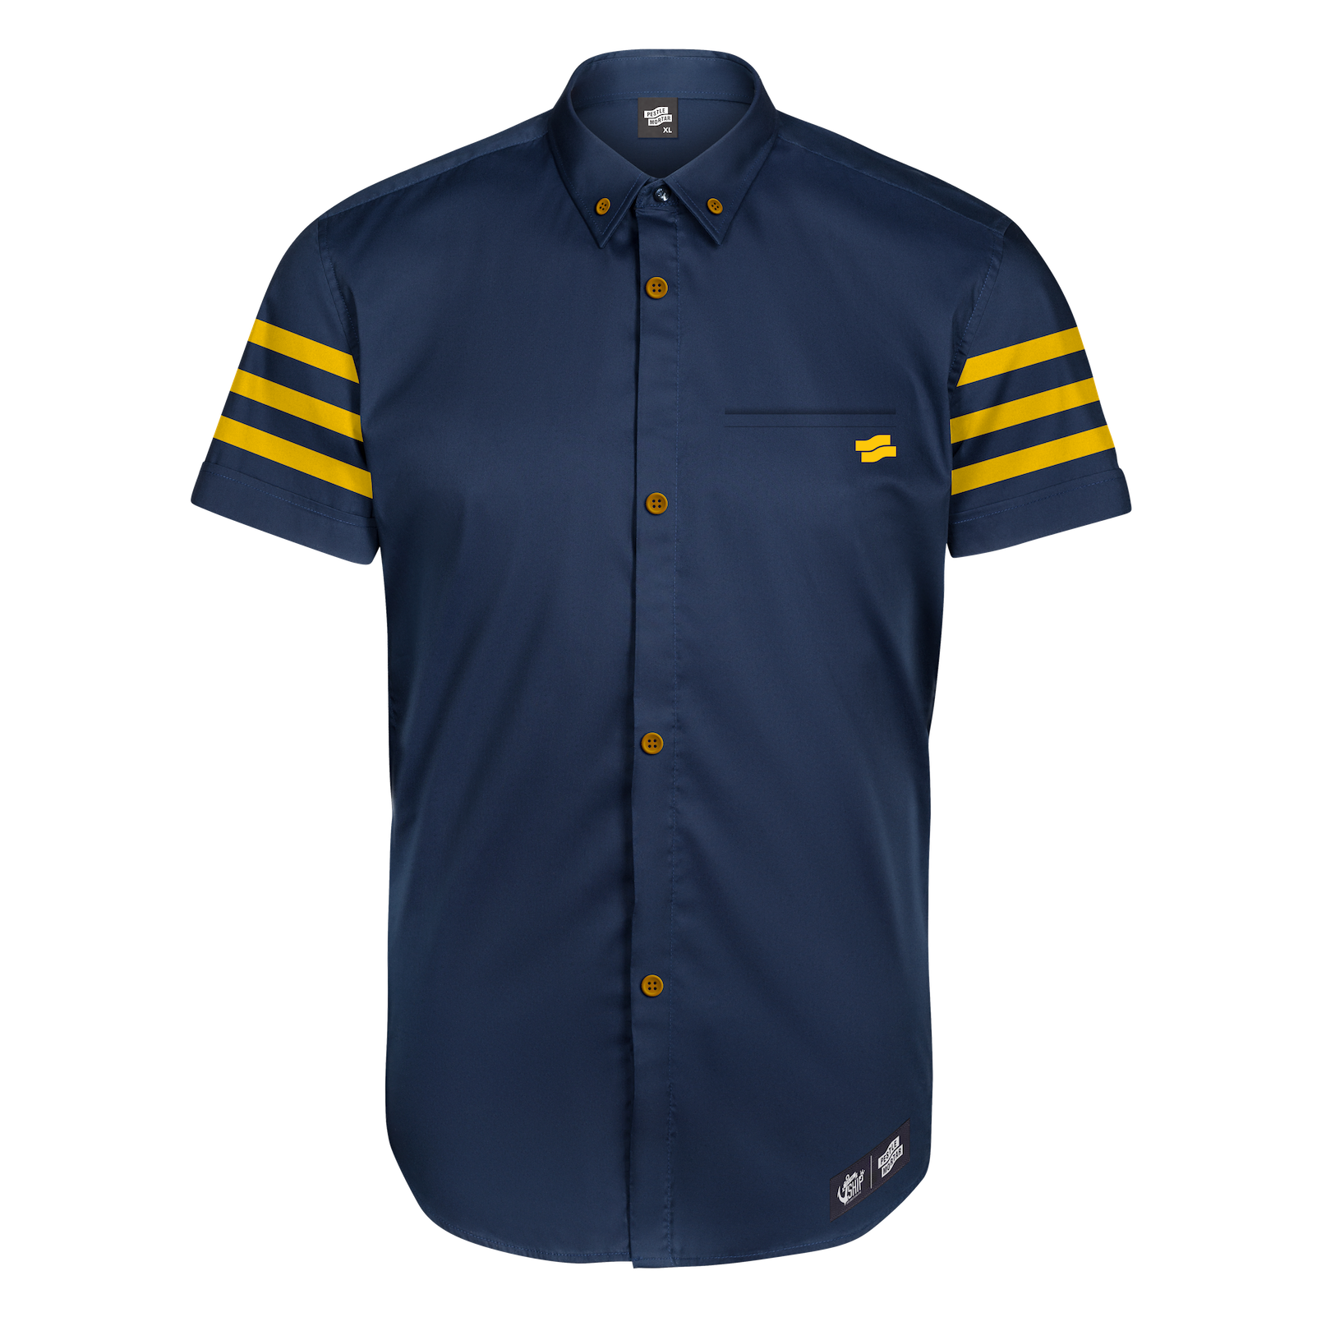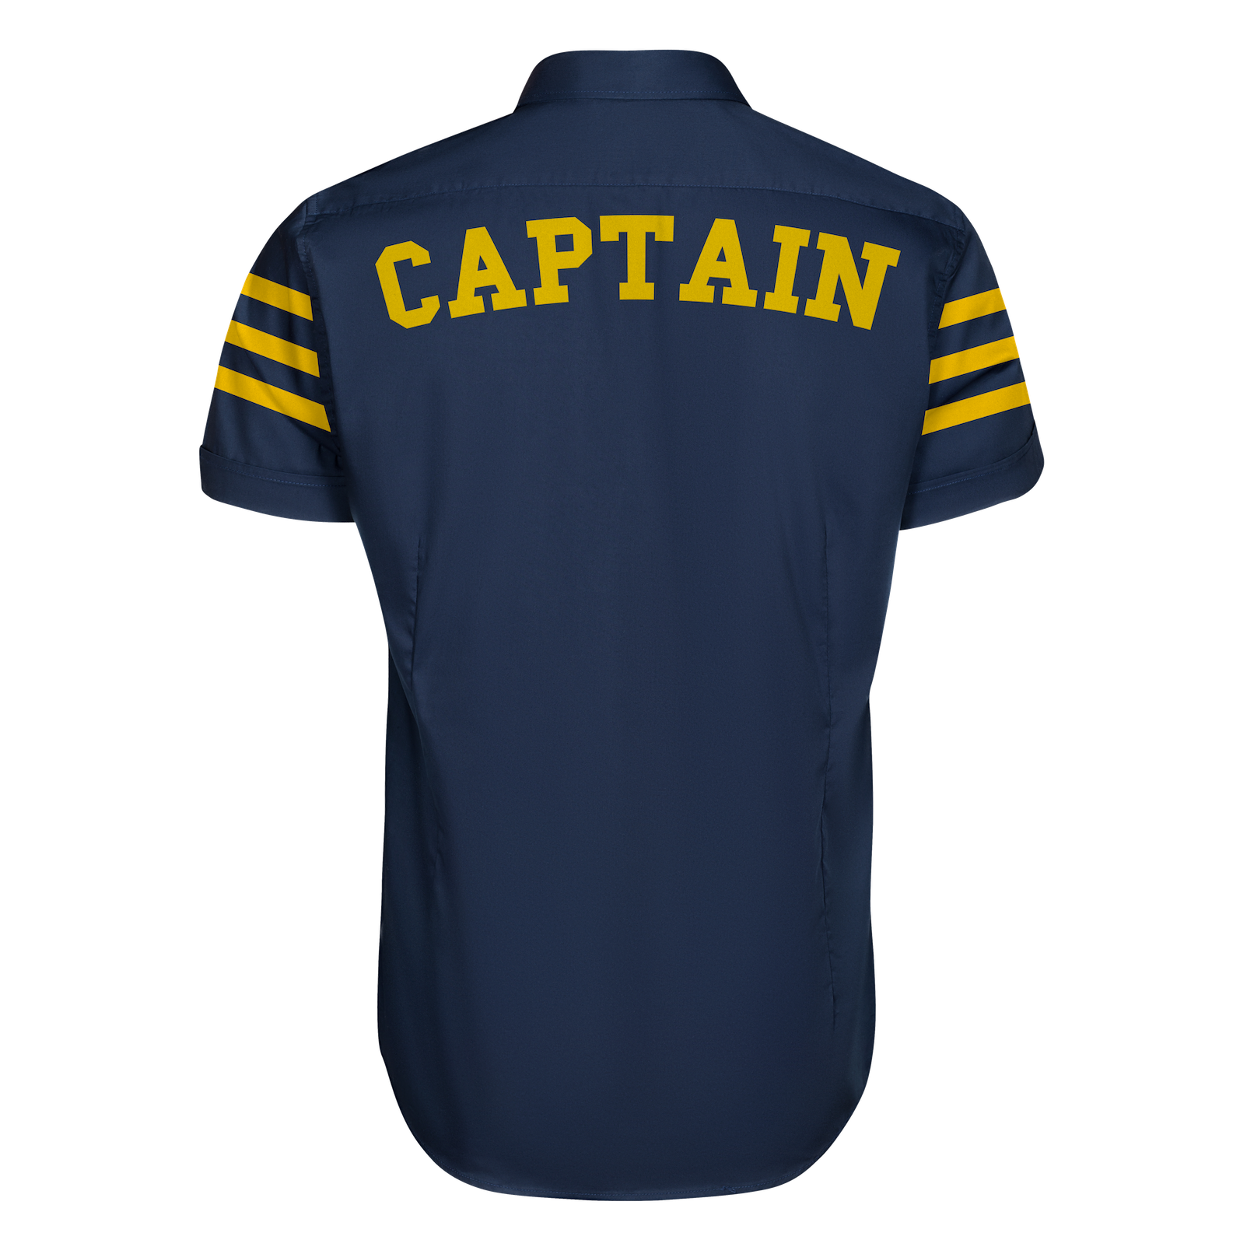

Those keen on shipping from Malaysia to Singapore, IT’S THE SHIP’s got you fam. Those partying onboard this year’s uninterrupted shipcation can also collect their pre-order purchases on the ship by selecting “Onboard Pickups: It's The Ship” at check-out.

The collection is not limited to 2019’s shipmates. While cabin sales have re-opened for last minute bookings, the collection is available for all. Shipmates, future and past, can also purchase the exclusive collection!

Shop the collection now at
https://pestlemortarclothing.com/collections/its-the-ship

IT'S THE SHIP 2019 DETAILS

Dates: 13 November 2019 to 15 November 2019
Starting Point: Marina Bay Cruise Centre, 61 Marina Coastal Drive, Singapore 018947
Ending Point: Marina Bay Cruise Centre, 61 Marina Coastal Drive, Singapore 018947
Stopovers: None
Cabin Prices: USD$749++ to USD $2,088++ per shipmate

FOR MORE INFORMATION AND TO PURCHASE CABINS, LOG ON TO www.itstheship.com

#ITSTHESHIP #ITSSG19

#

ABOUT IT'S THE SHIP
Since its inception in 2014, the IT’S THE SHIP brand has grown to become Asia’s largest festival at sea with the highest representation of shipmates from over 88 countries around the world. What some may consider as a once-in-a-lifetime experience, others consider as an annual milestone event – offering shipmates with a variety of fun activities, themed parties, and non-stop music – all on international waters. Previous sailings have seen popular artistes Lil Jon, Knife Party, Yellow Claw, Higher Brothers, and Dash Berlin hyping up the crowd, with 2019 being no exception. This year will mark the epic shipcation’s sixth embarkation with multiple sailings planned to take place within different regions.

ABOUT LIVESCAPE GROUP
The Livescape Group is Southeast Asia's largest award-winning entertainment and creative agency. Offering in-house marketing, creative design, event production, logistics management, and artist management and booking, The Livescape Group has successfully created and managed world class events including IT’S THE SHIP, Rockaway Festival, Armin Only Embrace, and After Dark Social Club (ADSC). Its 360-degree approach to event management has driven them to be the go-to event agency for the best-known brands on the planet. The Livescape Group currently has offices based in Malaysia, Singapore, and Jakarta.

OFFICIAL PARTNERS
TItle Presenter - Brewed by LEO Beer
Official Whisky - Auchentoshan
Official Bourbon - Jim Beam
Official Gin - Roku Gin
Official Vodka - HAKU Vodka
Official Tequila - Sauza Tequila
Official Ready To Drink - Horoyoi
Official Energy Drink - RedBull

Official Beverage - Pepsi Black
Official Flip Flops - Havaianas
Official Shoe Care - ShoeMo
Official Portable Speaker - SoundStream
Official Headwear - NEW ERA
Official Merchandise Partner - Pestle & Mortar
Official Pleasure Partner - ONE Condoms
Official Sports Lifestyle - JD Sports
Official Cosmetics - Benefit
Official Experience Partner - ALTRXEGO
Official Fitness Partner - TRIBE
Official Ticketing - Galactix

OFFICIAL MEDIA PARTNERS
T.H.E Music Essentials
EDM Addicts
MTV
World of Buzz
SG Magazine

For media enquiries and interview opportunities, please contact us at:

Shamani Krishnan
E: shamani@madhat.asia
M: +6012 9100 353

Nicole Main
E: nicole@madhat.asia
M: +6012 5670 129

END

