2 October 2019
FOR IMMEDIATE RELEASE

For further information, interview requests and media enquiries
Shamani Krishnan | 012 910 0353 | shamani@madhat.asia
Nicole Main | 012 567 0129 | nicole@madhat.asia

A Celebration of Wayyyy More Apples with Apple Fox Cider
Apple Fox Cider brings wayyyy more apples to Malaysians this apple season
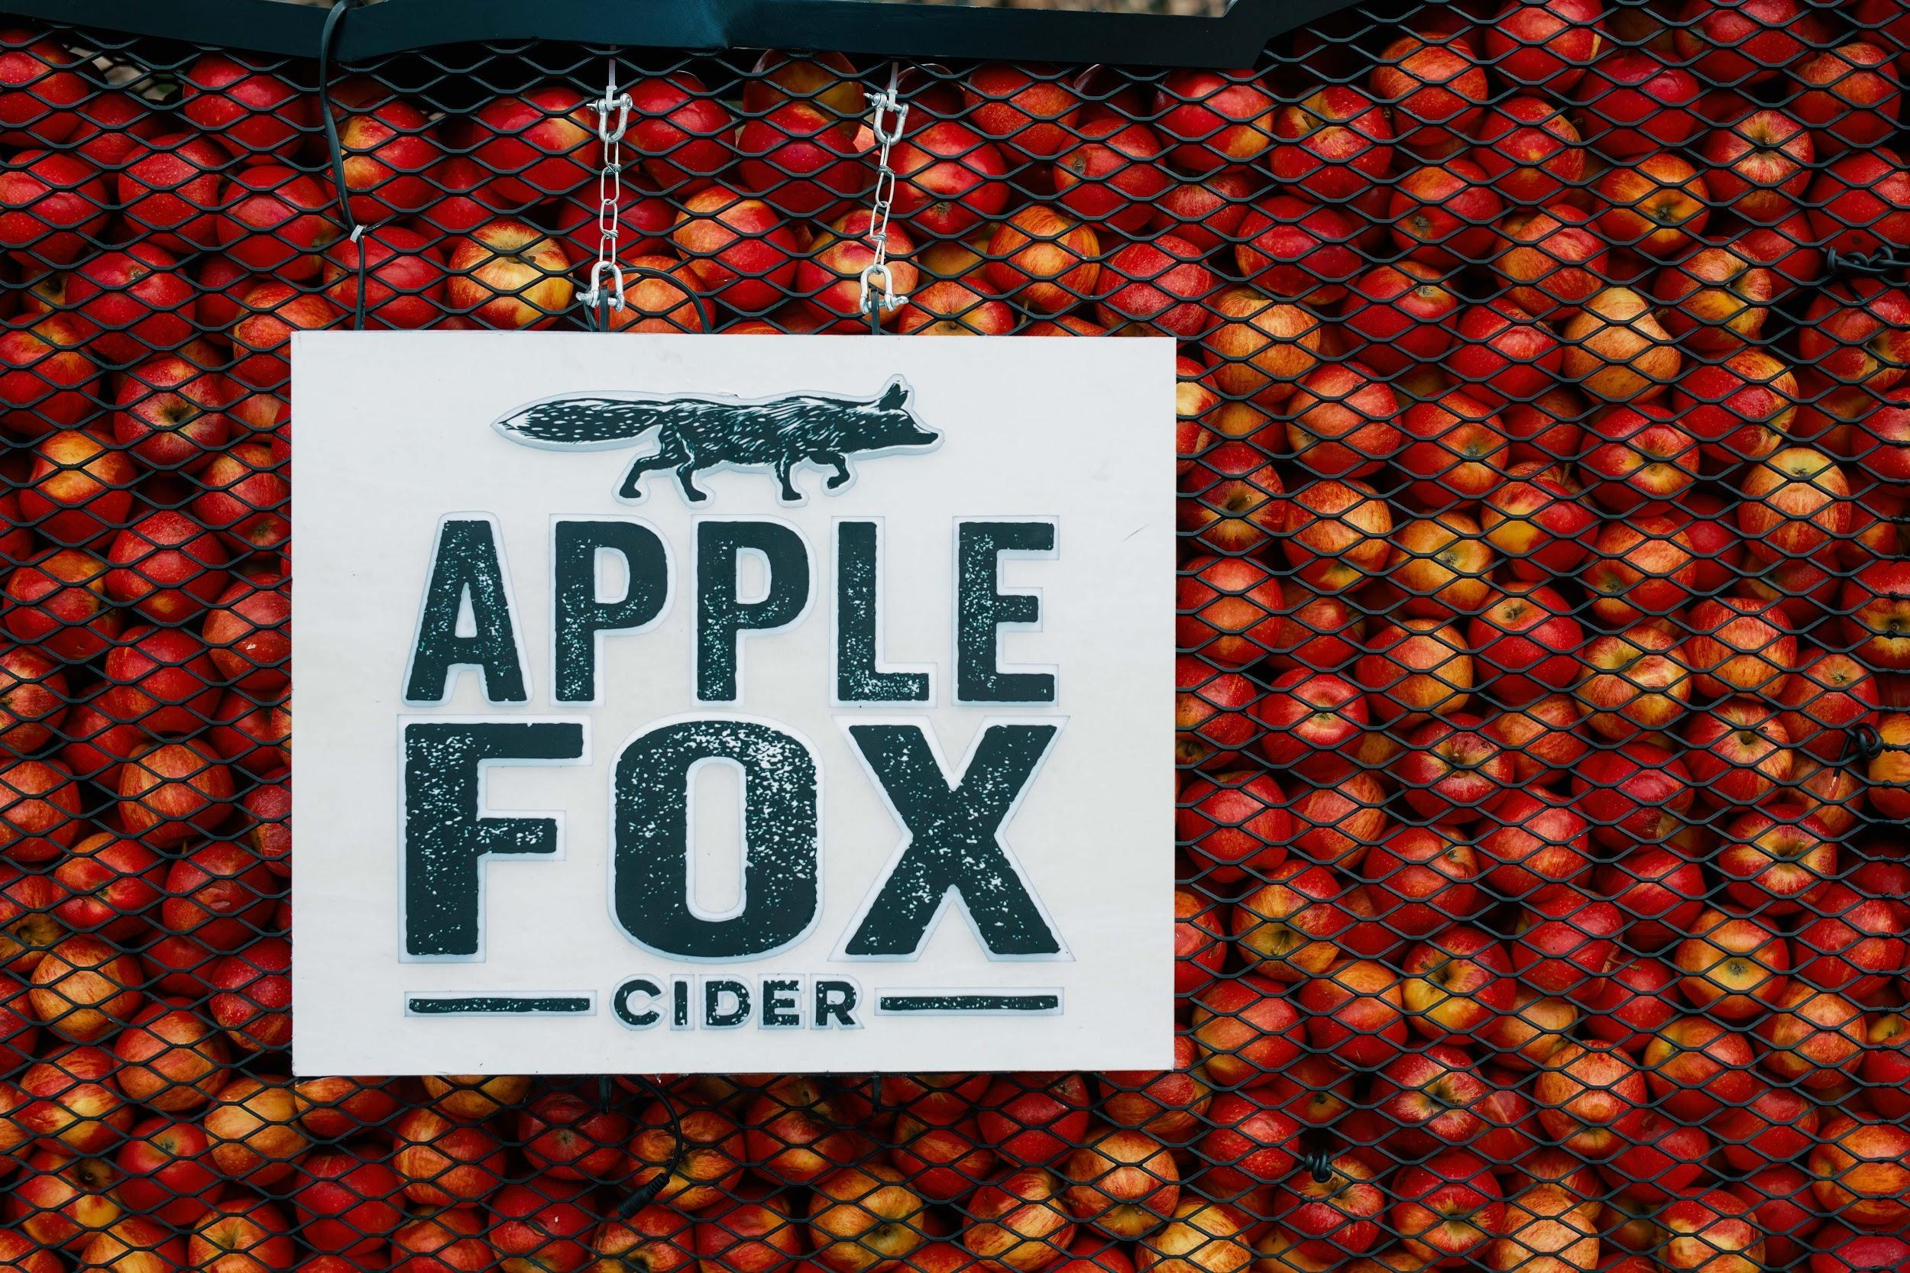
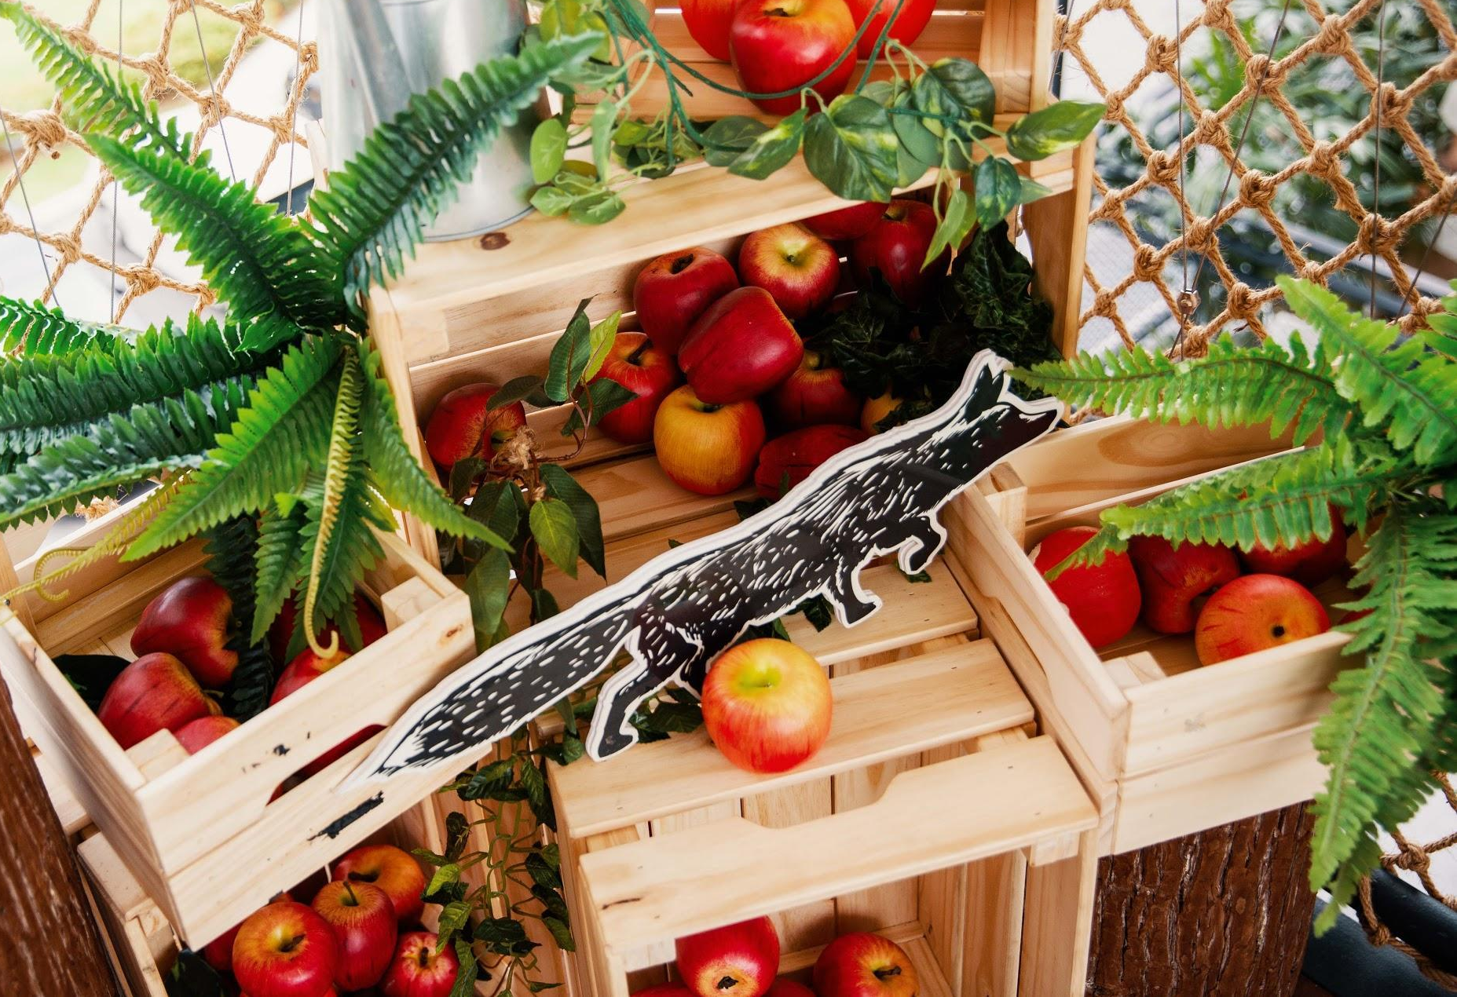
KUALA LUMPUR, 2 OCTOBER 2019 - The cider brand that prides itself with wayyyy more apples, Apple Fox Cider, is celebrating its key ingredient - apples - by bringing Malaysians the chance to experience wayyy more apples through a series of exciting activities! In this month long celebration of the apple season, you can catch the Fox Mobile which will be traveling nationwide giving you a taste of the Apple Fox experience and in line with Apple Day, you can enjoy a free glass of Apple Fox Cider when you bring your own (B.Y.O) glass to participating outlets!

Inspired by New Zealand cider makers, Apple Fox Cider places utmost importance and emphasis on the quality and the quantity of the ingredient that goes into the perfect pick-me-up beverage. Using only real apples from the freshest source, the orchard, Apple Fox pays homage to the apple harvest season and Apple Day - an annual affair celebrated globally.
“It’s no secret that the key to Apple Fox Cider lies in the fresh, crisp, real apples we use - and of course made with way more apples because quality and great tasting cider is our priority in every sip! And what better way to do so than to bring light to the international annual celebration of Apple Day and give Malaysians the Wayyyy More Apples experience!” said Pablo Chabot, Marketing Director at Heineken Malaysia Berhad.

The fox has been busy thieving loads and loads of the freshest and juiciest apples to make a cider that contains wayyy more apples. Here’s how you can get in on the fun this apple season!

Catch The Swift and Sleek Fox Mobile

The Fox Mobile will tour Klang Valley and across the region to bring Malaysians a taste of Apple Fox Cider! You can learn about the brewing process of Apple Fox Cider and even ‘harvest’ your own Apple Fox Cider draught fresh from the Fox Mobile. Participate in exciting activities lined up to win exclusive Apple Fox merchandise!

Bring Your Own Glass (B.Y.O.G) for Wayyy More Apples

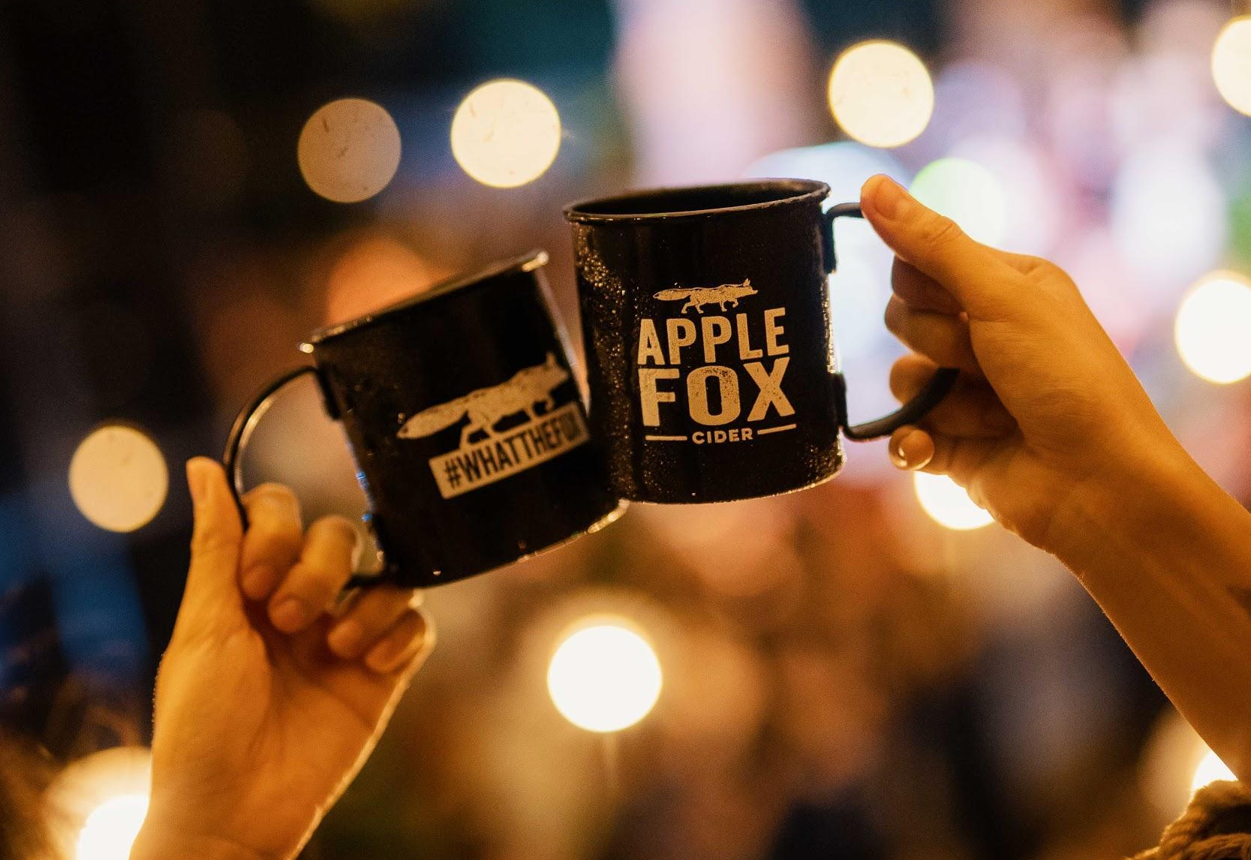

In conjunction with Apple Day, Apple Fox Cider is inviting all cider lovers to bring your own glass* to be filled with Apple Fox Cider, at no cost. This weekend affair will take place on the 19th and 20th of October 2019 at participating pubs, bars, and restaurants.
*Terms and conditions apply

Read and Reap The Apple-y Reward


Find the Fox in major newspapers on 18th October 2019 to get your hands on wayyyy more apples! Turn the Fox in for a free can of Apple Fox Cider on 19th to 20th October 2019 in participating supermarkets and hypermarkets from 12pm to 8pm.

Get In On the Apple Thieving Fun

Join the Fox in the apple thieving fun with the Grand Theft Apple online game! All you have to do is collect as many apples as you can to stand a chance to win exclusive prizes! Top 3 scorers will win the grand prize of 288 cans of Apple Fox Cider! Get your game on and see if you can thieve like the Fox!

Visit this link https://applefox.com/appleseason/ for clues on where you can harvest your share of Apple Fox Cider and more details on all the fun activities happening this month!
Keep updated with the Fox by following Apple Fox Cider’s social channels for updates on the Fox Mobile, B.Y.O.G and latest deals:
Facebook: https://www.facebook.com/applefoxmy
Instagram: https://www.instagram.com/applefox_my/
Website: www.applefox.com
Hashtags: #WayyyMoreApples #AppleFoxCider
###

About Apple Fox Cider

Inspired by New Zealand cider makers, Apple Fox uses the best-kept secrets of cider making in creating a distinct, refreshing smooth drinking experience, served over ice. Stealthy by nature, the fox has been known to sneak into orchards to hunt for delicious, juicy apples.

Apple Fox Cider contains 4.5% ABV and delivers an instant refreshing taste. Only the freshest apples sourced from orchards all over the world are picked to make the cider, ensuring a naturally crisp texture and intense flavour that makes the best tasting cider.

The meticulous process of creating Apple Fox Cider adds to the superior taste of the product. The selection of a perfect mix of crisp and tart apples is the first step in ensuring the unique brand flavour before the milling and pressing process that releases the natural apple juice, which is the basis for the fresh apple taste. On to the fermentation, blending and filtration processes in producing cider that consistently delivers refreshing apple taste.

Apple Fox Cider is available in 320ml cans and 325ml bottles from hypermarkets, supermarkets and convenience stores. Bottles and draught are also available in bars, pubs and restaurants.

About Heineken Malaysia Berhad
HEINEKEN Malaysia with its portfolio of iconic international brands is the leading brewer in the country. The Company brews, markets and distributes:
- The World’s No. 1 international premium beer Heineken®
- The great taste of Heineken® with zero alcohol Heineken® 0.0
- The World-acclaimed iconic Asian beer Tiger Beer
- The crystal-cold filtered beer Tiger Crystal
- The World’s No. 1 stout Guinness
- The World’s No. 1 cider Strongbow Apple Ciders
- The New Zealand inspired cider Apple Fox Cider
- The all-time local favourite Anchor Smooth
- The premium Irish ale Kilkenny
- The real shandy Anglia

HEINEKEN Malaysia also produces the wholesome, premium quality non-alcoholic Malta. HEINEKEN Malaysia’s brand portfolio also includes the No. 1 German wheat beer Paulaner and Japan’s No. 1 100% malt beer Kirin Ichiban. The Company continues to lead the responsible drinking agenda through its Drink Sensibly campaign.

Listed on the Main Market of Bursa Malaysia, HEINEKEN Malaysia’s principal shareholder is GAPL Pte Ltd based in Singapore. GAPL Pte Ltd is 100% owned by Heineken N.V.
For more information please visit: www.heinekenmalaysia.com

