

FOR IMMEDIATE RELEASE

Kickin’ it old school with JD

The 1990s is often referred to as one of the best decades from the introduction of signature music icons such as Notorious B.I.G to the debut of sports legends such as Michael Jordan.
If there’s something that everyone from this decade truly identified with, it was the freedom of expression through fashion. Fashion enthusiasts were bold and experimented with high-waisted ripped jeans, windbreakers, and chunky sneakers; ‘90s clothes were more than style statements, they were also really comfortable.

Although all good things come to an end as was such with this decade, all great trends do come back in style and the '90s look is here with a bang. Instead of trying your luck by rummaging through your parents’ closets, you can achieve that vintage look with some classic sneakers. If you're all about staying comfortable, but don't want that futuristic look of today's athletic wear, these are some of the best selections to add that “old school” flair with any look.

Image | Gender | Name
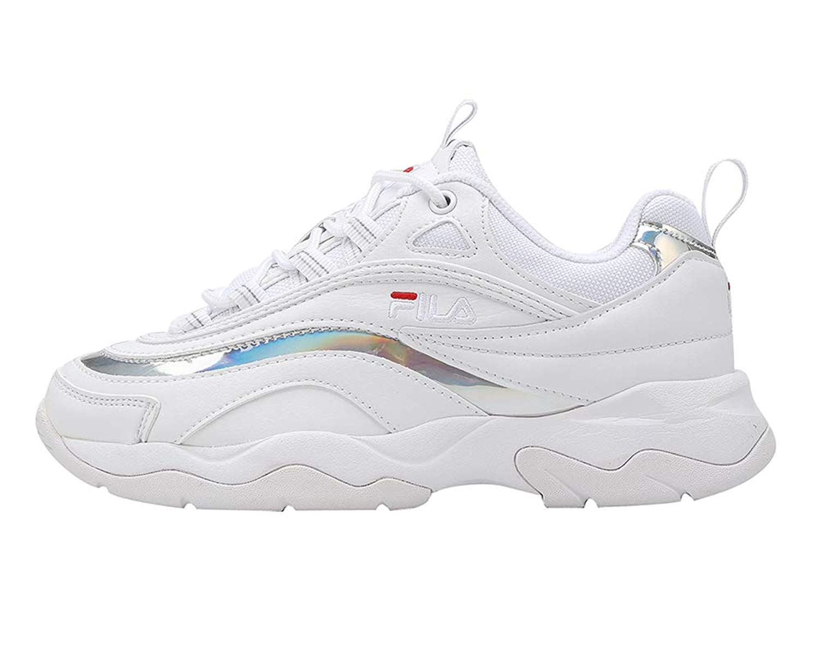 | Both | Fila Ray
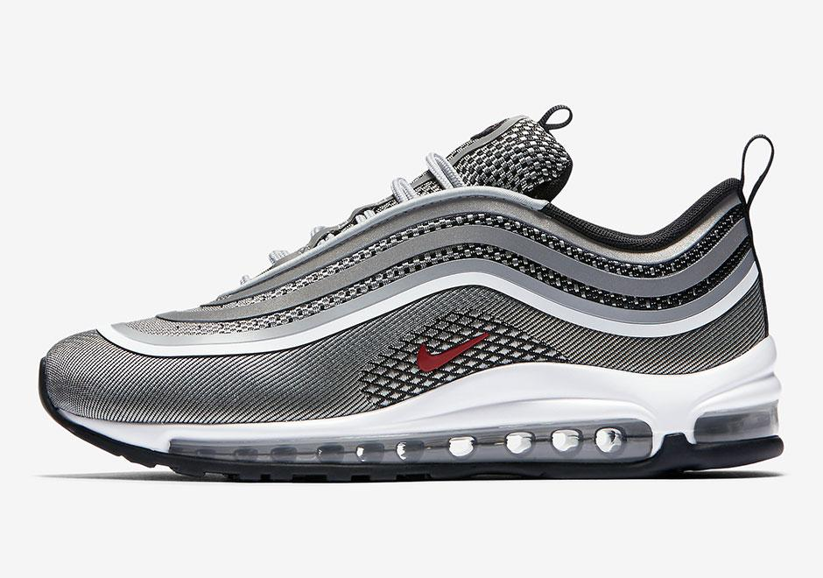 | Men’s Footwear | Nike Air Max 97 Ultra ‘17
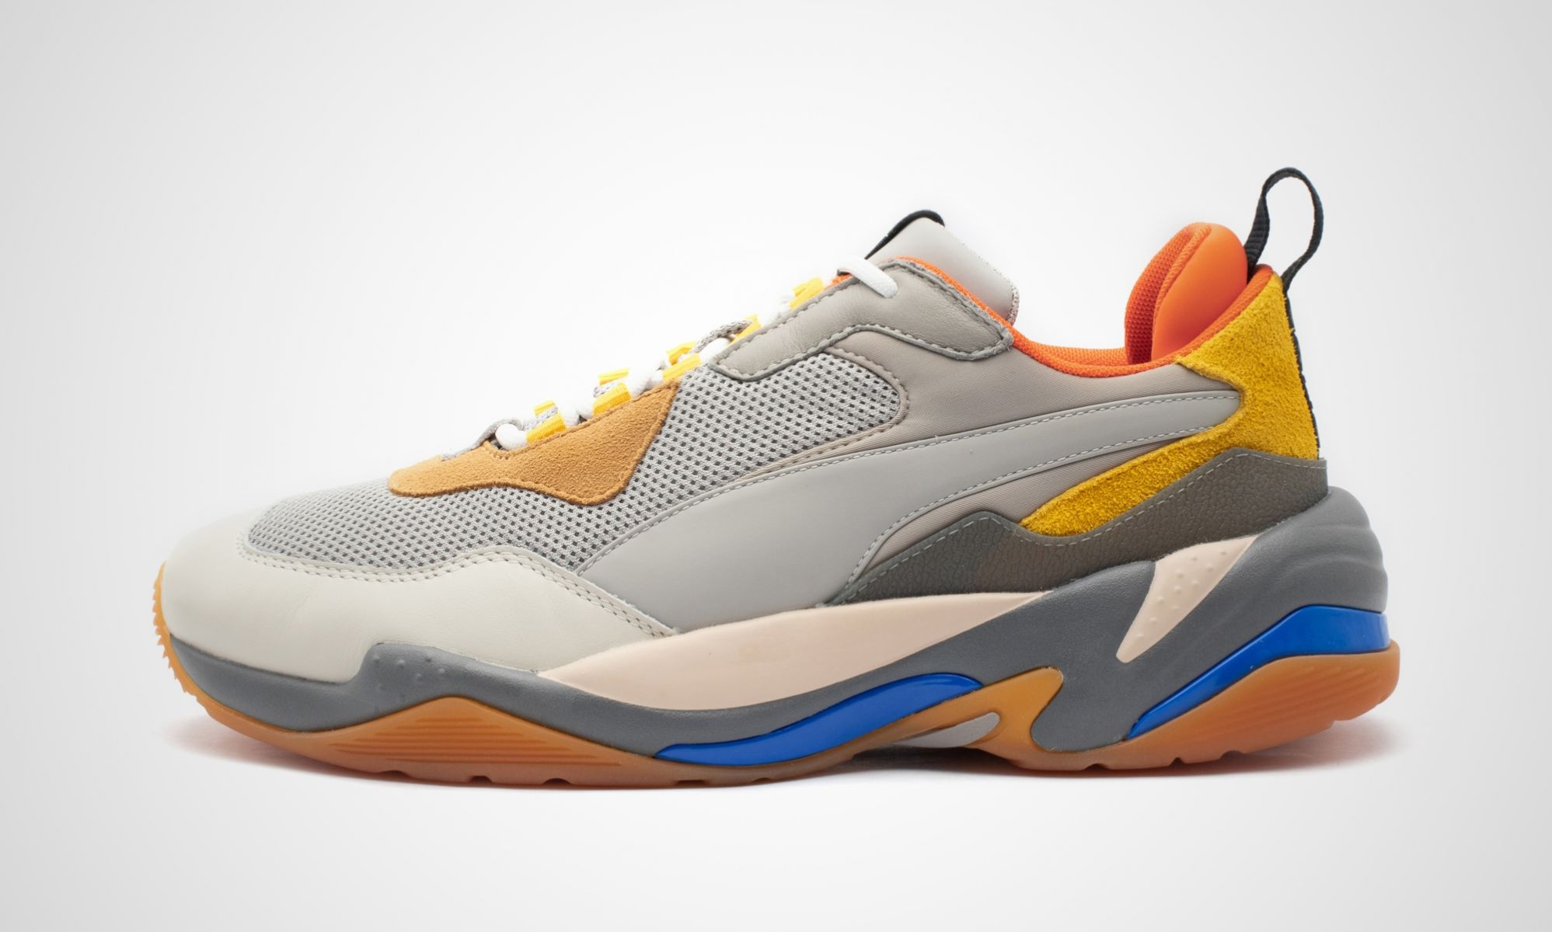 | Men’s Footwear | Puma Thunder Spectra
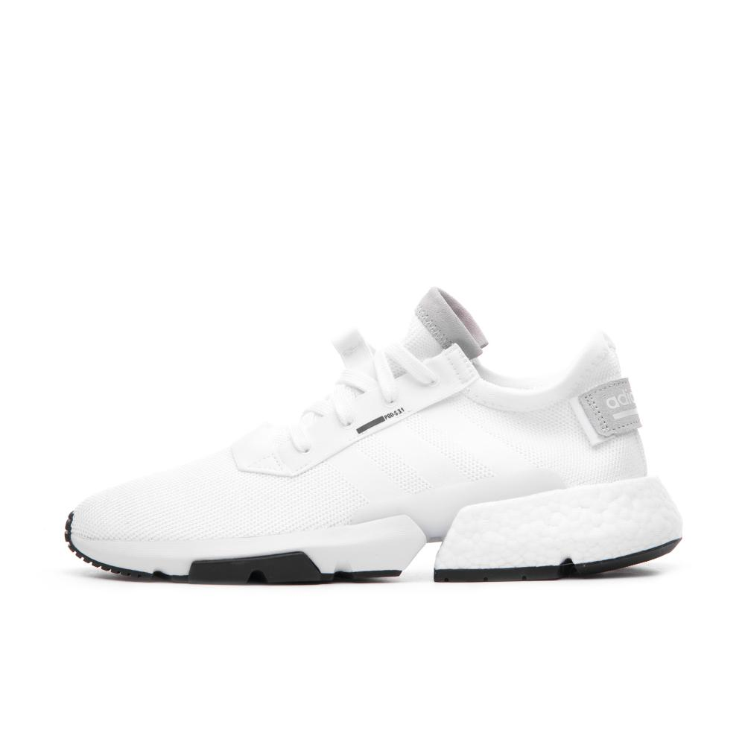 | Men’s Footwear | Adidas POD-S3.1
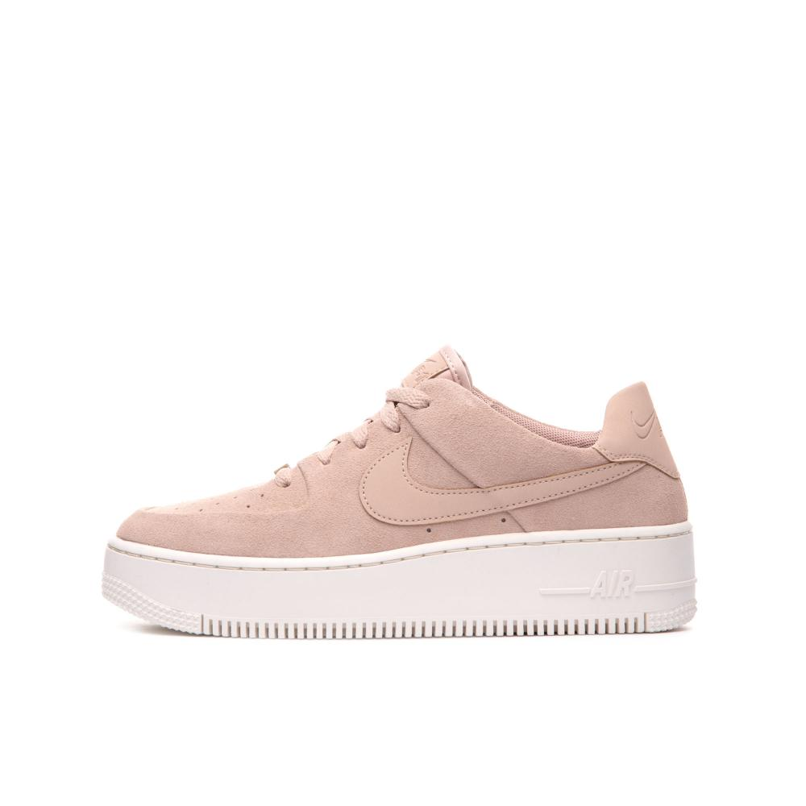 | Women’s Footwear | Nike Air Force 1 Sage Low

Looking to add one of these stylish retro kicks to your collection? Visit any of these JD stores near you:
- JD Pavilion Elite (Flagship)
- JD Sunway Pyramid
- JD Sunway Velocity
- JD Mid Valley
- JD IOI City Mall
- JD Setia City Mall
- JD Sunway Carnival Mall
- JD Mahkota Parade
- JD AEON Tebrau City
- JD East Coast Mall

To keep up to date with all things JD follow us on: Facebook; JD Sports Malaysia and Instagram; jdsportsmy. JD is also available online at www.jdsports.my.

For further information, please do not hesitate to contact:

Elizabeth Kate Harding | Foo Hui Shan
Mad Hat PR | Mad Hat PR
T: +6012 2205703 | T: +6012 2951732
E: elizabeth@madhat.asia | E: huishan@madhat.asia

Note to the Editors:
About JD Sports

JD Sports Fashion Sdn Bhd is part of JD Sports Fashion plc, the leading multichannel retailer of sports fashion and outdoor brands in the UK and Europe. The Group has over 800 stores across a number of retail fascias. For further information visit www.jdplc.com

