

FOR IMMEDIATE RELEASE
Bringing the 90’s back in style
90’s fashion was anything but boring. Now, whether it’s in stores, on the streets or even on the runway, these trends are reappearing. Fashion statements that were considered not much to look at, are making a debut again decades later once again in bright, fun and vibrant colours. The 90s saw a birth of rebellious style as well as a rise in streetwear and sneaker culture. When it came to sneakers, the rule was, the brighter, the better.
Chunky platforms, cropped tops and pops of colour were the way to make a statement. JD Sports is bringing these looks back because just like these trends, you too can make a comeback in style.
Image | Name
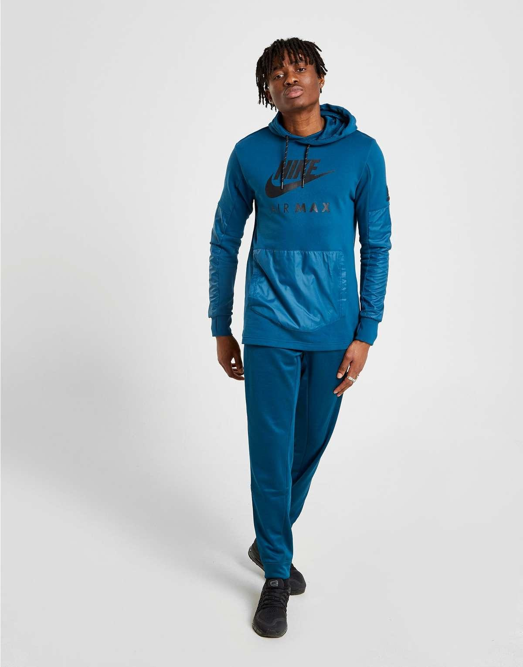 | AIR MAX FZ HOOD B'FORCE

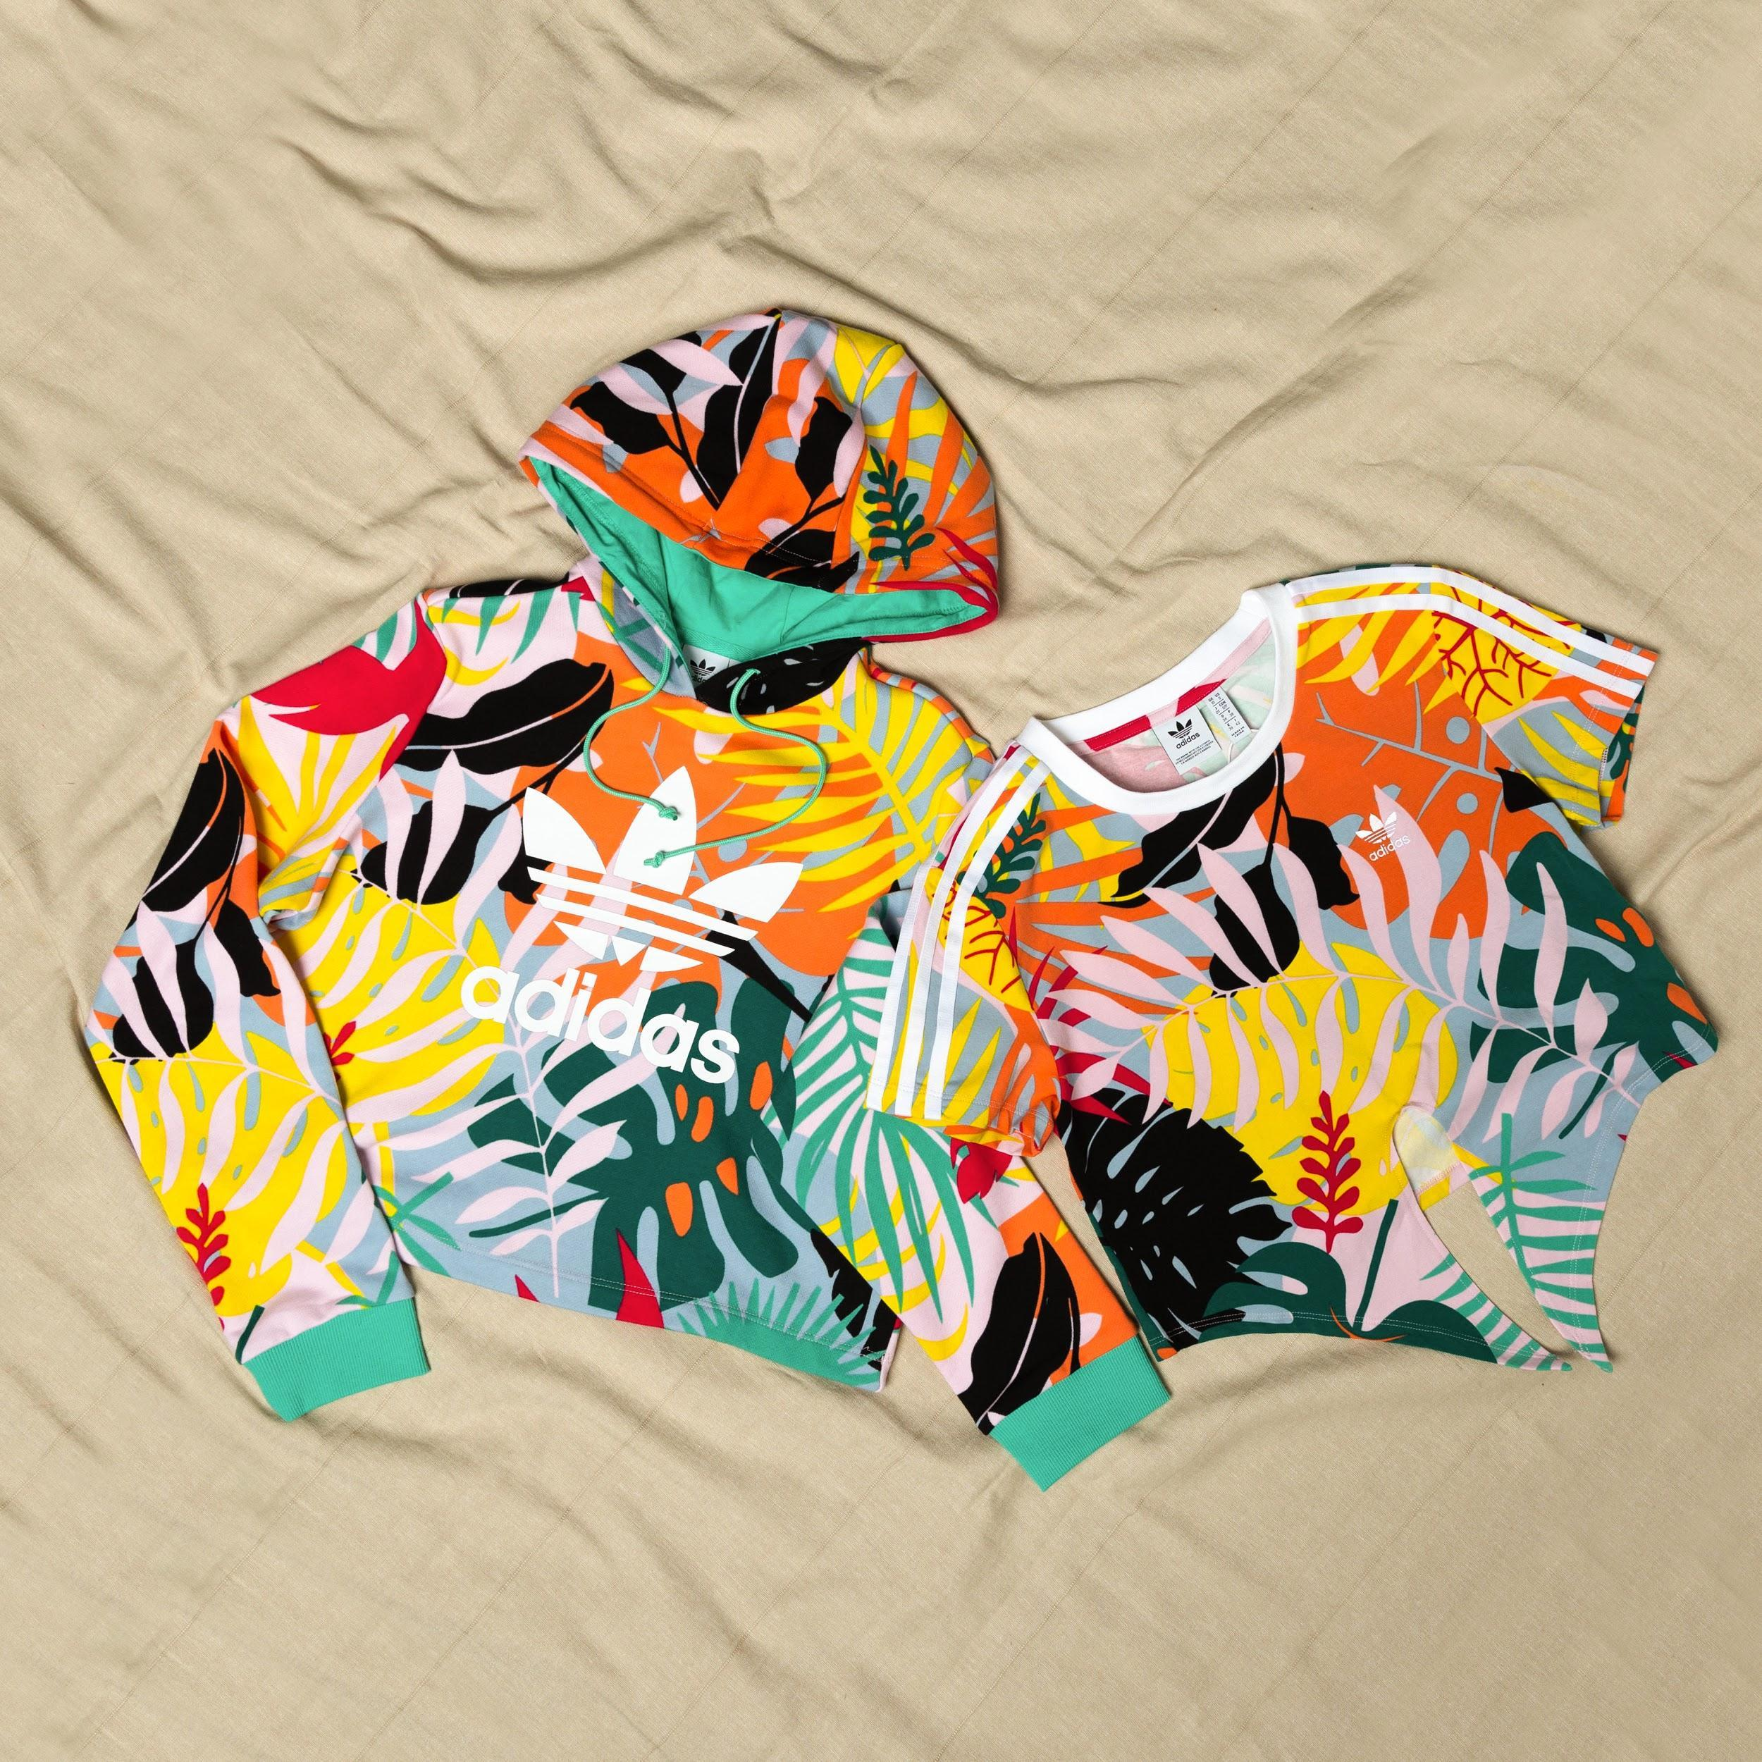 | TROPICALAGE CROPPED HOODIE  TROPICALAGE CROPPED TEE
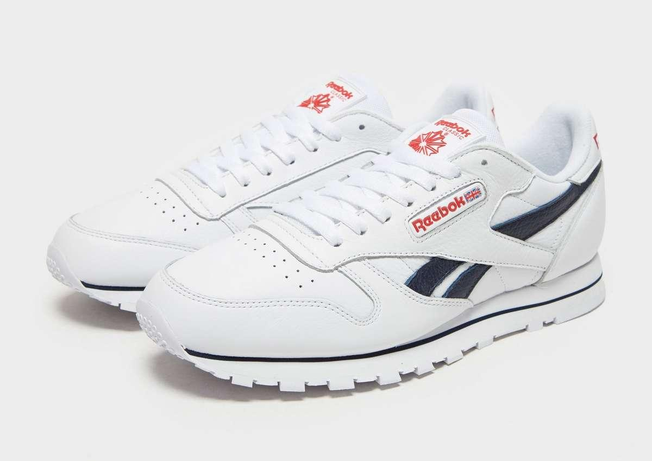 | Reebok Classic Leather 'JD Exclusive'

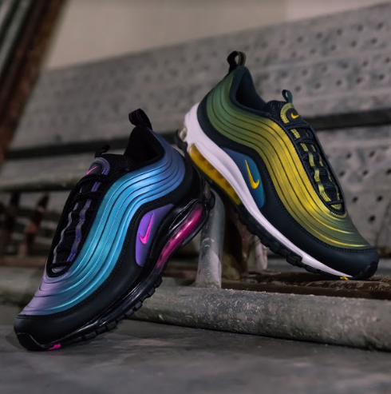 | NIKE AIR MAX 97 LX  'Throwback Future'
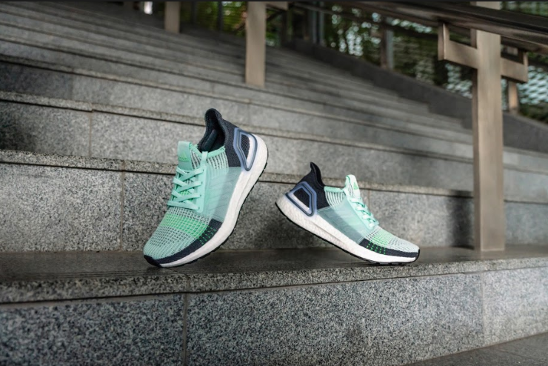 | Adidas Ultra Boost 19 Women
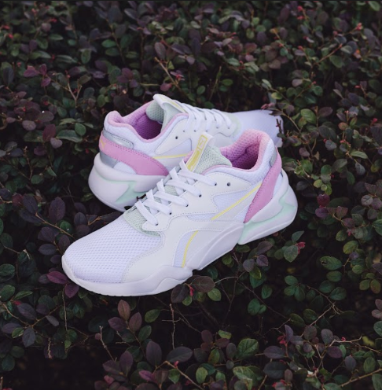 | PUMA RS-O MESH

Find the style you want with these latest apparel and shoes. Visit any of these JD stores near you to check them out:
- JD Pavilion Elite (Flagship)
- JD Sunway Pyramid
- JD Sunway Velocity
- JD Mid Valley
- JD IOI City Mall
- JD Setia City Mall
- JD Sunway Carnival Mall
- JD Gurney Plaza
- JD Mahkota Parade
- JD AEON Tebrau City
- JD East Coast Mall

To keep up to date with all things JD follow us on: Facebook; JD Sports Malaysia and Instagram; jdsportsmy. JD is also available online at www.jdsports.my.

For further information, please do not hesitate to contact:

Elizabeth Kate Harding | Nicole Aldeth
Mad Hat PR | Mad Hat PR
T: +6012 2205703 | T: +6012 5670129
E: elizabeth@madhat.asia | E: nicole@madhat.asia

Note to the Editors:
About JD Sports

JD Sports Fashion Sdn Bhd is part of JD Sports Fashion plc, the leading multichannel retailer of sports fashion and outdoor brands in the UK and Europe. The Group has over 800 stores across a number of retail fascias. For further information visit www.jdplc.com

