10 APRIL 2019
FOR IMMEDIATE RELEASE
PRESS RELEASE

IT’S THE SHIP CHINA’S FIRST VOYAGE READY TO
SET SAIL WITH EXCITING LINEUP
Featuring headliners Blasterjaxx, Kill The Noise, Ookay, Sander Van Doorn, Vicetone, Wildstylez, E-Life and more

CHINA - The wait is finally over! IT’S THE SHIP China has announced the first phase lineup for its inaugural sailing from Shanghai to the island of Shimonoseki in Japan and back happening this 13th to 17th June 2019. With the unveiling of electrifying headliners including EDM DJ duo Blasterjaxx, iconic electro house DJ Sander Van Doorn, Dutch electronic DJ duo Vicetone, hardstyle DJ Wildstylez featuring MC E-Life, EDM DJ and record producer Kill The Noise, Ookay plus more artistes to be announced, IT’S THE SHIP China is set to provide shipmates worldwide an experience of a lifetime only made possible onboard the MSC Splendida.

Journeying from being relatively unknown producers to becoming one of the biggest acts in the EDM scene, Blasterjaxx will be taking over IT’S THE SHIP China’s first expedition with their signature killer drops and infectious melodies alongside world-renowned DJ, Sander Van Doorn. Ranking at #36 on the DJ Mag Top 100 poll, Vicetone are expected to take the festival to new heights after headlining various sold out festivals around the world. Best believe that the award-winning duo will also showcase their multiple Beatport Top 10 charting singles set to immerse shipmates in a dynamic experience. All in all, there are some solid inclusions in the lineup with another exciting headliner act to be announced soon.

Joram Metekohy, otherwise known by his stage name Wildstylez, is a Dutch hardstyle DJ and record producer ranked #85 on DJ Mag Top 100. Throughout his career in the hardstyle scene combining influences from techno and hardcore, Wildstylez has made numerous collaborations with other hardstyle artistes. Performing with him is rapper turned MC E-Life, who won best hip hop song for the 1997 TMF Awards that has since opened up several doors for him to perform with rap legends such as LL Cool J, Snoop Dogg, Ice Cube, the Wu-Tang Clan, Public Enemy, Blackstreet and Run DMC.

Active in the music industry since 2003, Kill The Noise has had an extensive list of EPs, singles, collaborations and remixes, the most popular being “Recess” on which he collaborated with Skrillex in 2014. Besides that, he has also channelled his best skills on multiple major film soundtracks such as Zoolander 2, Teenage Mutant Ninja Turtles, and XXX: The Return of Xander Cage. Together with the pop electronic dance music sensation Ookay, the American DJ and music producer strives to get shipmates on IT’S THE SHIP China pumped up with their high energy performances.

Joining these world-class ensembles are Korean EDM sensations, DJ Soda and Justin Oh, Taiwan based DJ RayRay, deep house DJ LVNDSCAPE, and dubstep DJ Trampa. Besides that, world-renowned international EDM record labels such as SPINNIN' SESSIONS, Yellow Claw’s inaugurated label BARONG FAMILY, MONSTERCAT, as well as Tencent & Sony Music Entertainment Asia-based label LIQUID STATE who has had multi platinum-selling artiste Alan Walker playing an integral part in the label. Also not forgetting Asia's leading music labels, ASIAN HARDSTYLE ALLIANCE and JUNGLE EVENTS will be taking centre stage of IT’S THE SHIP China, set to give revellers onboard a show of infinite epic proportions.

This inaugural sailing promises a unique shipcation made for festival-goers, adventure seekers and music enthusiasts around the globe. On top of that, each shipmate will be rewarded with an outré adventure throughout the 5-day 4-night journey that features various pop-up parties as well as a range of artiste-led side activities.

The Early Duck 2 promotion is available from now until the 15th of April, offering shipmates up to 17% discount off cabin prices. The rates are also inclusive of complimentary round-the-clock dining, non-alcoholic beverages and free access to most of the ship’s facilities. Don’t miss out on this promotion by purchasing your Early Duck 2 cabin here: www.galactix.asia/itstheship-china-2019

Stay in the loop by following IT’S THE SHIP’s social channels for updates on both IT’S THE SHIP Singapore and IT’S THE SHIP China sailings.

Facebook : www.facebook.com/itstheship
Instagram : www.instagram.com/itstheship
Twitter : www.twitter.com/itstheshipasia
Weibo : www.weibo.com/itstheshipchina

FOR MORE INFORMATION, LOG ON TO

www.itstheshipchina.com
#ITSTHESHIP #ITSCN19

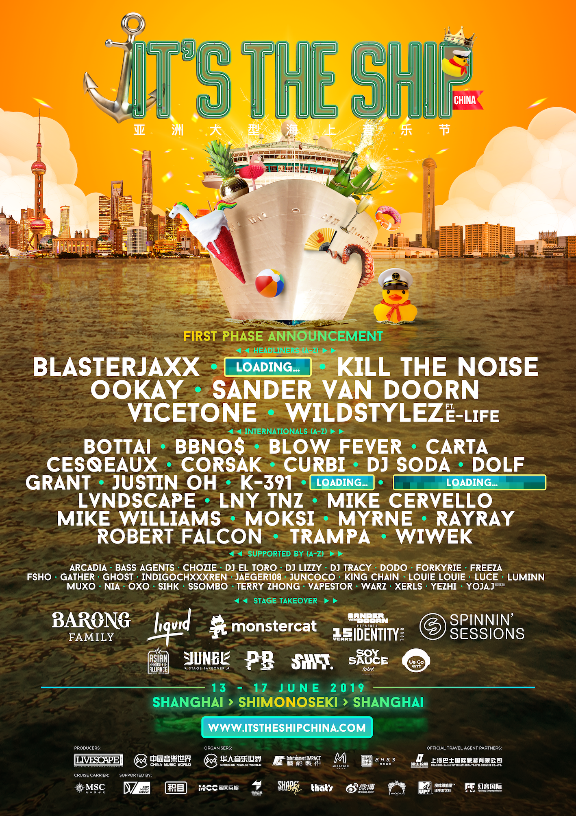
IT’S THE SHIP
Since its inception in 2014, the IT’S THE SHIP brand has grown to become Asia’s largest festival at sea with the highest representation of shipmates from over 87 countries around the world. What some may consider as a once-in-a-lifetime experience, others consider as an annual milestone event – offering shipmates with a variety of fun activities, themed parties, and non-stop music – all on international waters. Previous sailings have seen popular artistes Lil Jon, Knife Party, Yellow Claw, Higher Brothers, and Dash Berlin hyping up the crowd, with 2019 being no exception. This year will mark the epic shipcation’s sixth embarkation with multiple sailings planned to take place within different regions.

About Chinese Music World (CMW)
Chinese Music World Limited (CMW) is a comprehensive entertainment and culture company that develops international entertainment intellectual property (IP), organization and operation of large entertainment events, derivation of entertainment contents, entertainment education and training as well as planning and operation of cultural entertainment activities. CMW focuses on live entertainment, education, training and cultural entertainment activities. In addition to introducing world-top entertainment contents and services, developing and managing the world-known IP such as GRAMMY and IT’S THE SHIP, the company also aims to build a world-class platform for education and training, introducing and providing globally famous brands of pop music, dances and entertainment programs, so as to promote various types of trainings on pop music, dances and music camps activities across the country.

About The Livescape Group
The Livescape Group is Southeast Asia’s largest award-winning entertainment and creative agency. Offering in-house marketing, creative design, event production, logistics management, and artist management and booking, The Livescape Group has successfully created and managed world class events including IT’S THE SHIP, Rockaway Festival, Armin Only Embrace, and After Dark Social Club (ADSC). Its 360-degree approach to event management has driven them to be the go-to event agency for the best-known brands on the planet. The Livescape Group currently has offices based in Malaysia, Singapore, and Jakarta.

For media enquiries, please contact Mad Hat PR:
Candy Lo
+6016 588 0966
candy@madhat.asia

Hui Shan Foo
+6012 295 1732
huishan@madhat.asia

