29 April 2019
FOR IMMEDIATE RELEASE
Press Release

For further information, interview requests and media enquiries
Shamani Krishnan | 012 910 0353 | shamani@madhat.asia
Lee Joelynn | 012 909 8284 | joelynn@madhat.aisa

APPLE FOX CIDER BRINGS WAYYYY MORE APPLES INTO MALAYSIA BOOK OF RECORDS
With 6,148 real apples, Apple Fox Cider set a record with the Most Number of Apples Used in a Fox Shaped Display in Malaysia.

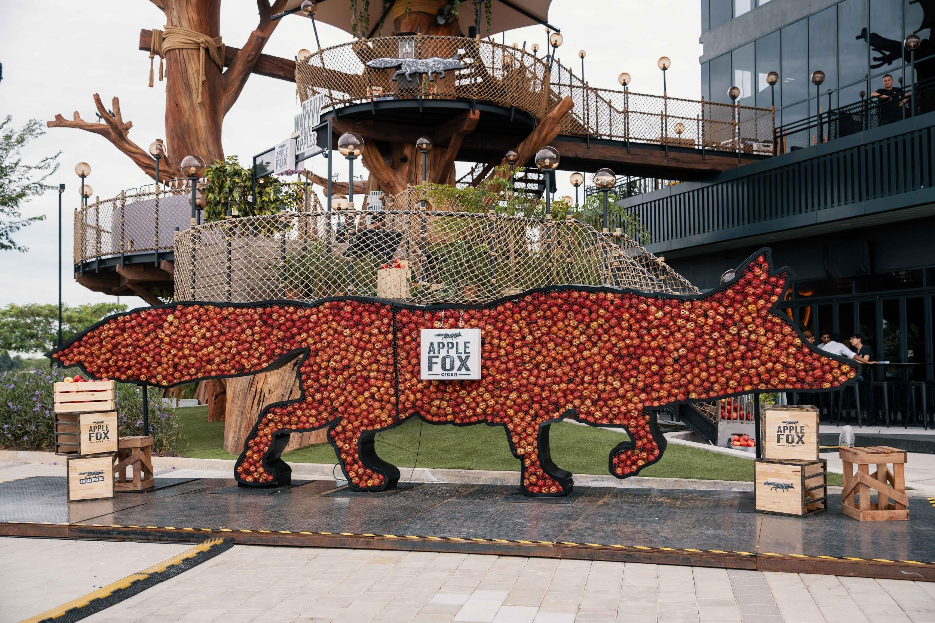

KUALA LUMPUR - 29 APRIL 2019 - Apple Fox Cider revealed a record setting giant fox installation made with 6,148 real apples, in conjunction with the brands ‘Wayyyy More Apples’ campaign. Rolling its way into the Malaysia Book of Records, Apple Fox has successfully snatched the title of the Most Number of Apples Used in a Fox Shaped Display in Malaysia! The installation was debuted at the Apple Fox Den Party - a celebration of the brand and the campaign which took place last Saturday on the 27th April 2019, which was attended by an estimated 300 guests.

Standing tall at 6.5 feet and 24 feet long this Apple Fox installation was officially certified the first ever fox shaped display made with the most number of real apples in Malaysia. The installation is a representation of Apple Fox Cider which is made with wayyyy more apples giving consumers the delicious taste of apples in every sip.

Apple Fox hosted an estimated 300 guests to the party held at the Apple Fox Den which was located in a secret venue. Guests were gathered and brought to the secret venue where they enjoyed an array of decadent grub, a lineup of entertainment and experienced pouring their own Apple Fox Cider in draught! From the giant apple pool to guessing the number of apples in the giant fox, guests were absolutely absorbed in the fun-filled night and got to walk away with some goodies.

“We’re so glad to have the Apple Fox brand in the Malaysia Book of Records! As a fun and young brand, showcasing a giant fox installation with fresh apples really brings out what Apple Fox stands for – the quality of our cider. In line with our campaign, the installation also represents that we use wayyy more apples in our cider - giving our consumers a quality cider without compromising the taste of fresh apples,” said Eileen Chui, Senior Brand Manager at Heineken Malaysia Berhad.

Apple Fox Cider takes its quality seriously. Made with wayyyy more apples, Apple Fox Cider emphasizes on the quantity and quality of the ingredients that goes into making a distinct apple cider. Using only the freshest and juiciest apples from the best orchards - Apple Fox prides itself with wayyyy more apples with each bottle containing the juice from more than one apple, to deliver the original, crisp apple taste.

While Apple Fox Cider uses wayyyy more apples in the Apple Fox installation as well as its cider, the brand believes nothing should go to waste and therefore will be composting the apples from the installation. With the support from the swift hands of GroundControl, Apple Fox Cider will be composting the apples used in the installation - producing in an estimated 1,200 litres of compost. The compost will be distributed among local community gardens in Klang Valley such as Kebun-Kebun Bangsar, Dignity Garden, and TTDI Edible Community Garden, in an effort to contribute to the environment.

Great news! For those who are interested to catch the record-breaking Apple Fox installation, it will be touring around Malaysia. Stay tuned as the exact locations of the Apple Fox installation will be announced soon. Don’t miss out on the chance to spot the Fox shaped display with the most number of apples in Malaysia!

Stay updated by following Apple Fox on Facebook at https://www.facebook.com/applefoxmy & Instagram at @AppleFox_MY or visit www.applefox.com. Don’t forget to include #WhatTheFox when you catch the Apple Fox installation with the Most Number of Apples Used in a Fox Shaped Display in Malaysia or even when enjoying your Apple Fox Cider with friends.

###

About Apple Fox Cider
Inspired by New Zealand cider makers, Apple Fox uses the best-kept secrets of cider making in creating a distinct, refreshing smooth drinking experience, served over ice. Stealthy by nature, the fox has been known to sneak into orchards to hunt for delicious, juicy apples.

Apple Fox Cider contains 4.5% ABV and delivers an instant refreshing taste. Only the freshest apples sourced from orchards all over the world are picked to make the cider, ensuring a naturally crisp texture and intense flavour that makes the best tasting cider.

The meticulous process of creating Apple Fox Cider adds to the superior taste of the product. The selection of a perfect mix of crisp and tart apples is the first step in ensuring the unique brand flavour before the milling and pressing process that releases the natural apple juice, which is the basis for the fresh apple taste. On to the fermentation, blending and filtration processes in producing cider that consistently delivers refreshing apple taste.

Apple Fox Cider is available in 320ml cans and 325ml bottles from hypermarkets, supermarkets and convenience stores. Bottles and draught are also available in bars, pubs and restaurants.

About Heineken Malaysia Berhad
HEINEKEN Malaysia with its portfolio of iconic international brands is the leading brewer in the country. The Company brews, markets and distributes:
- The World’s No. 1 international premium beer Heineken®
- The World-acclaimed iconic Asian beer Tiger Beer
- The World’s No. 1 stout Guinness
- The World’s No. 1 cider Strongbow Apple Ciders
- The New Zealand inspired cider Apple Fox Cider
- The all-time local favourite Anchor Smooth
- The premium Irish ale Kilkenny
- The real shandy Anglia

HEINEKEN Malaysia also produces the wholesome, premium quality non-alcoholic Malta. HEINEKEN Malaysia’s brand portfolio also includes the No. 1 German wheat beer Paulaner and Japan’s No. 1 100% malt beer Kirin Ichiban. The Company continues to lead the responsible drinking agenda through its Drink Sensibly campaign.
Listed on the Main Market of Bursa Malaysia, HEINEKEN Malaysia’s principal shareholder is GAPL Pte Ltd based in Singapore. GAPL Pte Ltd is 100% owned by Heineken N.V.

For more information please visit: www.heinekenmalaysia.com

