FOR IMMEDIATE RELEASE
Event Listing

For further information, and media enquiries
Elizabeth Harding | 012 220 5703 | elizabeth@madhat.asia

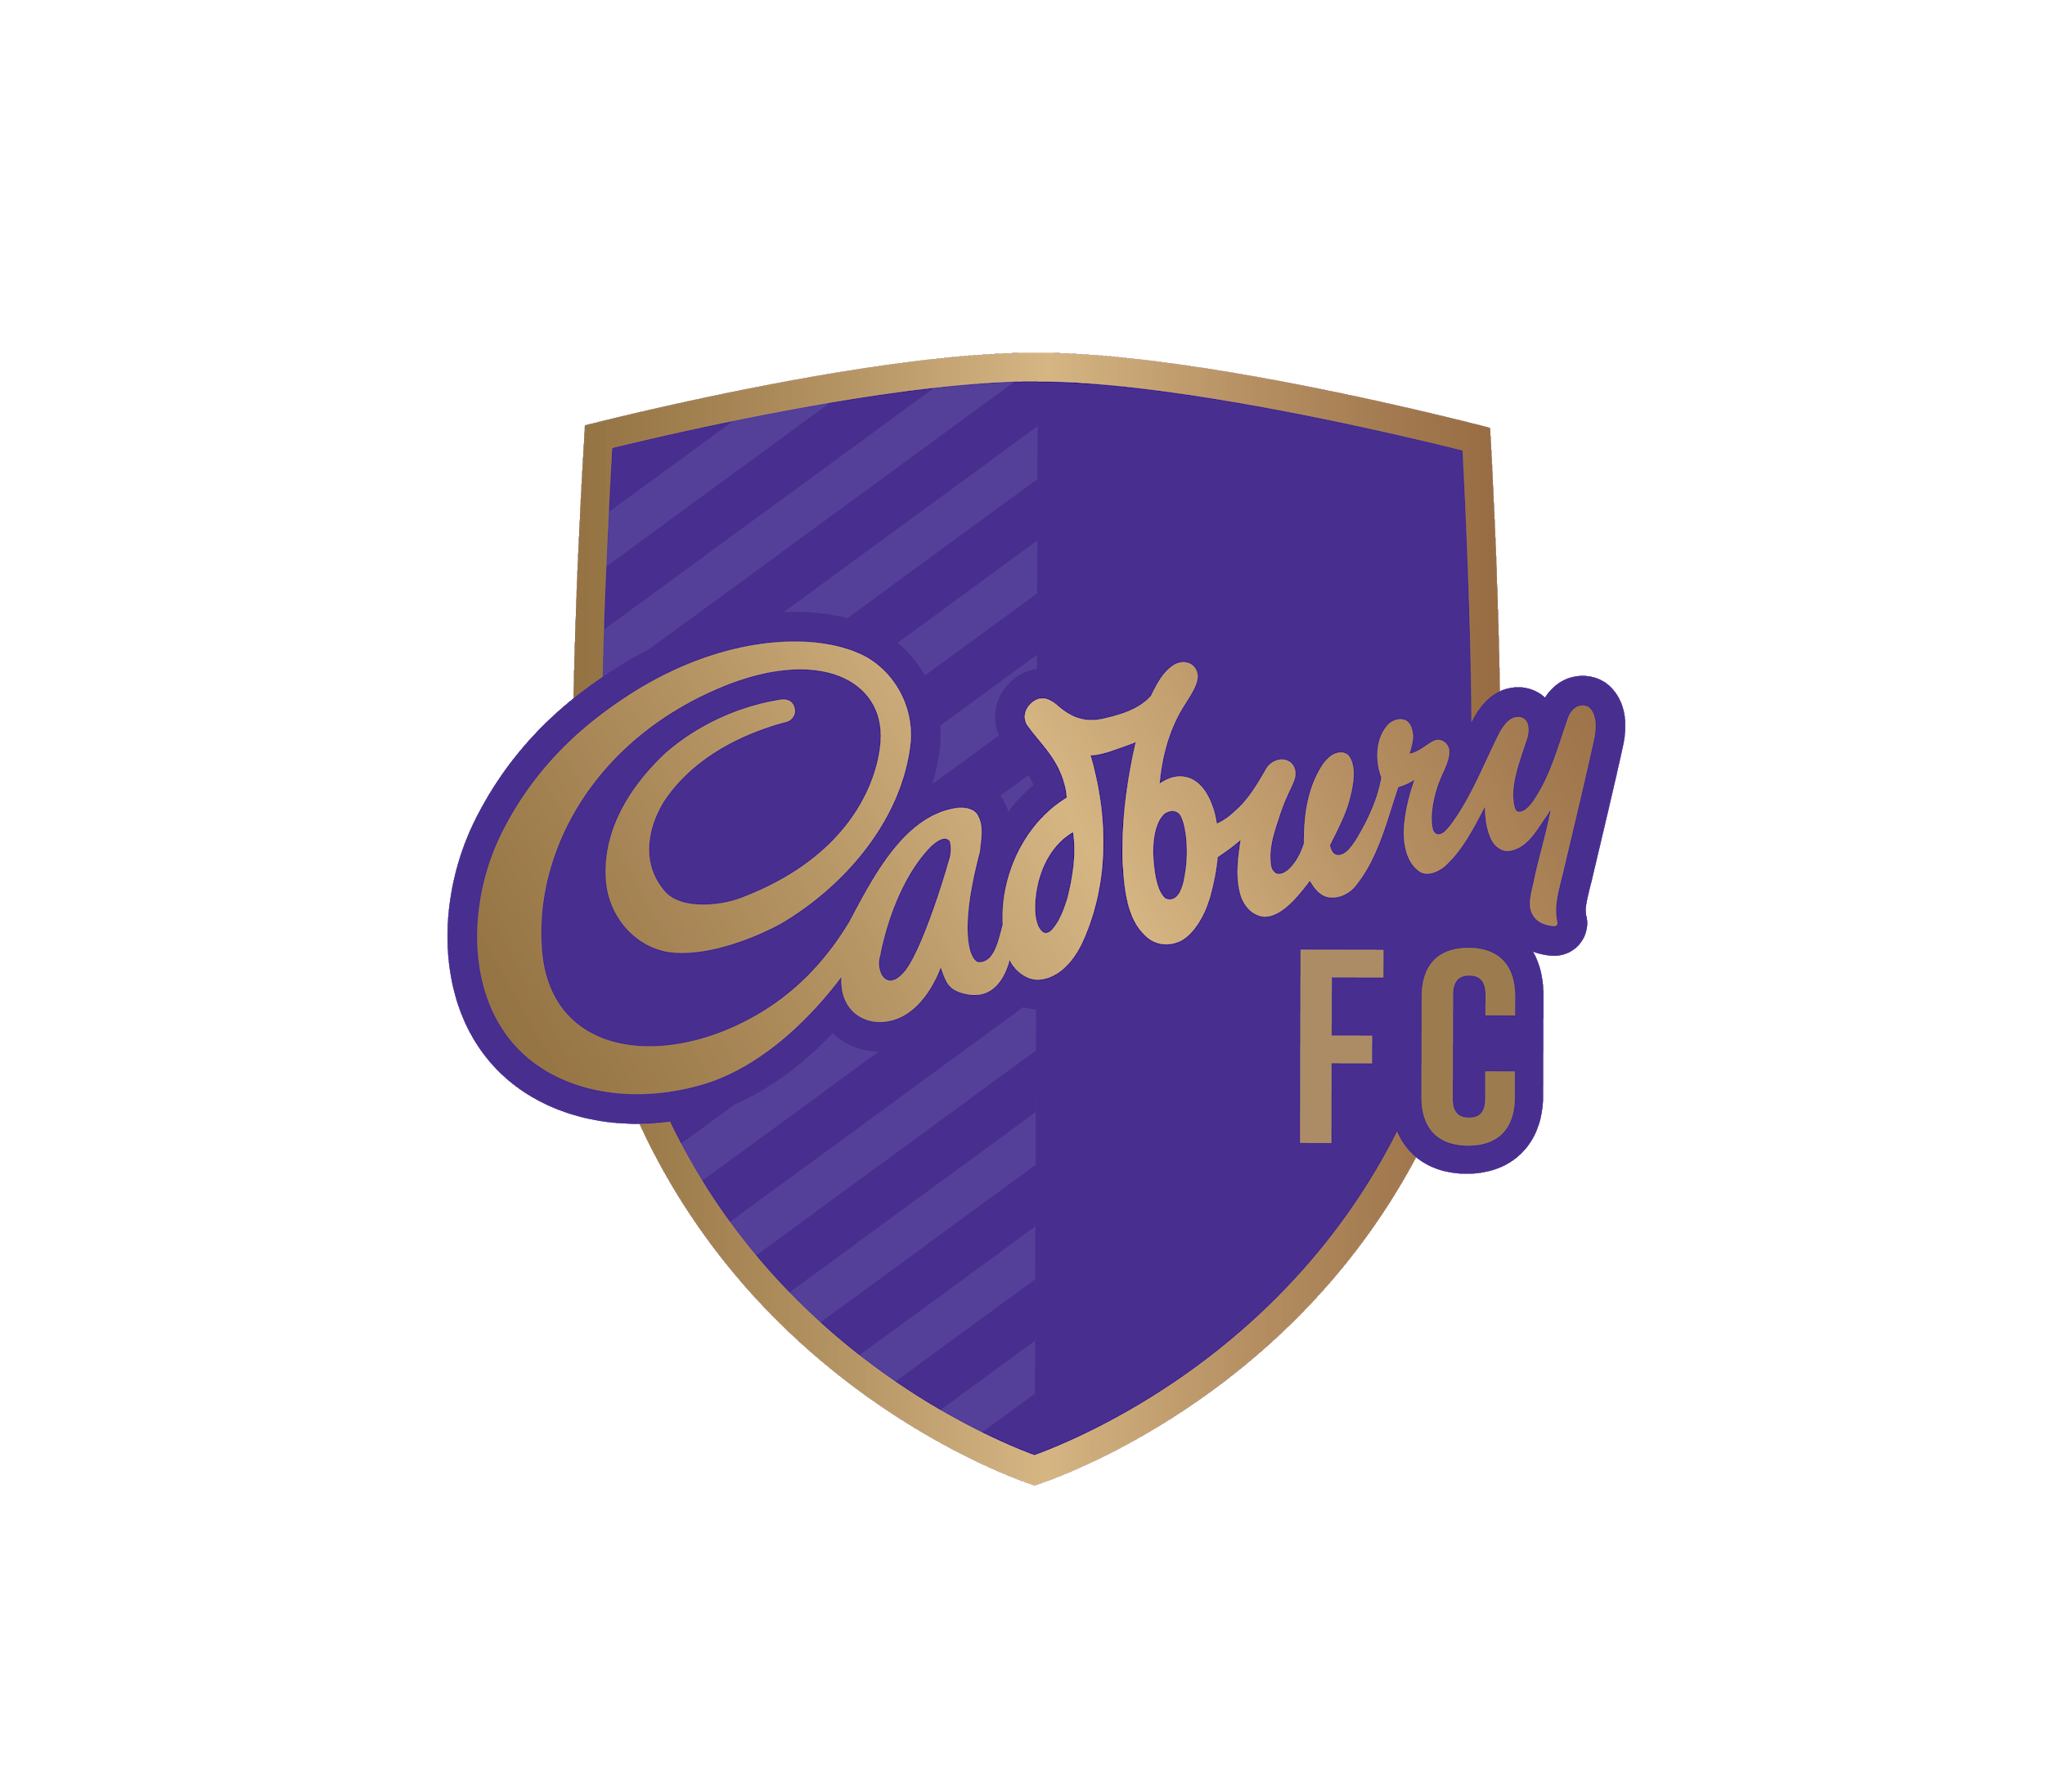
Come be part of Liverpool vs Everton viewing party with Michael Owen

Football is an iconic game that continuously excites fans because of its unpredictability. You never know what’s going to happen next, you just know that each game ensures sheer excitement and is guaranteed to fill you with emotions. Similar to indulging in a bar of Cadbury chocolate, each experience is full of surprises and always leaves you wanting more.

With this in mind, leading confectionery brand, Cadbury became the Official Snack Partner of the Premier League in 2017. The partnership is set for another thrilling season in Malaysia as Cadbury hosts a fun-filled night for football fans with a viewing party of the Liverpool v Everton match at The Square, Publika on Sunday, 3rd March. This match is one not to be missed as it features the longest top-flight derby in English history, the Merseyside Derby.

To continue creating memorable moments for football and chocolate fans alike, England and Liverpool legend, Michael Owen will be making a special appearance. The EPL legend is well known for being the only English player in this century to win the Ballon d’Or, the most prestigious award an individual can achieve in their professional footballing career.

Do not miss out on a chance to participate in exciting one-on-one games and activities with the Liverpool legend. Lucky fans also stand a chance to be part of a selfie session with Michael Owen. Join us for an unforgettable night with Cadbury and the Premier League!

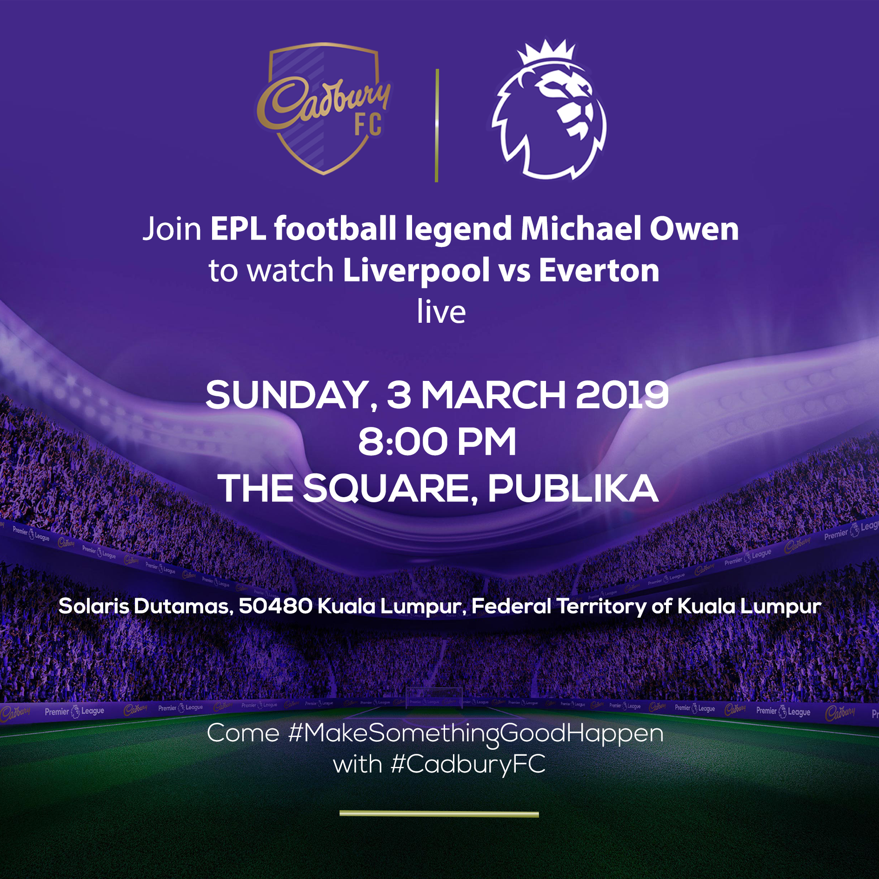

Details on the viewing party are as stated below:

Day/Date: Sun, 3rd March 2019
Time: 8.00pm (Activities and refreshments)
12.05am (Liverpool v Everton match commences)
Venue: The Square, Publika

Do note that entry to the event are on first come, first serve basis so be sure to be there early!

