07 November 2018
FOR IMMEDIATE RELEASE
Event Listing

For further information, and media enquiries
Elizabeth Harding | 012 220 5703 | elizabeth@madhat.asia

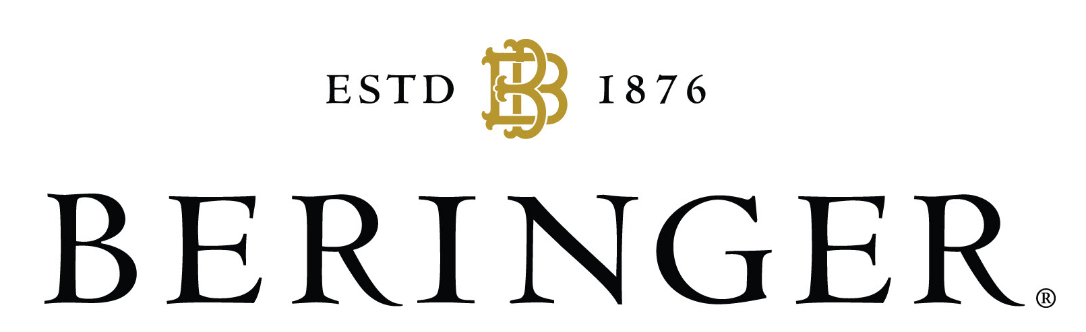

A recent survey, conducted across five countries in Southeast Asia by Beringer Vineyards, a Napa Valley wine brand, revealed that while 94 percent of Malaysians claim to long for their next vacation, four out of five believe that they could have maximised their annual leave if only they were better at travel planning.
To help give some travel planning inspiration, Beringer Vineyards is hosting an exclusive Winederlust-themed dinner to help Malaysians kick start their wanderlust dreams over a three-course meal accompanied by some of Beringer’s finest wines.
Join world-traveler and fellow wanderluster, Levy Li as she gives guests her first-hand insight into the culturally rich and visually spectacular, Bangkok, Thailand - Asia’s City of Angels.
Levy’s travelling experience is one that’s envious as she’s explored everything from the monuments of Florence, Italy to meeting K-pop stars in Seoul, Korea. Yet, there is nothing she loves more than traveling to the beautiful city of Bangkok, Thailand. Come discover how she selects her favourite eateries and the best time to travel while also managing a travel budget.

Details on the dinner are as stated below:

Day/Date: Wed, 14th November 2018
Time: 7.30pm
Venue: 6 Senses Gastrobar
Ticket prices: RM70
All tickets include:
Three-Course Wine Pairing Dinner (24, Jalan PPU 2A, Taman Perindustrian Pusat Bandar Puchong, Puchong)
2 bottles of Beringer Founders' Estate Wine (RRP RM100)

For full details and to book your tickets for this exciting dinner, visit
https://peatix.com/event/556658/view

For updates on Beringer Vineyards’ happenings follow their Facebook (https://www.facebook.com/BeringerVineyardsSEA) and Instagram (https://www.instagram.com/beringervyds).

What are you waiting for? Get your tickets today!

