FOR IMMEDIATE RELEASE

For more information, interviews, and media enquiries, kindly contact
Sarah James | sarah@madhat.asia | 012 246 1506
Elizabeth Harding| elizabeth@madhat.asia | 012 220 5703

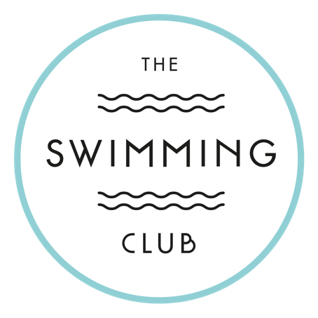

THE SWIMMING CLUB MAKES A SPLASH IN THE HEART OF KUALA LUMPUR

The eclectic pool bar at The KL Journal Hotel officially opens this September 2018

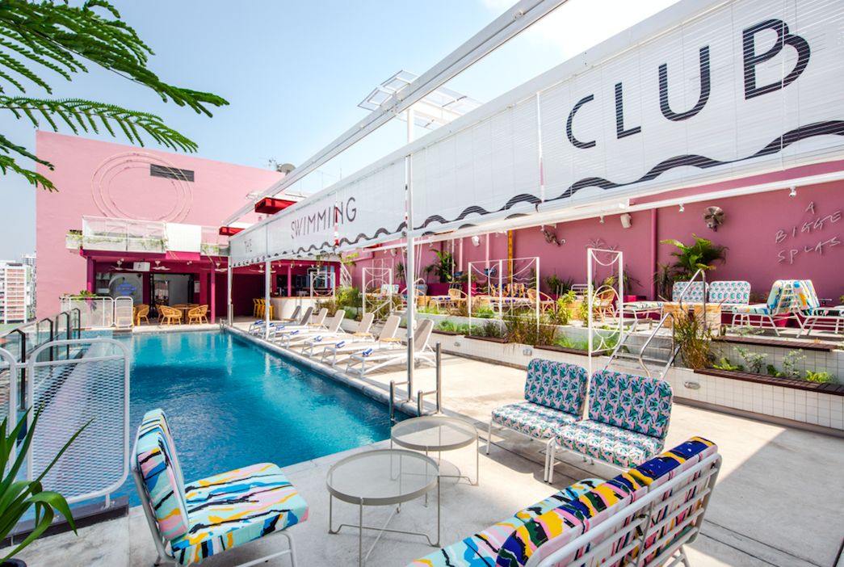

Kuala Lumpur, 1st September 2018 – Kuala Lumpur, get ready for an exciting new pool bar with the arrival of The Swimming Club at The Kuala Lumpur Journal Hotel. Located on the 11th floor rooftop, The Swimming Club is the perfect place to get sun-kissed, unwind with friends, and share sundown moments with classic cocktails with a local twist in hand.

In-line with the hotel’s approach to independent design, the newly revamped pool bar takes cues inspired by a tropical Mid-Century look with a retro Malaysian touch. Think Palm Springs, Penang Island Architecture and Wes Anderson. The resulting aesthetic with striking splashes of colour, eye-catching details and motifs sets this unique pool bar apart from other rooftop venues in Kuala Lumpur.

“The new revamped pool bar at The Kuala Lumpur Journal Hotel is intended to further strengthen our overall hotel portfolio and expand our opportunities to work with local collaborators and designers. We are truly a homegrown independent boutique hotel and our design approach was and always will be important to us, and we hope that patrons can see this with the revamped pool bar.” said Ramesh Singh, General Manager of The Kuala Lumpur Journal Hotel.

He added, “We are keeping the brand relevant and fresh by focusing on giving our guests an overall curated experience. By evolving and elevating the brand’s offerings, we believe that we will create a best-in-class experience that will truly redefine any guests’ stay at our hotel.“

As guests relax and laze by the gorgeous surroundings and saltwater infinity pool, an enticing bar menu will keep guests refreshed. Signature cocktails with a local twist such as Assam Boi Mojito, Kaffir Lime Margarita and Rooftop Cucumber Lemonade lead an extensive bar menu of different beer brands, boutique wines, spirits, non-alcoholic beverages and healthy juices. Guests can also indulge in some truly simple and delicious poolside fare like the signature Journal Burger, Poolside Katsu Bun and Classic Caeser Salad– great for sharing with friends.

The Swimming Club is open daily from 12pm to midnight. From work happy hours, romantic drinks with sunset views, to Saturday nights out on the town, The Swimming Club is the perfect destination for a special evening with company — #TogetherWeSwim!

In conjunction with the opening of the bar, guests will be able to enjoy 1 for 1 cocktails from 4pm to 7pm daily. Be sure to check out The Swimming Club’s Facebook and Instagram page and keep up to date with weekly theme nights, events and special offers all year long! #TheSwimmingClub #TogetherWeSwim.

Facebook: https://www.facebook.com/swimmingclubkl/
Instagram: https://www.instagram.com/swimmingclubkl/
Twitter: https://twitter.com/swimmingclubkl

###

FACT SHEET

About The Swimming Club

The Swimming Club takes its design cues from an inspired tropical Mid-Century look with a retro Malaysian touch. Think Palm Springs, Penang Island Architecture and Wes Anderson! The resulting aesthetic with striking splashes of colour, eye-catching details and motifs sets apart from other rooftop venues in Kuala Lumpur. Grasp the opportunity to create distinct and memorable events at The Swimming Club! With a bespoke approach to service and menus, modern retro aesthetics and colours - not forgetting plenty of photo and video opportunities surrounding your event - there won't be a dull moment throughout!

Check out the The Swimming Club’s Facebook and Instagram page and keep up to date with events and special offers all year long. #TheSwimmingClub #TSC #TogetherWeSwim.

Facebook: https://www.facebook.com/swimmingclubkl/
Instagram: https://www.instagram.com/swimmingclubkl/
Twitter: https://twitter.com/swimmingclubkl

About The KL Journal Hotel

The KL Journal is well located in the Bukit Bintang area, right in the hub of the city, where luxury retail, high street brands, restaurants and commercial offices jostle neck to neck. We are also within walking distance of the iconic Petronas Twin Towers and Jalan Alor, KL’s most famous food street. For a night out, we are just minutes away from the vibrant Changkat neighbourhood with its speciality bars, live music and restaurants. Plus we have excellent access to the monorail, LRT stations and bus networks so getting around is easy and hassle free.

Stylishly designed with a modern retro vibe and a unique local flavour, we like to think we take care of the essentials like fuss free WIFI, a great night’s sleep and good service but pay attention to the things discerning modern day travellers really want. On our checklist – fast check-in, good connectivity for all smart devices, flexible communal space

Website: https://www.kljournalhotel.com/

