FOR IMMEDIATE RELEASE

For more information, interviews, and media enquiries, kindly contact
Vanesa Paxton | vanesa@madhat.asia | 016 342 5957
Sarah Miranda James | sarah@madhat.asia | 012 246 1506

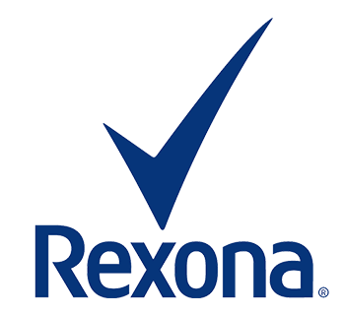

Rexona’s #AFreshStart campaign inspires women to start fresh with the new Rexona Whitening Fresh Rose
The new Rexona Whitening Fresh Rose contains natural whitening ingredients – vitamin E and licorice extract for whiter underarms, naturally!
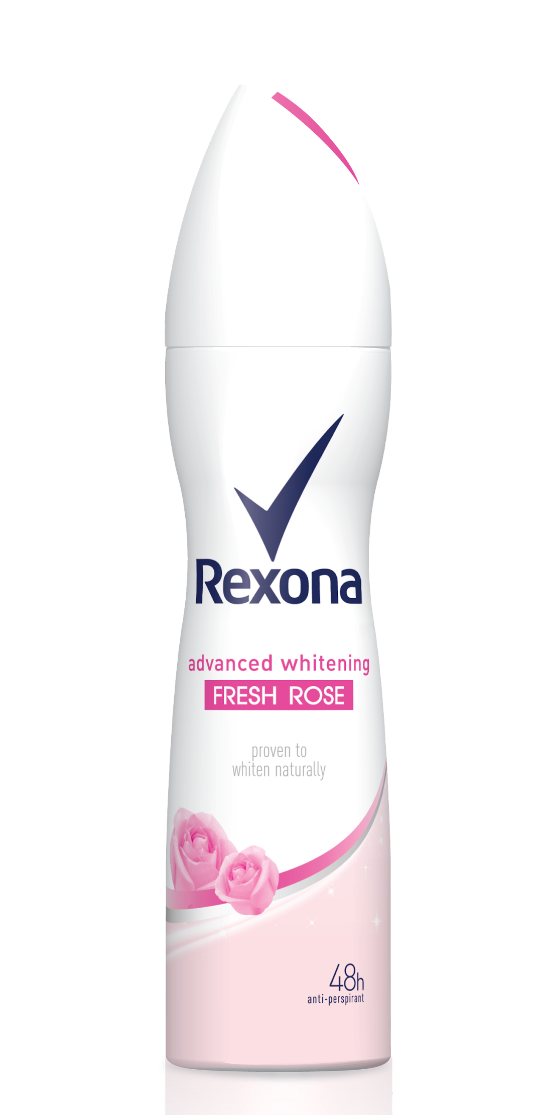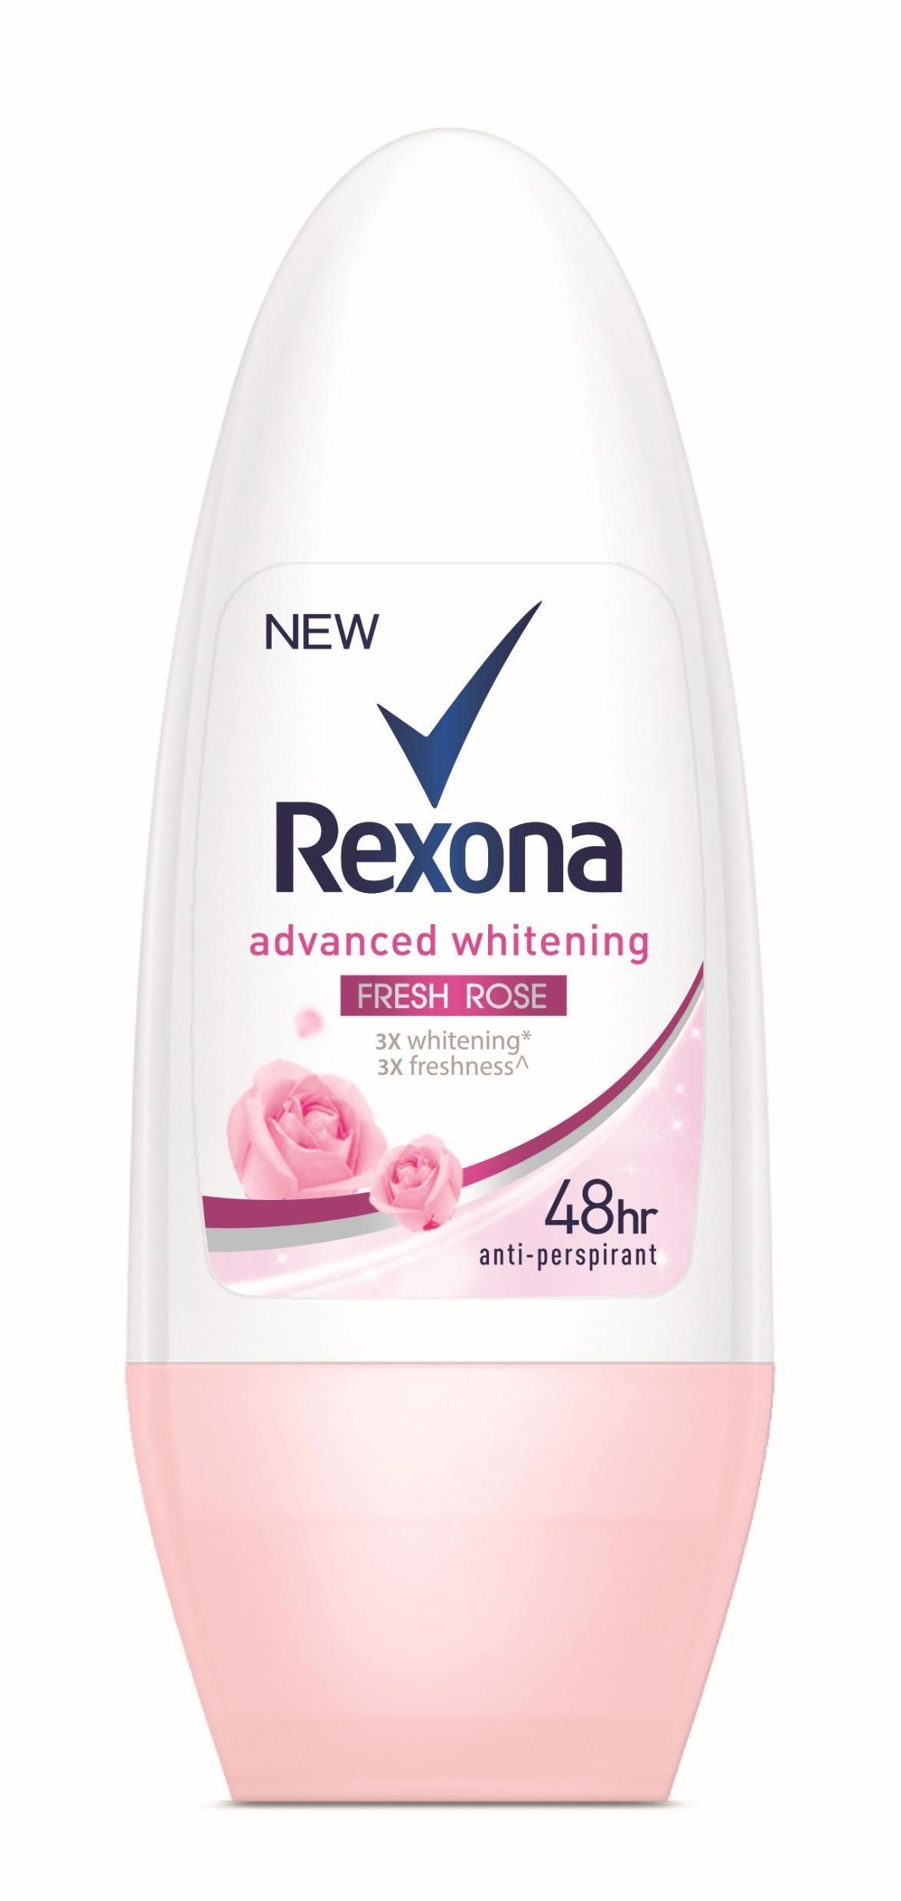

Kuala Lumpur, 11th April 2019 - The world's No. 1 deodorant brand, Rexona today introduced the new Rexona Whitening Fresh Rose. With Vitamin E and Licorice Extract, the new range is clinically proven to whiten naturally. The women of Malaysia can now have whiter underarms naturally and get the protection you need while simultaneously providing lasting floral freshness – the first of its kind.

In conjunction with the launch of Rexona Whitening Fresh Rose today, the #AFreshStart campaign by Rexona will be carried out throughout the year, empowering women to have a fresh start in everything they do. The aim of this movement is to empower the women of Malaysia by giving them a confidence boost in all aspects of their lives - be it beauty, fitness and even fashion. Allowing them to strut their best version of themselves without having to feel insecure about their underarms. In view of this, the Rexona Whitening Fresh range exists to help all women feel fresh while whitening their underarms naturally.

“As the world’s leading deodorant brand, we understand that women want a dependable and long-lasting solution for their underarms. Many people tend to innocently overlook the care needed for underarms as it’s part of the body that can be hidden when needed but people don’t realise that having smooth, white and fresh underarms that you’re proud of are key factors to having the confidence needed to give yourself the extra boost to do everything you want to do. Hence why, we are thrilled to offer this new range to the women of Malaysia” said Callista Fernandez, Senior Brand Manager for Deodorants of Unilever Malaysia

The Rexona Whitening Fresh Rose, is the third range following the launch of Rexona Whitening Fresh Sakura and Fresh Lily last September. The three flower power deodorants in this new Whitening Fresh range combines natural whitening ingredients, alongside Rexona’s unique MotionSense technology, which releases bursts of fresh fragrance that is activated by your movement. So, the more you move the more it works!

In order to inspire more women to have #AFreshStart with Rexona, brand ambassador Ayda Jebat joined in the celebration at the launch event to celebrate the reveal of the new variant and success of the campaign with Rexona.

“It's a very humbling yet amazing opportunity to have been able to be a part of this movement for women. To have grown up feeling very insecure in my skin and body and on top of having a busy schedule, it feels very liberating to know that I can be confident without having to worry knowing there's now a product that finally provides long-wearing freshness and the ability to whiten underarms naturally that lasts all day.” said Ayda Jebat, Rexona’s Brand Ambassador.

The new Whitening Fresh range by Rexona offers three types of floral freshness, which are Fresh Sakura, Fresh Lily and the star of the day – the new, Fresh Rose.

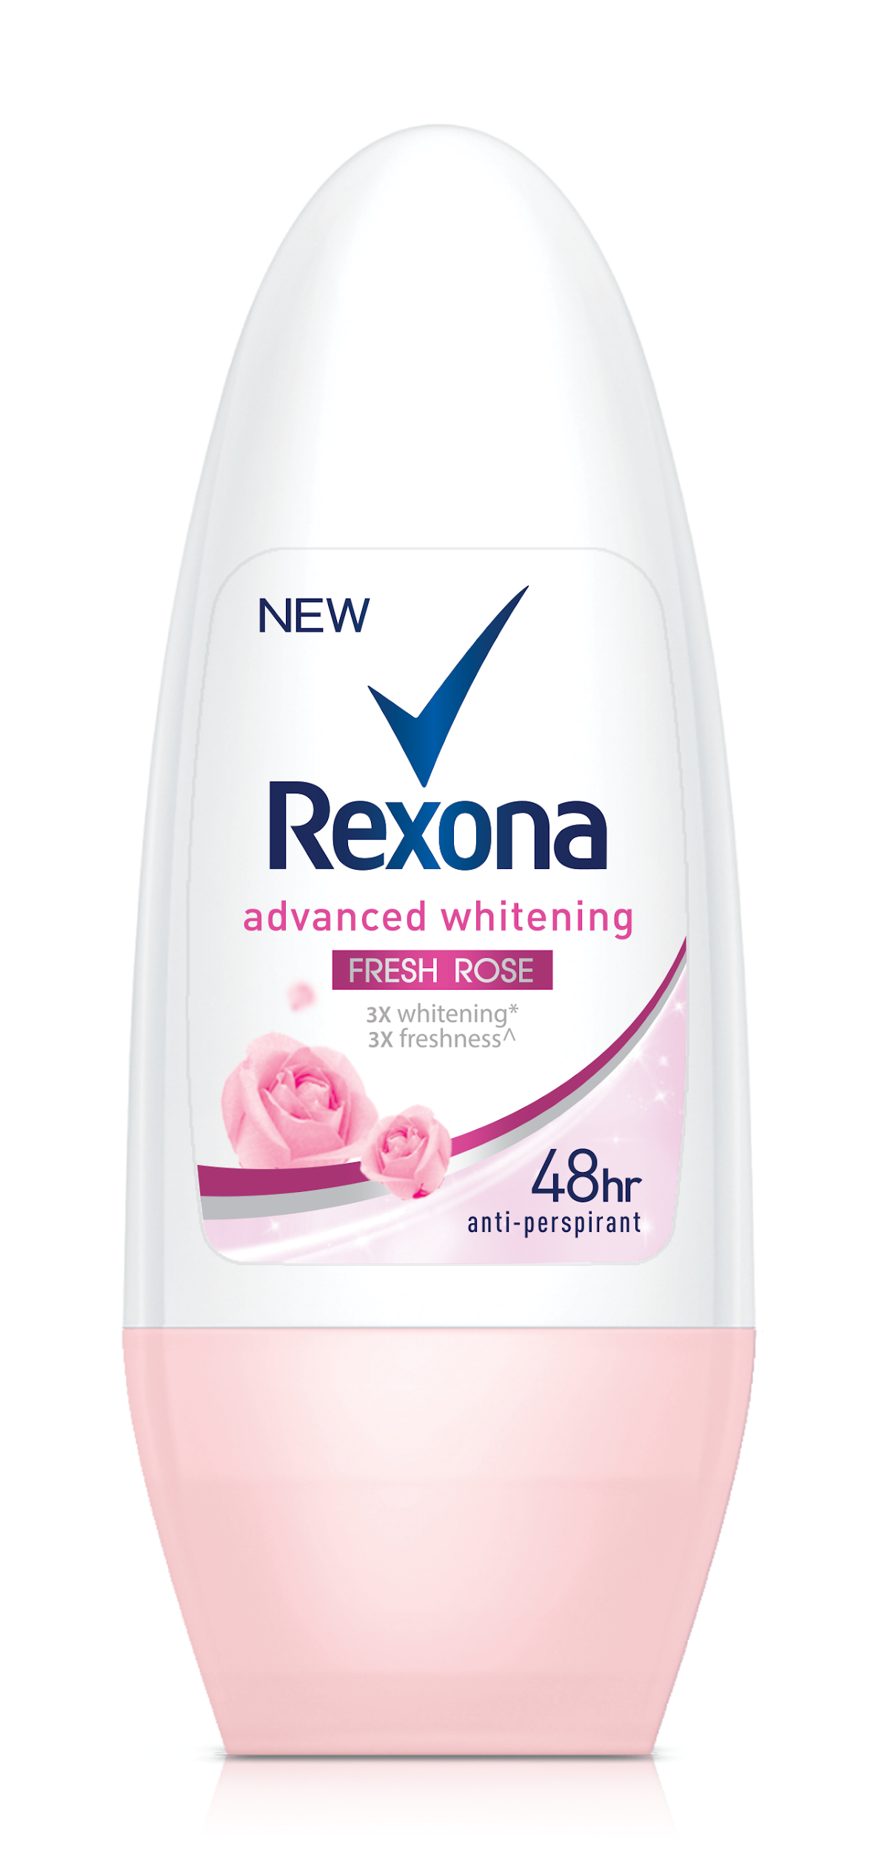 | Rexona Whitening Fresh Rose  RM9.85 – RM15.40*
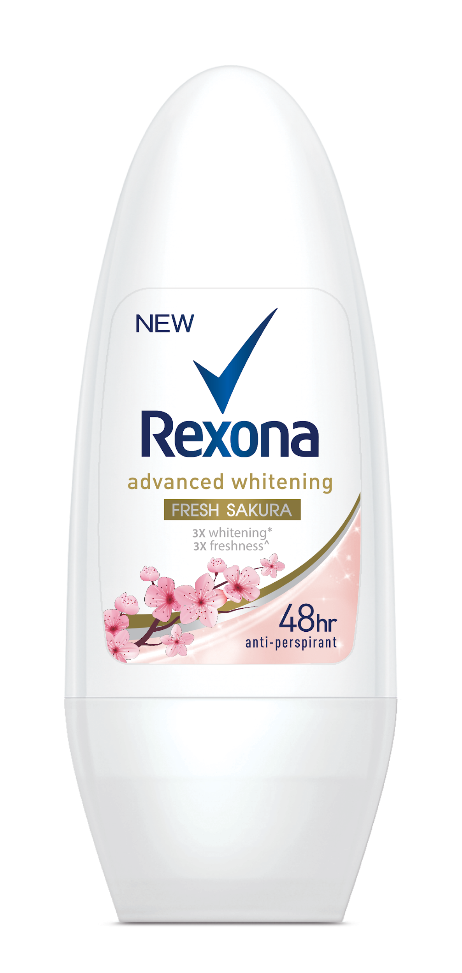 | Rexona Whitening Fresh Sakura  RM9.85 – RM15.40*
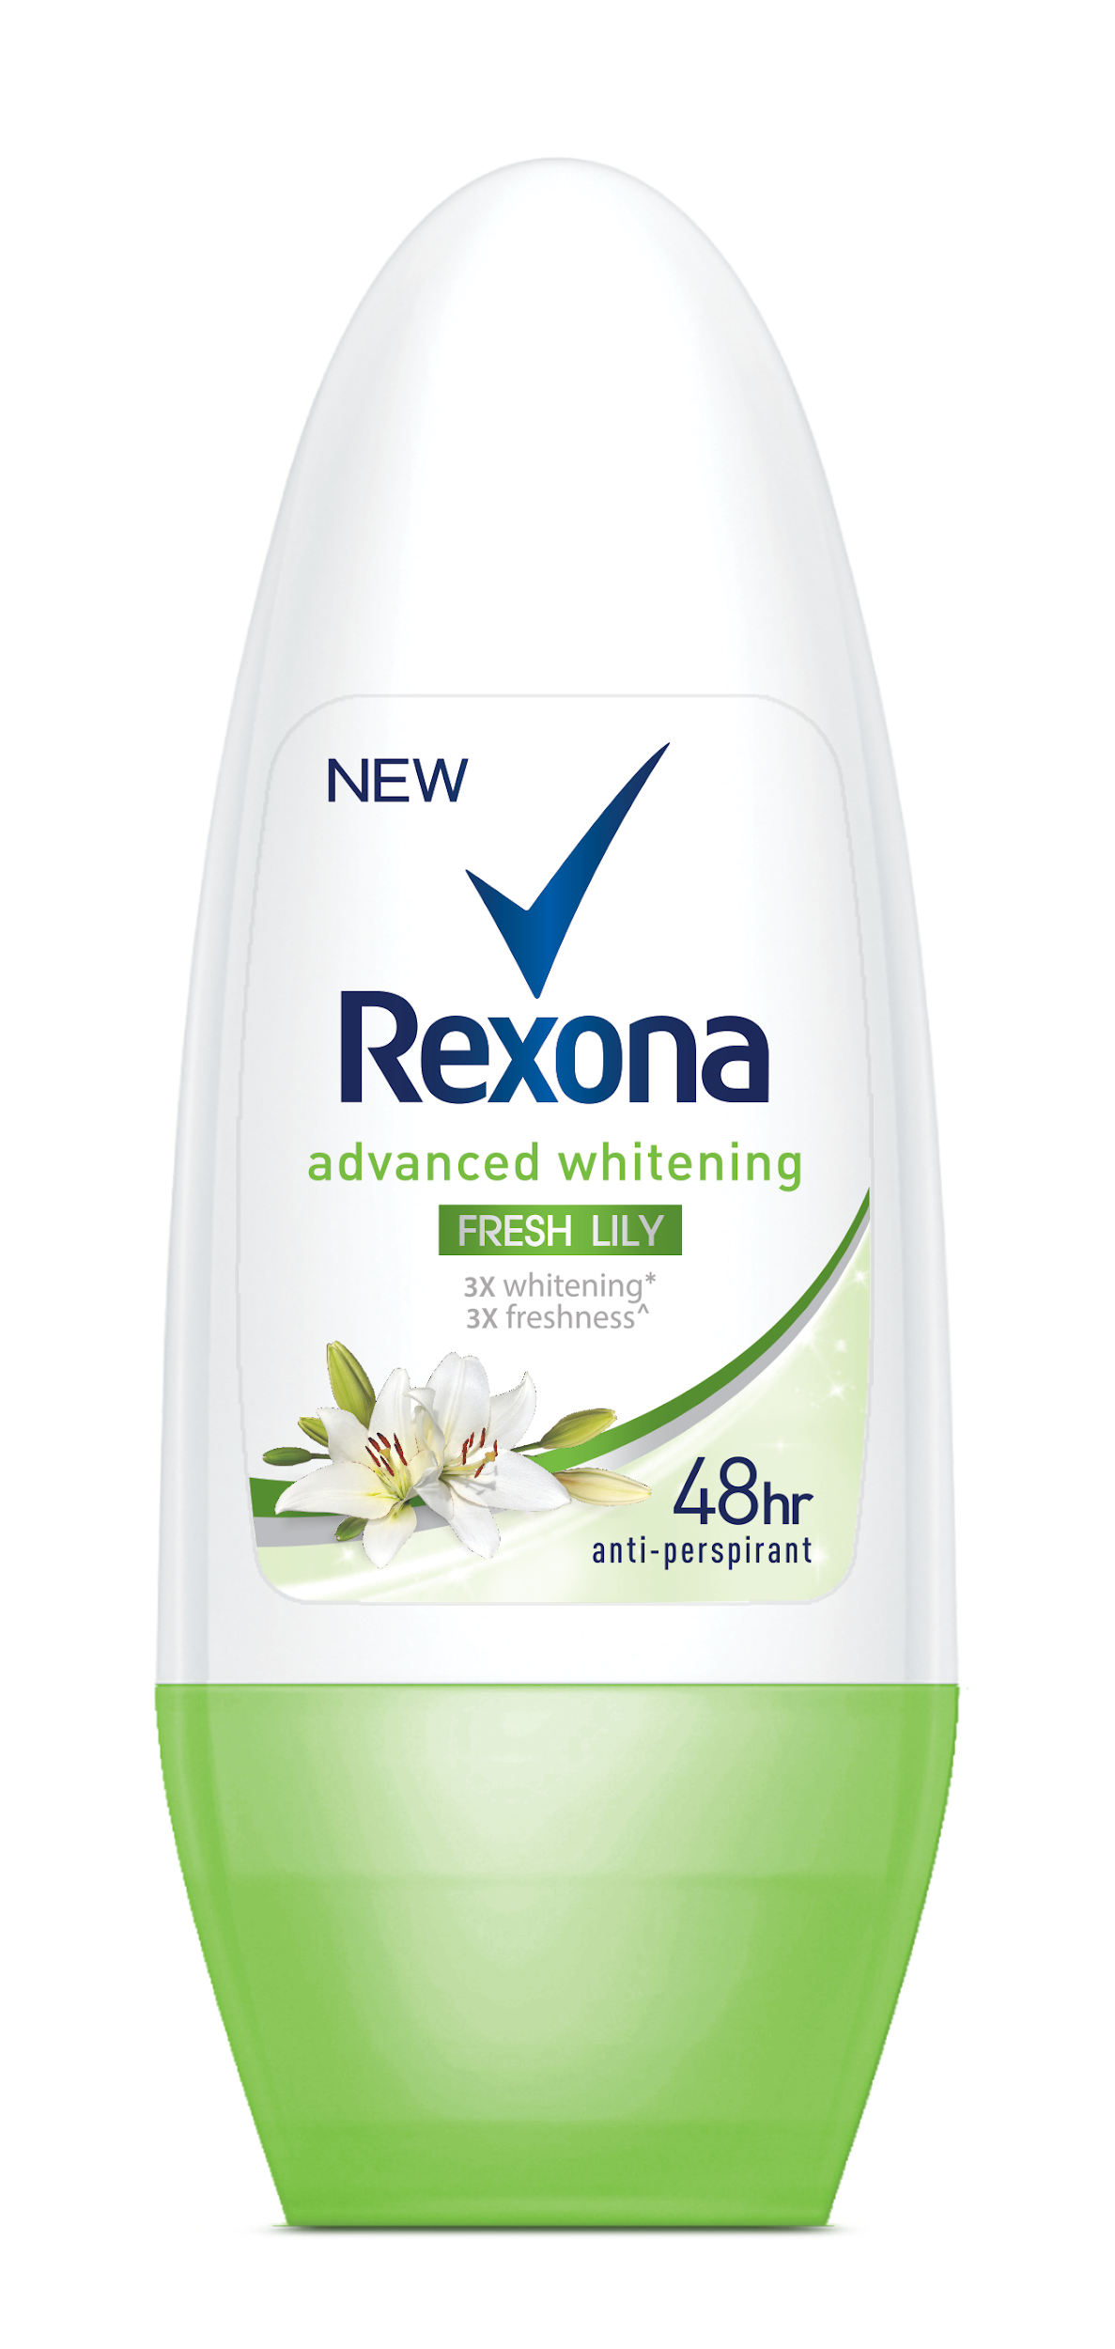 | Rexona Whitening Fresh Lily  RM9.85 – RM15.40*

*Recommended selling price

The new Rexona Whitening Fresh Rose is now available at all major hypermarkets, pharmacies and supermarkets nationwide.

Facebook: https://www.facebook.com/RexonaMY
Instagram: https://www.instagram.com/rexonamalaysia

###

NOTES TO EDITOR

About Rexona

Rexona offers maximum protection you can rely on, all day long. Our antiperspirants and deodorants are developed to meet different demands for men and women, responding to your body to keep you feeling confident and fresh for up to 48 hours.

Our Motionsense™ technology was inspired by your movements; the freshness protection range is scientifically proven to prevent body odor and sweat when you need it the most. So whether you’re rushing to work, working out, presenting to your boss or going on a date, you can be confident because it won’t let you down.

