FOR IMMEDIATE RELEASE

For more information, interviews, and media enquiries, kindly contact
Vanesa Paxton | vanesa@madhat.asia | 016 342 5957
Sarah Miranda James | sarah@madhat.asia | 012 246 1506

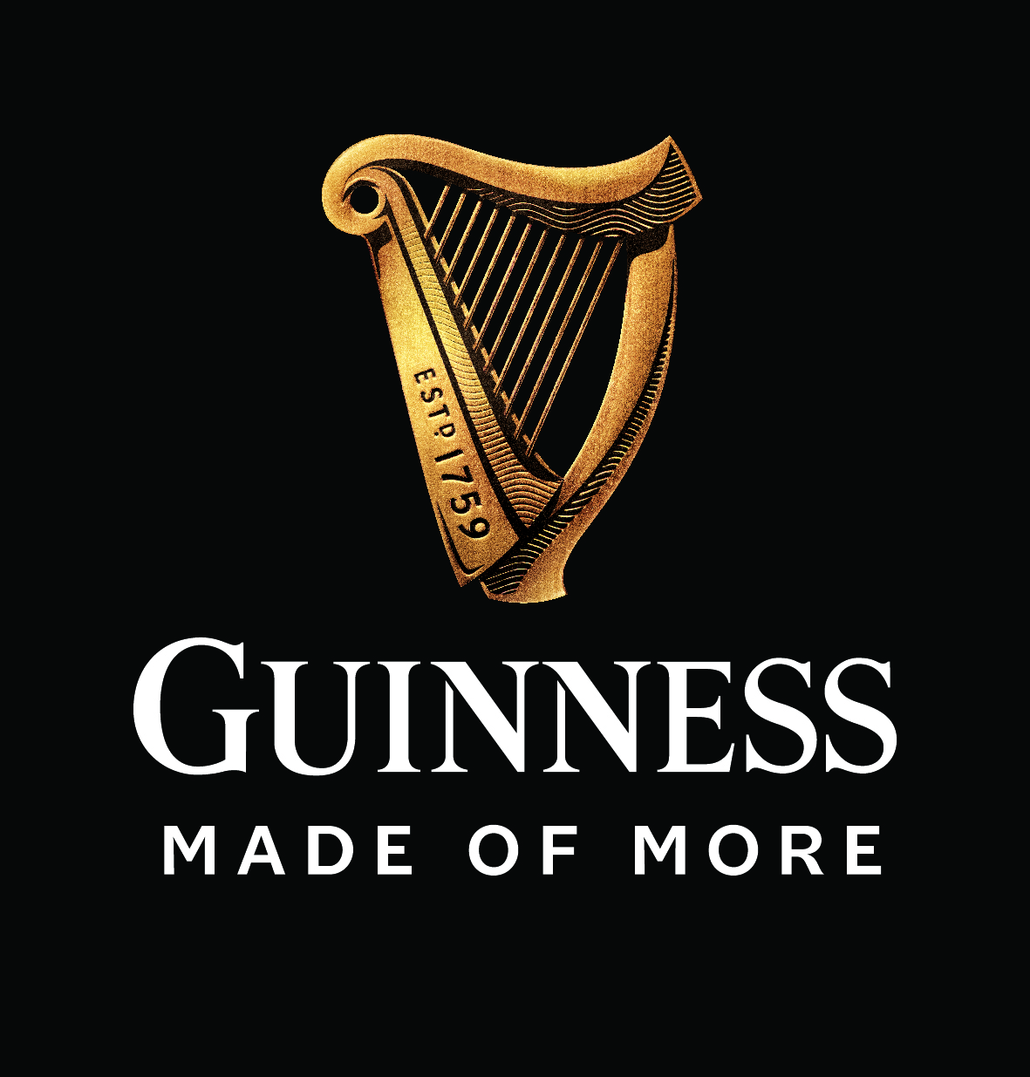

GUINNESS PROVES ONCE AGAIN THAT ITS DRAUGHT IS MADE OF MORE QUALITY
GUINNESS Malaysia awards four Top Guinness bartenders an all-expenses paid trip to the home of GUINNESS, the legendary St James’s Gate in Dublin

KUALA LUMPUR, 25 April 2019 - GUINNESS Malaysia ended their Perfect Pour training programme today by announcing four top bartenders for an all-expenses paid trip to the home of GUINNESS, Dublin. The announcement is the perfect icing on the pint after a month-long journey with GUINNESS Brand Ambassador Cian Hulm who travelled to 8 states training participating bartenders to bring home 16 finalists to compete at the Kuala Lumpur GUINNESS Perfect Pour Finale.

Hailing from the home of GUINNESS – the legendary St James’s Gate in Dublin – Hulm is recognised as one of the foremost experts on GUINNESS in the world and leads a team which travels the globe sharing knowledge on all things GUINNESS, while ensuring the perfect quality standards are carried out everywhere.

The GUINNESS Perfect Pour campaign aims to further establish the quality of GUINNESS Draught amongst HEINEKEN Malaysia’s trade partners by means of a nationwide training programme run for bartenders, covering over 180 outlets and 640 bar staff this year. Through the programme, GUINNESS goes further to prove its quality amongst consumers as they rove the GUINNESS Perfect Pour truck around the Klang Valley to allow consumers the chance to experience what goes into a GUINNESS and how to master the 2-part pour that is unique to GUINNESS Draught.

“It’s been such an experience being here with all the bartenders across Malaysia - I’m so proud to see that across the globe, the drive and passion to produce quality GUINNESS Draught for the end consumers that I’ve been witnessing with each and everyone of them has been consistent throughout and that’s truly something I can say I’m honoured to be able to witness and take pride in,” said Cian Hulm, GUINNESS Brand Ambassador.

GUINNESS Draught is a beer Made of More - more craft, more anticipation, and more satisfaction in every glass because GUINNESS Draught is nitrogenated, uniquely made with barley roasted to a state of perfection, and uses the same strain of yeast that legendary founder, Arthur Guinness, has been using from 260 years ago. Hence, it is the beer of choice for those who will never accept anything less.

“GUINNESS Draught has been able to maintain its status as the world’s no. 1 stout because we only use the finest quality ingredients, and a unique ‘two-part pour which is our guaranteed method to deliver the perfect pint. Hence why, as a brand, we’ve made it a point to ensure bars up and down the country are consistently trained on how to deliver the perfect GUINNESS,” said Julie Kuan, Senior Brand Manager for GUINNESS Malaysia

Thanks to this ongoing campaign, Malaysians will be able to enjoy a perfect pour of GUINNESS at any one of the 16 finalists outlets, below:

- SOULed OUT, Kota Kinabalu
- FIV5 Bar, Hotel N5, Kota Kinabalu
- The Sarawak Club, Kuching
- Senso Bar and Lounge, Hilton Hotel, Kuching
- 5 Senses, Penang
- Rabbit’s Tale, Penang
- The Deck Gastro Bar, Ipoh
- Like Long Bar, Ipoh
- La Primeur, Johor Bahru
- Mulligans Irish Restaurant, Trove Hotel, Johor Bahru
- Old Merchant, Malacca
- The Beer Factory, Malacca
- The Rabbit Hole, Kuala Lumpur
- Genting Club, Kuala Lumpur
- Three Stooges, Uptown Damansara
- The Beer Factory Cheras

For more details on GUINNESS Draught, check out www.facebook.com/GuinnessMalaysia.
###

NOTES TO EDITOR

About HEINEKEN Malaysia Berhad

HEINEKEN Malaysia with its portfolio of iconic international brands is the leading brewer in the country, The Company brews, markets and distributes:

- The World’s No. 1 international premium beer Heineken®
- The World-acclaimed iconic Asian beer Tiger Beer
- The world’s No. 1 stout Guinness
- The World’s No. 1 cider Strongbow Apple Ciders
- The New Zealand inspired cider Apple Fox Cider
- The all-time local favourite Anchor Smooth
- The premium Irish ale Kilkenny;
- The real shandy Anglia
HEINEKEN Malaysia also produces the wholesome, premium quality non-alcoholic Malta. HEINEKEN Malaysia’s brand portfolio also includes the No. 1 German wheat beer Paulaner, Japan’s No. 1 100% malt beer Kirin Ichiban and the World’s No. 1 ready-to-drink alcoholic beverage Smirnoff Ice. The Company continues to lead the responsible drinking agenda through its Drink Sensibly campaign.
Listed on the Main Market of Bursa Malaysia, HEINEKEN Malaysia’s principal shareholder is GAPL Pte Ltd based in Singapore. GAPL Pte Ltd is 100% owned by Heineken N.V.
For more information please visit: www.heinekenmalaysia.com

