FOR IMMEDIATE RELEASE

For more information, interviews, and media enquiries, kindly contact
Vanesa Paxton | vanesa@madhat.asia | 016 342 5957
Sarah Miranda James | sarah@madhat.asia | 012 246 1506

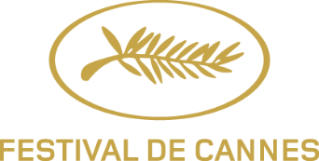

ASIA DEBUT: "Festival de Cannes Film Week" at K11 MUSEA this November
Pierre Lescure, President of Festival de Cannes and Thierry Frémaux, General Delegate of Festival de Cannes, join forces with Adrian Cheng, founder of K11 Group, to bring the essence of the world’s most prestigious film festival to Hong Kong with the Festival de Cannes Film Week.

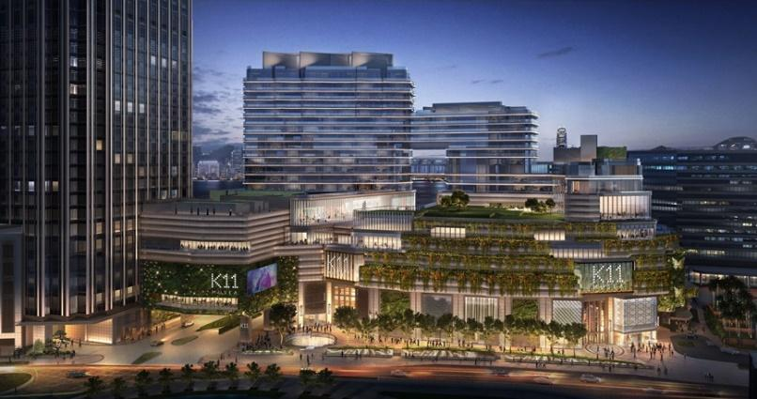
Victoria Dockside

KUALA LUMPUR, 27 May 2019 - The Festival de Cannes Film Week will land in Hong Kong and make its Asia debut at pioneering retail destination K11 MUSEA, Victoria Dockside from 12-17 November 2019. An exclusive and intimate moment of cinema, the Festival de Cannes Film Week will present six films from the selection of the Festival de Cannes 2019 and invite a few select industry professionals to introduce their work and practices through a series of Q&As and masterclasses. Brought to Hong Kong by Pierre Lescure, President of Festival de Cannes, and Thierry Frémaux, General Delegate of Festival de Cannes and Adrian Cheng, Founder of K11 Group and Executive Vice-Chairman of New World Development, Festival de Cannes Film Week is committed to the celebration of creativity, culture and cinema and is set to become the city’s iconic film week.

“The story of Festival de Cannes Film Week began in Buenos Aires almost ten years ago with the idea of taking the spirit of the Festival on a global journey, thereby continuing the dialogue with people from all over the world who visit us in Cannes every year in May and creating a cinema moment with a unique format. At the Festival de Cannes we invite the whole world to come to Cannes to celebrate the art of filmmaking, to discover the latest works of great contemporary directors and to get a taste for what is up and coming in the world of cinema. With our Festival de Cannes Film Week, we hope to initiate the very opposite by taking to the road and bringing the spirit of the Festival and the work of artists to other parts of the globe. There is no better place to extend this experience than Hong Kong which has seen the origins of so many great filmmakers who have come to show their films in Cannes!” said Pierre Lescure, President of the Festival, and Thierry Frémaux, its General Delegate.

Adrian Cheng, who believes in the power of creativity, culture and innovation to enrich daily life across businesses and local communities, commented, “I am honoured to partner Mr. Pierre Lescure and Mr. Thierry Frémaux in debuting Festival de Cannes Film Week in Hong Kong and Asia. For decades, Festival de Cannes has been synonymous with culture and creativity, and through them, it has grown to become the landmark festival that brings together the very best creative powers of cinematography. It is through our aligned vision to bring world-class curated content to a global audience that Festival de Cannes Film Week at K11 MUSEA is made possible. This is an important milestone for K11 MUSEA as we look to develop an on-going programme of innovative cultural events for our international audience.”

On 12 November, the six-day Festival de Cannes Film Week will kick off with an opening night. It will present six feature films from the 2019 Festival de Cannes Official Selection throughout the period, and will immerse Hong Kong in the spirit of the festival. Those attending Festival de Cannes Film Week can expect guest appearances from directors and actors, as well as masterclasses hosted by some of cinema’s brightest lights, offering a truly unique intimate opportunity for enthusiasts to experience the essence of the best of the world’s film industry in Hong Kong.

Tickets and further details will be released later in the year.

###

Hi-res images can be downloaded here:
Link: http://gallery.sinclaircomms.com/
Password: talkofthetown

FESTIVAL DE CANNES
5 rue Charlot, 75003 Paris, France
Website: https://www.festival-cannes.com
Facebook: https://www.facebook.com/festivaldecannes/
Instagram: https://www.instagram.com/festivaldecannes/

K11 MUSEA
18 Salisbury Road, Tsim Sha Tsui, Hong Kong
Website: https://www.k11musea.com/en/
Facebook: https://www.facebook.com/K11MUSEA/
Instagram: https://www.instagram.com/k11musea/

About K11 Musea

K11 MUSEA is a unique retail destination, designed to enrich the new consumer’s daily life through the power of creativity, culture and innovation. It is the latest innovative development by K11 Group, a concept brand founded in 2008 by renowned entrepreneur Adrian Cheng. The Cultural-Retail concept K11 MUSEA, set to open in Q3 2019, will anchor the new 3 million square foot art and design district Victoria Dockside, revitalising Hong Kong’s harbour front.

K11 MUSEA is set to be a world-class, art and culture-led retail destination, which speaks to the growing consumer expectation of naturally immersive experiences of art, culture and commerce. Inspired by ‘A Muse by the Sea’, the architecture was led by James Corner and Forth Bagley, in collaboration with over 100 other international and local architects, artists and designers. The building itself features over 50,000 square feet of green walls, new green building pre-certifications including the U.S. LEED (Gold) and the Hong Kong BEAM Plus (Gold) standards.

