FOR IMMEDIATE RELEASE

For more information, interviews, and media enquiries, kindly contact
Sarah James | sarah@madhat.asia | 012 246 1506
Vanesa Paxton | vanesa@madhat.asia | 016 342 5957

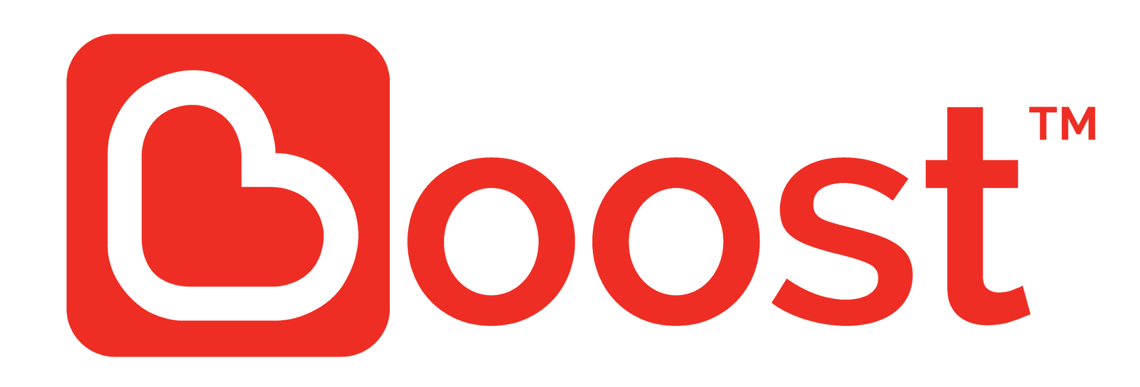

BOOST PAVING THE WAY FOR CASHLESS PUBLIC TRANSPORTATION IN MALAYSIA

Partnerships between Boost, KLIA Ekspres, KTM, CatchThatBus, EzCab and citycarpark aims to drive the digital evolution of Malaysian public transport

Kuala Lumpur, 12 November – Boost, the homegrown e-wallet, is paving the way towards digitizing and converging the way people book and buy public transport rides in Malaysia. By partnering with KLIA Ekspres, KTM, CatchThatBus, EzCab and citycarpark, Boost makes public transport a lot more convenient, cashless, secure and easily managed from a single e-wallet.

These collaborations aim to evolve, transform and digitalise the public transport industry as well as on-street city parking to further expand the cashless ecosystem in Malaysia. The integration between these partners allow Boost to be a single point for customers to plan all their domestic travel and on-street parking conveniently, easily and securely through their e-wallet.

“Together with our partners, we hope to foster the next evolution in Malaysian public transport. Travel in Malaysia has largely been a disconnected, cash-based transaction in the past. With these partnerships, we hope to connect customers to a complete experience from parking their cars and e-hailing a car ride, to taking intercity KTM trains or even riding the KLIA Ekspres to the airport, all from one app on their smartphones,” said Christopher Tiffin, Chief Executive Officer of Boost.

“With Boost, everyone in Malaysia is now able to travel cashless in just a few easy steps. This comes at a great time as we are approaching the holiday season when we get peak volumes in travellers and the longest queues at ticketing counters,” Tiffin added.

Chief Executive Officer of Express Rail Link Sdn Bhd (ERL), Noormah Mohd Noor said, “Our customers today expect more product options and innovative payment solutions. Our partnership with Boost is in line with our mission to provide a more seamless and secure payment system, and further improve the customer experience. With Boost onboard, customers can now buy KLIA Ekspres tickets using Boost at the Ticket Counter, online and even through Boost app.”

Through these partnerships, Boost users can now expect to easily:

- Pay for on-street car parks within Kuala Lumpur which are managed by citycarpark and extend parking duration from within the Boost app
- Buy bus tickets from CatchThatBus from within the Boost app
- Buy KLIA Ekspres tickets from within the Boost app
- Pay for KTM intercity train tickets from the KTM website using their Boost e-wallet
- Purchase F&B from Brahims on KTM trains (ETS)
- Pay for e-hailing rides on EzCab with their Boost app

As Boost continues to expand its merchants and partners, the step into the public transportation industry will provide a more holistic digital customer experience for millions of people on their commutes.

With over 3.2 million users to date and nearly 50,000 online and offline merchants located nationwide, Boost has revolutionized the way people transact in today’s digital world, making cashless e-wallet payment trendy.

Boost CEO Tiffin said, “As a homegrown brand, we are continuously looking to partner with like-minded homegrown organisations and businesses to reach a common goal of turning Malaysia into a digital society. That makes these partnerships significant – with our partners, we are taking traditionally cash-based services that millions of people in Malaysia use frequently and digitizing them so more people can benefit from the ease-of-use, convenience and security we offer.”

As a lifestyle application, Boost users can perform various services, from buying prepaid top ups and digital vouchers as well as gifting them, to free cash transfers and even “Go Dutch” with its unique split bills feature. Boost users can enjoy paying utility bills and street parking within Kuala Lumpur and also be rewarded with instant cash back via the “Shake” feature which is an overall gratifying and addictive experience.

For more information, check out the website at https://www.myboost.com.my/. Keep up to date with Boost on social media and hashtags #Homegrown #Gocashless #BoostIt #BoostApp.

Facebook: https://www.facebook.com/myboostapp/
Instagram: https://www.instagram.com/myboostapp/.

###

FACT SHEET

About Boost

Boost is a homegrown lifestyle e-wallet that aims to revolutionise the way consumers transact on a daily basis. Combining lifestyle needs and cutting edge digital technology, Boost strives to make transactions easier, faster, more secure & overall a more rewarding experience for consumers.

Boost officially launched in January 2017 as a platform that digitised one of the telco’s core services - the way prepaid users top up their mobile credit. Boost allows users to pay via their mobile phone at participating locations without the hassle of using physical cash or cards. More than 3.2 million Boost users can now pay at over 50,000 touchpoints nationwide.

Key features include:
- Cashback
- Paying utility bills with partners such as Telekom Malaysia, Astro and Syabas
- Paying for parking (most major streets around Klang Valley)
- Booking and Buying public transport rides on KLIA Ekspress, KTM intercity, EzCab and CatchThatBus
- Instant rewards through “Shake” feature
- Cashless donations to several organizations #DoGoodwithBoost
- Buying and gifting digital vouchers for online merchants, F&B outlets, entertainment, health & beauty
- Splitting bills through unique feature “Go Dutch”
- Buying prepaid top up
- Free money transfers

Android users can download Boost from the Play Store while iOS users can download from the App Store.

For more information, check out the website at https://www.myboost.com.my/ or follow Boost on Facebook (https://www.facebook.com/myboostapp/) and Instagram (https://www.instagram.com/myboostapp/).

About Express Rail Link

Express Rail Link (ERL) is the operator of KLIA Ekspres service that connects Kuala Lumpur International Airport (KLIA & KLIA2) and the city. The non-stop 57-km journey between KL Sentral and KLIA takes only 28 minutes. Passengers can also take a 3-minute ride between KLIA2 and KLIA. ERL has been recognised locally and internationally for consistently providing high standards in the air-rail service. ERL was named AirRail Link of the Year at the Global AirRail Awards in 2012, 2014, 2015 and 2016. To date, ERL has carried 94 million passengers.

About CatchThatBus

CatchThatBus is an online travel aggregator (OTA) for express buses across Malaysia and Singapore.

CatchThatBus provides consumers with the ability to browse options and to purchase tickets from a range of trusted operators to over 700 destinations in Malaysia and Singapore via its website www.catchthatbus.com or the CatchThatBus Android and iOS apps.

