AUGUST 2019
FOR IMMEDIATE RELEASE
Press Release

For media enquiries, kindly contact:
Amri Rahim | amri@rebl.my | +60123058829

THAT PERFECT BALANCE
Enjoy the Delightful Taste of Sweet and Savoury with
the New Munchy’s LEXUS Salted Sandwich!

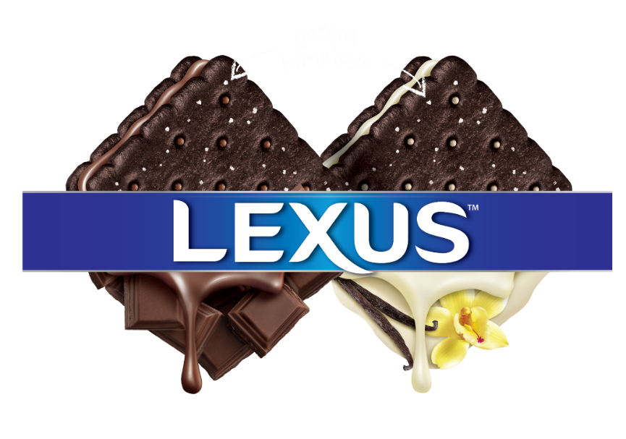

KUALA LUMPUR – This October family moments just got a whole lot sweeter with the introduction of yet another ingenious biscuit creation by Munchy’s LEXUS. Presenting a perfectly balanced taste of sweet and savoury with the new Munchy’s LEXUS Salted Sandwich; soon be a staple in every Malaysian home.

Recent food trends have seen the increasing popularity of creating delicacies that combine flavours not traditionally mixed together to create new taste profiles. Munchy’s LEXUS rose to the challenge of creating products that merges sweet and savoury: that perfect balance gives something pleasantly tasty.

Sweet and creamy on the inside or crunchy and salty on the outside, one can certainly have it all with the new Munchy’s LEXUS Salted Sandwich. The taste journey starts with a tasty chocolate biscuit topped with a dash of Himalayan salt. Biting through the crunchiness of the biscuit reveals a smooth creamy filling of chocolate or vanilla flavour giving a burst of sweetness. The carefully crafted recipe balances out the sweetness of each biscuit, pleasing different taste buds. This perfectly balanced combination of sweet and savoury truly makes the new Munchy’s LEXUS Salted Sandwich a unique experience with every bite delighting all taste sensations.

The Munchy’s LEXUS Salted Sandwich gives more delicious ways for families to create special moments together. Whether enjoyed at home, family picnics or taken for day-outs each individually packed biscuit unwraps is a special treat for everyone and a great way to connect with your loved ones.

Munchy’s LEXUS has been producing the nation’s well-loved biscuits since 1998. The new additions to the family, Munchy’s LEXUS Salted Vanilla Sandwich and Munchy’s LEXUS Salted Chocolate Sandwich are available in 190gm packs (containing 10 convenient sachets). They are sold at major hypermarkets, supermarkets and retail outlets nationwide at a recommended retail price of RM5.15 (WM) and RM5.45 (EM).

- End -

Note to Editors

About MUNCHY’S

MUNCHY’S, since its birth in 1991, is Malaysia’s No.1 homegrown biscuit brand* with a state-of-the-art manufacturing facility in Batu Pahat, Malaysia. MUNCHY’S brand name is present in all biscuit categories and has strong brand presence that caters for all consumer segments. In line with its mission to fill all kinds of fun-eating snacks in every home, MUNCHY’S products are available in most retail outlets in Malaysia and can be found in more than 50 countries globally. Its main products include MUNCHY’S Cream Crackers, LEXUS Sandwich Biscuits, Oat Krunch, MUZIC Wafer, CHOC-O and CAPTAIN MUNCH cookies.

Log on to www.facebook.com/munchys or website http://www.munchys.com for more information.

*Nielsen Retail Index Corporate Value Share, MAT July 2019.

