FOR IMMEDIATE RELEASE

For media enquiries, kindly contact
Elizabeth Harding | elizabeth@madhat.asia | +6012 220 5703

First Artbox in Malaysia wraps up with 349,000 in attendance over two weekends

KUALA LUMPUR – Artbox Malaysia has concluded its debut in Malaysia with two exciting weekends, attracting 349,000 visitors to the unique creative market at Sunway City Outdoor Open Air Carpark from 9-11 November and 16-18 November.

This very first Malaysian edition featured over 500 vendors across two weekends with some of the best retailers that Malaysia, Thailand and Singapore have to offer. Each weekend exhibited different styles and trends in fashion, accessories and artisanal novelties from streetwear by Pestle and Mortar to hand-painted bags by Thai retailer, Nokkajib.

Visitors also had the opportunity to take a bite into the various cuisines at Artbox Malaysia. Food lovers were able to experience delicious and unique treats such as rainbow cheese buns by PP Happy Cheese, black tea stinky tofu and neon-coloured beverages by Juicy Baby. Signature delights such as Thai iced milk tea and Singapore laksa by PGFN were also big hits with the crowd at Artbox Malaysia.

As an all-inclusive creative market, Artbox aspires to provide something for everyone to enjoy. One of their greatest attractions were the creative and Instagram-worthy art installations crafted on Artbox’s unique shipping containers with one of the containers being specially designed by students from Sunway University.

Artbox Malaysia also saw numerous up and coming musicians take centre stage to perform to crowds of people who captivatingly watched on and cheered throughout their performances. Local musicians such as DANI, Billie Blue and The Nowhere Men, Wanted Symphony and more set the mood with their serenades under the dazzling ambience of Artbox’s iconic fairy lights.

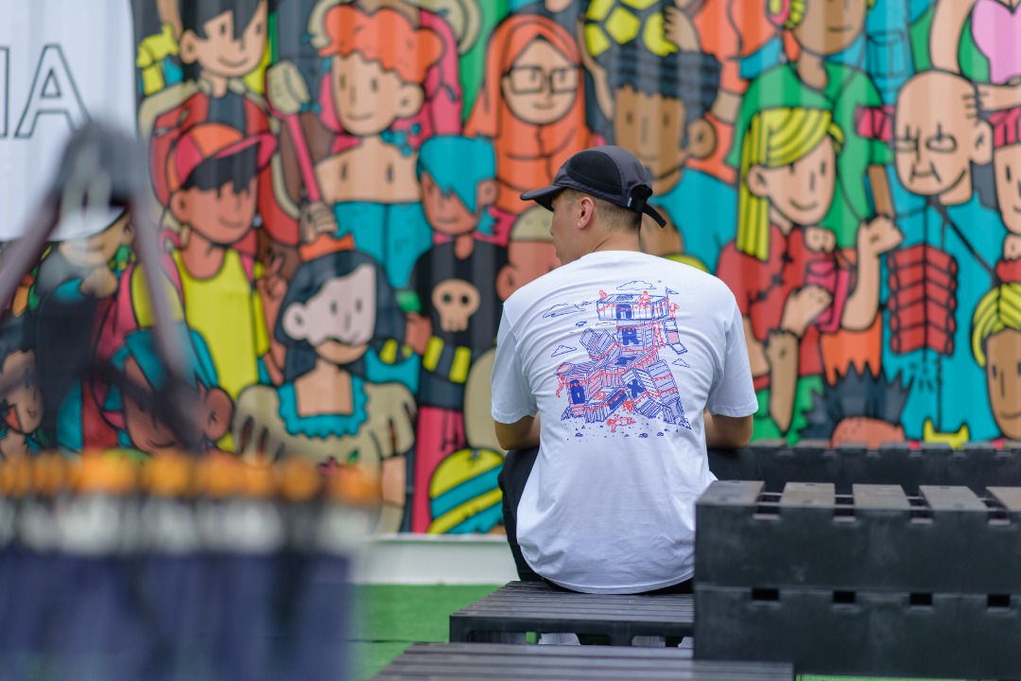  Exclusive designs by Pestle & Mortar clothing in collaboration with Artbox | Visitors were able to shop for all sorts of items from Artbox Malaysia’s vast range of retailers including clothing, accessories, handmade stationery and artisanal novelties.
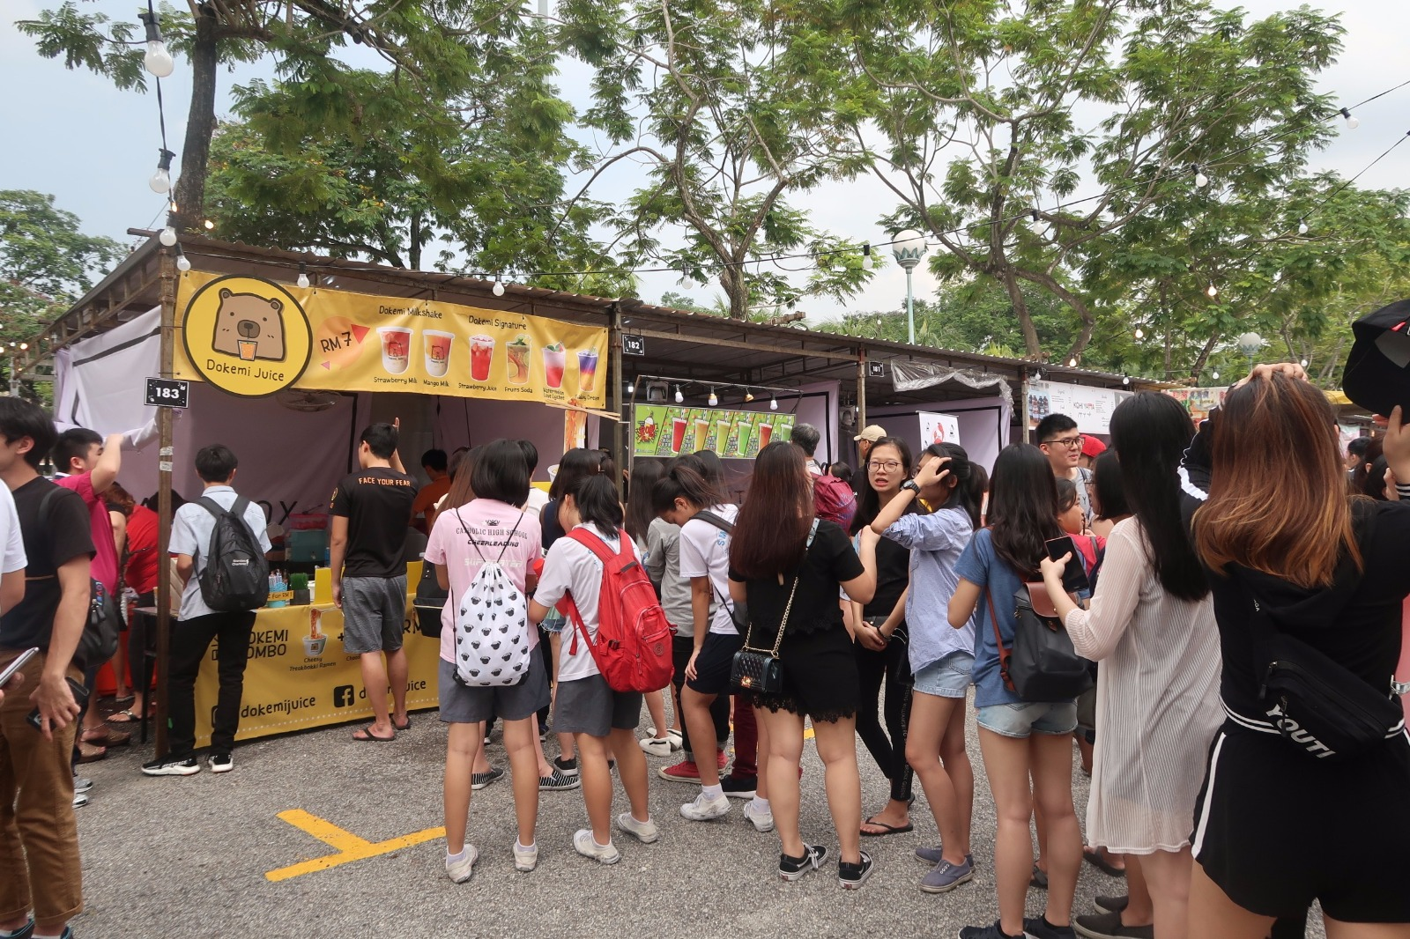  Visitors waiting in line for delicious juice and milkshakes by Dokemi Juice | Some of the most popular vendors were food and beverage stalls such as Sawa Tea Cup, Black Tea Stinky Tofu and Nachoslah.
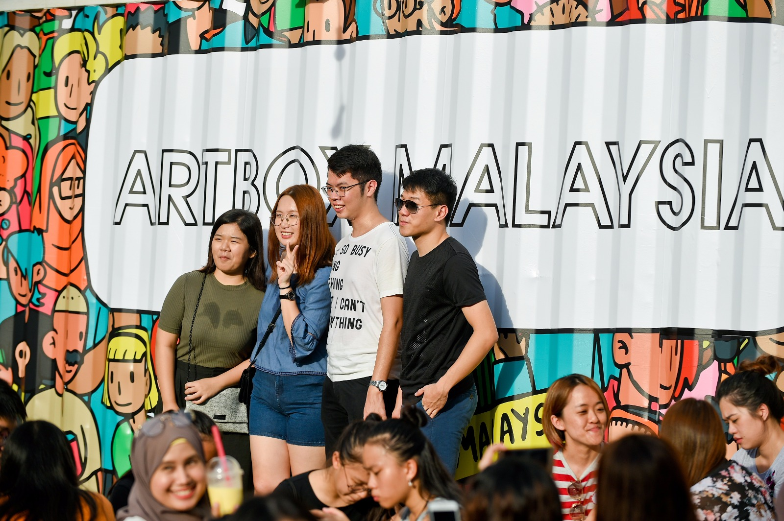  A container decorated in artwork by students of Sunway University. | Artbox is recognised internationally as a creative container market with its signature containers that surround the perimeters decked out in unique designs by local graffiti artists.
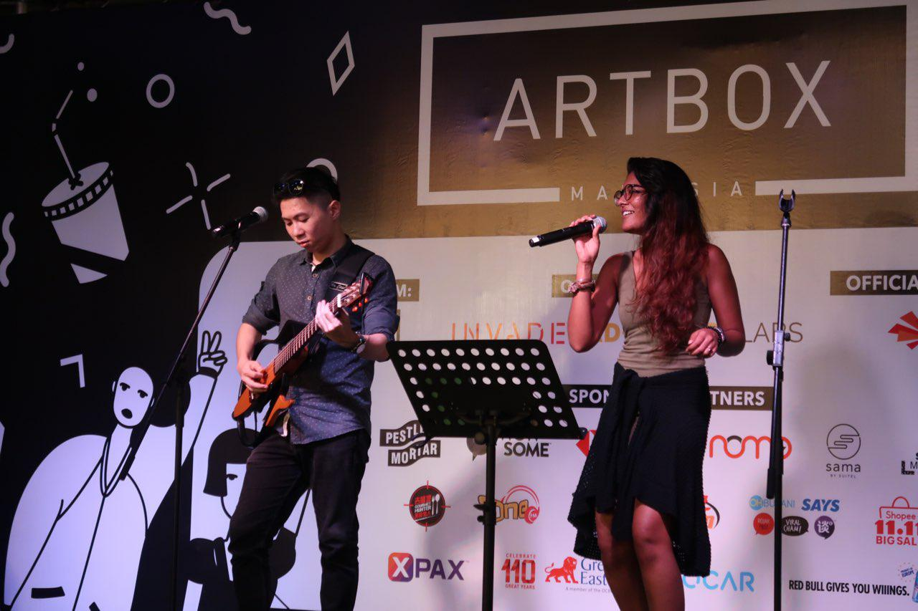  DANI took the stage on the last day of Artbox Malaysia and mesmerised the crowd with her powerful vocals. | Artbox Malaysia continuously aims to provide a platform for creative local talents including musicians and singers.
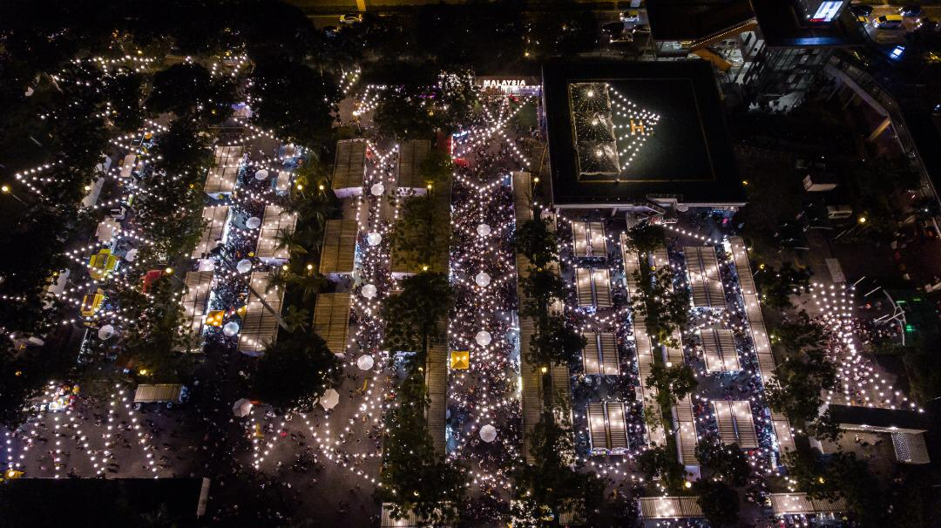  Top view of the entire layout of Artbox Malaysia. | Artbox Malaysia transforms from a day time event to a beautiful night market with its signature fairy lights that go on for 6km.

###

About Artbox
Originated from Bangkok, Artbox is recognised for its unique curation of local entrepreneurs and makers presented in a creative night market! Seeing that it was widely acclaimed regionally, Artbox ventured out beyond Bangkok and created a wave in the Singapore night market scene two years ago. Artbox Singapore, brought in by Invade, has become one of the most highly-anticipated event every year and this coming November, Artbox will be venturing to Malaysia!
Spanning across two weekends in November, munch on unique delicacies while being serenaded by music as you trail down the endless stretch of fairy lights! Capture magical moments with creative art installations and enjoy interactive elements that will intrigue all of your sense! Bring home one of a kind artisanal knick-knacks or deck up your wardrobe with quirky fashion! Artbox Malaysia promises an event to remember and definitely something that you would not want to miss!
Artbox Singapore 2018 drew 757,000 visitors over 6 days.
About Invade
Invade is a creative retail space activation and events management company founded in 2010. Known for its innovative retail concepts, Invade manages pop-up retail stores, runs some of the largest flea markets, and also operates a real-time retail booking system that allows businesses to rent and list spaces in an efficient manner in Singapore. Invade will also host the Artbox Asia tour, bringing the best of creative markets to the region with each city’s installation infused with the local flavour. Invade is part of iFashion, a leading venture platform company focused on investing and acquiring fashion and lifestyle e-commerce ventures based in Southeast Asia. For more details, please visit: http://invade.co.
About Ad-nology
A boutique marketing firm focused in strategic planning, ideation, creative execution and digital marketing with heavy focus on technology.
The Ad-nology family consist of three subsidiaries solely focused in revolutionizing the marketing and advertising strategies towards our forever generation. The vision of the group is to create a sustainable ecosystem for brands to harness when targeting the youth of tomorrow.

