Viu Reboots Iconic Malaysian Sitcom ‘Kopitiam’
Viu’s latest Original series, Kopitiam: Double Shot, showcases true Malaysian culture in 10 episodes of light-hearted comedy

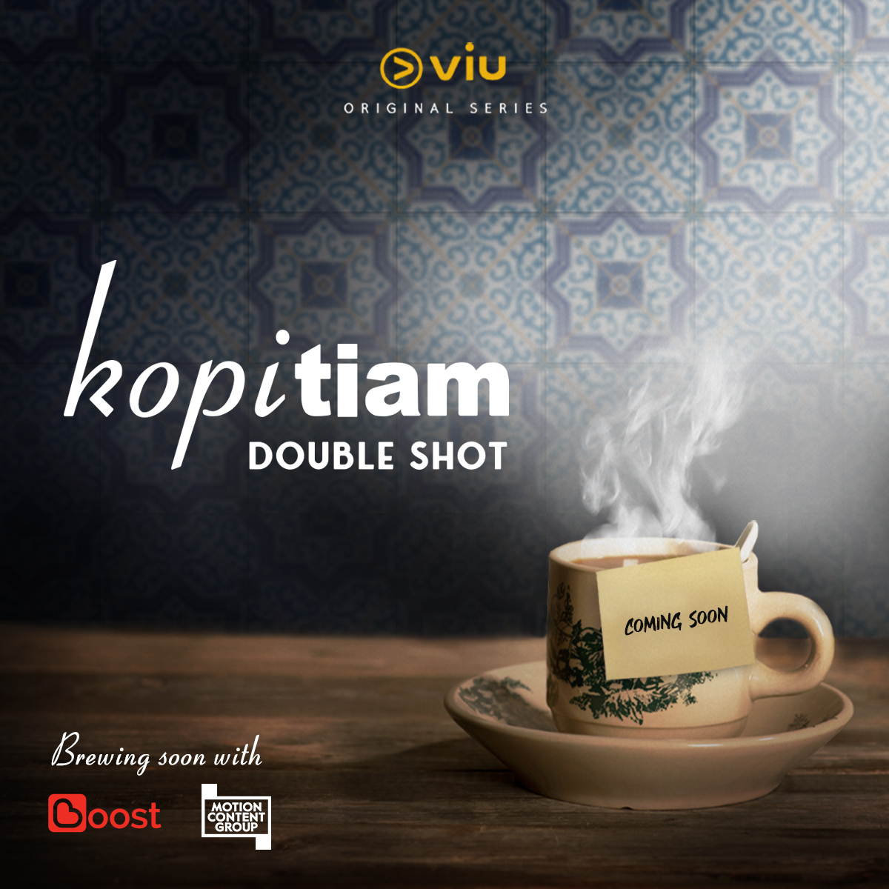

KUALA LUMPUR – Viu, a leading regional streaming service with 36 million monthly active users, brings back the classic Malaysian sitcom, Kopitiam, with a fresh twist. Rebooted as Kopitiam: Double Shot, the series is slated to air exclusively on Viu starting the end of November. The new version will star established actors and comedians such as Douglas Lim, Rashid Salleh and Sharifah Amani.

In this series directed by Imri Nasution, the Kopitiam once owned by Marie is now the property of a prematurely jaded Steven (played by Lim). Just as he plans to sell off the unloved business, a couple of regulars offer to take it over. Recently retrenched dreamer Alia (played by Amani), and her spacey but well-intentioned bestie, Seleb (played by Melissa Campbell). Together with a cute but awkward chef (played by Harvinth Skin), a know-it-all helper who refuses to be fired (played by Charles Roberts), and the world’s most improbable Hollywood star (with the role of Jo reprised by Rashid Salleh), the gang embark on all manner of (mis)adventures in their bid to bring the long-forgotten Kopitiam into the 21st century.

“We are extremely pleased and humbled to see our Malaysian audiences enthusiasm and adoption of our Viu Originals aired thus far. This inspires us in our journey to continue to strive harder and harder to bring exciting local stories that our audience can relate to and enjoy. Kopitiam was loved by many Malaysians and we realized the opportunity to present it to the newer generation who were not as aware of the iconic series. In a digitally native format and situations that resonate with them, we have decided to continue the show’s legacy!” said Kingsley Warner, General Manager of Vuclip Malaysia.
Malaysia’s first English-language series was released in 1998 and ran for 7 seasons - making Kopitiam the longest running Malaysian-English sitcom. The heartwarming and comical story of friendship, community and family set against a quintessentially Malaysian backdrop paved the way for a number of accolades, including a Best Sitcom win at the Asian Television Awards in 1998.

A truly Malaysian affair, Viu, has partnered with local e-wallet platform, Boost to revive the Kopitiam legacy with the all new Viu Original. Mohd Khairil Abdullah, Chief Executive Officer of Boost said, “As Malaysia’s leading lifestyle e-wallet, we are excited to partner Viu on a local production filled with nostalgia and one which Malaysians can welcome into their homes once again as well as on the go via the Viu app. As a proudly homegrown brand that understands what Malaysians love, Boost is delighted to be able to connect everyone to fun and engaging content accessible anytime, anywhere.”
Steven Murphy, Motion Content’s Managing Director of Asia Pacific said: “We are honoured to be working with Viu to support their efforts to create original Malaysian content and also producers, Double Vision. The classic comedy is remembered with such affection by audiences and we have no doubt this new version and perspective on Malaysian culture will be warmly received and excite viewers.”

Kopitiam: Double Shot is co-produced by Motion Content Group and Double Vision (DV), the latter being Viu’s longtime partner and the production house behind the original Kopitiam, shepherded by DV's Head of Production, Min Lim. The series commenced shoot in September and is set to air on 28 November 2019, with 2 back-to-back episodes out every Thursday. Kopitiam: Double Shot will be available exclusively across Viu’s 17 markets spanning Asia, Middle East and Africa. Viu-ers can watch the series on the Viu app, available for free on the App Store or Google Play Store.

###

About Viu

Viu is a leading entertainment streaming service, operated by PCCW Media Group, available in 17 markets including Hong Kong, Singapore, Malaysia, India, Indonesia, the Philippines, Thailand, Myanmar, South Africa and Middle East countries of UAE, Saudi Arabia, Egypt, Bahrain, Iraq, Jordan, Kuwait, Oman, Qatar. Viu’s unique value proposition of fresh and localized regional and local premium TV shows, movies and originals entertains millions of consumers every day. Viu Originals bring to light compelling stories with world class production quality, also providing the opportunity for local talent to showcase their skills on a world stage. The service can be accessed via the Viu app available for free on the App Store and Google Play, on connected devices such as smartphones and tablets, as well as on the web at www.viu.com.

About Boost
Boost is a homegrown lifestyle e-wallet that simplifies the way consumers transact daily. Combining lifestyle features and cutting-edge technology, Boost makes transactions easier, faster, secure and rewarding for users. Boost allows its 4.7 million users to pay via their smartphones at over 113,000 participating locations without the hassle of using physical cash or cards.
Key features within the Boost app include, instant rewards through our signature “Shake”; buying prepaid and mobile game top-ups; online shopping; paying utility bills; paying for gated and on-street parking in select areas; booking local and outstation public transport; booking cinema tickets and holiday packages; getting roadside assistance; buying and gifting digital vouchers; food delivery and restaurant bookings; as well as money transfers and cashless donations to charities.
Download Boost from Google Play Store or Apple App Store. For more information, visit https://www.myboost.com.my/ or follow Boost on Facebook (https://www.facebook.com/myboostapp/) and Instagram (https://www.instagram.com/myboostapp/).

About Motion Content Group
Motion Content Group is a global content investment and rights management company. It invests and partners with the world’s leading talent, producers and distributors to fund, develop, produce and distribute premium content. Motion supports editorially and commercially vibrant networks and platforms by helping meet the ever-increasing demand for premium content, for the benefit of advertisers and its content partners.
Headquartered in London and Los Angeles, Motion currently operates in 27 countries worldwide and has a broad range of award-winning programming distributed globally. Motion Content Group is part of GroupM, the world’s leading full-service media investment management operation, a WPP company.
Follow Motion on Twitter here: @motion_content and Instagram @MotionContentGroup

