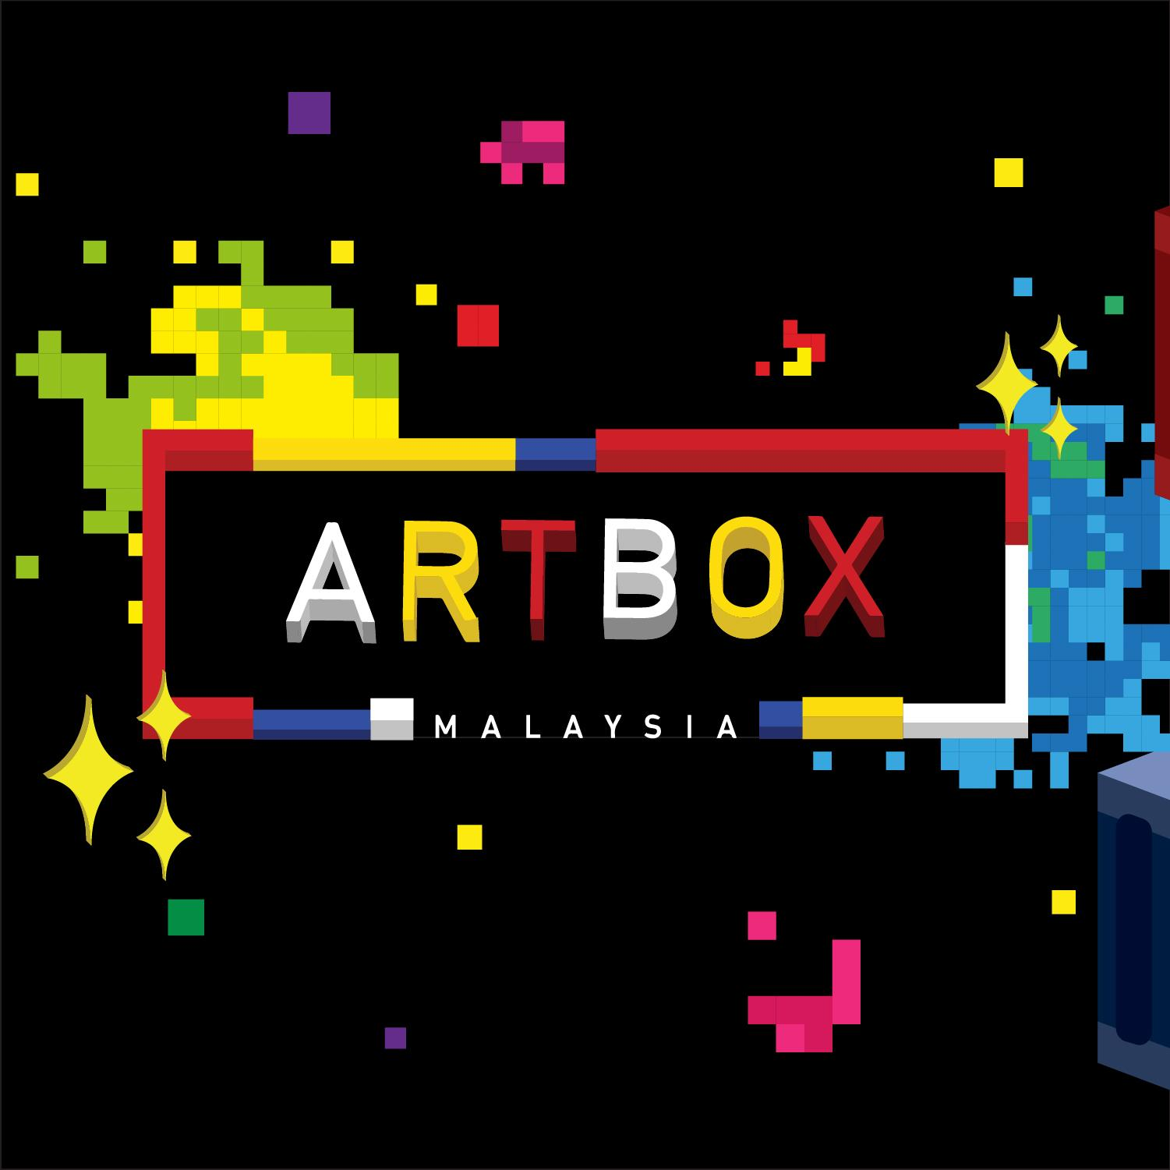

FOR IMMEDIATE RELEASE

Artbox Malaysia 2019: Assemble
Southeast Asia’s most popular creative market returns to Malaysia this
September 2019

KUALA LUMPUR, 27 June 2019 - Artbox, the much anticipated creative market, is back in Malaysia for the second year in a row from 6 -8 and 13-15 September 2019 at Sunway City Kuala Lumpur, Outdoor Open Air Carpark.

Inspired by nostalgic childhood games such as Tetris and Jenga, Artbox Malaysia is levelling up for its second edition, with its signature containers being stacked and arranged to form captivating structures surrounding the vicinity. With this year’s edition themed Artbox Malaysia: Assemble, the creative market will once again piece together unique and creative retailers, food and beverage vendors, musicians and artists from around the region to form a holistic, one-of-a-kind curated experience.

With plans to be bigger and better than its predecessors, Artbox Malaysia: Assemble will be assembling a creative force unlike any other with more pop-up stores from the region while allowing customers to immerse themselves in thrilling experiential activities, games and art installations. The market will also be filled with endless aisles of attractive fashion and lifestyle retailers with their own unique range of curated and artisanal goods.

Artbox Malaysia: Assemble is also set to showcase a range of over 300 booths from local and regional food and beverage vendors from that will excite your taste buds. In true Artbox flair, visitors will be also able to lounge and unwind to the serenade of local performers throughout the night. Artbox Malaysia; Assemble is set to be an extraordinary experience for all guests to explore and indulge in.
“We are all set to make Artbox Malaysia even more memorable than last year. We hope visitors from all walks of life from Malaysia will be intrigued and entertained with Artbox’s unique installations and immersive experiences. Artbox Malaysia will be filled with countless exclusive activities, games and art installations from local artists that we know will be exceptional. Back by popular demand, Artbox Malaysia 2019 will be marked as an experience like no other.” said Kent Teo, founder and Chief Executive Officer of Invade Industry Singapore.

Make sure you’re not missing out by following Artbox’s social channels for all announcements regarding their vendors and lineup!

Instagram: https://www.instagram.com/artbox_my/
Facebook: https://www.facebook.com/malaysia.artbox/
Website: https://www.artbox.my/

#ARTBOXASSEMBLE
#ARTBOXMY2019

-ENDS-

For further information, please do not hesitate to contact:
Nicole Aldeth Main Elizabeth Kate Harding
Mad Hat PR Mad Hat PR
T: +6012 5670129 T: +6012 2205703
E: nicole@madhat.asia E: elizabeth@madhat.asia

About Artbox
Artbox is recognised for its unique curation of local entrepreneurs and creative retailers presented in a creative night market! Artbox Malaysia, brought in by Invade has become one of the most highly-anticipated experiences with the first year bringing in more than 350,000 visitors. Artbox Malaysia created numerous magical moments last year and will be back again for two weekends in September.

The second Malaysian edition, themed Artbox Malaysia: Assemble, will capture stunning moments with creative art installations and interactive elements that will intrigue all your senses. Artbox Malaysia: Assemble aims to be bigger and better than everything you’ve ever imagined and creating an artistic force unlike any other. Artbox Malaysia: Assemble will feature unique retailers, tantalising meals and fascinating art installations in a space that pushes the boundaries of creativity.
Artbox Malaysia: Assemble is an event not to be missed!
About Invade
Invade is a creative retail space activation and events management company founded in 2010. Known for its innovative retail concepts, Invade manages pop-up retail stores, runs some of the largest creative markets, and also operates a real-time retail booking system that allows businesses to rent and list spaces in an efficient manner in Singapore. Invade will also host the Artbox Asia tour, bringing the best of creative markets to the region with each city’s installation infused with the local flavour. For more details, please visit http://invade.co.
About Ad-nology
Ad-nology is a boutique marketing agency who focuses on innovation and creativity. Ad-nology is build by the forever generation, for the forever generation. Working towards uncharted territory, ad-nology creates live experiences that has never been done before and to create unique and memorable events.
Discovering uncharted grounds . For more info visit us at https://ad-nology.com

