FOR IMMEDIATE RELEASE

For more information, interviews, and media enquiries, kindly contact
Priyanka | priyanka@madhat.asia | 017 249 9507
Hui Shan | huishan@madhat.asia | 012 295 1732

The Fairytale Insta-Worthy Ice-Cream Finally Hits Malaysia
Cornetto debuts Unicornetto in Malaysia this February 2019

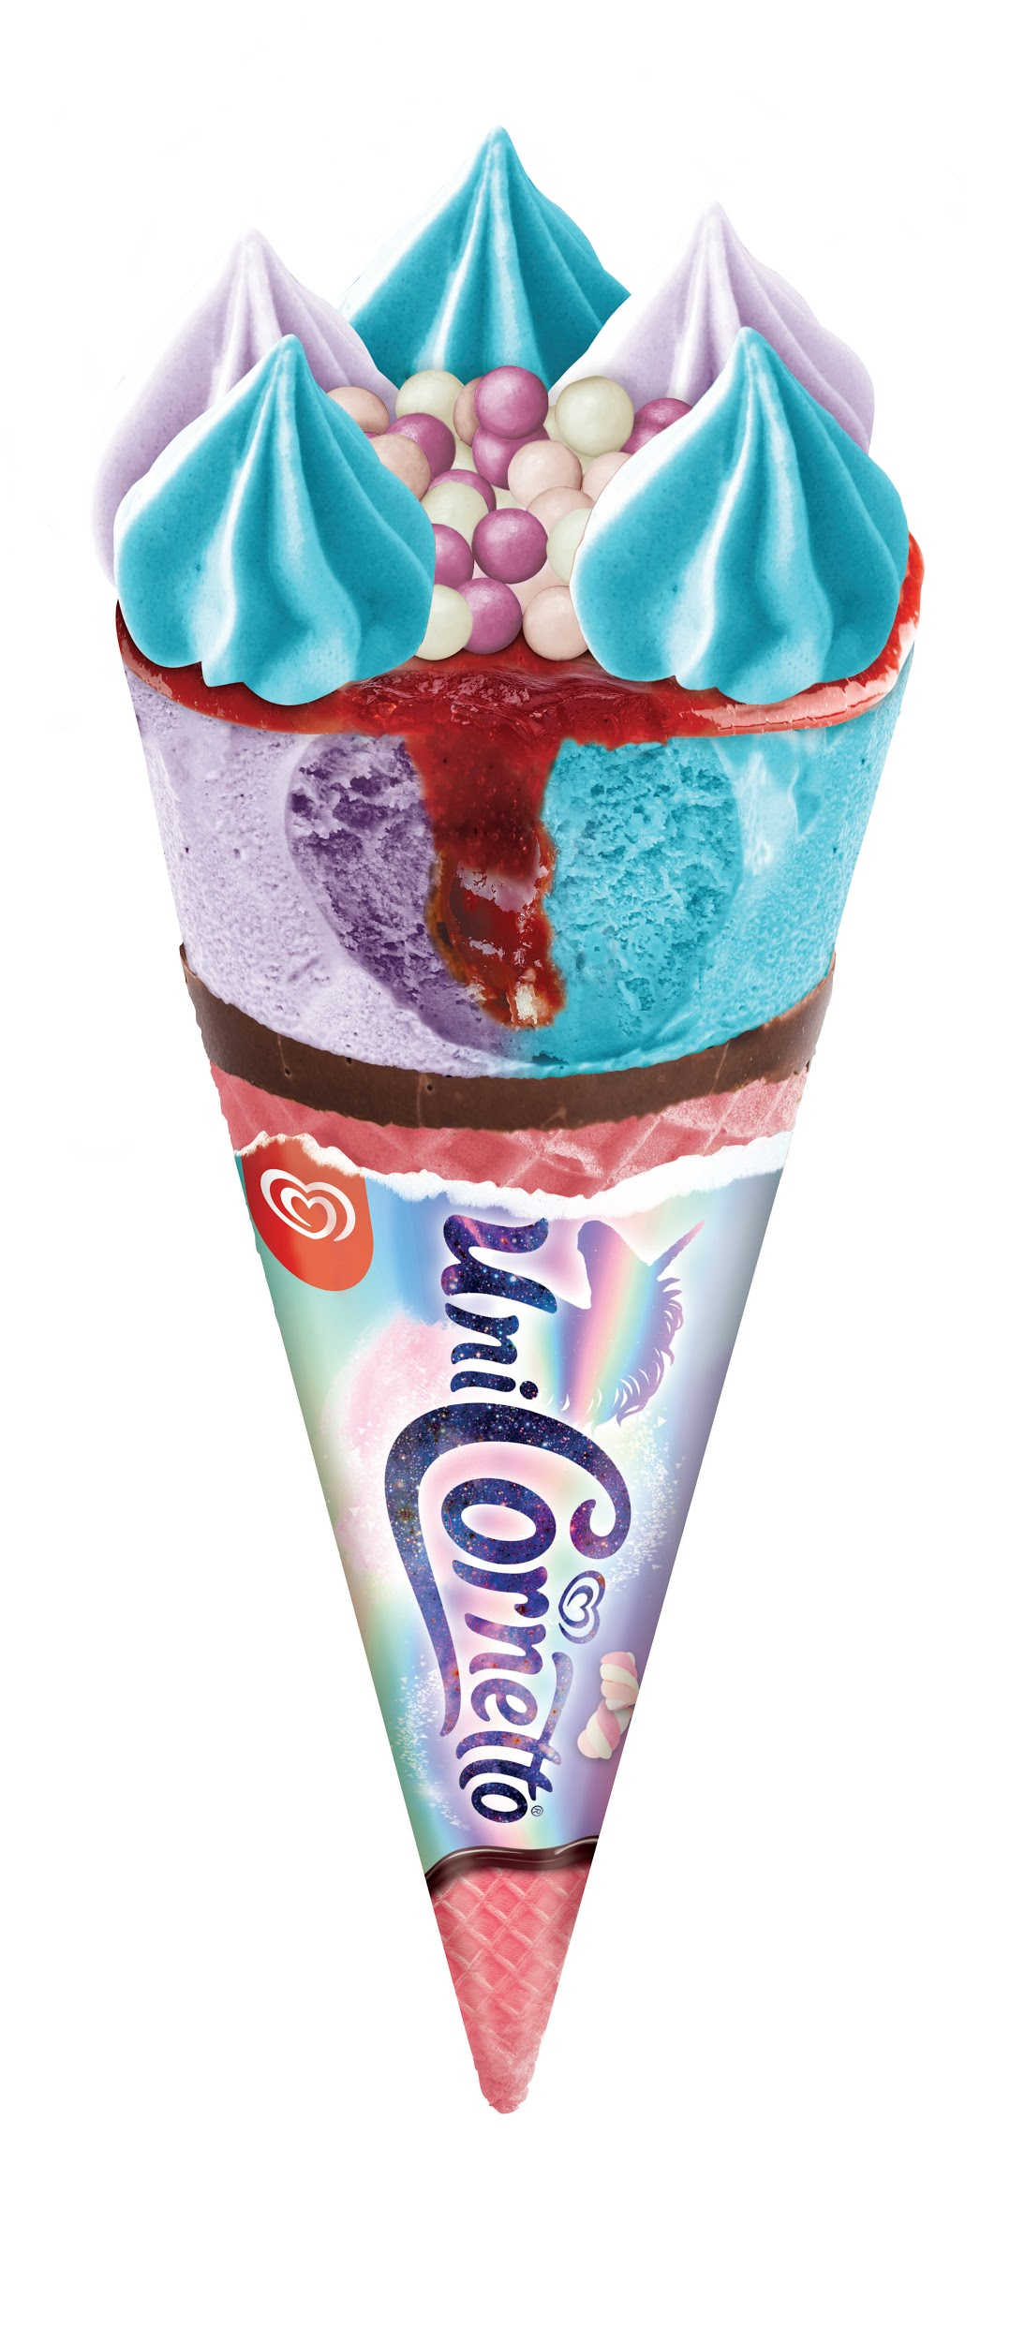

Kuala Lumpur, 18 February 2019 - An ethereal delight is the perfect start to brighten 2019. Debuting a unicorn inspired snack, Cornetto is introducing its first cotton candy and marshmallow flavour ice-cream this February making Malaysia the 3rd country to distribute the exclusive flavour globally.

“We’re always looking to our consumers for inspiration when creating our next flavour. Everything our fans share online and tag us, we take notice of it. Their interests and feedback are always taken into consideration when the brand begins its next ice-cream innovation idea.”, Shiv Sahgal, Marketing Director Foods & Refreshments category, Unilever Malaysia.

Packaged in a holographic wrap, Unicornetto pairs tangy Strawberry sauce, creamy Cotton Candy and Marshmallow flavoured ice-cream making it a cool balance between its tangy and sweet flavours. It is topped with crispy tri-coloured chocolate covered rice balls for that added crunchy delight.

Valued at RM 3.00 and available in nationwide, Unicornetto is set to be 2019’s ultimate pick-me-up snack.

To commemorate the launch, Cornetto will be running an Instagram contest whereby fans will be encouraged to upload a picture of Unicornetto with a creative caption with the hashtag #MYUnicornetto based on the bi-weekly themes and they will have the chance to win an all expense paid trip for 2 to the Unicorn Island in Philippines. Contest ends on 28th April 2019.

“Inspired by the popular trends we’ve seen over the last couple of years, we thought what better way than to treat our consumers to a delicious, cool delight that not only tastes good but looks great too.”, added Shiv Sahgal, Marketing Director Foods & Refreshments category, Unilever Malaysia.

Cornetto will also be collaborating with GRAB Malaysia to reward their fans with special magical unicorn gifts. 50 GRAB cars will be designed in the theme of a unicorn and drive around the Klang Valley area. When spotted, fans will be encouraged to take a picture of the GRAB car and upload it on Instagram with the hashtag #MYUnicornetto and #GrabAUnicornetto to win the exclusive unicorn prizes. Contest ends on 17th March 2019.

Visit this Cornetto’s Facebook at https://www.facebook.com/CornettoMalaysia/ for more information on the nation’s newest must-have delight.

-End-

About CORNETTO®
Originated in Italy in 1959, Cornetto celebrate its 60th anniversary this year. Known and loved for its creamy and crunchy combination, Cornetto has always been an advocate for love and connections. We help making a conversation a little easier by sharing Cornetto cones.

