FOR IMMEDIATE RELEASE

HIGH-OCTANE EXPERIENCE AWAITS AS IT’S THE SHIP ANNOUNCES
ECLECTIC LINEUP OF HEADLINERS AND ARTISTES FOR 2019
Asia’s Largest Festival at Sea stars headliners Nervo, Quintino, Darren Styles,
Sam Feldt, Ben Nicky, Ookay, What So Not and more

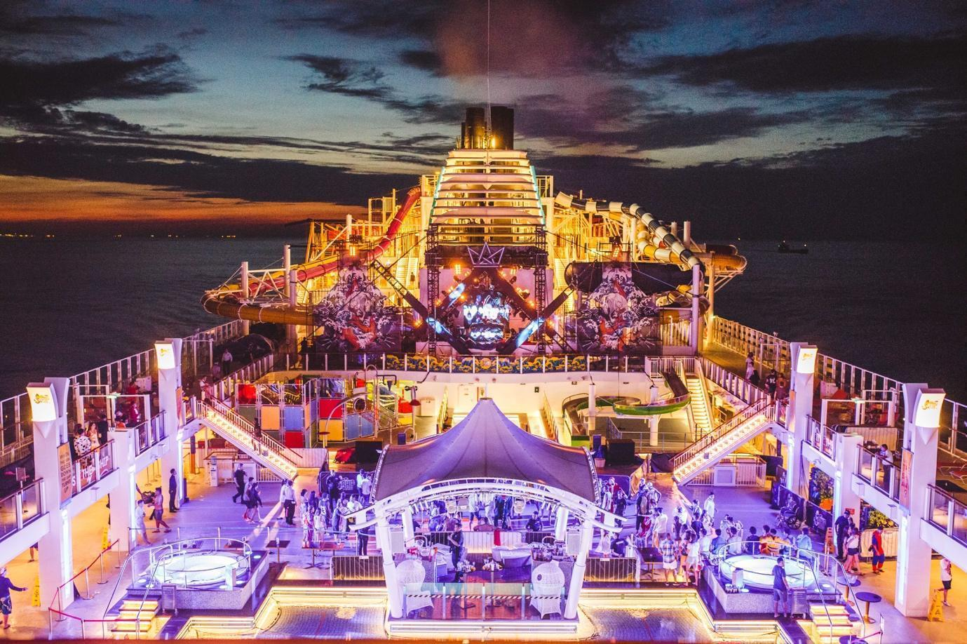

Singapore, 8 August 2019 – Taking the open waters by storm from 13th to 15th November, the sixth rendition of IT’S THE SHIP announces its electrifying roster of widely-acclaimed headliners and talented music artistes.

Featuring an impressive lineup of artists, IT’S THE SHIP's high-octane, uninterrupted 3D2N experience onboard the award-winning Genting Dream brings to attention EDM bigwigs Nervo and Quintino, crowd-favourite hardstyle DJ Darren Styles, electronica bass masters Ookay and What So Not, tropical house DJ Sam Feldt and award-winning Trance DJ Ben Nicky.

IT’S THE SHIP’s larger-than-life acts will see electronic dance music duo, Nervo who have been voted DJ Mag’s Top 100 DJs 2since 2012 and are currently the highest rated women DJs in the world, return to rule the dance decks, alongside with modern UK dance music legend, Darren Styles who is known for blazing the path for hardstyle crossover to mainstream. The epically talented Dutch DJ, Quintino who currently ranked #25 on DJ Mag’s Top 100 DJs list, is also set to bring his signature sound and infectious energy onboard this year’s 6th festival edition.

Shipmates can also expect an experience like never before as the tropical house hitmaker Sam Feldt set to bring his world renowned signature Heartfeldt Pool Party onboard to pump the crowd with his unique summer sounds.

Joining the world-class ensemble is newly-crowned “Best Trance DJ” Ben Nicky whose unstoppable tracks regularly hit number 1 on the charts and radio stations all over the world, trap maestro Ookay whose Billboard hit Thief took the world by storm and the electronic dance producer What So Not who constantly pushes the envelope with his boundary-pushing bass that revived electronic scene in his native Down Under.

Not to be missed is the newly added FYRE FAN CLUB theme party with hip hop acts amping up the stage featuring Singapore’s own viral rap sensations Fariz Jabba and Yung Raja, along with Malaysia’s rap icon Joe Flizzow. Urban fanatics can fuel up on the trap, hip hop, and bass with Malaysian DJs Jhin and NAHSYK along with a soon to be announced “Special Guest”.

In addition to this star-studded lineup, dance-ready shipmates can also look forward to busting out their moves to the EDM beats of Brooklyn, Indigo Starlight, Kate Fox, Tenzin, The Him, and Zonderling.

IT’S THE SHIP also shines the spotlight on the Asian hardstyle and hip hop pioneers with Asia's premier euphoric hardstyle artist Theo Gobensen from Singapore, blazing duo Bass Agents of Malaysia, and Australian breakout hard dance star DNA.

Electronic music lovers can immerse themselves in uplifting electro and deep house beats as IT’S THE SHIP brings Dannic, Eli Brown, Matisse & Sadko, Kill The Buzz, Lucille Croft, and Ruby Phoenix while trance diehards can get mesmerised by the anthemic rhythms of Alex M.O.R.P.H. and Jordan Suckley.

Full list of artists appended below:

FULL ARTIST LINEUP

HEADLINERS:
- BEN NICKY (UK)
- DARREN STYLES (UK)
- NERVO (AU)
- OOKAY (US)
- QUINTINO (NLD)
- WHAT SO NOT (AU)

HEARTFELDT POOL PARTY:
- SAM FELDT (NLD)
- THE HIM (NLD)
- ZONDERLING (NLD)

INTERNATIONALS:
- ALEX M.O.R.P.H. (GER)
- DANNIC (NLD)
- ELI BROWN (UK)
- HYO (KR)
- JORDAN SUCKLEY (UK)
- KILL THE BUZZ (NLD)
- MATISSE & SADKO (RU)
- MERCER (FR)

SUPPORTED BY:
- ACE RAMOS & MC PAO (PH)
- AXEL GROOVE (MY)
- AZRAN (MY)
- BASS AGENTS (MY)
- BROOKLYN (AU)
- CALVIN ALLAN CLARKE (UK)
- DJ HAPA BOY (US)
- DJ MACHU (MY)
- DNA (AU)
- DON’T DIE BEFORE (TH)
- DOUBLE NOIZE (VN)
- D.A (VN)
- EJ MISSY (SG)
- EKO (SG)
- FARID (FRA)
- FARIZ JABBA (SG)
- HIGH CELLS (VN)
- INDIGO STARLIGHT (AU)
- IRWAN + RICO GREENE (NLD)
- ION (US)
- JHIN (MY)
- JOE FLIZZOW (MY)
- K FAITH (SG)
- KAKU (TW)
- KANA (AU/ID)
- KATE FOX (AU)
- KENNETH FRANCIS (SG)
- KS (VN)
- LONDONBRIDGE (US)
- LUCILLE CROFT (AU)
- MAYO (ID)
- NAHSYK (MY)
- NAZKIMO (MY)
- NITTI GRITTI (US)
- ONI - WAN (US)
- RAVE REPUBLIC (SG)
- RICHI (ID)
- RUBY PHOENIX (AU)
- SANTAROENA (MY)
- SEXY SAX MAN (US)
- SIVANESH (SG)
- SUREN (SG)
- SVTO + AD-RYAN (US)
- TENZIN (AU)
- THEO GOBENSEN (SG/CHE)
- VALY MO (FRA)
- YUNG RAJA (SG)
- YUSEF KIFAH (MY)
- ZUSHAN (SG)

IT’S THE SHIP 2019 is set to present its famed array of entertainment experiences. A slate of secret and closed-door events as well as interactive performances will be unveiled later this year but meanwhile, shipmates can expect novel themed pop-up parties such as the Communion Sunrise, Sleepless Society: One Hell of A Party, ONESIE, LET'S KARNAVAL: FOAMO and FYRE FAN CLUB. During this 3D2N shipcation, there will be ample opportunities for shipmates to rub shoulders with their favourite artistes at the various pop-up parties and side activities.

With its venue being none other than the Genting Dream, IT’S THE SHIP offers a 5-star resort at sea experience as well as a multitude of recreational options including six water slides, glow bowling alley, rope obstacle course, mini golf course, rock climbing wall, and zip-line above the ocean.

Early Duck 3 cabins are still available until mid-August, offering shipmates an amazing saving offer of up to USD249 off per person. Cabin prices are inclusive of complimentary dining at selected restaurants, selected non-alcoholic beverages and free access to most of the ship’s facilities and events. Don’t miss out on this promotion by purchasing your Early Duck 3 cabin now at www.galactix.asia/itstheship-2019.

So lift the anchors and get ready to set off on this year's highly-anticipated voyage as Asia’s Largest Festival at Sea brings shipmates on another stellar edition of IT'S THE SHIP!

Click here to watch the artist lineup reveal - https://youtu.be/VibWN1K_bn8

https://www.facebook.com/itstheship/
https://www.instagram.com/itstheship/
https://twitter.com/itstheshipasia/

IT'S THE SHIP 2019 DETAILS

Dates: 13 November 2019 to 15 November 2019
Starting Point: Marina Bay Cruise Centre, 61 Marina Coastal Drive, Singapore 018947
Ending Point: Marina Bay Cruise Centre, 61 Marina Coastal Drive, Singapore 018947
Stopovers: None
Early Duck 3 Prices: USD$471++ to USD $2,370++ per shipmate

FOR MORE INFORMATION AND TO PURCHASE CABINS, LOG ON TO www.itstheship.com

#ITSTHESHIP #ITSSG19

#

ABOUT IT'S THE SHIP
Since its inception in 2014, the IT’S THE SHIP brand has grown to become Asia’s largest festival at sea with the highest representation of shipmates from over 88 countries around the world. What some may consider as a once-in-a-lifetime experience, others consider as an annual milestone event – offering shipmates with a variety of fun activities, themed parties, and non-stop music – all on international waters. Previous sailings have seen popular artistes Lil Jon, Knife Party, Yellow Claw, Higher Brothers, and Dash Berlin hyping up the crowd, with 2019 being no exception. This year will mark the epic shipcation’s sixth embarkation with multiple sailings planned to take place within different regions.

ABOUT LIVESCAPE GROUP
The Livescape Group is Southeast Asia's largest award-winning entertainment and creative agency. Offering in-house marketing, creative design, event production, logistics management, and artist management and booking, The Livescape Group has successfully created and managed world class events including IT’S THE SHIP, Rockaway Festival, Armin Only Embrace, and After Dark Social Club (ADSC). Its 360-degree approach to event management has driven them to be the go-to event agency for the best-known brands on the planet. The Livescape Group currently has offices based in Malaysia, Singapore, and Jakarta.

OFFICIAL PARTNERS
TItle Presenter - Brewed by LEO Beer
Official Whisky - Auchentoshan
Official Bourbon - Jim Beam
Official Gin - Roku Gin
Official Vodka - HAKU Vodka
Official Tequila - Sauza Tequila
Official Ready To Drink - Horoyoi
Official Energy Drink - RedBull
Official Partner - NERF
Official Beverage - Pepsi Black
Official Flip Flops - Havaianas
Official Shoe Care - ShoeMo
Official Portable Speaker - SoundStream
Official Headwear - NEW ERA
Official Merchandise Partner - Pestle & Mortar
Official Pleasure Partner - ONE Condoms
Official Experience Partner - ALTRXEGO
Official Fitness Partner - TRIBE
Official Ticketing - Galactix

OFFICIAL MEDIA PARTNERS
T.H.E Music Essentials
EDM Addicts
MTV
World of Buzz

For media enquiries and interview opportunities, please contact W Communications at:

Joel Tan
Account Manager
E: joelt@wcommunications.sg
M: +65 9177 2510

Laura Goh
Account Executive
E: goh.laura@wcommunications.sg
M: +65 9386 0027

END

