
Discovery Channel (Astro Channel 561)

Ed Stafford: Man Woman Child Wild
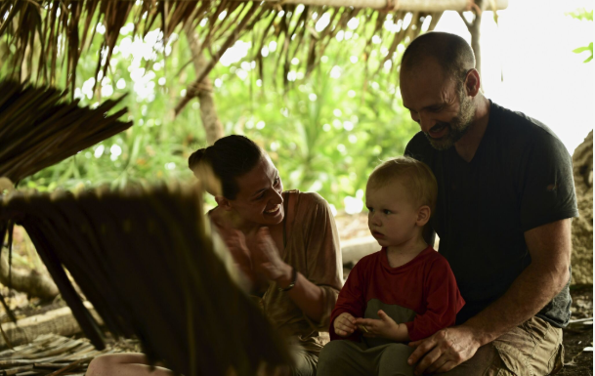
*Image is attached to this email*

This one-off special sees explorer Ed Stafford living marooned with his wife, Laura, and toddler on a remote, uninhabited island in Indonesia. Laura is herself an adventurer and led an all-female expedition down one of the longest rivers in Guyana, and the two will test their survival skills and ability to live away from the comforts of civilization.

Premiere Date: Tuesday, 5 November 2019
Time: 8.00pm (MY)
Episodes: 1 x 60 mins

Mummies Unwrapped

*Image is attached to this email*

In this all-new, ground-breaking series, MUMMIES UNWRAPPED, host and acclaimed Egyptologist Ramy Romany expertly guide viewers around the world as he investigates the spellbinding secrets of the most fascinating burial sites, mass graves and ancient tombs on Earth. With the help of emerging, cutting-edge technologies, MUMMIES UNWRAPPED introduces new theories about how ancient civilizations once lived and died, and shines a light on what, if any, mystical forces or supernatural phenomena may be at work.

Premiere Date: Tuesday,19 November 2019
Time: 9.50 pm (MY)
Episodes: 8 x 60 mins

---



Animal Planet (Astro Channel 556)

How Do Animal Do THat S1B
*Image is attached to this email*

Animals do the most incredible things. They have superpowers humans can only dream of. On How Do Animals Do That? new science and amazing demonstrations reveal the secrets of the animal world.

Premiere Date: Wednesday,13 November 2019
Time: 8.00 pm (MY)
Episodes: 20 x 30 mins

I Was Prey S3
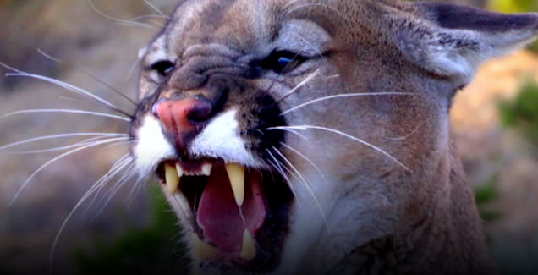
*Image is attached to this email*

I Was Prey recounts the hauntingly true stories of people who found themselves in a life or death situation, face-to-face with a dangerous animal.
Premiere Date: Monday,18 November 2019
Time: 8.55 pm (MY)
Episodes: 9 x 60 mins

Just Animal

*Image is attached to this email*

A spectacular celebration of the world's wildlife. In this engaging series of documentaries, favorite creatures have been singled out and showered with attention, having a full episode dedicated to each. Every fascinating aspect of their lives is delved into physical attributes, sensory perceptions, communication skills, plus extraordinary behaviors and ingenious adaptations. Tour the globe and be intrigued, surprised and enthralled by the visual feast that is JUST ANIMALS.
Premiere Date: Tuesday,5 November 2019
Time: 8.00 pm (MY)
Episodes: 10 x 60 mins

---



HGTV (Astro Channel 731)

Unspouse My House S1

*Image is attached to this email*

Designer and self-proclaimed breakup expert Orlando Soria, known for his celebrity clients and his passionate fan base on Instagram, works with newly single clients to overhaul their homes and heal their lonely hearts.

Premiere Date: Monday,11 November 2019
Time: 8.00 pm (MY)
Episodes: 6 x 30 mins

Flip Or Flop Nashville S2

*Image is attached to this email*

Former NFL defensive back DeRon Jenkins and real estate agent Page Turner work together taking advantage of the city's booming housing market and older houses that need renovation. The business partners, who find depressed properties in Nashville and transform them into stylish and functional family homes.

Premiere Date: Monday,11 November 2019
Time: 8.00 pm (MY)
Episodes: 12 x 30 mins

My Lottery Dream House S6

*Image is attached to this email*

Armed with overflowing bank accounts and dreams of living in mansions bigger than city blocks, recent lottery winners embark on searches for their new homes. Host David Bromstad shows overnight millionaires three luxurious properties on each episode. After visiting seven-figure listings, 10-acre properties, and nine-bedroom mansions, the big winners' ultimate, life-changing decisions mean an upgrade from average digs to high-dollar properties.

Premiere Date: Wednesday, 20 November 2019
Time: 8.00 pm (MY)
Episodes: 14 x 30 mins

---



TLC(Astro Channel 707)

Bizarre Foods: Delicious Destination S8

*Image is attached to this email*

Andrew Zimmern's culinary curiosity knows no bounds. From melt-in-your-mouth chocolate in Zurich to decadent gelato in Florence, savory paella in Barcelona to creamy clam chowder in Boston, Zimmern samples quintessential, "to die for" delicacies that define iconic cities. Each half-hour episode focuses on one destination's classic foods -- where they came from, how they are prepared, and the right way to eat them.

Premiere Date: Tuesday, 12 November 2019
Time: 8.00 pm (MY)
Episodes: 24 x 30 mins

sMothered

*Image is attached to this email*

If you thought you knew what the phrase "Like Mother, Like Daughter" meant, just wait until TLC's new family series sMothered, which follows four outrageous mother/daughter duos who take their bonds to the extreme!

Premiere Date: Monday, 25 November 2019
Time: 7.05 pm (MY)
Episodes: 8 x 60 mins

90 Day Fiance: The Other Way

*Image is attached to this email*

Americans move to a foreign country all in the name of love. Will uprooting their lives in the United States pay off, or will they be packing up and moving back to America brokenhearted?

Premiere Date: Friday, 29 November 2019
Time: 8.55 pm (MY)
Episodes: 19 x 60 mins

---

