FOR IMMEDIATE RELEASE
10 October 2019

For media enquiries, kindly contact
Vanesa Paxton | vanesa@madhat.asia | 016 342 5957
Sarah Miranda James | sarah@madhat.asia | 012 246 1506

The Cooler Lumpur Festival 2019 celebrated #SuperCanggih people

Southeast Asia’s first and only festival of ideas The Cooler Lumpur Festival returned for its seventh year from 30 September to 6 October 2019 at its home ground Publika. This year, the festival took on a theme that aimed to celebrate those amongst us who do their part in combating the major concerns of our time - recognising these everyday heroes as #SuperCanggih.

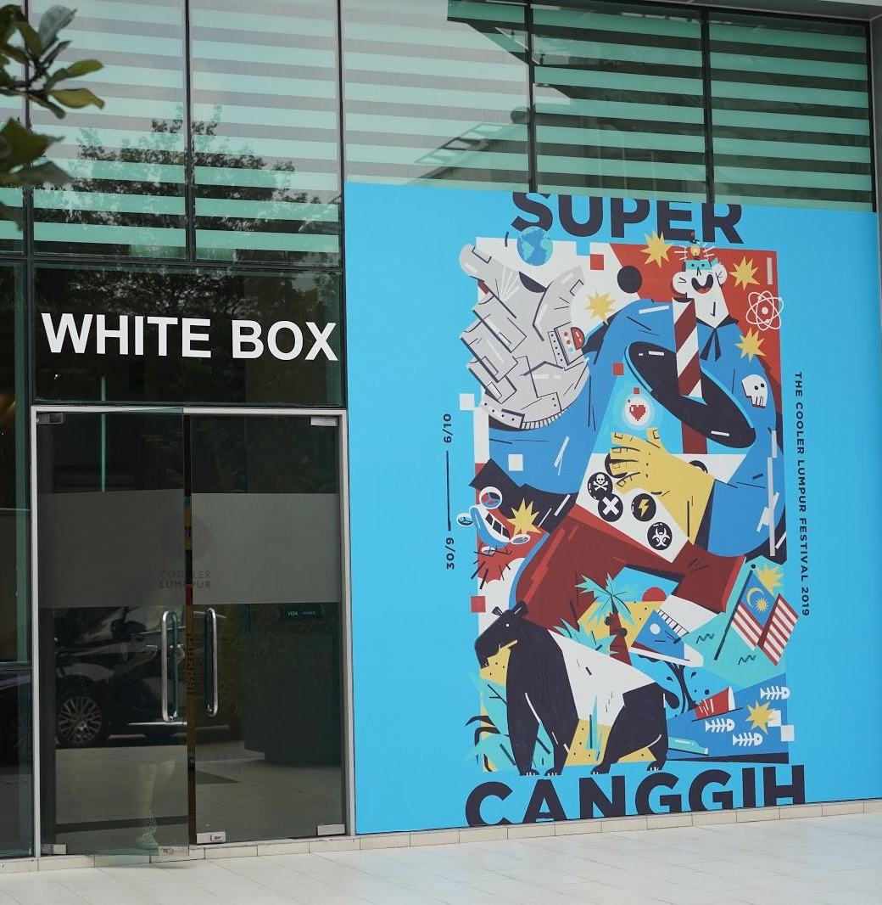

This year’s theme celebrated the everyday heroes who are doing extraordinary things that contribute to making the world a better place. In standing up to try to overcome some of the daunting and overwhelming issues we face, they stretch the chances of hope for change - making them the SuperCanggih beings of our time. Apart from the insightful panel sessions and interactive workshops led by experts in their respective fields, the festival brought back some favourites including artisanal food fair The Belly Good Food Market, alternative book publisher’s pop-up market KLAB and evening skills-based sessions Nite sCool.

With that, let’s take a look at the top highlights from the past week.

Journalism Campus

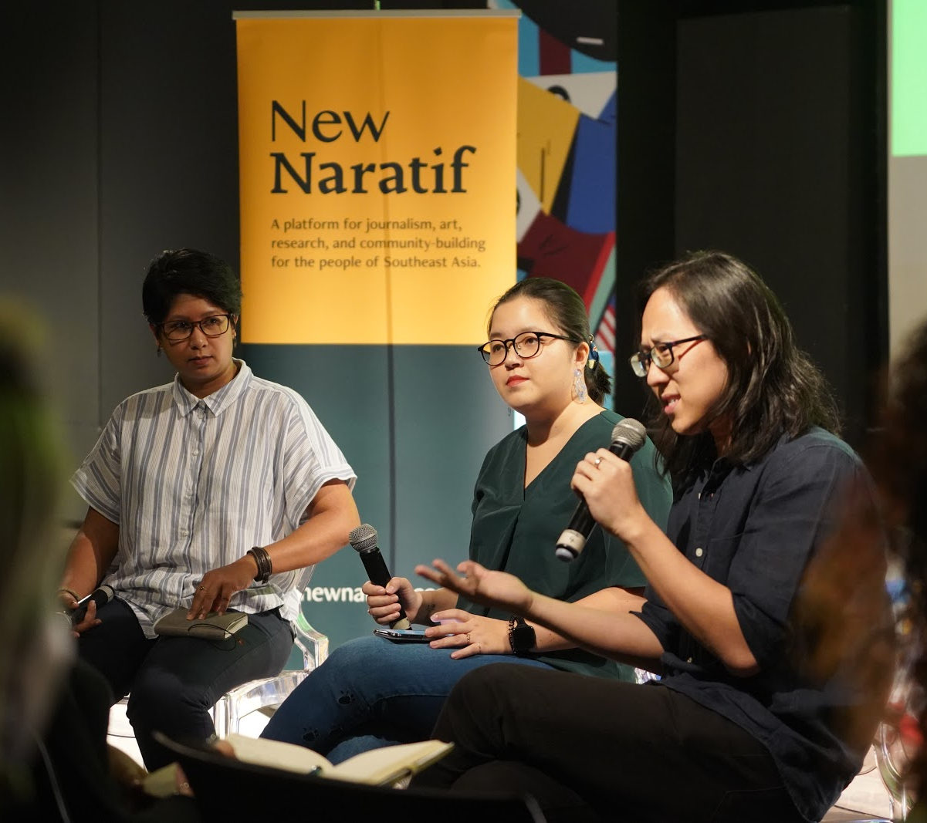

A staple event of the festival, Journalism Campus made its return. This time, in collaboration with New Naratif, the series of interactive workshops, panel discussions and talks touched on the state of today’s media. The journalistic-centric segment saw speakers from the likes of Andreas Vogiatzakis, Group Chief Executive Officer of Star Media, to discuss a range of topics from photojournalism in the age of Instagram, to the issues around fake news.

[WORKSHOP] Sustainable Fashion: Making Clothes from Reusable Materials

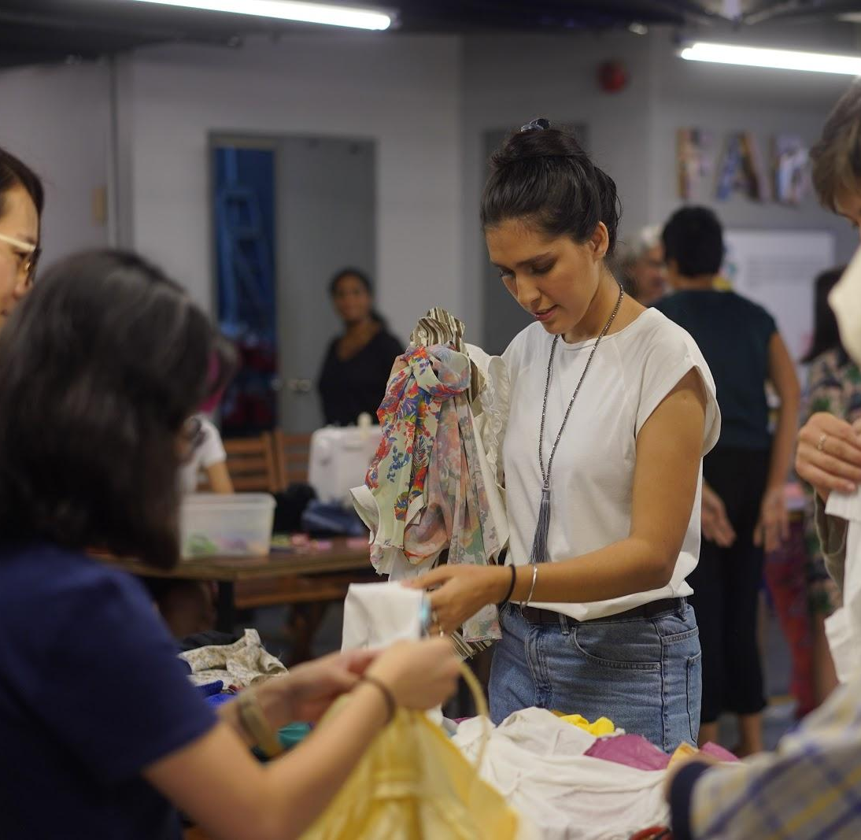

While fast fashion seems to be the most popular choice for how we shop and clothe ourselves, it has also contributed to increasing amounts of waste, cut into the sustainability of materials, and contributed to unethical production and labour practices. These are areas of focus for UK artist and designer Eliza Collin, as her work is concerned with issues surrounding production in relation to materials and people.

Participants joined in her two-hour workshop to explore the vast issues of sustainability on a personal and cultural level, and participated in a collective exercise of upcycling and finding alternative ways of making clothes from reused materials brought by the participants themselves. This workshop was presented in collaboration with the British Council Malaysia, and was hosted by Biji-biji Ethical Fashion.

[WORKSHOP] Nothing to Haid - A Mum and Daughter Conversation

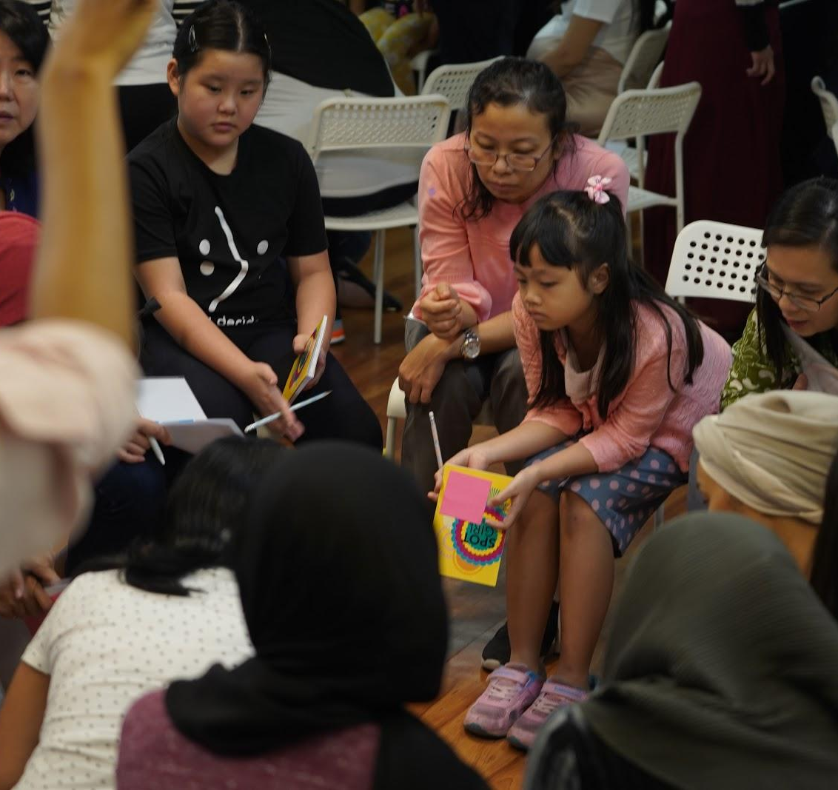

As mothers, we want to do everything humanly possible to make sure our daughters live happy, healthy lives which includes loving themselves, being confident, and more importantly, staying safe. However, in achieving this, there’s one area we tend to avoid talking about - sexual education.

Makchic, together with SPOT, organised a Mother-Daughter workshop to get the conversation started. The objective of the workshop was to create a safe, non-judgmental place to discuss the intimate details of human sexuality, to encourage a healthy discourse about it, and to empower young girls with the right knowledge.

Bummed that you missed out? Visit SPOT (https://www.hellospotgirl.com/) and Makchic’s websites (https://www.makchic.com/) for more information and be kept in the loop on future events.

[PANEL] Super Canggih Definers Forum

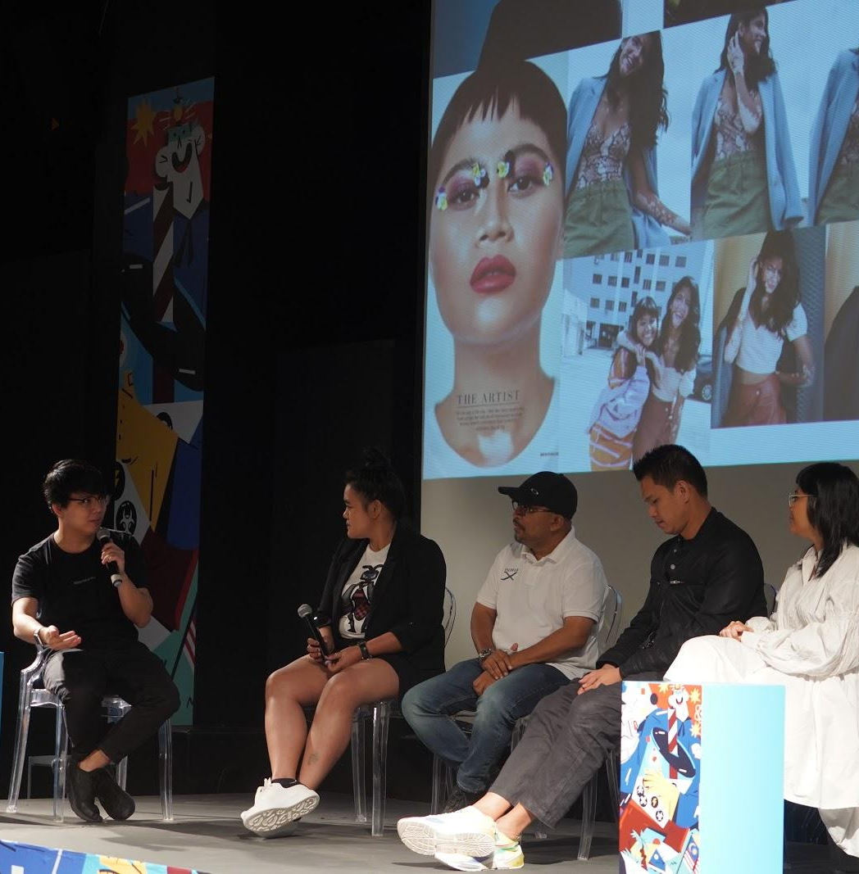

Here comes a band of powerful creators from Asia who uses their art to elevate issues that impact society and culture. Attendees got to catch these PIXERF ambassadors' photography exhibition throughout the whole festival week and attend a forum, with the four extraordinary visual creators who have shaken up the photography industry and culture at large.

Xyza Cruz Bacani humanises migrant workers in Asian cities through her black-and-white photos. Nadirah Zakariya reframes the idea of womanhood with raw, personal and bracingly honest portraits. Tom Potisit uses fashion photography to bring awareness to unspoken issues in Thailand. Yaman Ibrahim makes it his mission to represent the Malaysian point of view in the photography scene.

Participants were also invited to walk the streets of Kuala Lumpur with these four inspiring photographers to capture some extraordinary moments to open up new perspectives through their lenses.

[WORKSHOP] Distant Thoughts

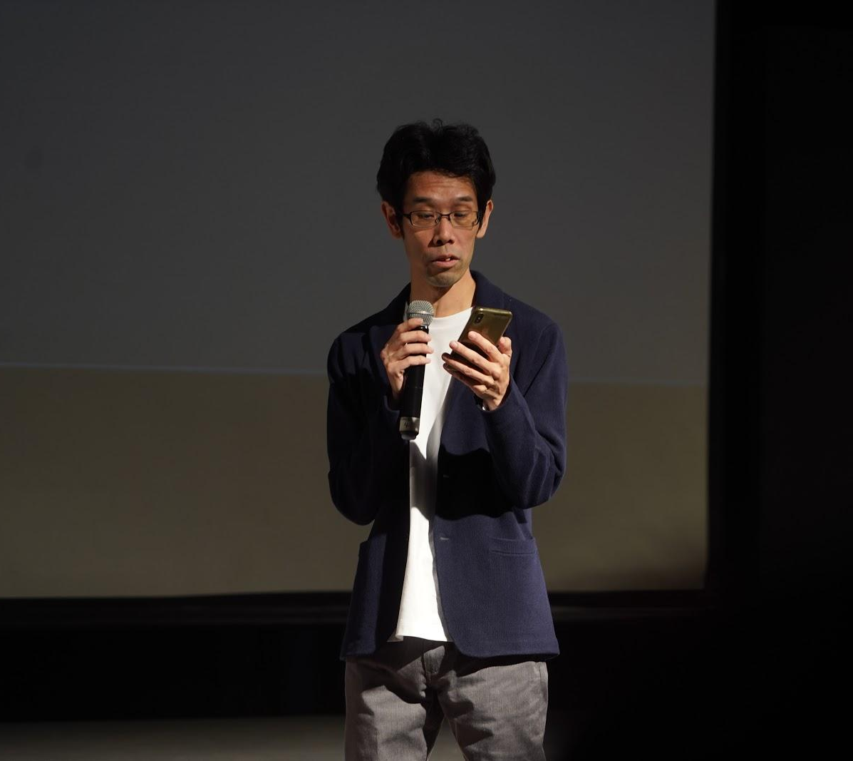

Every once in a while, do we make it a point to stop and think about things that are distant from here and now? Notably, in the history of humans, these “Distant Thoughts” have brought breakthroughs in science and technology many times.

In this workshop with Japanese app developer Isana Kashiwai, participants experienced an interactive lecture using the audience’s body scale, was tested in short and sweet quizzes, and posed questions and received answers about “distance”.

[SCREENING] Science Film Festival

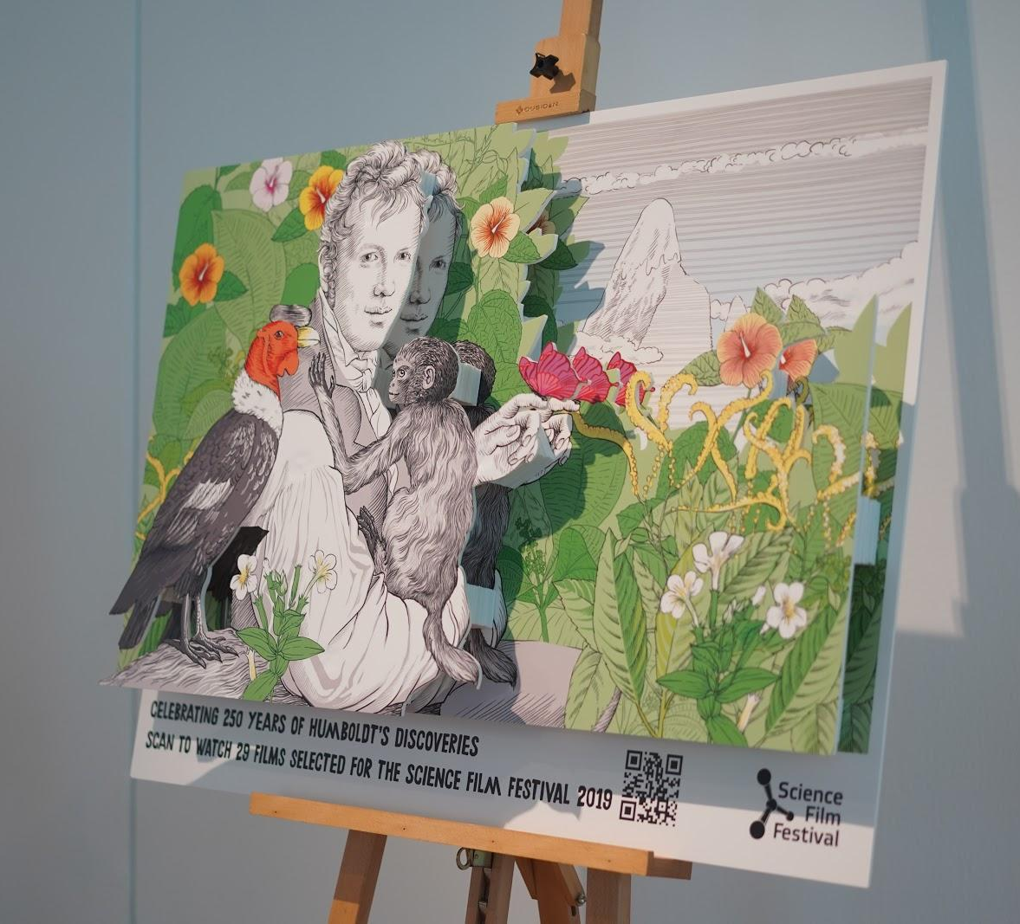

In collaboration with the Goethe Institut, The Cooler Lumpur Festival screened two selections from the Science Film Festival:
- Decoding The Weather Machine - In this documentary, NOVA cut through the confusion around climate change. The festival’s audience joined scientists around the world on a quest to better understand the workings of the weather and climate machine we call Earth, and discover how to stay resilient— even thrive— in the face of enormous change.
- The Exploitation Of The Forests - In this film about global hotspots of deforestation, Manfred Ladwig and Thomas Reutter’s investigative research revealed that the Forest Stewardship Council (FSC) does not remove the eco-label from companies accused of processing illegally harvested virgin forest. Audience got to sit through and understand the links between FSC, illegal logging and the expulsion of indigenous people living in the forests.

For more information, check out the website at https://www.goethe.de/prj/sff/en/index.html.
Don’t fret if you missed these screenings! You can catch Decoding The Weather Machine on Netflix for some late-night binge watching.

[EVENT] SALT

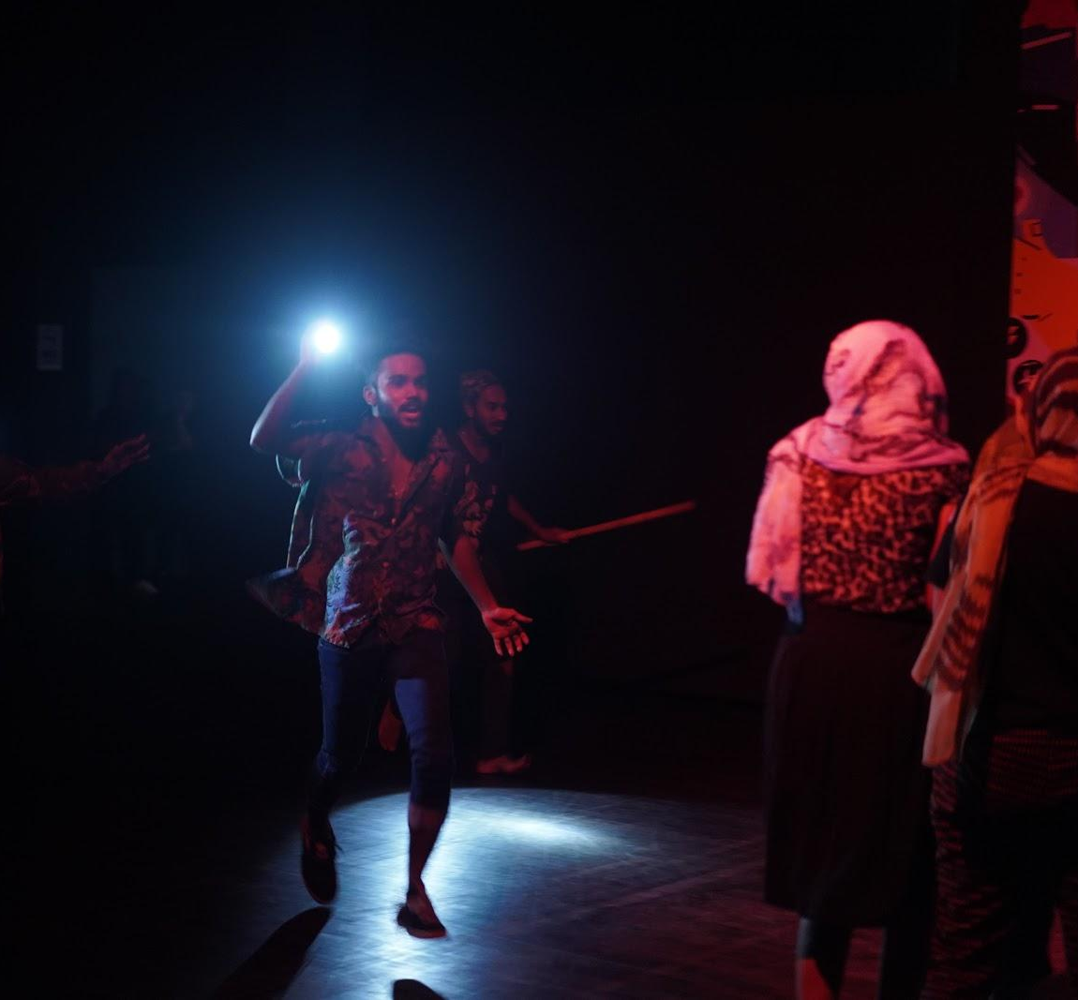

Around the world right now, there are more than 70.8 million people who are forced to flee home due to war, persecution and danger. In search of safety, hundreds of thousands have chosen to cross the ocean, risking their lives to seek for a safer home and a better life.

SALT was a unique and immersive dining experience offering a glimpse into the journey of a refugee courtesy of PichaEats. With no guarantee of whether you can reach the shore safely, participants stepped into a refugee’s shoes for 20 minutes, and experienced first-hand, the struggles faced by refugees during their escape. At the end, participants were treated to a feast prepared by Syrian refugee Chef Nesreen.
[COMMUNITY BUILD] Me.reka x Ignition Lab

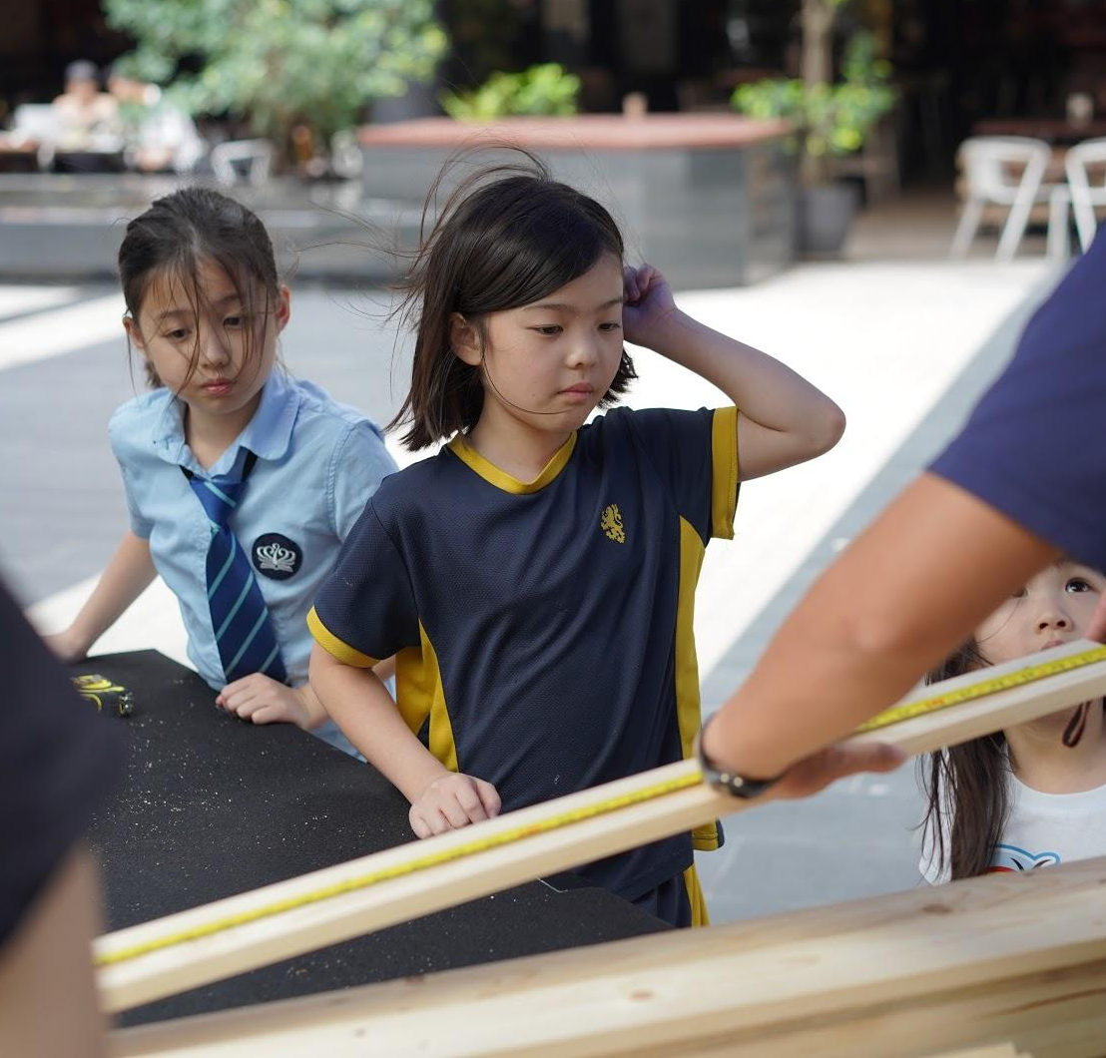

This collaboration between Me.reka and Ignition Lab was a gotong-royong project to build furniture from used wooden pallets that were custom made for partner orphanages in the Klang Valley.

Passersby were able to donate a total of RM10 to build furniture ranging from shoe racks to chairs that are necessary for the upkeep and betterment of two selected orphanages.

The built-up furniture has since been delivered and made its home in the orphanages since Monday, 7 October.
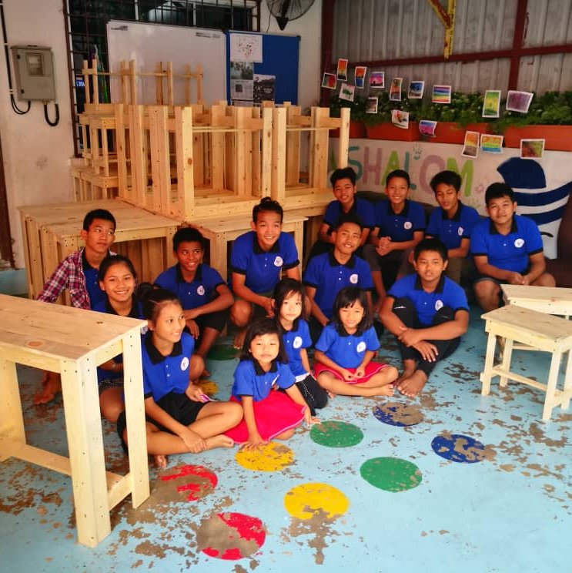
[POP-UP] Tune Protect EasyMart



As a first-time partner of the festival, Tune Protect set up a convenience-store concept booth that showcased the brand’s products and services of which passersby were able to redeem attractive merchandise. Apart from that, the brand also hosted a travel photography workshop led by travel and wedding photographer Vinoth Raj Pillai of The Real VRP who shared his tips and tricks on how to capture envy-inducing wanderlust photos.

[PANEL] We Didn’t Start This Fire

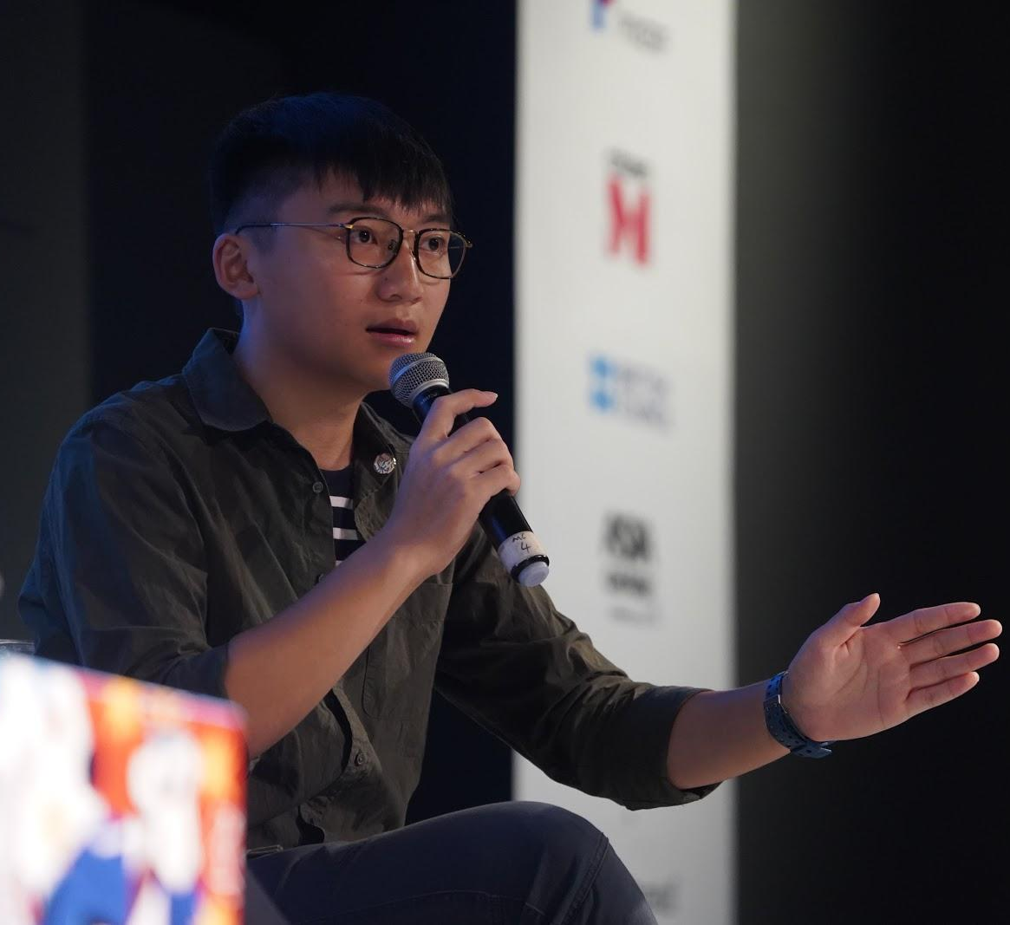

Issac Cheng is the vice-chairman of Demosistō and is currently a year three student in Sociology at Shue Yan University. He was inspired by the protests against the National Education curriculum, and went onto join Demosistō when he was in secondary school.

Attendees joined in on the conversation with Isaac to understand the various pressure points unfolding in Hong Kong. The panel was followed by a Q&A session led by Isaac himself.

[POP-UP] British Council x Institut Kraf Negara Craft Showcase

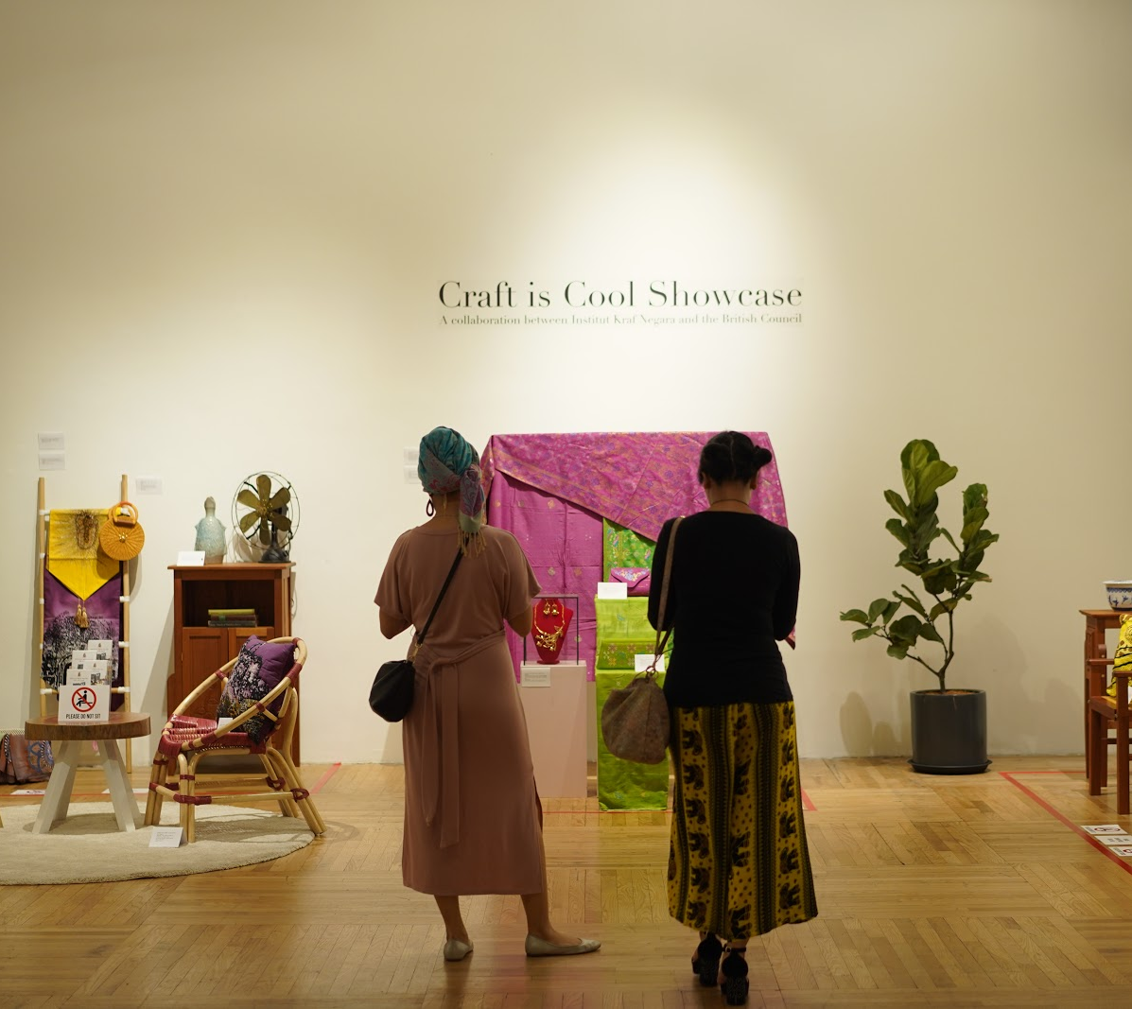

British Council in partnership with Institut Kraf Negara held a craft showcase that featured a wealth in local craft heritage made by Institu Kraf Negara’s students, from intricate weaving to bespoke furniture pieces.

[PANEL] Building A Challenger Hotel Brand In An Extremely Competitive Market

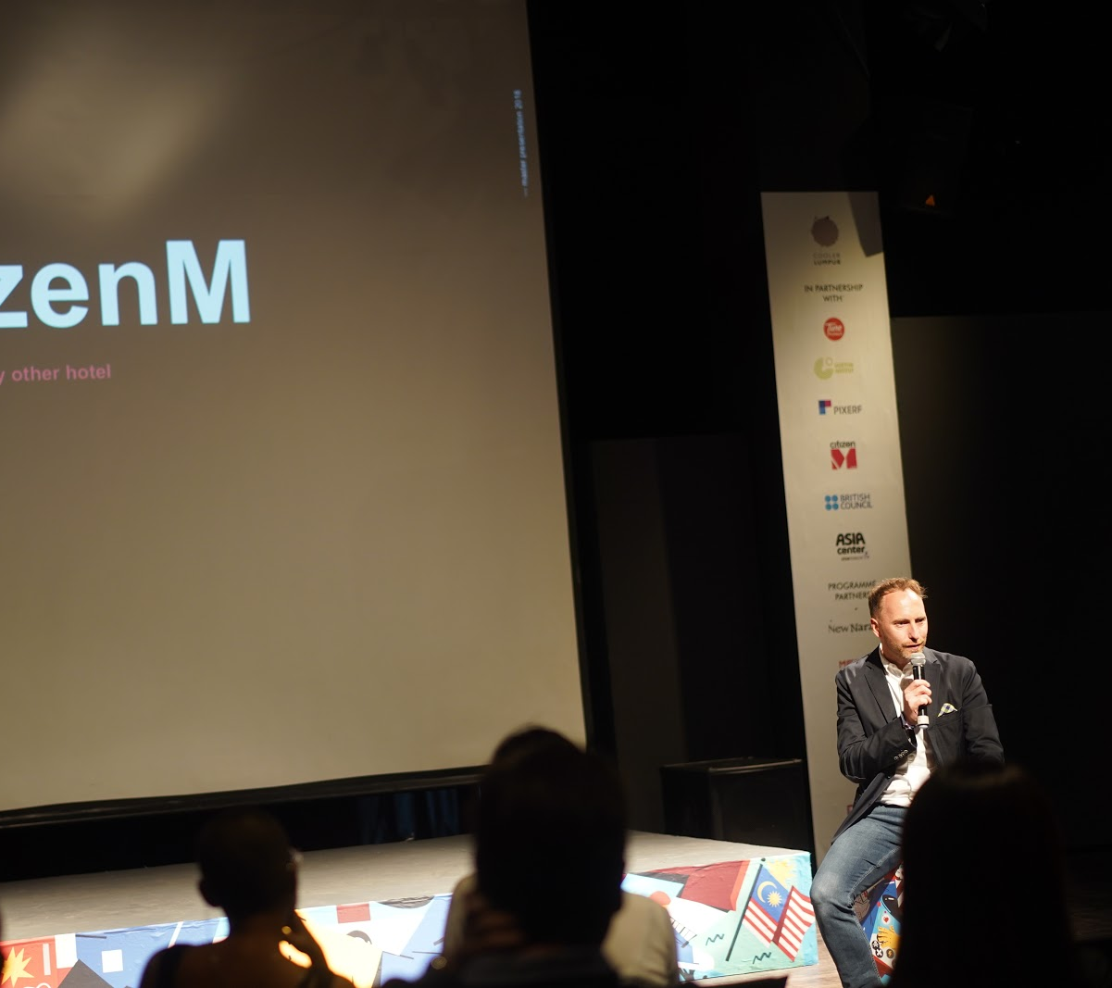

citizenM is a big time disrupter in the traditional hotel industry, known for its luxury hybrid hotel catered to today’s modern travellers that work to eliminate these travellers’ frustrations. Over the weekend, Vice President Asia of citizenM hotels, Toni Hinterstoisser hosted an in-depth session sharing the brand’s approach to cut through the crowd and emerge victorious from its tech strategy, interior design aesthetic and unique communication lingo.

For more information on the festival, log on to www.coolerlumpur.com and follow The Cooler Lumpur Festival on Instagram (@CoolerLumpur) and Facebook (www.facebook.com/CoolerLumpur/) to check out what went down.

Hope to catch you at next year’s festival!

Notes to Editors

About This Year’s Theme “SuperCanggih”
Climate change. The 1 percent. Gender equality. Poverty. Extinction. Supremacists. Refugees. The issues we face are daunting and overwhelming. There is a real chance we may not even reverse some of these major concerns in time.

But hope is the last to die.

While most of us are merely standing by, there are some amongst us who are doing extraordinary things to stretch our chances just a little bit more. They are everyday heroes. They are SuperCanggih.

This year we will celebrate them, across arts, science, politics, policy, technology and ideas.

About The Cooler Lumpur Festival
The Cooler Lumpur Festival is a multidisciplinary festival curated by PopDigital. The Kuala Lumpur-centric festival adopts specific themes each year with the aim to expand the city’s cultural horizons, build stronger communities and cultivate the creativity and imagination of people.

In 2013, The Cooler Lumpur Festival debuted under the simple theme of #WORD which set out to explore the written and spoken word. It was a serendipitous result of being invited to host the Edinburgh World Writers' Conference (EWWC) in Kuala Lumpur by the British Council. The inaugural event received overwhelming response and resulted in a Memorandum of Understanding between the British Council and PopDigital to further develop an annual literary festival. Over the years, The Cooler Lumpur Festival has evolved into an Ideas Festival, but we maintain a close working relationship with the British Council as a literary partner to continue building this segment.

The annual festival’s sophomore edition was themed #FAST – rooted in the notion that the driving-force behind successfully fast-forwarding development was through sharing, engaging and experimenting in new ideas. 2014’s #FAST was attended by over 5,000 attendees and featured contributions from artists, musicians, writers and thinkers including Man As a Literary Prize winner Miguel Syjuco, The Man Booker-nominated writer Adam Foulds and Damian Barr who was named Writer of the Year at the 2013 Stonewall Awards.

2015’s festival theme DANGEROUS IDEAS celebrated ideas as the driving force behind every decision we make, the root of all human progress, the power and means to overcome difficulty and the impetus to take action against injustice. DANGEROUS IDEAS featured panels and lectures by Lindy West, Ian Doescher and Tun Dato' Seri Dr. Mahathir Mohamad.

Its fourth installment in 2016 titled RE: INDEPENDENCE drove healthy discourse amongst communities, on everything from independence in nation building, right down to independence in our everyday lives. Amongst the concepts explored was the paradox of technology – it automates so many daily tasks for humans free their minds for other things, but most urban dwellers are also slaves to these mobile devices.
Its sixth installment in 2017 titled NOTES FROM THE FUTURE looked to the social, political, technological, and cultural ideas that have become representative of these times and tell the story of our collective futures.

In 2018, the festival’s theme was centred around the idea of ‘reboot’ and was aptly titled CTRL- ALT-DEL. It explored these individual notions of ‘control’, ‘alternate’, and ‘delete’ and what they mean when taken as a whole. The festival wondered how to redo and remake the world if offered the chance at a reset.

About PopDigital
PopDigital is a creative media and investment group specialising in media and technology.

About Tune Protect Group Berhad
Tune Protect Group Berhad (Tune Protect) is a financial holding company listed on the main market of Bursa Malaysia. As a leading digital insurer in the region and with the tagline ‘Protection Made Easy’, Tune Protect offers affordable, yet comprehensive protection plans to suit individual and corporate needs. Tune Protect has established a strong foothold in the travel, retail and digital insurance space globally with presence across more than 45 countries through its own general insurance and reinsurance arms, as well as via strategic partnerships with local underwriters in these markets. The Group also has a strong focus to move beyond insurance by embracing insurtech and introducing differentiated product solutions such as on-demand products as part of its diversified portfolio.

For more information on Tune Protect, visit the website at https://www.tuneprotect.com/.

About PIXERF
PIXERF is the global visual community and marketplace for authentic Asian content.

Our mission is to provide collaborative opportunities for visual creators and brands to define themselves through authentic Asian content.

With a diverse community of visual creators from across Asia on one platform, PIXERF gives businesses opportunities to get immediate access to the best images and multiple ways to create amazing visuals of Asia to meet their content needs.

Visual creators now have a platform to showcase their works, get recognised, connect and learn. They can earn in three ways – royalties from licensing of their images (on the Creative Marketplace), participating in photo missions (Crowdsourced Missions) and getting matched to jobs (Custom Commissions).

Our talented creators are located in over 56 countries, including Indonesia, Malaysia, Thailand, Singapore, Philippines and Vietnam.

PIXERF is on the web and available for download as a mobile app.

For more information on PIXERF, visit the website at https://pixerf.com/.

About Goethe-Institut Malaysia
The Goethe-Institut is the cultural institute of the Federal Republic of Germany with a global reach. We promote knowledge of the German language abroad and foster international cultural cooperation. We convey a comprehensive image of Germany by providing information about cultural, social and political life in our nation. Our cultural and educational programmes encourage intercultural dialogue and enable cultural involvement. They strengthen the development of structures in civil society and foster worldwide mobility.

With our network of Goethe-Instituts, Goethe Centres, cultural societies, reading rooms and exam and language learning centres, we have been the first point of contact for many with Germany for over sixty years. Our long- lasting partnerships with leading institutions and individuals in over ninety countries create enduring trust in Germany. We are partners for all who actively engage with Germany and its culture, working independently and without political ties.

For more information on Goethe-Institut Malaysia, visit the website at https://www.goethe.de/ins/my/en/.

About citizenM
The citizenM philosophy is ‘affordable luxury for the people’, offering guests all the luxuries they would expect from a high-end hotel in a prime location, but without sky-high prices. citizenM was founded by Rattan Chadha, the founder and former CEO of the fashion brand Mexx. The first citizenM hotel opened at Amsterdam’s Schiphol Airport in 2008, followed by citizenM Amsterdam in 2009; citizenM Glasgow in 2010, and citizenM London Bankside in 2012. Rotterdam, New York and Paris locations followed in 2014. In 2016, two more hotels were added to the London portfolio: citizenM Tower of London, and citizenM Shoreditch. In 2017, citizenM opened Paris La Defense and Paris Gare de Lyon hotels. Also in 2017, the company moved into the Asian market, with its first location at Taipei North Gate. citizenM New York Bowery, the second New York hotel, opened in September 2018, followed by Copenhagen and Shanghai in December 2018. Further announcements about expansion in the US, Europe and Asia will follow soon.

citizenM aims to keep growing as an integrated owner-operator in gateway cities around the world and has funds available from its shareholders to do so. Its unique value proposition, delivering a high profitability per square meter, allows the brand to develop hotels on prime locations in cities with the highest barriers to entry. Suitable projects could be new-built developments, office conversions, components of mixed-use schemes or conversions of existing hotels and portfolios. citizenM can acquire development sites, existing buildings or turnkey delivered hotels and is open to joint ventures with local partners. The company will also selectively consider management agreements, preferably in combination with a co-investment.

In Asia Pacific the key target cities for further expansion are Sydney, Melbourne, Tokyo, Osaka, Hong Kong, Singapore, Shanghai and Beijing. citizenM aims to develop multiple hotels per selected target city.

For more information on citizenM, visit the website at https://citizenm.com/.
About Japan Foundation Kuala Lumpur
The Japan Foundation is a non-profit organization established in 1972 with the purpose of promoting mutual cultural exchange between Japan and other countries. The Kuala Lumpur office was established in October 1989 and its status upgraded to Cultural Centre in February 1992. Three years later in April 1995, the Language Centre was formed under the umbrella of the Cultural Centre. The facilities available at The Japan Foundation Kuala Lumpur include the Tatami room and the Library.

The primary objective of JFKL is to develop mutual understanding between people through culture and language within the region. The office also facilitates and supports the exchange of personnel and experts who works in the field of Arts, Culture, Humanities and Social Sciences. Other objectives include developing a pool of local expertise in the field of Japanese language teaching and developing teaching materials suitable for local needs. Lastly it facilitates the exchange of information between bodies concerned with Japan related cultural issues.

For more information on Japan Foundation Kuala Lumpur, visit the website at https://www.jfkl.org.my/.

About British Council
The British Council is the UK’s international organisation for cultural relations and educational opportunities. We work with over 100 countries in the fields of arts and culture, English language, education and civil society. Last year we reached over 80 million people directly and 791 million people overall including online, broadcasts and publications. We make a positive contribution to the countries we work with – changing lives by creating opportunities, building connections and engendering trust. Founded in 1934, we are a UK charity governed by Royal Charter and a UK public body. We receive 15 per cent core funding grant from the UK government. For more information on British Council, visit the website at www.britishcouncil.org.

The British Council has been working with Malaysia since 1948.
About C27
C27 is a digital enablement firm fuelled by a curious bunch of digital natives, consisting of an unusual collection of thinkers, creators and rule-breakers. The company aspires to drive meaningful change through strategic thinking, brand engagement, and user experience design, with a big client base including the likes of Netflix, UMobile, Touch ’n Go Digital, MONIN and more.

For more information on C27, visit the website at https://whatisc27.com/.

About New Naratif
New Naratif is a movement for democracy, freedom of information, and freedom of expression in Southeast Asia. We aim to make Southeast Asians proud of our region, our shared culture, and our shared history. We fight for the dignity and freedom of the Southeast Asian people by building a community of people across the region to imagine and articulate a better Southeast Asia.

We do this by:

- identifying, and conducting research on important issues facing the people of Southeast Asia;
- publishing in-depth evidence-based information about these issues, in a variety of accessible formats (research articles, journalism features, comics, podcasts, and videos) and languages (the languages of the people of Southeast Asia, including Bahasa Indonesia, Bahasa Melayu/Malaysia, Vietnamese, and Chinese);
- empowering people to become fully engaged citizens of their communities; and
- advocating for and modelling ethical, moral, and progressive values rooted in the Southeast Asian context.

For more information on New Naratif, visit the website at https://newnaratif.com/.

