Title: [PROGRAM HIGHLIGHTS] Discovery Networks Asia Pacific - April 2019

Copy:

Dear media



Discovery Channel (Astro Channel 561)

Treehouse Masters S7B

*Image is attached to this email*

Pete Nelson and his NT&S crew create the most magnificent, whimsical, staggering, spectacular, and jaw-dropping treehouses in forests and backyards all across the America and beyond.

Premiere Date: 5 April 2019, Friday
Time: 9pm (MY)
Episodes: 12 x 60 mins

Blowing Up History S2

*Image is attached to this email*

Each hour-long episode will reveal the secrets of a different iconic building. The structures will range in size, scale, age and location from ancient wonders like the Pyramids in Egypt to modern marvels in Manhattan such as the Empire State Building - fusing elements of engineering, history, geology and archaeology.

Premiere Date: 19 April 2019, Friday
Time: 10.50pm (MY)
Episodes: 12 x 60 mins

American Chopper S2

*Image is attached to this email*

American Chopper: The Series profiles the lives of New York natives Paul Teutul Sr. and his son Paul Jr. of Orange County Choppers, creators of the world’s most outrageous custom motorcycles. Each episode captures the day-to-day drama of this volatile father and son team as they they battle impossible deadlines and each other and push the envelope of motorcycle design and fabrication.

Premiere Date: 25 April 2019, Thursday
Time: 9pm (MY)
Episodes: 10 x 60 mins

---



TLC (Astro Channel 707)

Project Runway S17
<client to share image once available>
*Image is attached to this email*

Project Runway Series 17 will see the hottest new design aesthetics as well as brand new additions to the judging panel: supermodel Karlie Kloss joins as host alongside former Project Runway champion Christian Siriano as the mentor.

Premiere Date: 1 April 2019, Monday
Time: 8pm (MY)
Episodes: 16 x 60 mins

Bizarre Foods: Delicious Destinations S7

*Image is attached to this email*

Chef Andrew Zimmern explores the delectable and iconic foods that define a location. Traveling the globe has never been more mouthwatering, and culinary classics have never been more comforting as he discovers the secrets and stories behind these legendary meals.

Premiere Date: 9 April 2019, Tuesday
Time: 8pm (MY)
Episodes: 24 x 30 mins

---



Animal Planet (Astro Channel 556)

The Wild Canadian Year
<client to share image once available>
*Image is attached to this email*

From the creators of the acclaimed series WILD CANADA, comes a new five-part legacy series,
which will view Canada's extraordinary wildlife through the lens of its four distinct seasons.
The seasonality of the weather on our planet defines and drives the lives of every creature on
earth.

Premiere Date: 2 April 2019, Tuesday
Time: 9pm (MY)
Episodes: 4 x 60 mins

How do Animals do that?
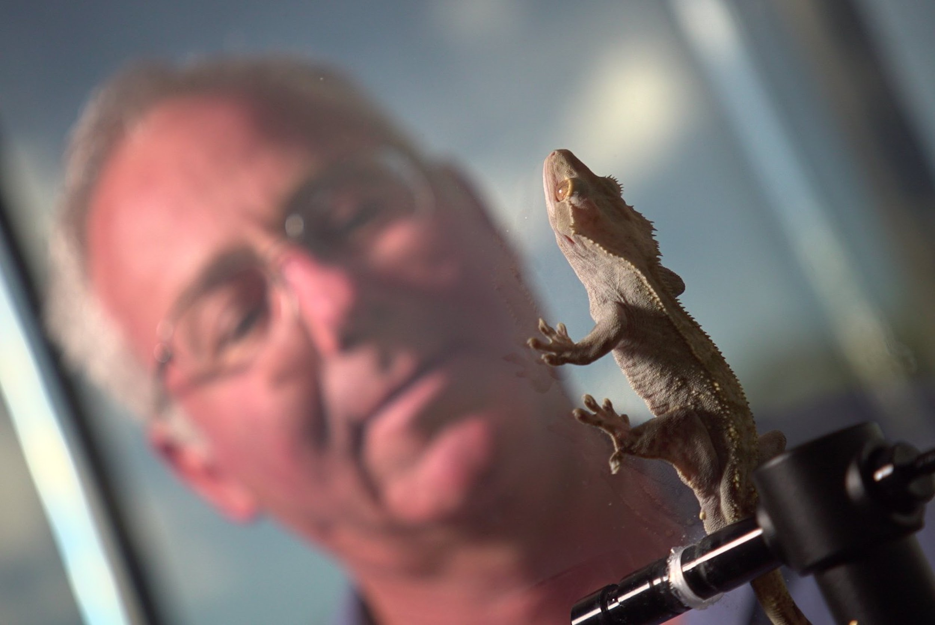
*Image is attached to this email*

How do Jesus Christ lizards walk on water? How do fireflies glow in the dark? How do electric eels create electricity without electrocuting themselves? Animals can do extraordinary things the question is: how do they do it? In this show, we find out. How Do Animals Do It?

Premiere Date: 17 April 2019, Wednesday
Time: 8.05pm (MY)
Episodes: 40 x 30 mins

Jeremy Wade Dark Waters
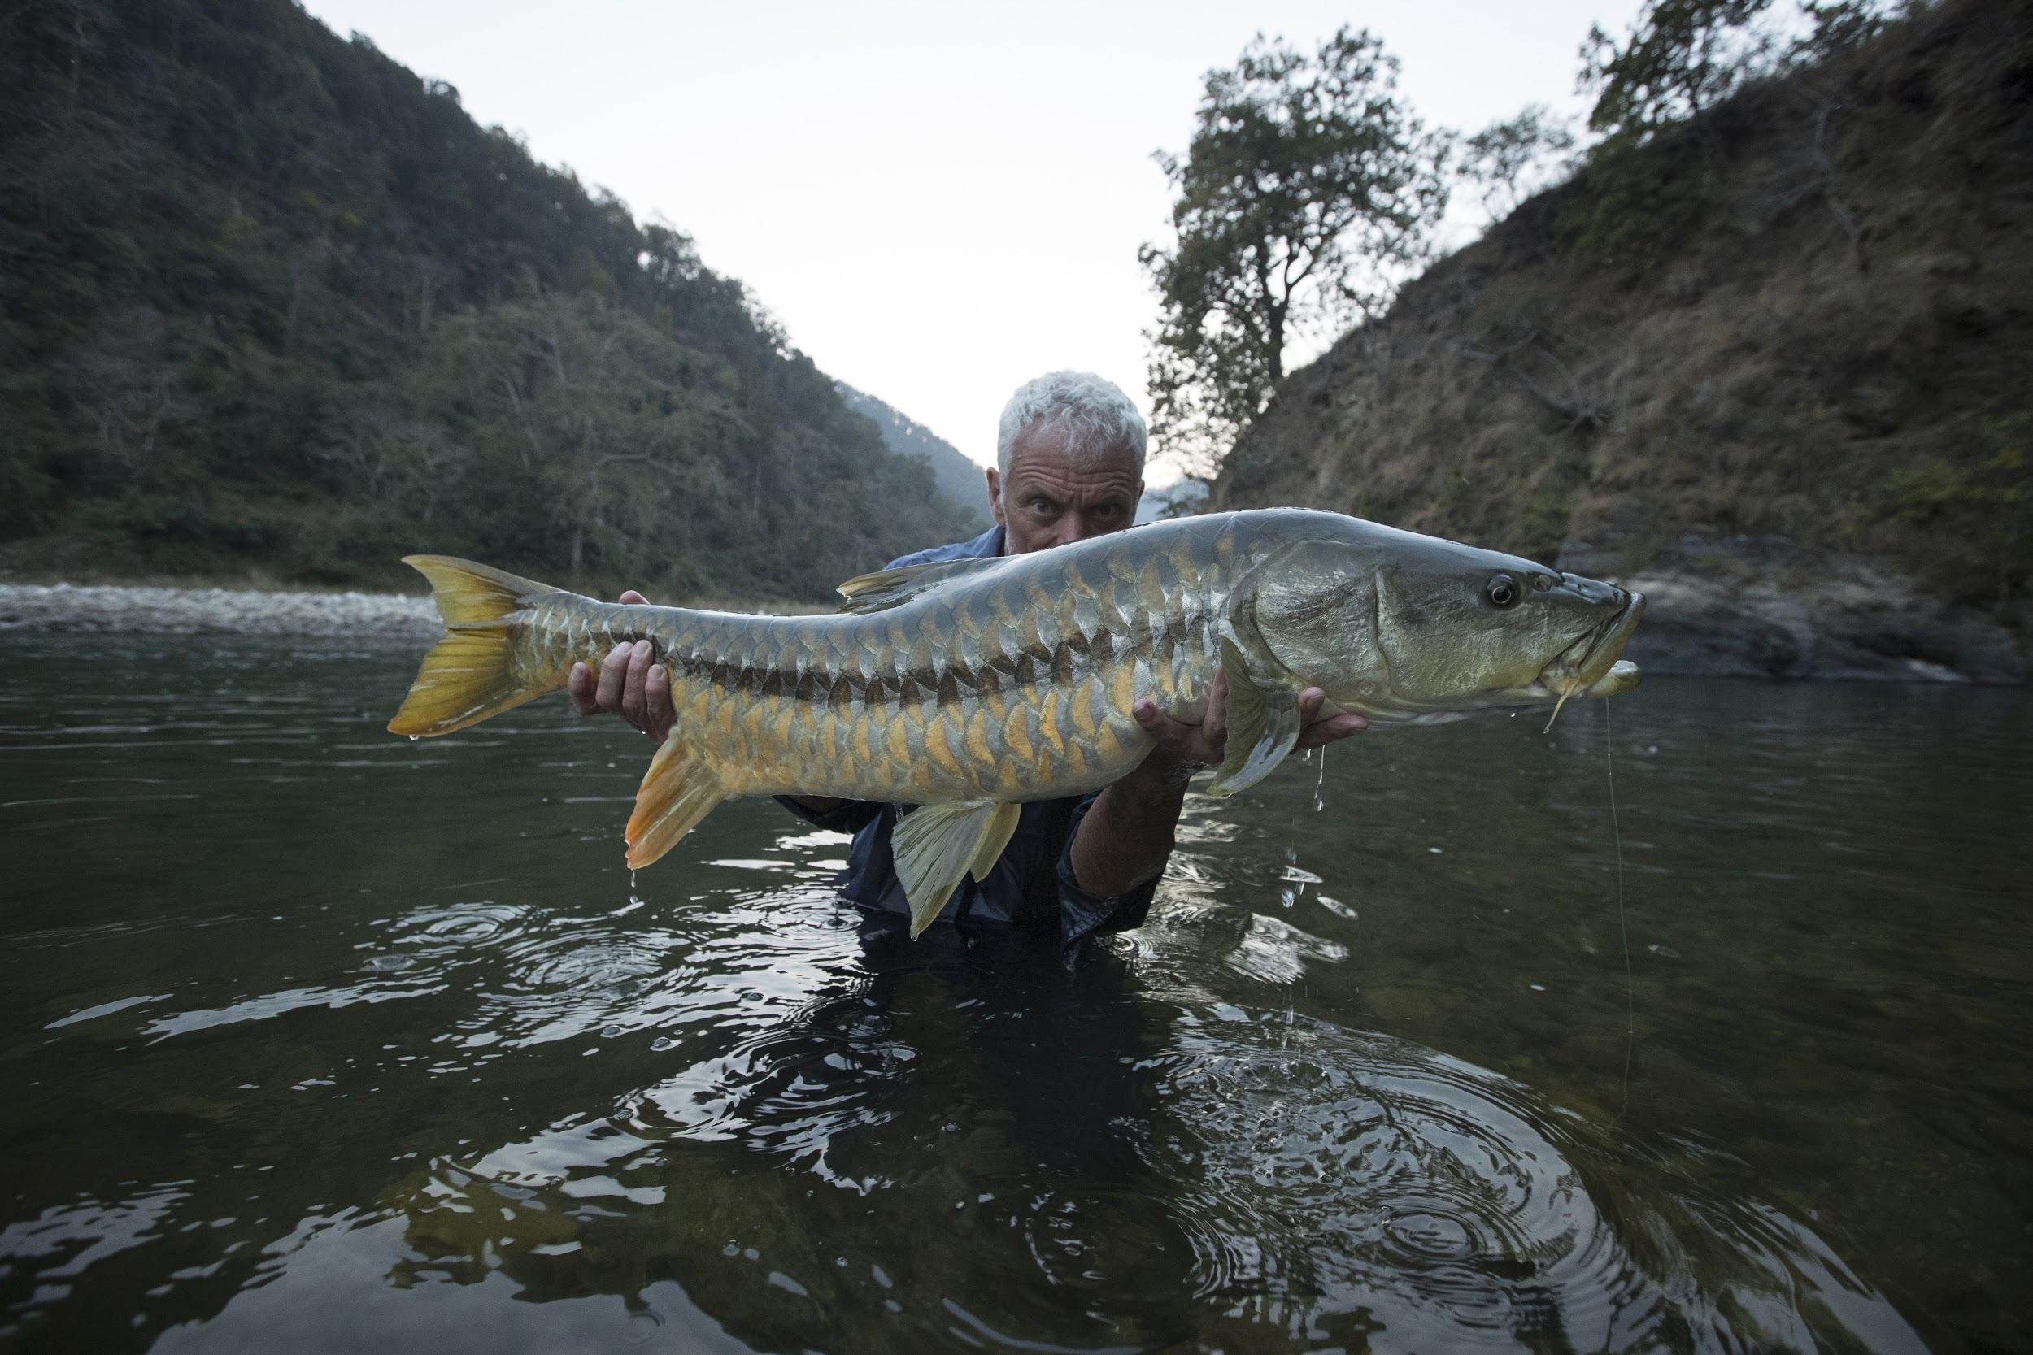
*Image is attached to this email*

Jeremy Wade has spent decades hunting river monsters in the most remote waters on the
planet. With unrivaled skill and a healthy dose of luck, Jeremy's caught nearly all the suspects
... but there are plenty more fish on his bucket list, each with mysteries of their own that he's
determined to solve. Now Jeremy's heading to unfished waters on a quest to hook them from
the deep.

Premiere Date: 22 April 2019, Monday
Time: 9.55pm (MY)
Episodes: 8 x 60 mins

---



Discovery Asia (Astro Channel 571)

Aerial Asia 2

*Image is attached to this email*

This four-part series shot in stunning 4K captures the history and culture of this extraordinary continent and reveals a spectacular view of Asia that has never been seen before

Premiere Date: 19 April 2019, Tuesday
Time: 9pm (MY)
Episodes: 4 x 60 mins

Bollywood: World’s Biggest Film Industry
<client to share image once available>
*Image is attached to this email*

The Indian film industry is the biggest in the world. India now sells a billion more tickets,
produces twice as many movies, and expands its global reach three times faster than Hollywood. How does it do it?

Premiere Date: 27 April 2019, Saturday
Time: 9pm (MY)
Episodes: 2 x 60 mins

---



Asian Food Channel (Astro Channel 703)

City Foragers S1
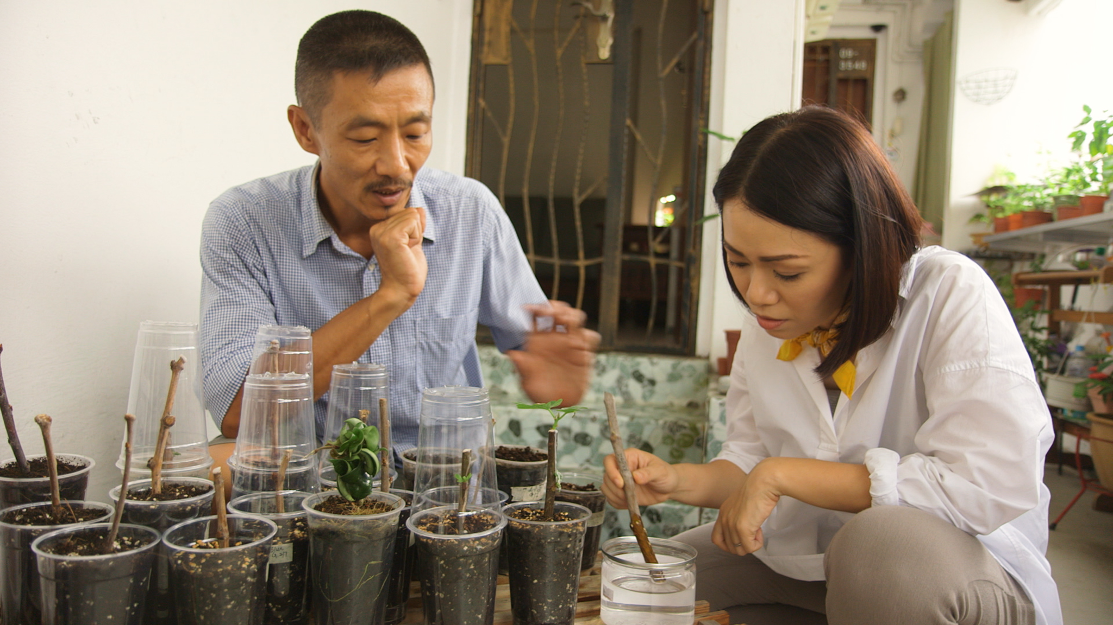
*Image is attached to this email*

Mediacorp Package consisting of Buzzing Hawkers, Our Makan Places S6, and City Foragers.

Premiere Date: 11 April 2019, Thursday
Time: 9pm (MY)
Episodes: 10 x 30 mins

Fast Indian Cooking with Sapna S2

*Image is attached to this email*

There are thousands of hawker stalls in Singapore but why are some so successful and others not? Is it the food, the location or the packaging? Chua Enlai and Rishi Budhrani will extend a helping hand to struggling hawkers hoping to keep their stalls afloat. With the help of a mentor chef and Taste Squad, each hawker will only have one chance to get it right. Will they be able to rejuvenate their business and bring in the customers? The challenge starts now!

Premiere Date: 20 April 2019, Wednesday
Time: 9pm (MY)
Episodes: 14 x 60 mins

---



Food Network (Astro Channel 727)

Worst Cooks in America S9

*Image is attached to this email*

Anne Burrell and Rachael Ray lead teams of celebrity recruits through a rigorous culinary boot camp as they try to teach kitchen skills to Mindy Cohn, Matt Dallas, Tommy Davidson, Barbara Eden, John Henson, Loni Love, Kenya Moore, Mike "the Situation" Sorrentino and Nicole Sullivan. They only have eight weeks to turn these kitchen disasters into kitchen masters, but in the end, one celebrity will earn $50,000 for the charity of their choice

Premiere Date: 15 April 2019, Monday
Time: 11pm (MY)
Episodes: 8 x 60 mins

Giada Entertains

*Image is attached to this email*

Whether it's a casual game night with girlfriends, a fun family get-together, or a party in the kitchen, Giada De Laurentiis knows how to make it an extra-special event. In Giada Entertains, she shares tips, secrets and recipes for planning the perfect party for family and friends.

Premiere Date: 28 April 2019, Tuesday
Time: 9pm (MY)
Episodes: 13 x 30 mins

---



HGTV (Astro Channel 731)

Good Bones S3
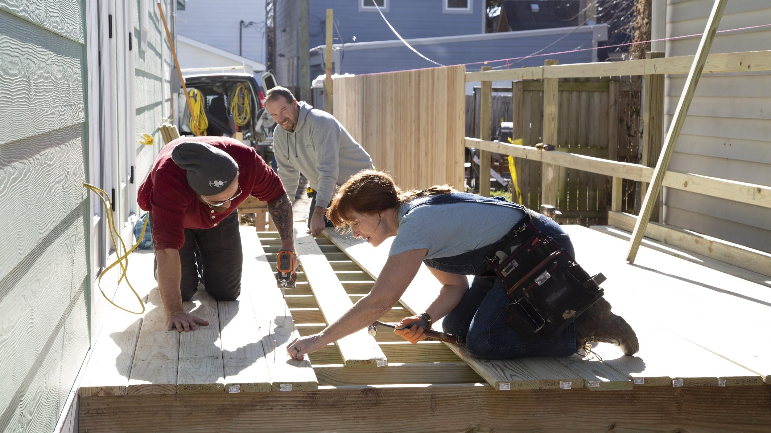
*Image is attached to this email*

Mother and daughter duo Karen E Laine and Mina Starsiak are setting out to revitalize their
hometown of Indianapolis one property at a time. They're buying up run down homes and
transforming them into stunning urban remodels. With Mina's real estate know-how and Karen's
no-nonsense legal background, these ladies are unstoppable in getting a property they want and enlisting their family's help with demo and construction. When it comes to exciting new homes in the city of Indianapolis, it all comes down to the ladies of Good Bones

Premiere Date: 2 April 2019, Tuesday
Time: 8pm (MY)
Episodes: 13 x 60 mins

Property Brothers: Buying and Selling S7
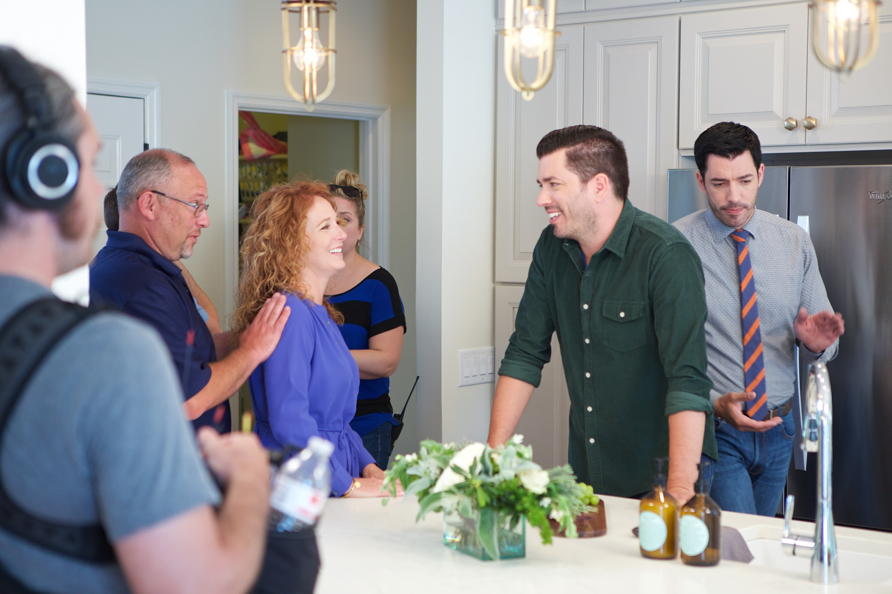
*Image is attached to this email*

Join the Property Brothers, Drew and Jonathan Scott, as they help homeowners sell their current home and buy a new property in HGTV's new series, "Buying and Selling". Jonathan renovates the family's current home for a successful sale, while Drew checks out the best options for the family's new property. Drew then oversees the selling of the renovated home and the buying of a new house.

Premiere Date: 15 April 2019, Monday
Time: 10pm (MY)
Episodes: 18 x 60 mins

We would appreciate if you could highlight this in your upcoming issues / online features. You may access hi-res images from this <link> for your usage.

Should you require further information, do not hesitate to drop me a line at vanesa@madhat.asia / 016 342 5957

