Title: [PROGRAM HIGHLIGHTS] Discovery Networks Asia Pacific - March 2019

Copy:

Dear media



Discovery Channel (Astro Channel 561)

Mythbusters Jr

*Image is attached to this email*

MYTHBUSTERS JR. gives America's best and brightest 8 to 14-year-olds a chance to show the whole nation what they know. Combined with the mythbusting DNA of the original series and adding elements of THE SEARCH, this is a format where kids show off their ingenuity and STEM superskills.

Premiere Date: 6 March 2019, Monday
Time: 9.55pm (MY)
Episodes: 10 x 60 mins

Street Outlaws: New Orleans

*Image is attached to this email*

New Orleans is known for having the largest and wildest street racing scene in the country. With matches held as often as 3 times a week, there are a ridiculous number of drivers - both serious and amateur- calling each other out.

Premiere Date: 7 March 2019, Thursday
Time: 10.50pm (MY)
Episodes: 19 x 60 mins

Trans Am

*Image is attached to this email*

In 2010, GM closed Pontiac's doors for good and it seemed like America's most iconic muscle car, the Firebird Trans Am, was dead and would never come back. But brothers Scott and Todd Warmack, obsessed with muscle cars and determined to bring them back, purchased the exclusive rights to Trans Am and set out to build brand new Trans Ams, while also modifying and restoring other classic muscle cars on the side.

Premiere Date: 14 March 2019, Thursday
Time: 9pm (MY)
Episodes: 6 x 60 mins

---



TLC (Astro Channel 707)

The Little Couple S9B

*Image is attached to this email*

Features a unique family from Houston and their adventures and experiences

Premiere Date: 7 March 2019, Thursday
Time: 8pm (MY)
Episodes: 12 x 60 mins, 1 x 120 mins

Buddy vs Duff
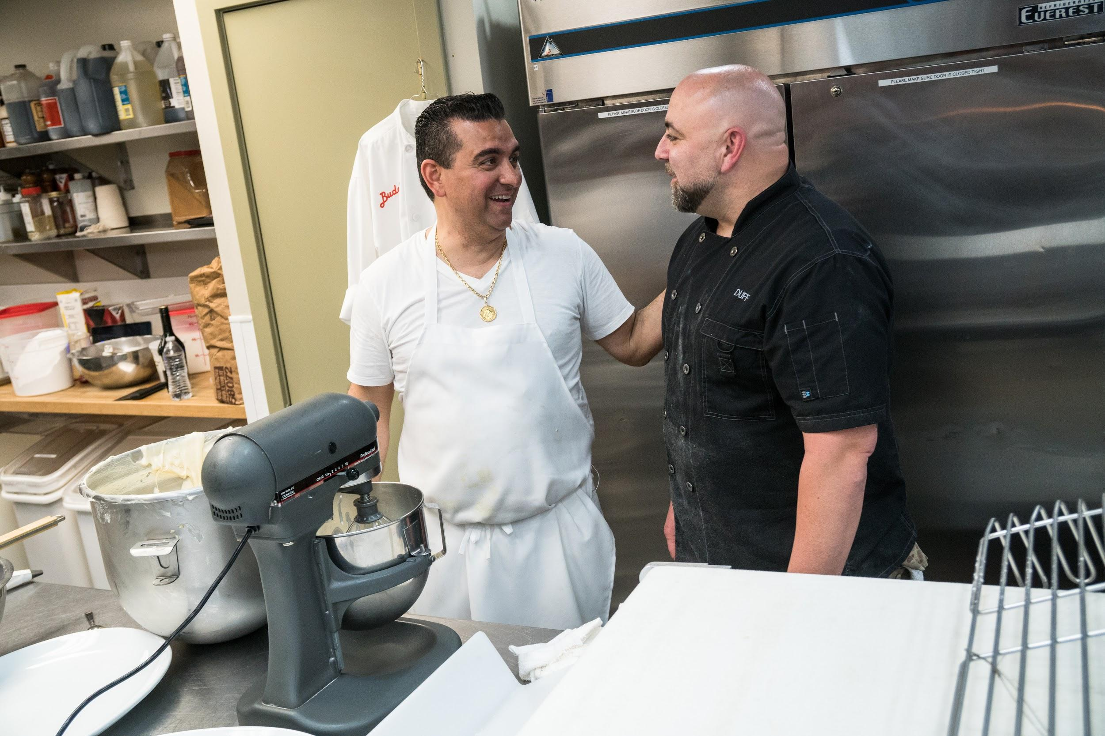
*Image is attached to this email*

In an epic competition to end the greatest feud in baking history, Buddy Valastro and Duff Goldman go head-to-head in a series of challenges befitting their extraordinary expertise. They start with a bake-off testing their dessert skills of all kinds, and then they head into the cake-off, where the chefs and their assistants try to outdo one another

Premiere Date: 27 March 2019, Wednesday
Time: 8pm (MY)
Episodes: 6 x 60 mins

---



Animal Planet (Astro Channel 556)

Tanked S8B
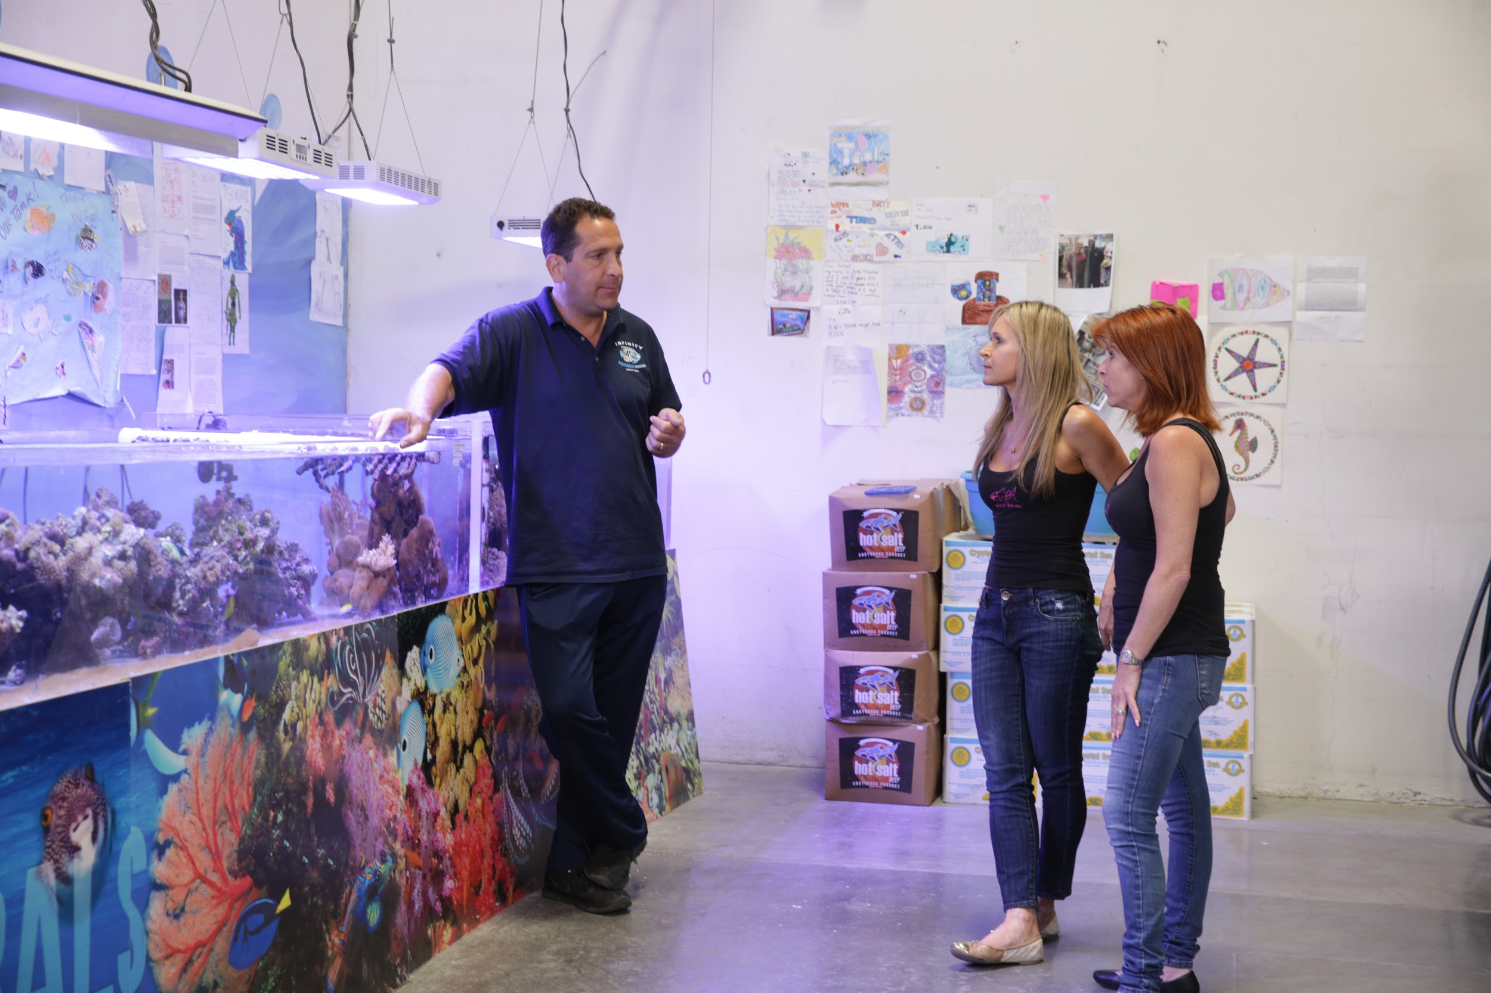
*Image is attached to this email*

Docu-series that follows the ATM aquarium building company in Las Vegas. A family business housed in a state-of-the-art 13,000 sq. ft. facility located in the center of Sin City, ATM takes on over 200 projects every year on every scale.

Premiere Date: 3 March 2019, Sunday
Time: 9pm (MY)
Episodes: 10 x 60 mins

Into Alaska

*Image is attached to this email*

Alaska's vast refuges were set aside solely for the purpose of maintaining and preserving irreplaceable natural assets, and protecting the wildlife population. For the men and women of the U.S. Fish and Wildlife Service, this is more than a job. It's a constant battle to protect America's endangered wildlife treasures on land, under water, and in the air a fight that never ends.

Premiere Date: 15 March 2019, Friday
Time: 9.55pm (MY)
Episodes: 10 x 60 mins

---



Discovery Asia (Astro Channel 571)

MH370: Inside The Situation Room

*Image is attached to this email*

On March 8th 2014 flight MH370 vanished less than an hour after take off. This is the exclusive behind-the- scenes documentary on the biggest, most mysterious and political plane crash since the Lockerbie disaster

Premiere Date: 8 March 2019, Friday
Time: 9pm (MY)

Orangutan Jungle School

*Image is attached to this email*

A docu-soap following the hilarious antics, triumphs, and tragedies of a gang of orphan orangutans as they progress through a unique forest school system. They don't know it yet, but these curious youngsters are destined for great things if they graduate from this school with a difference the chance to live free in the wild. Along the way they endure all the embarrassments, tears, tantrums and teenage crushes that come with growing up orangutan.

Premiere Date: 7 March 2019, Thursday
Time: 9pm (MY)
Episodes: 10 x 60 mins

---



Asian Food Channel (Astro Channel 703)

Our Makan Places Lost & Found S6

*Image is attached to this email*

What happens when your favourite food stalls move away from their usual spot? Our Makan Places: Lost and Found swoops in to find them of course! From your favourite local dishes, to more non – traditional hawker food, our host Gurmit Singh and his guests goes on an adventure to hunt down stalls which have relocated in this brand new season of Our Makan Places: Lost and Found.

Premiere Date: 15 March 2019, Friday
Time: 9pm (MY)
Episodes: 6 x 30 mins

Buzzing Hawkers

*Image is attached to this email*

There are thousands of hawker stalls in Singapore but why are some so successful and others not? Is it the food, the location or the packaging? Chua Enlai and Rishi Budhrani will extend a helping hand to struggling hawkers hoping to keep their stalls afloat. With the help of a mentor chef and Taste Squad, each hawker will only have one chance to get it right. Will they be able to rejuvenate their business and bring in the customers? The challenge starts now!

Premiere Date: 20 March 2019, Wednesday
Time: 9pm (MY)
Episodes: 14 x 60 mins

---



Food Network (Astro Channel 727)

Big Food Truck Tip

*Image is attached to this email*

Andrew Zimmern travels across the US to find food truck entrepreneurs who love sharing their culinary creations with the public. In the end, he helps a deserving truck owner take their business to the next level with a cash award

Premiere Date: 4 March 2019, Monday
Time: 9pm (MY)
Episodes: 6 x 30 mins

Cheap Eats

*Image is attached to this email*

Join host Marc Summers each week in Unwrapped which uncovers behind-the-scenes details on classic American food, from peanut butter and chocolate syrup to French fries and bubblegum

Premiere Date: 20 March 2019, Wednesday
Time: 11pm (MY)
Episodes: 13 x 30 mins

Girl Meets Farm

*Image is attached to this email*

Cookbook author, food blogger and Midwest transplant Molly Yeh is embracing her country life on the border of Minnesota and North Dakota. In her cozy farmhouse kitchen, Molly makes dishes inspired by her Jewish and Chinese heritage that are not only delicious but also beautiful to look at. With her fresh and tasty ideas, Molly brings multicultural Midwestern inspiration and fun to kitchens across America.

Premiere Date: 21 March 2019, Thursday
Time: 9pm (MY)
Episodes: 13 x 30 mins

---



HGTV (Astro Channel 731)

Home Town S2

*Image is attached to this email*

Erin and Ben Napier love their small Mississippi hometown, especially the old historical houses. Using found materials and old textiles, they're keeping the character of these classic homes but giving them modern and affordable updates.

Premiere Date: 11 March 2019, Monday
Time: 8pm (MY)
Episodes: 10 x 60 mins

Flip or Flop Nashville S1

*Image is attached to this email*

Page Turner and DeRon Jenkins are busy house flippers in Nashville and Atlanta - and, they
also happen to be exes. For this driven former couple, no job is too big, too small or too dirty.
With a decade of partnership, this duo knows the real estate game inside and out, and they're
willing to fight the market -- and maybe each other -- to get top dollar.

Premiere Date: 14 March 2019, Thursday
Time: 9pm (MY)
Episodes: 9 x 30 mins

We would appreciate if you could highlight this in your upcoming issues / online features. You may access hi-res images from this link for your usage.

Should you require further information, do not hesitate to drop me a line at vanesa@madhat.asia / 016 342 5957

