Viu Malaysia to Simulcast Latest Cantonese Content
from Hong Kong’s ViuTV

KUALA LUMPUR, 14 June 2019 - Leading entertainment streaming service, Viu Malaysia, today announced new Cantonese offerings including simulcast shows such as Retire To Queen and Limited Education. Viu Malaysia viewers will now have access to the latest Cantonese dramas and variety shows, such as Hong Kong’s hit shows, as well as upcoming ViuTV Hong Kong original series.

“Viu promises to bring the latest and fresh content to its audiences and hence simulcast Cantonese content made perfect sense to us. The Chinese community is the second largest population in Malaysia. By bringing Cantonese stars such as Bowie Lam and Bernice Liu to Viu Malaysia, digital audiences seeking the latest entertainment from Hong Kong will be able to easily access it. We are also subtitling these shows in Bahasa Malaysia, as well as English and Chinese, to make sure that they can be enjoyed by all our Viuers in Malaysia,” said Kingsley Warner, General Manager, Vuclip Malaysia.

Beginning in mid-June, Retire To Queen and Limited Education will be available. Both of the 20-episode dramas feature contemporary plots and award-winning stars. More details follow:

Retire to Queen
Flora King, comes back to her first major drama role in thirty years as Sara, alongside the members of Hong Kong hottest Boy Band “Mirror” in this 20 episode series. ‘Retire to Queen’ tells the story of a retiree taking her first bold step toward the world of esports. Watch the drama unfold as Sara who was once the most powerful lady at a big corporation is forced into early retirement unexpectedly. By accident, she ends up joining a gaming and esports company set up by five young gamers. When baby boomer meets millennial, a major clash between generations is inevitable. Against all the odds, they build an age-diverse, strong and powerful esports team. The show also stars Deep Ng, Ning Sit, Chui Ho Cheung, Tsz Hei Li, Chi Wai Pang and Show Keung.

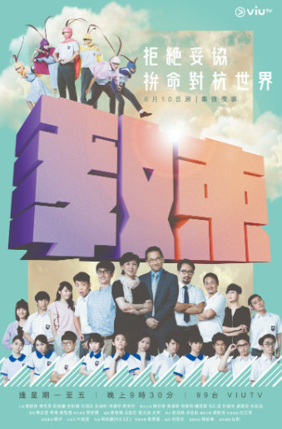
Limited Education

This campus drama revolves around a high school teacher and stars legendary TV actress, Amy Chan and Hong Kong Film Awards’ Best Supporting Actor, Dick Liu. As a teacher, having a stable income has always been Lo Man-Tat’s biggest concern. But everything changes when the school’s principal decides to join the Direct Subsidy Scheme. The school’s vice-principal Ms. Lam believes joining the scheme is going to hurt the reputation of her beloved school, so she enlists the help of Man-tat and a group of underdog students, hoping to stop the school from going private. Produced by one of Hong Kong’s hottest young filmmakers, Steve Chan, and also featuring actors such as Terrance Lau, Chu Pak Him, Kaki Sham, Sofiee Ng, Tong Ho Yin as well as Hon Ling Chau, this show is set to make you feel nostalgic about your high school days.

You can watch these shows and more on the Viu app, available for free on the App Store and Google Play, on connected devices such as smartphones and tablets, as well as on the web at www.viu.com.
###

About Viu

Viu is a leading entertainment streaming service available in 17 markets including Hong Kong, Singapore, Malaysia, India, Indonesia, the Philippines, Thailand, Myanmar, South Africa and Middle East countries of UAE, Saudi Arabia, Egypt, Bahrain, Iraq, Jordan, Kuwait, Oman, Qatar. Viu’s unique value proposition of fresh and localized regional and local premium TV shows, movies and originals entertains millions of consumers every day. Viu Originals bring to light compelling stories with world class production quality, also providing the opportunity for local talent to showcase their skills on a world stage. The service can be accessed via the Viu app available for free on the App Store and Google Play, on connected devices such as smartphones and tablets, as well as on the web at www.viu.com.

