12 DECEMBER 2018
FOR IMMEDIATE RELEASE

For further information, and media enquiries
Candy Lo +6016 588 0966 candy@madhat.asia
Hui Shan +6012 295 1732 huishan@madhat.asia

WORLD LEADING MUSIC: 2 BACK-TO-BACK WEEKENDS
Heineken® Live Your Music kick starts your year-end celebration
with a big bang across Malaysia!

In December, Heineken® Live Your Music invites its fans to join the brand for two weekends of high energy back-to-back music experiences across 4 cities featuring innovative artist collaboration and performances from established global and local music icons.

Rolling out across the country, the first weekend of Heineken® Live Your Music saw a strong crowd turnout in Kuala Lumpur and Malacca to celebrate the 2 back-to-back weekends of music experiences.

Week 1, Day 1 (6 December 2018)

Heineken® Live Your Music presents Jhin & Dan $hiv,
supported by Mayhem Jam at S I X, Bangsar.
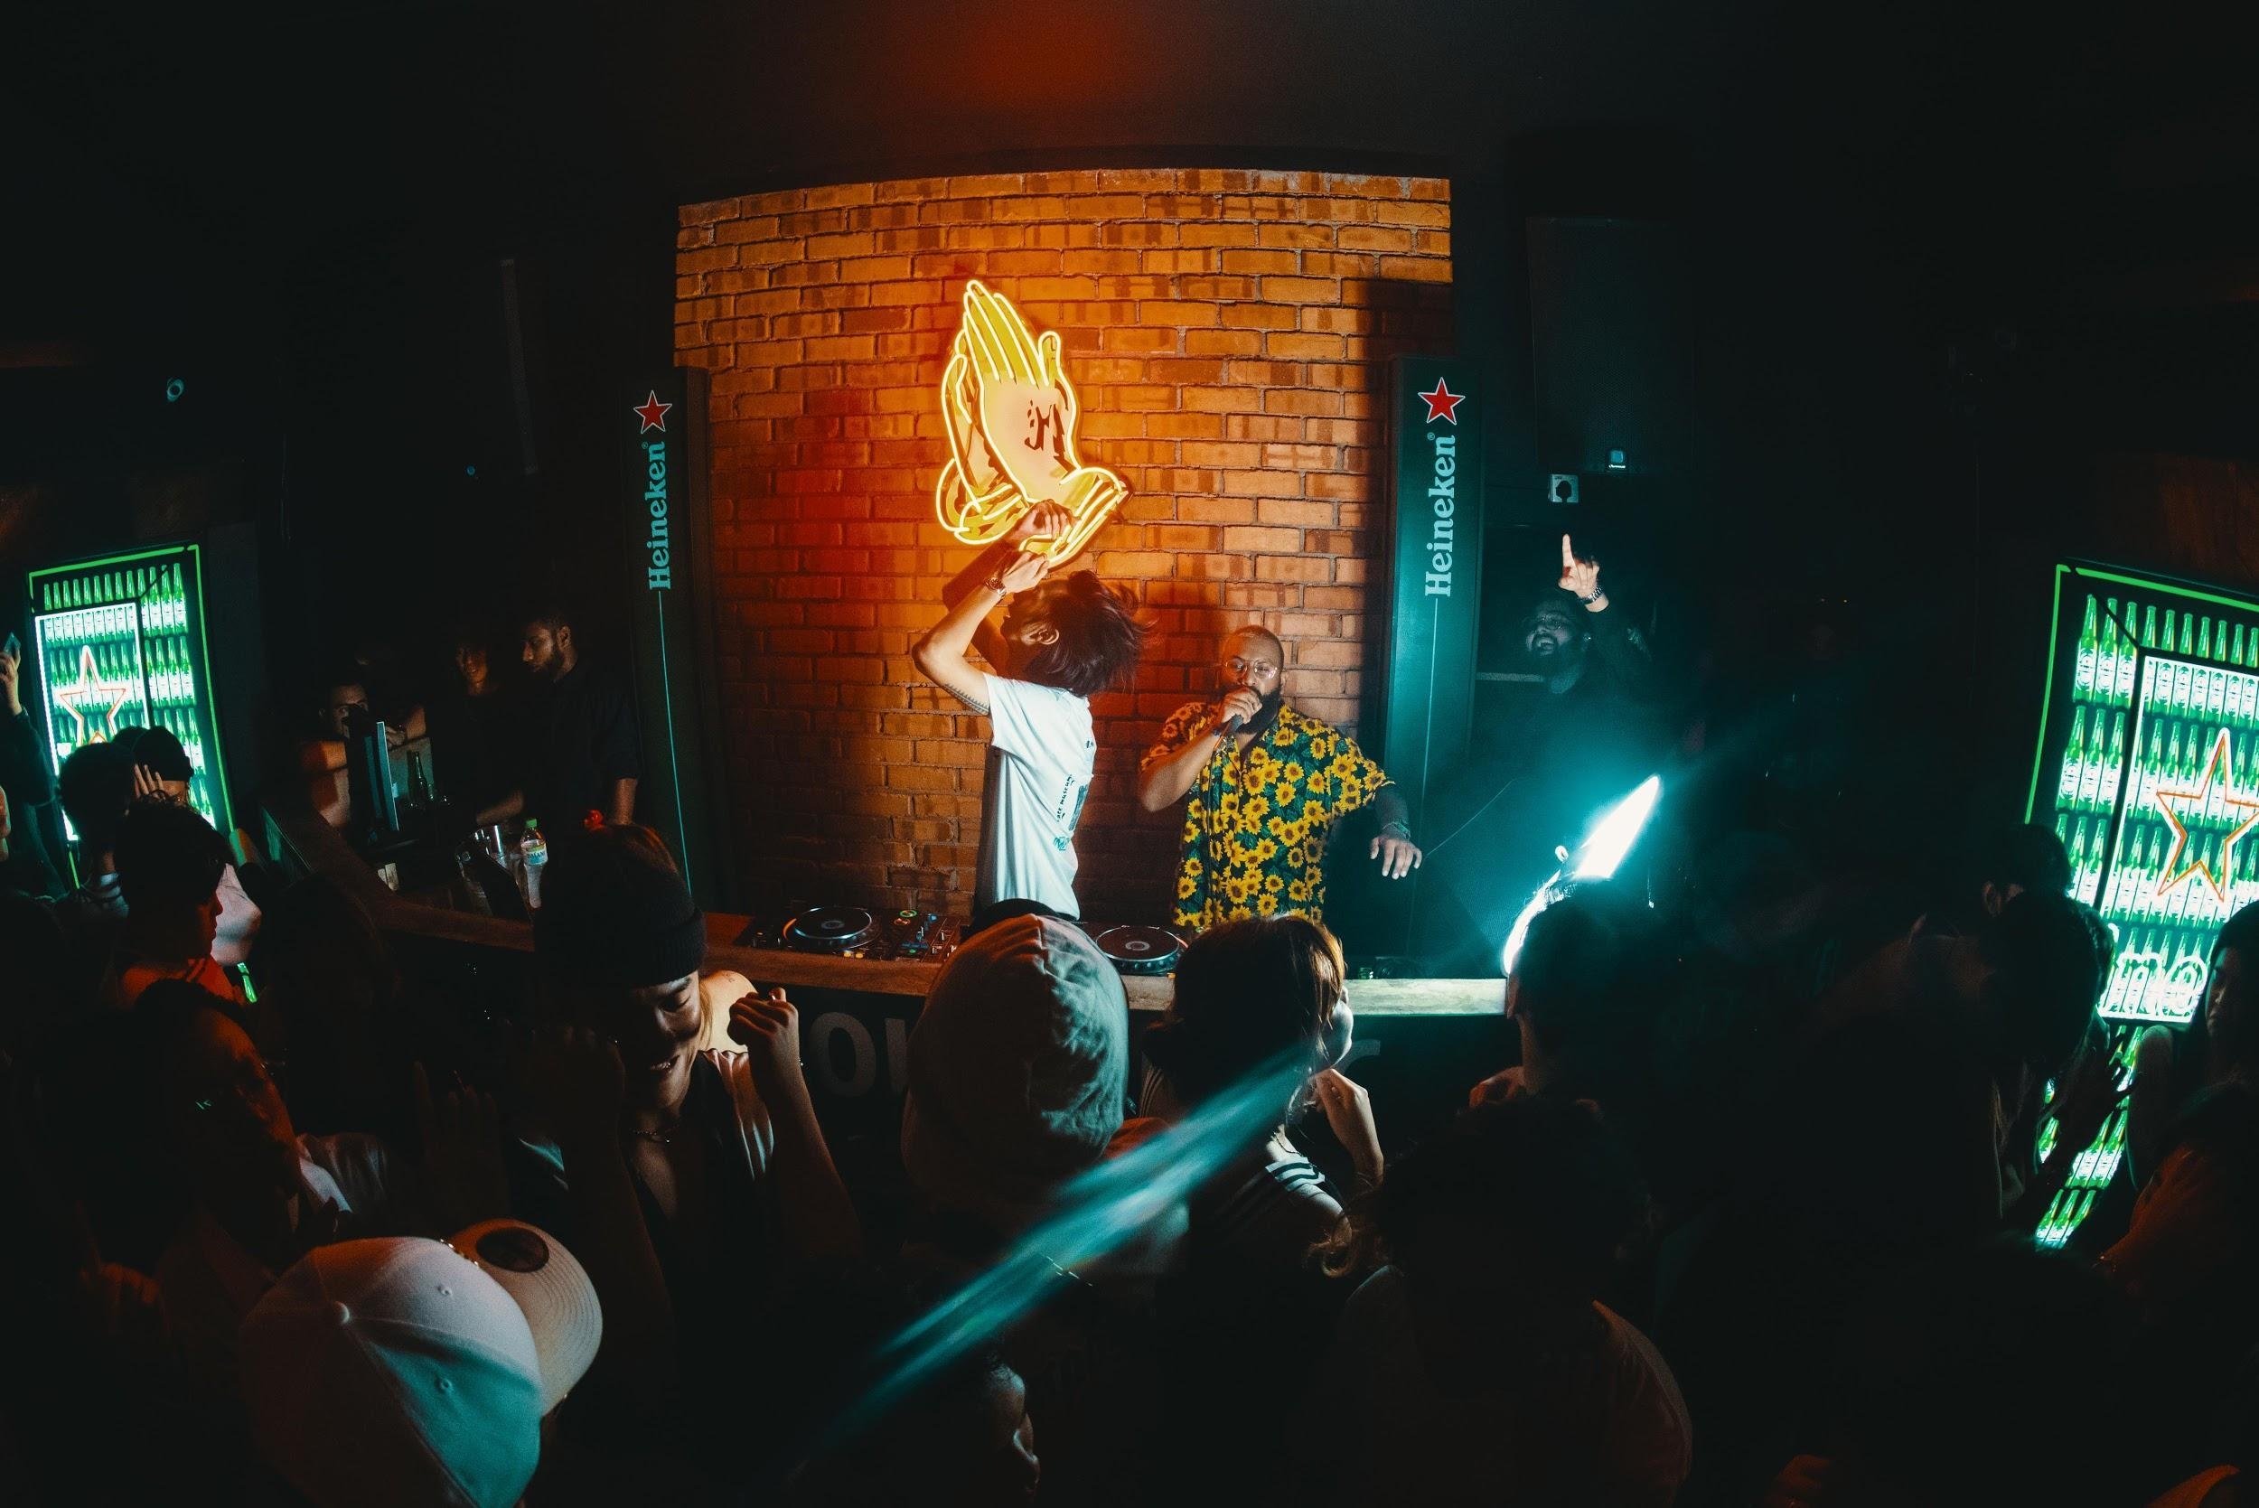
(HeinekenLiveYourMusic2018-01-PhotobyAllIsAmazing.jpg)

Mayhem Jam, freestyles its way onto the dancefloor, curated by
Malaysian dance icon MayB Wong.
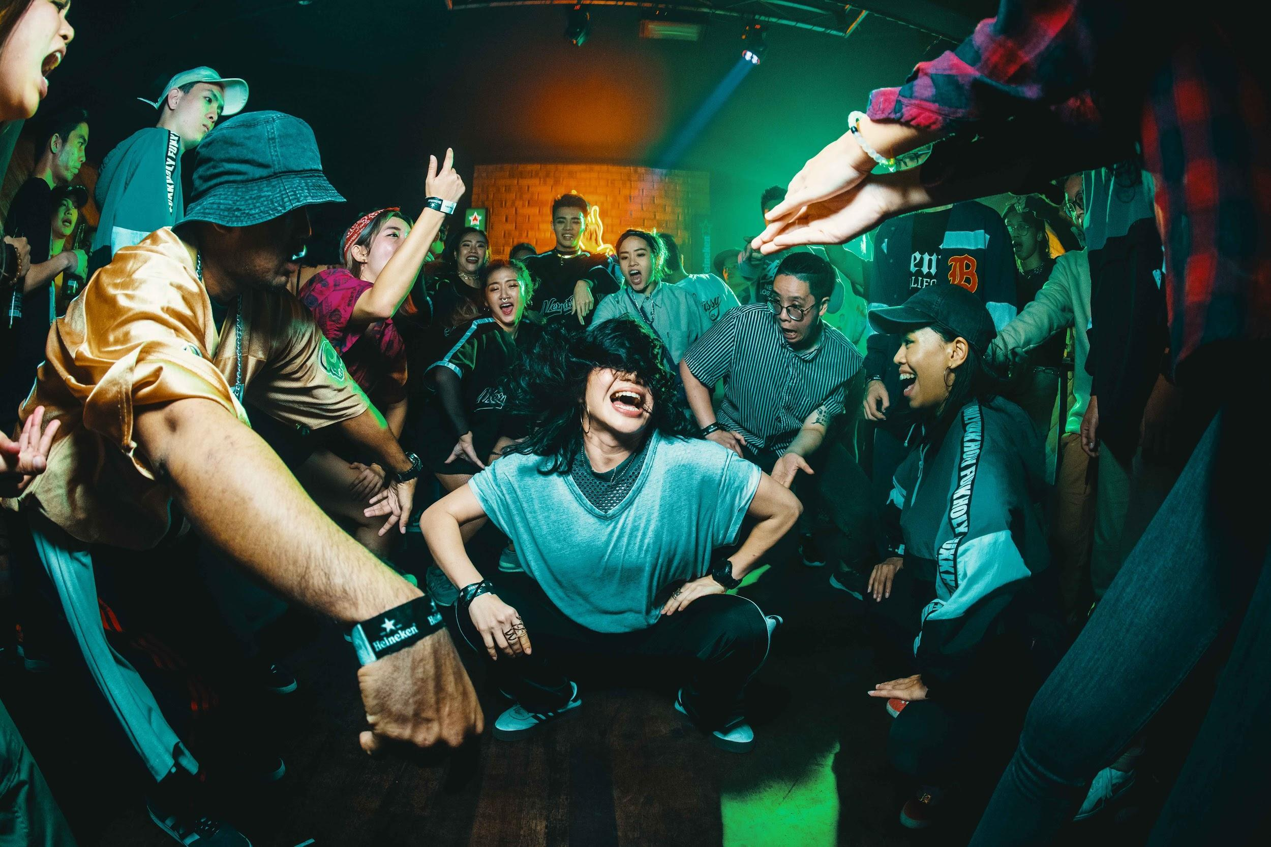
(HeinekenLiveYourMusic2018-02-PhotobyAllIsAmazing.jpg)

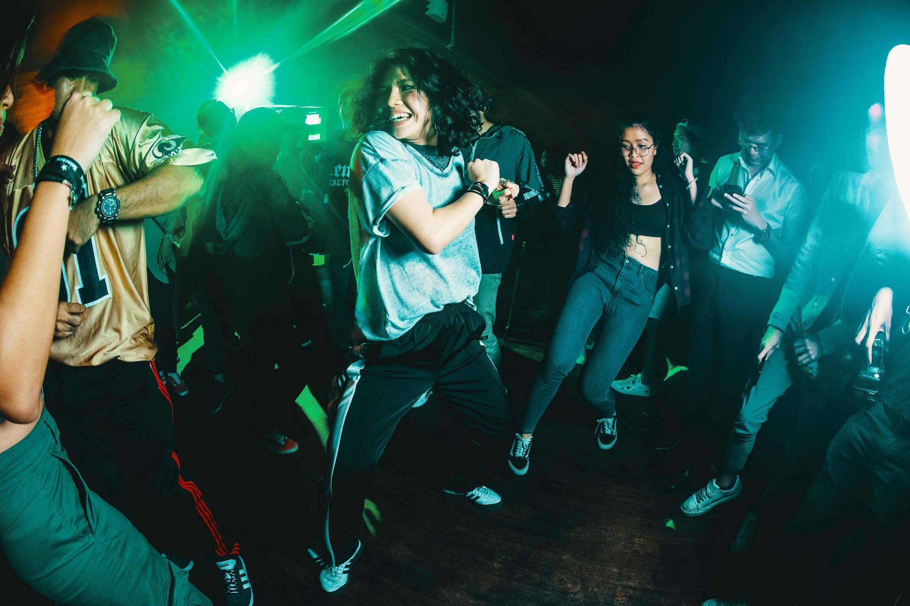
(HeinekenLiveYourMusic2018-03-PhotobyAllIsAmazing.jpg)
Week 1, Day 2 (7 December 2018)

Fans partied the night away at Heineken® Live Your Music presents Porter Robinson at Zouk KL, supported by homegrown music icons BATE and DJ Radz.
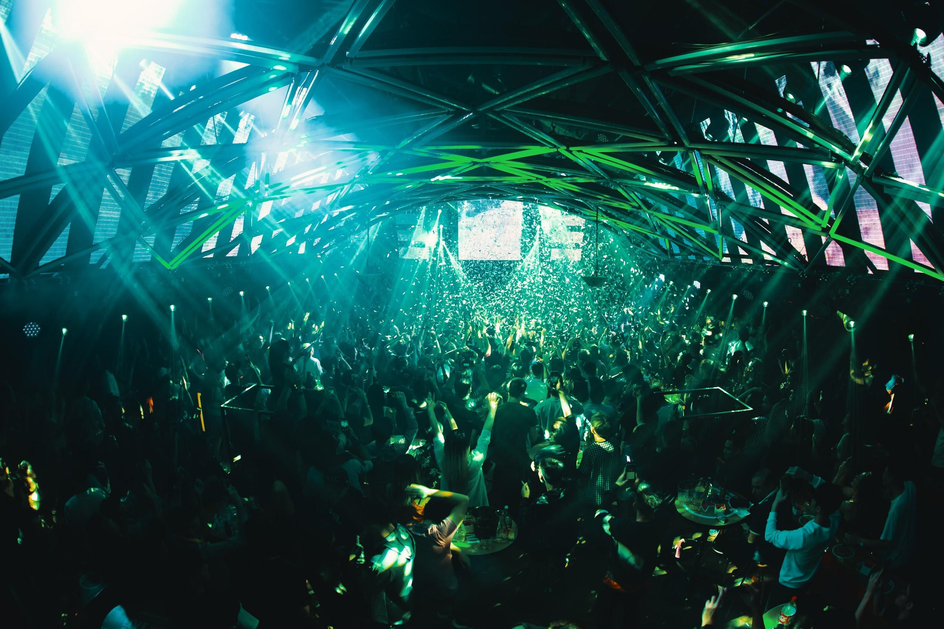
(HeinekenLiveYourMusic2018-04-PhotobyAllIsAmazing.jpg)

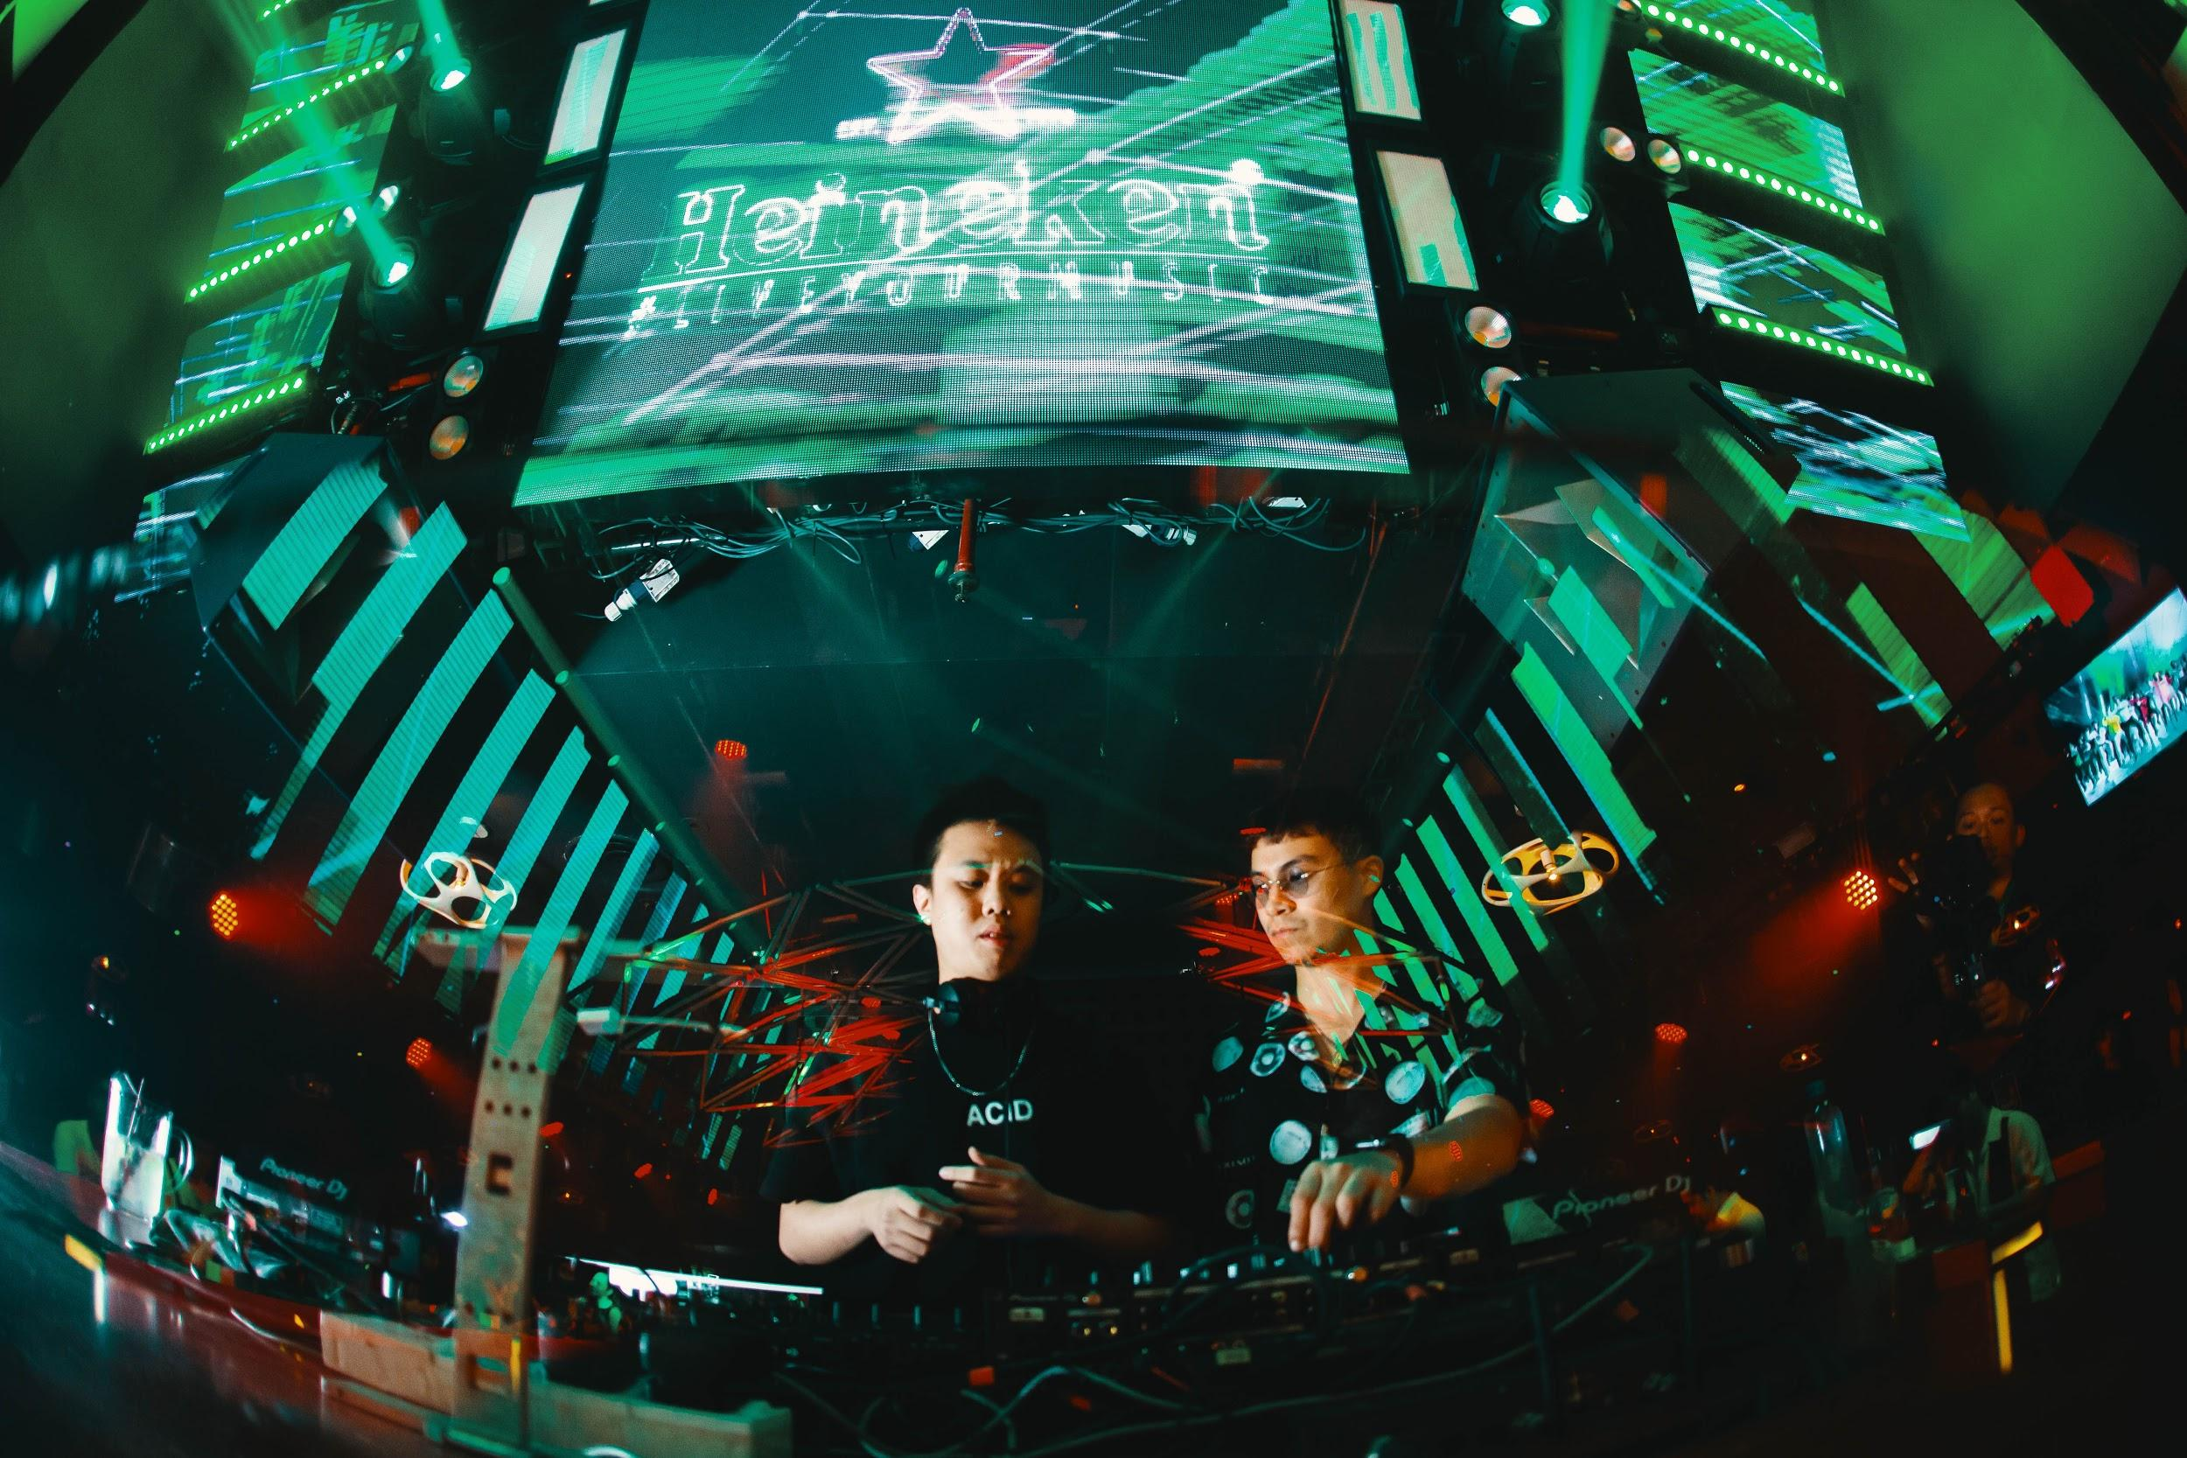(HeinekenLiveYourMusic2018-05-PhotobyAllIsAmazing.jpg)

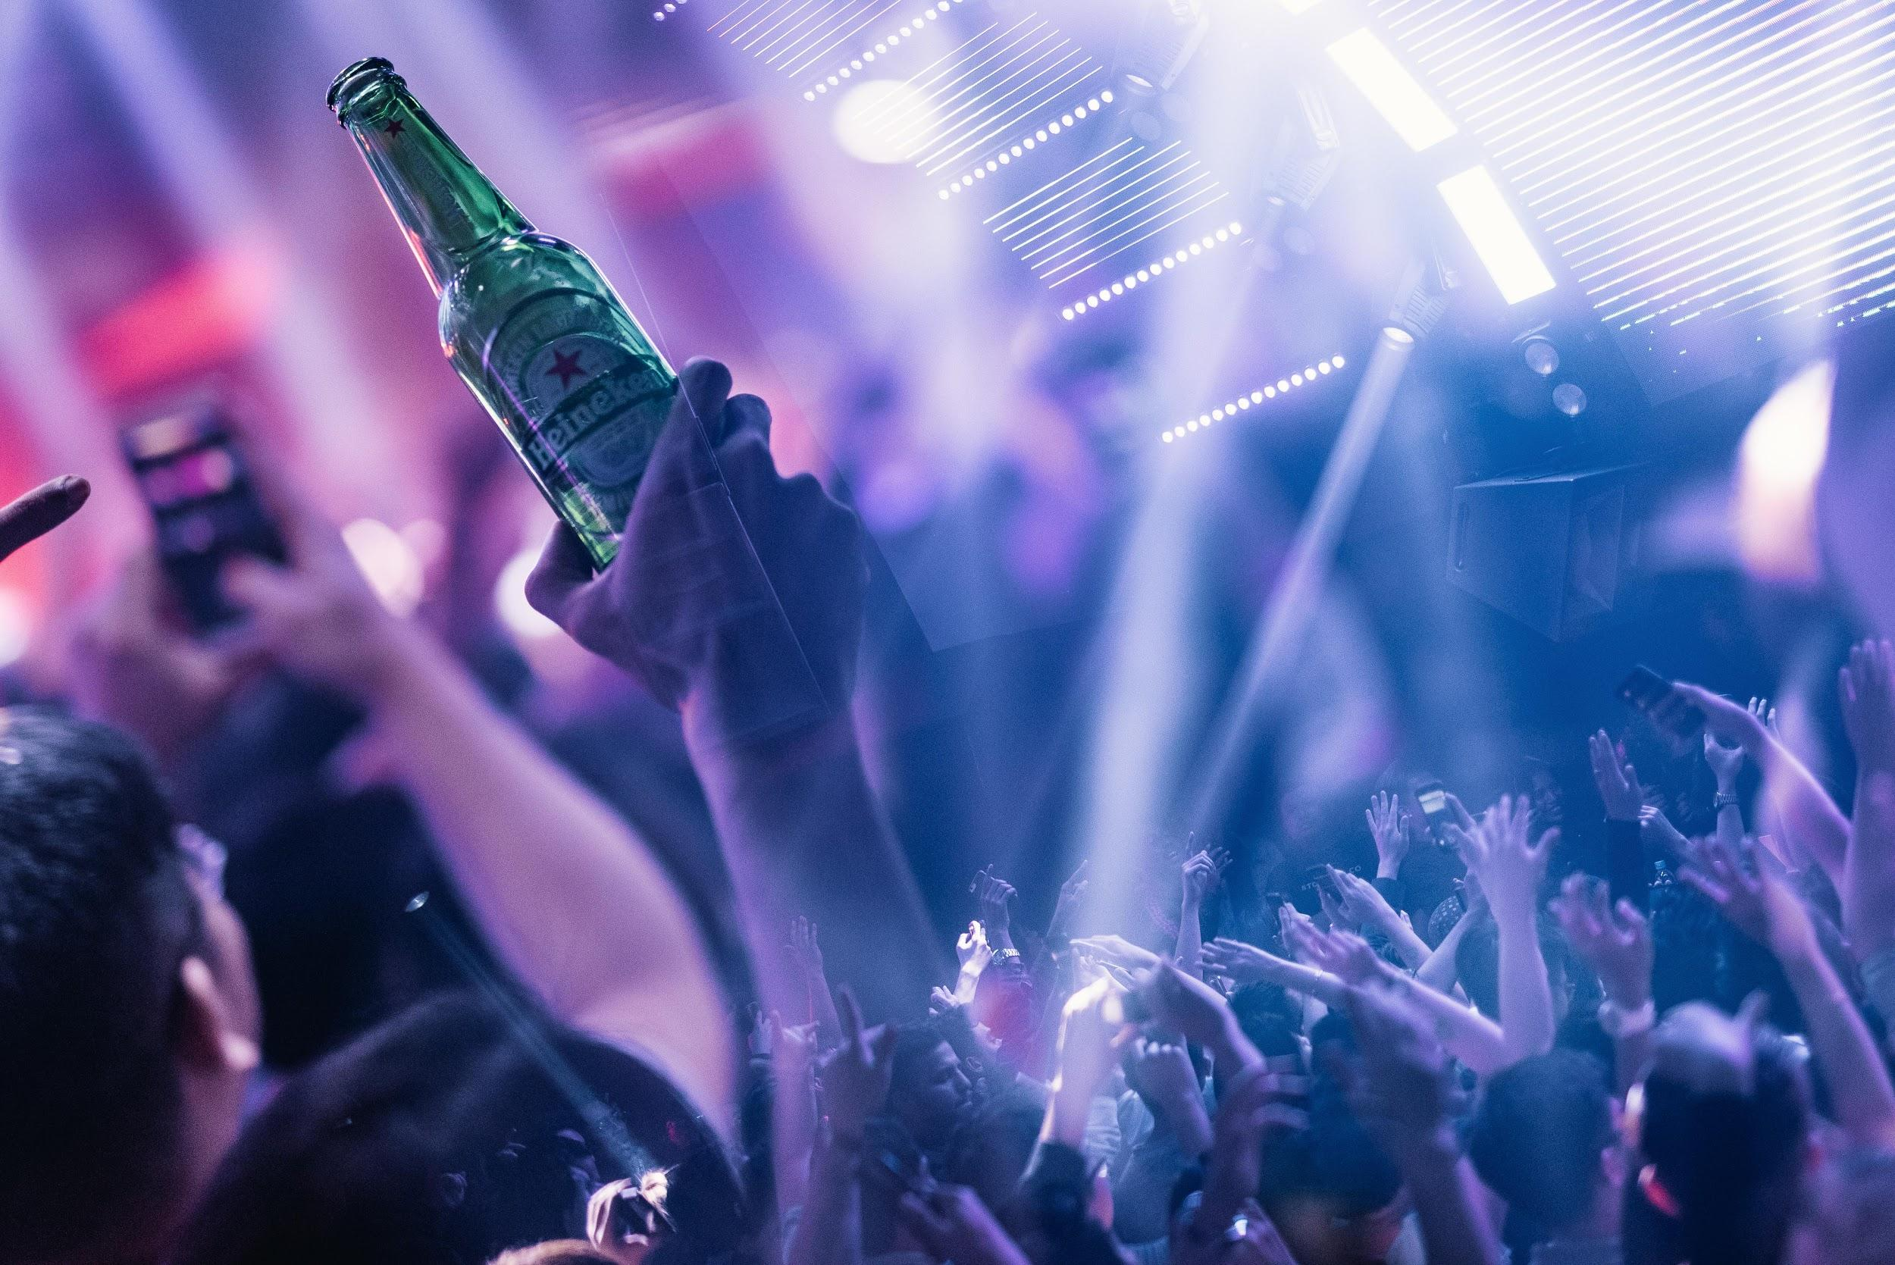
(HeinekenLiveYourMusic2018-06-PhotobyAllIsAmazing.jpg)

The interior of Zouk KL was transformed with the Heineken® green vector rooftop to give fans a cutting-edge visual experience at Heineken® Live Your Music presents Porter Robinson.
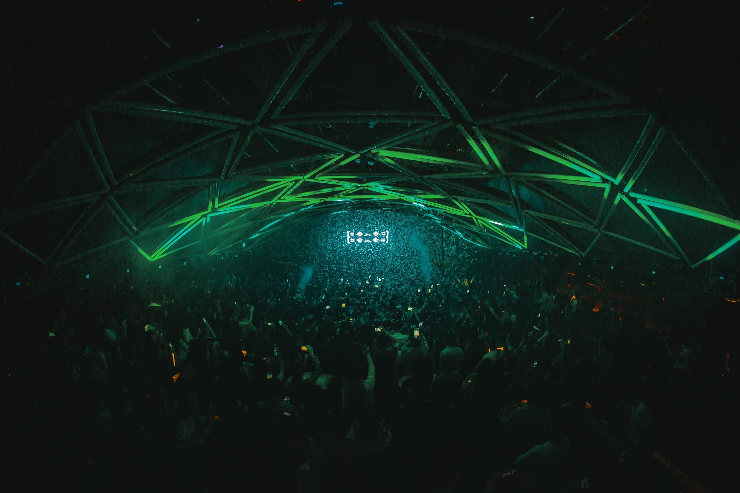
(HeinekenLiveYourMusic2018-07-PhotobyAllIsAmazing.jpg)

Porter Robinson brought a new flair to the Heineken® Live Your Music experience at Zouk KL, giving fans an unforgettable experience.
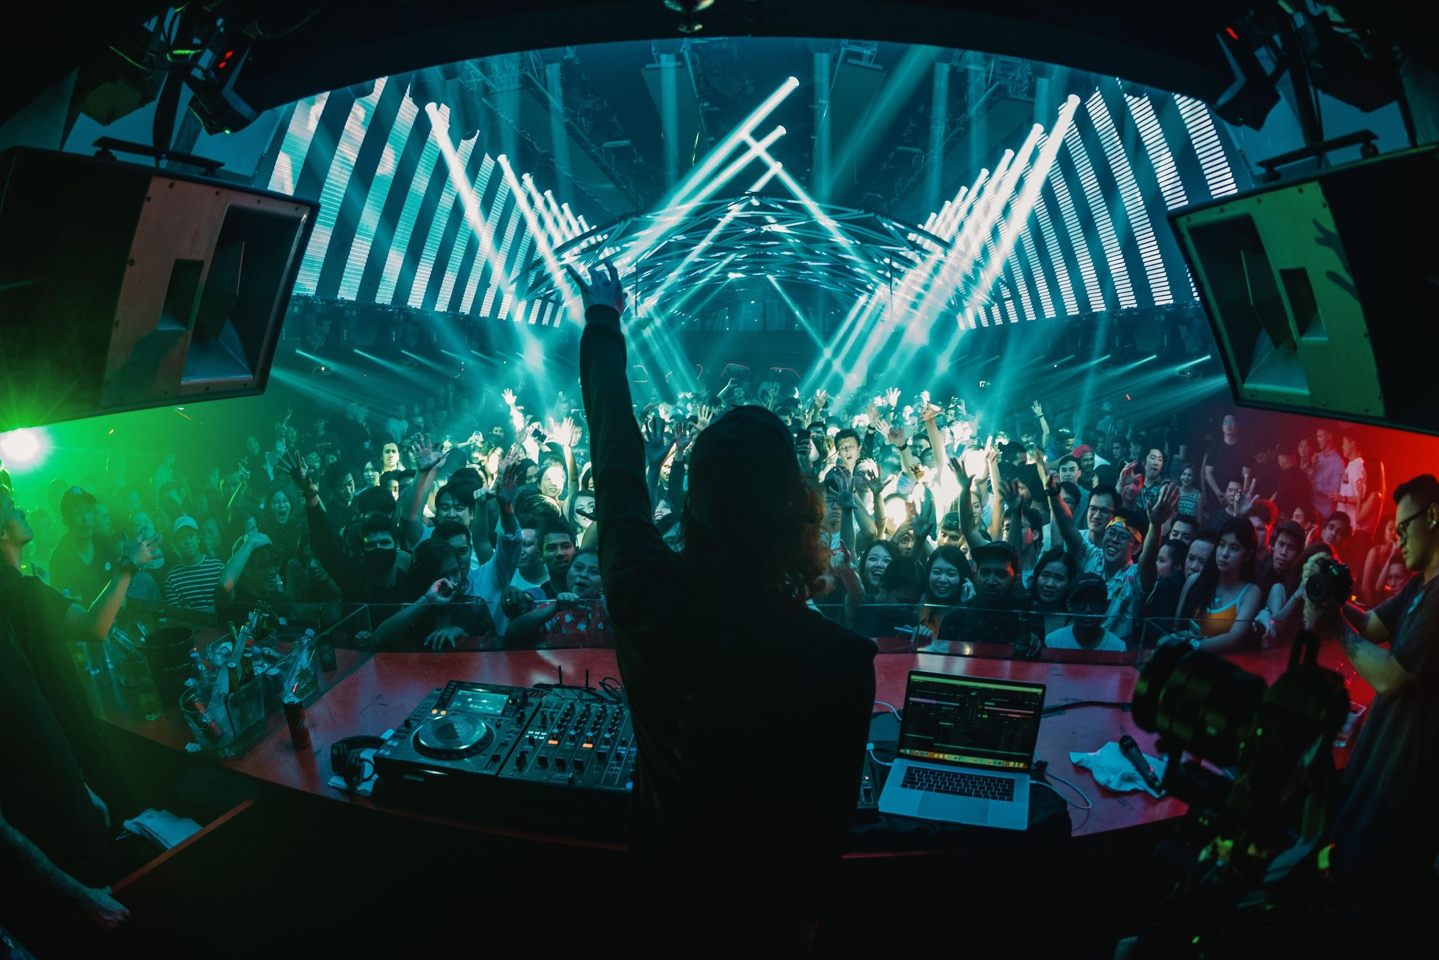
(HeinekenLiveYourMusic2018-08-PhotobyAllIsAmazing.jpg)

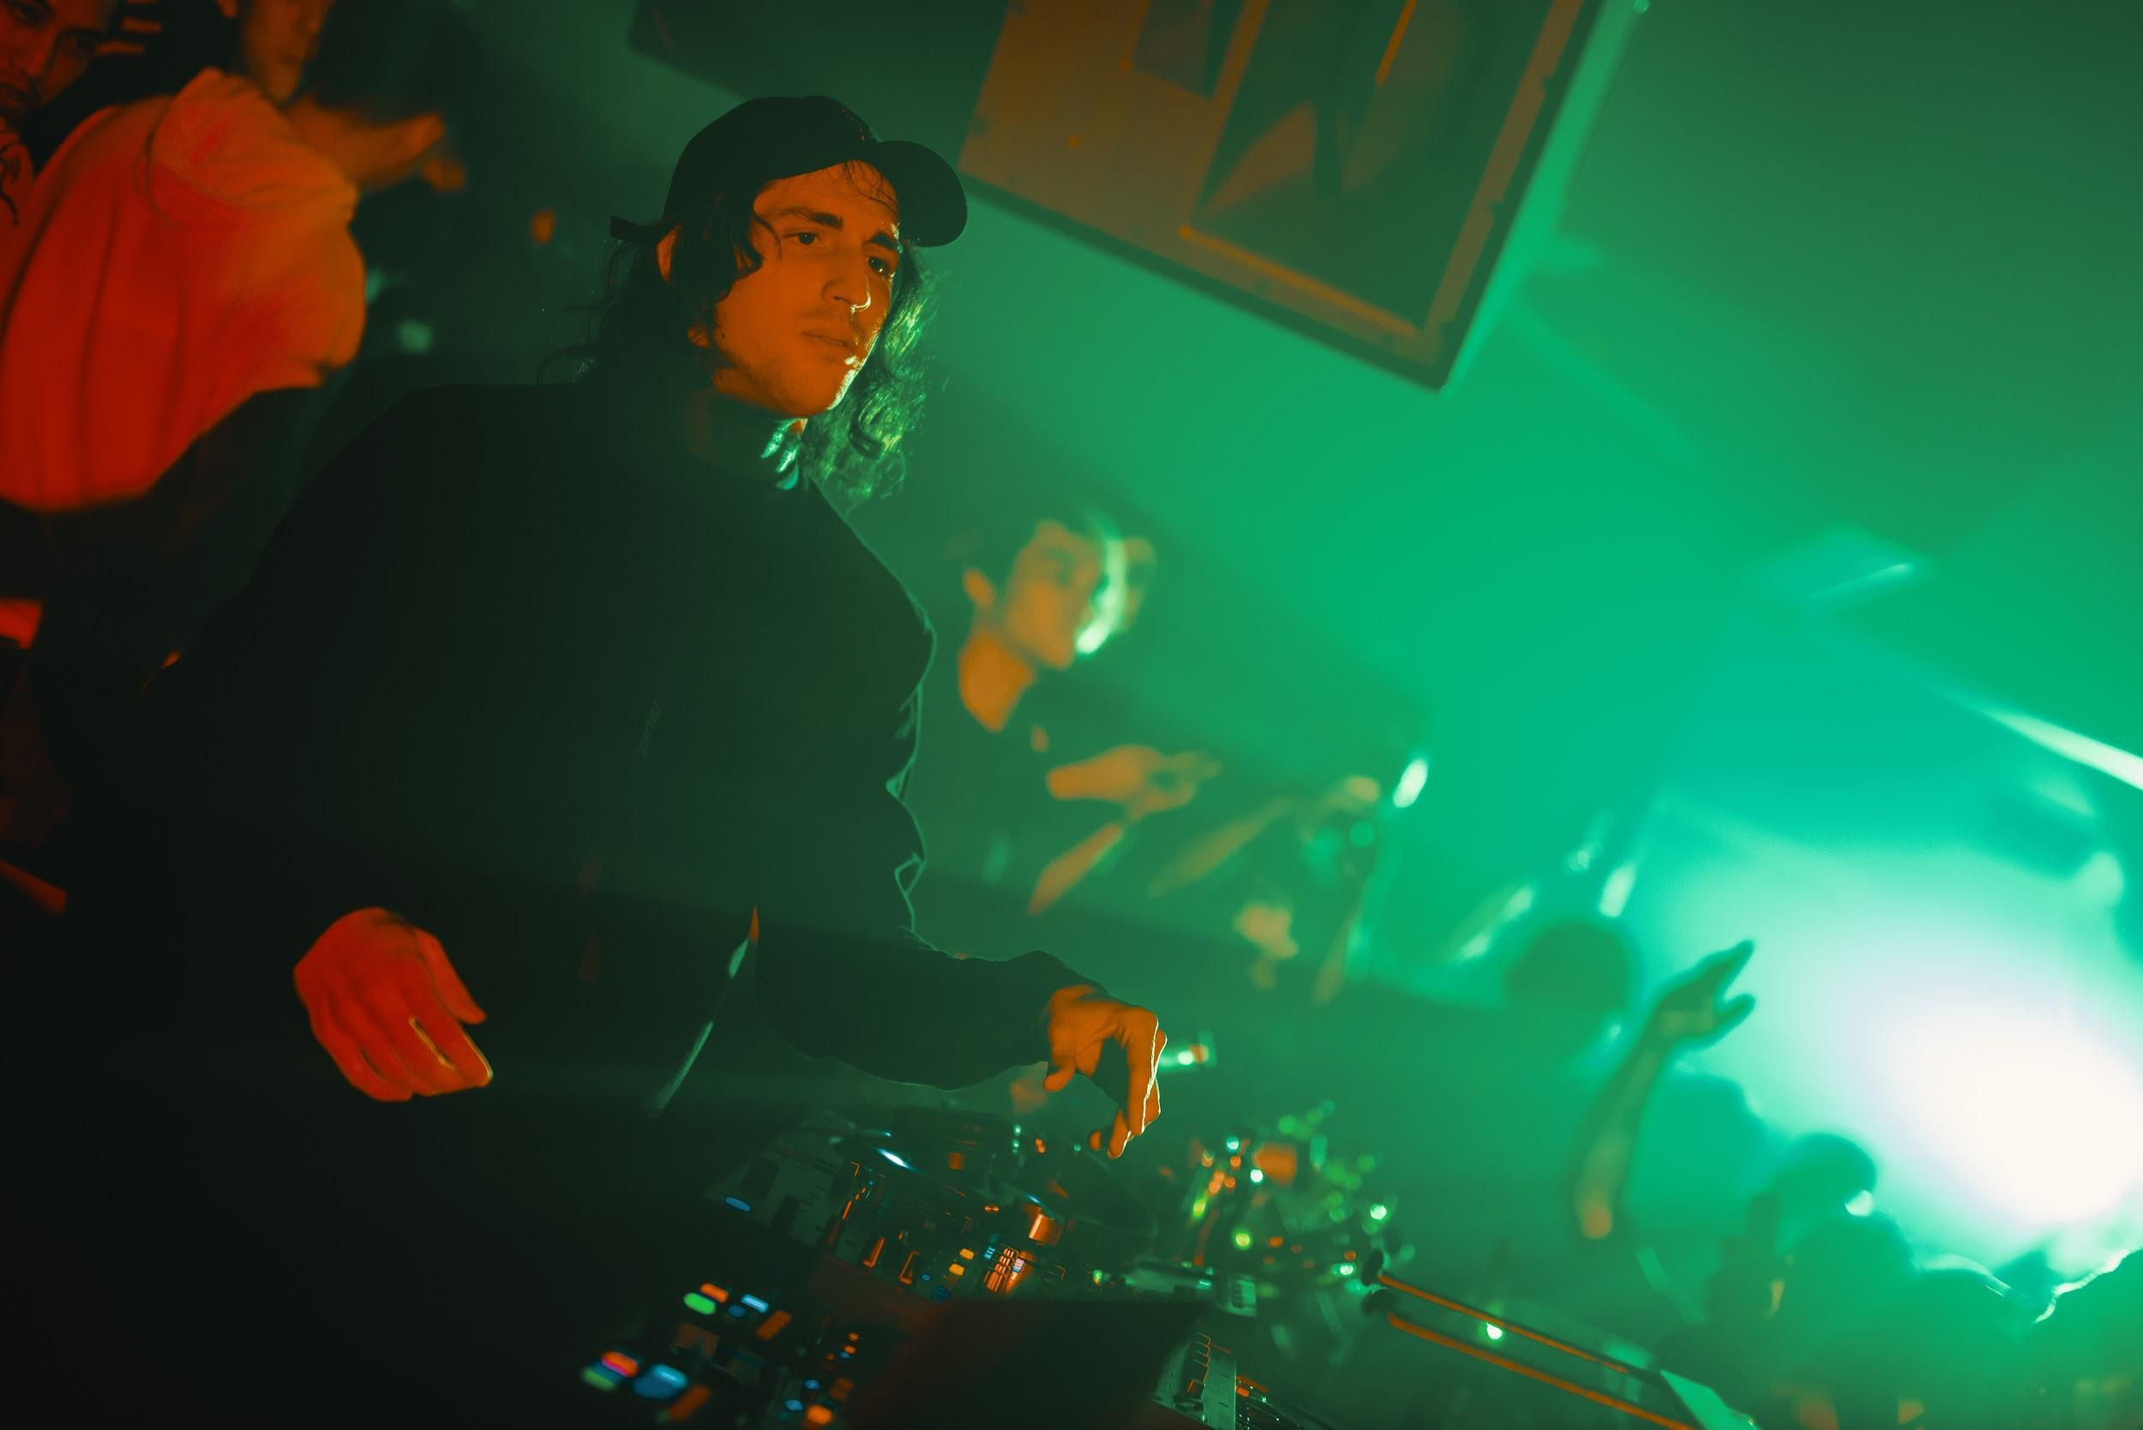
(HeinekenLiveYourMusic2018-09-PhotobyAllIsAmazing.jpg)

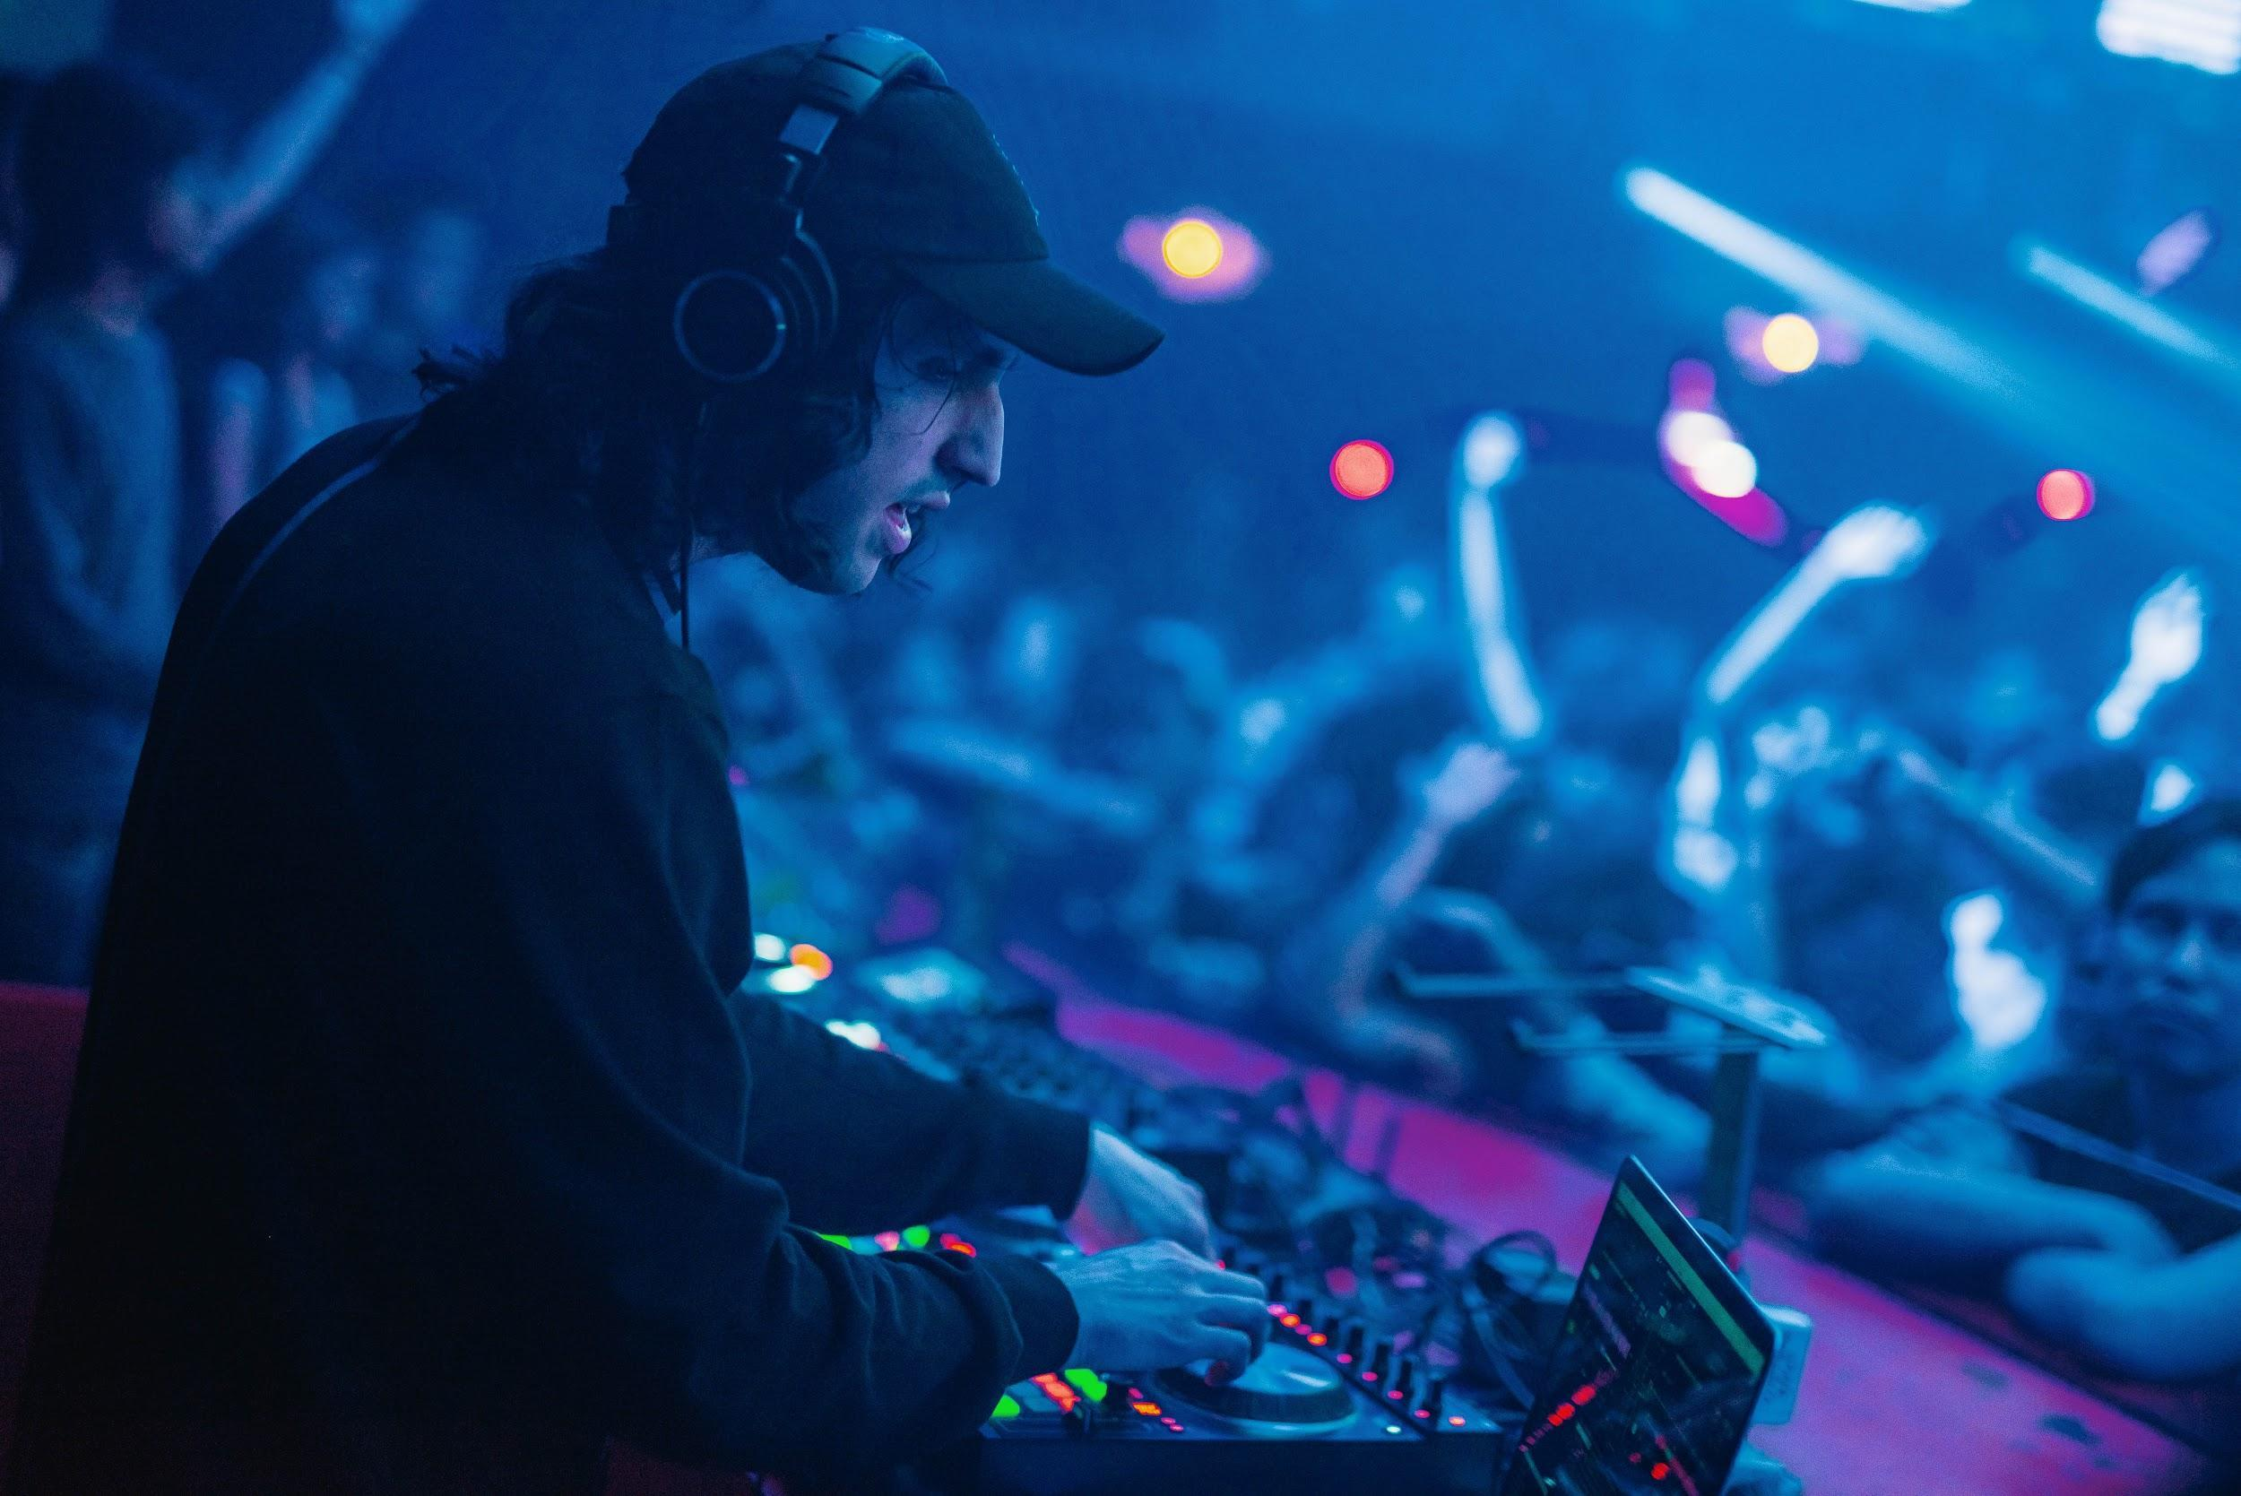
(HeinekenLiveYourMusic2018-10-PhotobyAllIsAmazing.jpg)

Week 1, Day 3 (8 December 2018)

Heineken® Live Your Music presents DJ Irwan turned Mixx Club, Malacca green in celebration of 2 weekends back-to back music experiences.
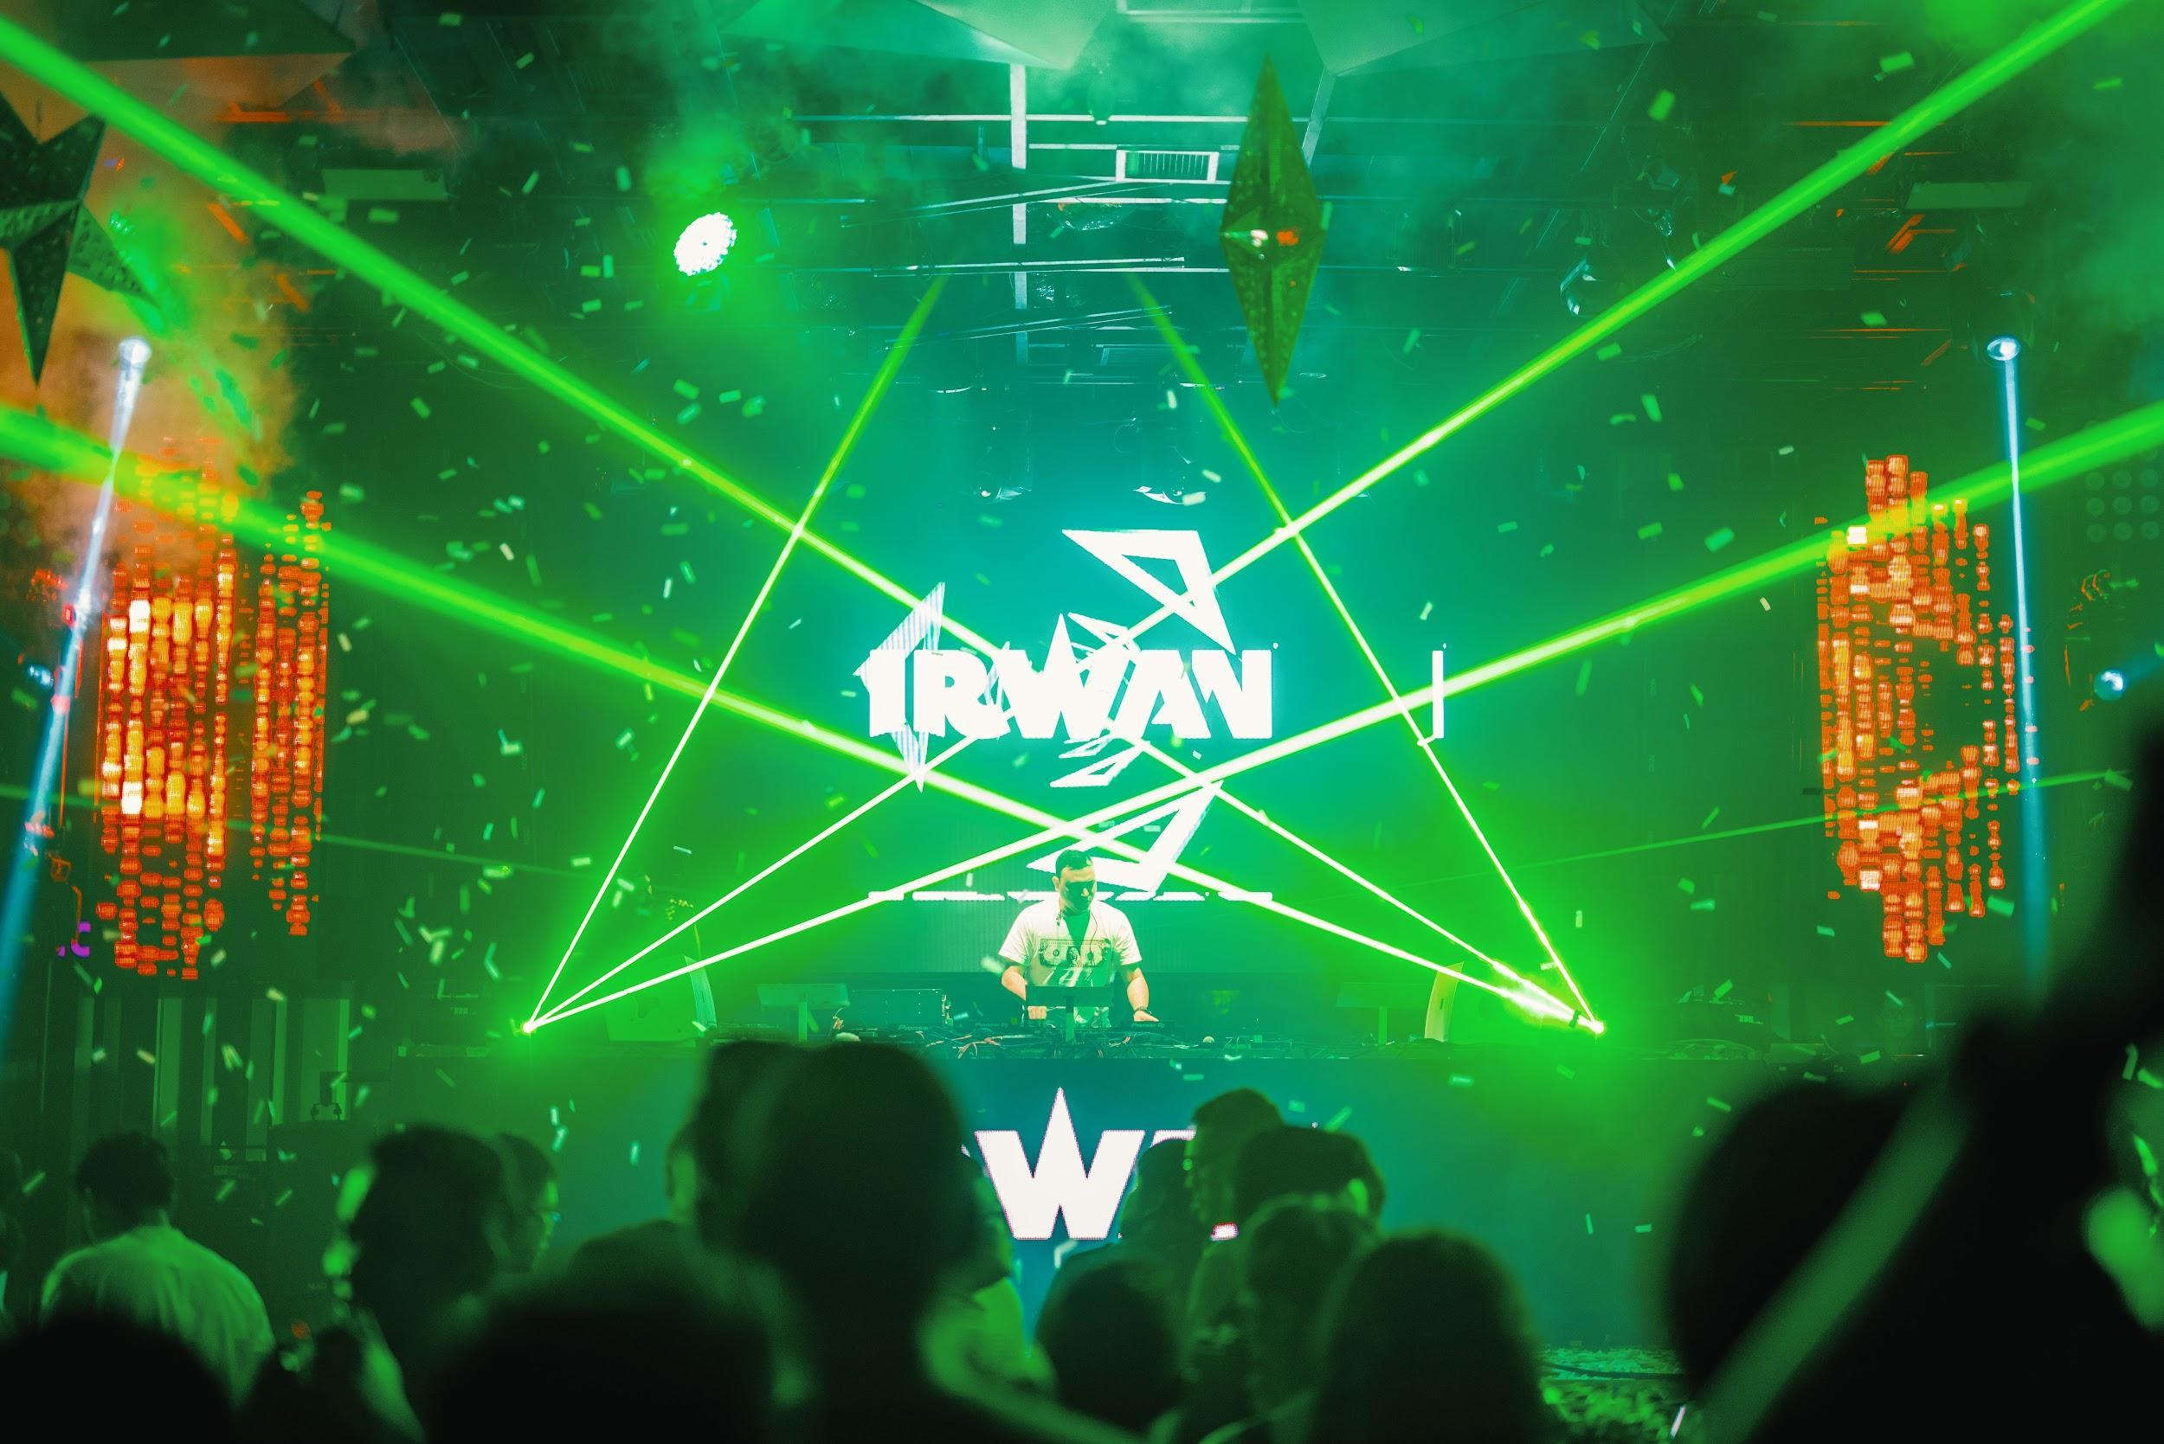
(HeinekenLiveYourMusic2018-11-PhotobyAllIsAmazing.jpg)

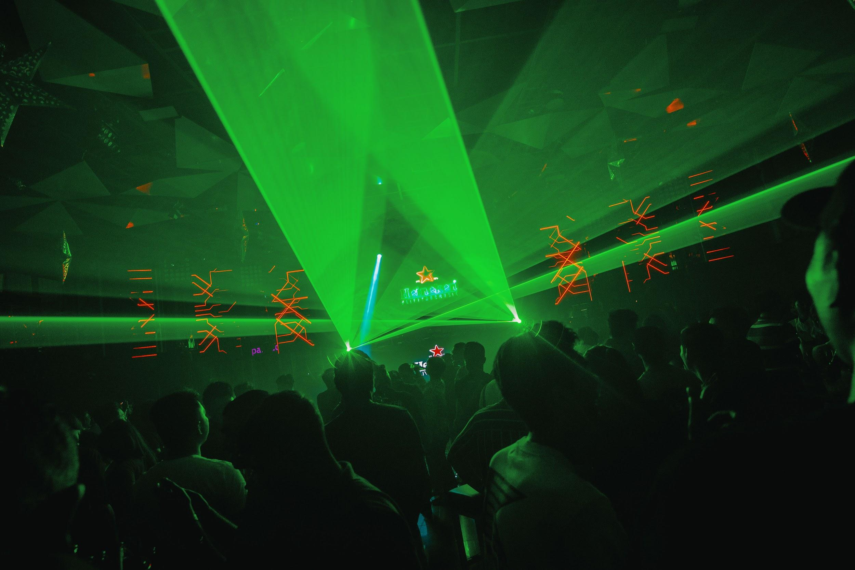
(HeinekenLiveYourMusic2018-12-PhotobyAllIsAmazing.jpg)

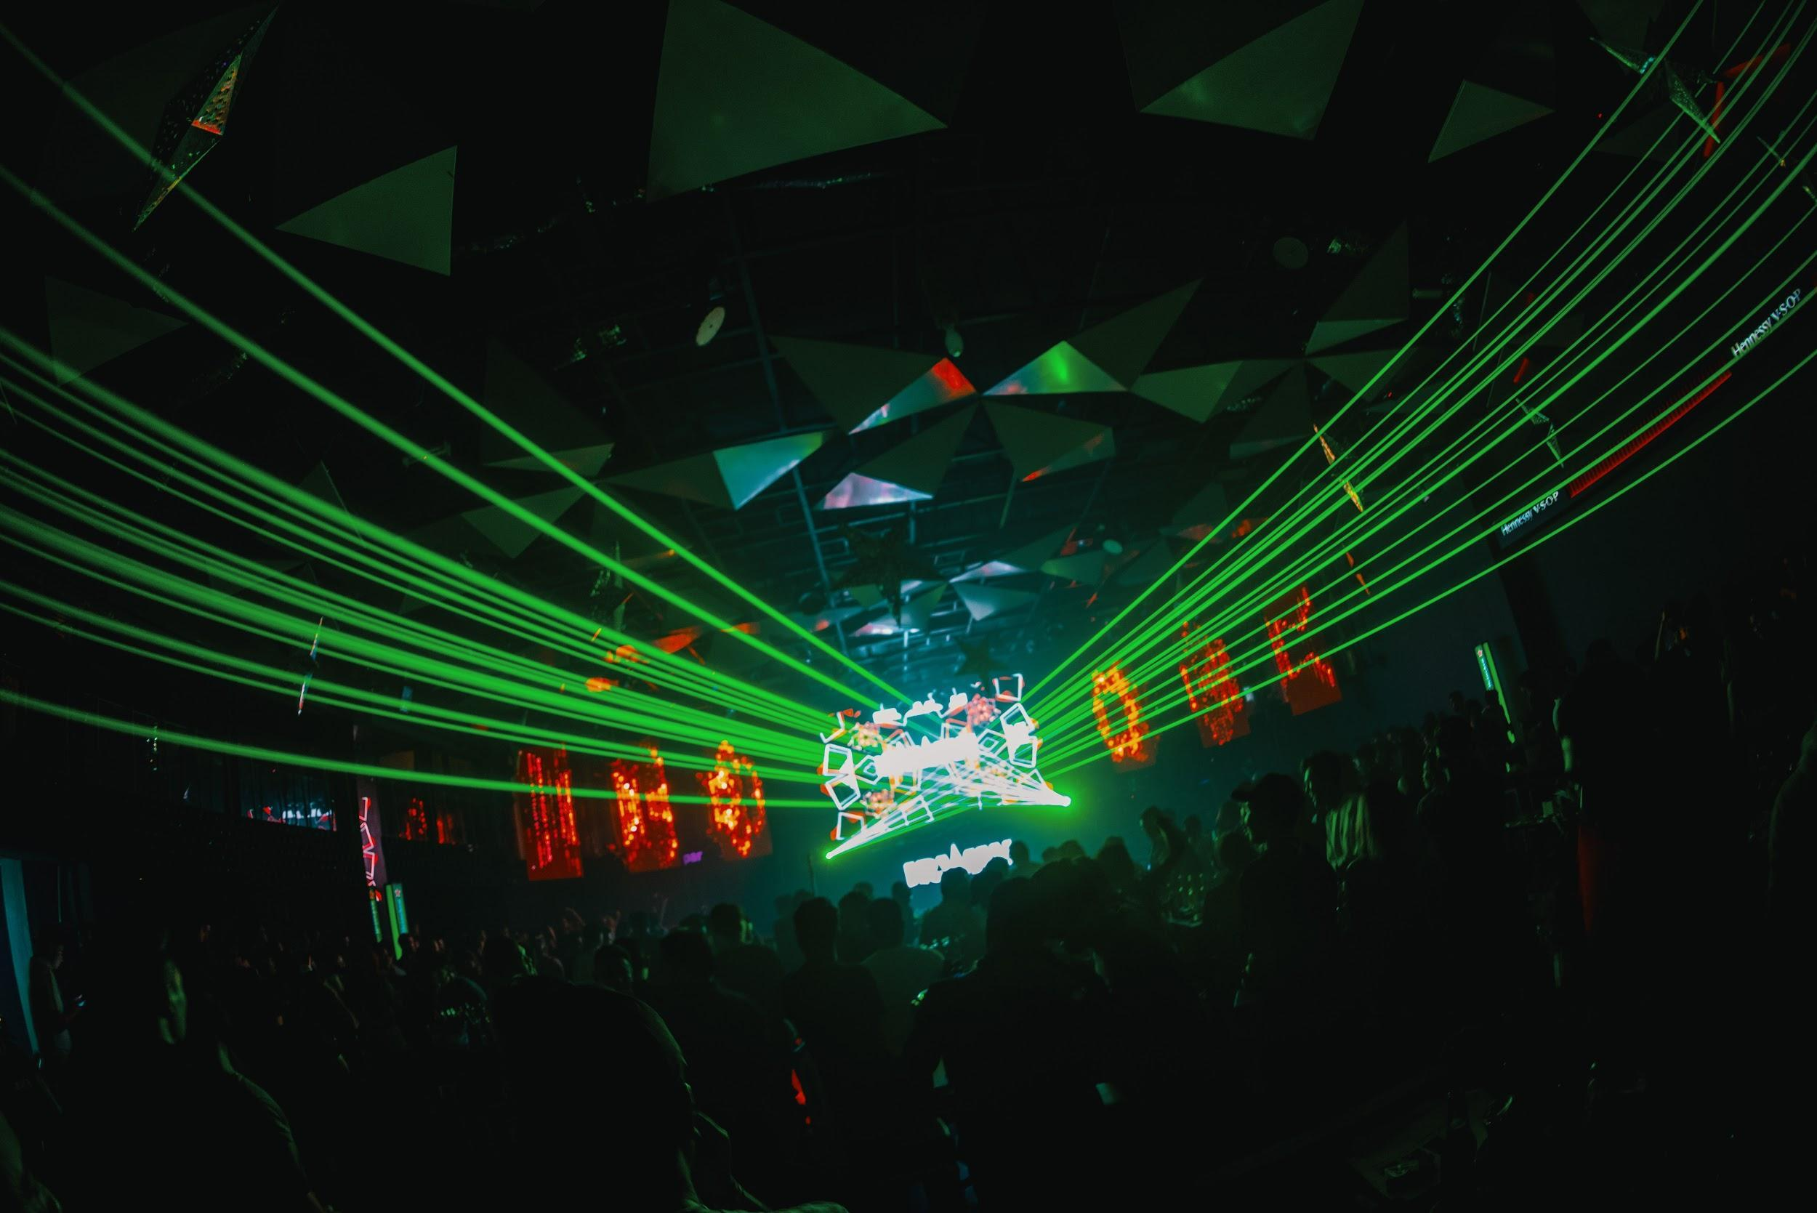
(HeinekenLiveYourMusic2018-13-PhotobyAllIsAmazing.jpg)

In Kuala Lumpur, guests had a great time experiencing the future at
the kaleidoscopically inventive LAH’LAH’LAND’s 10th Anniversary Party.

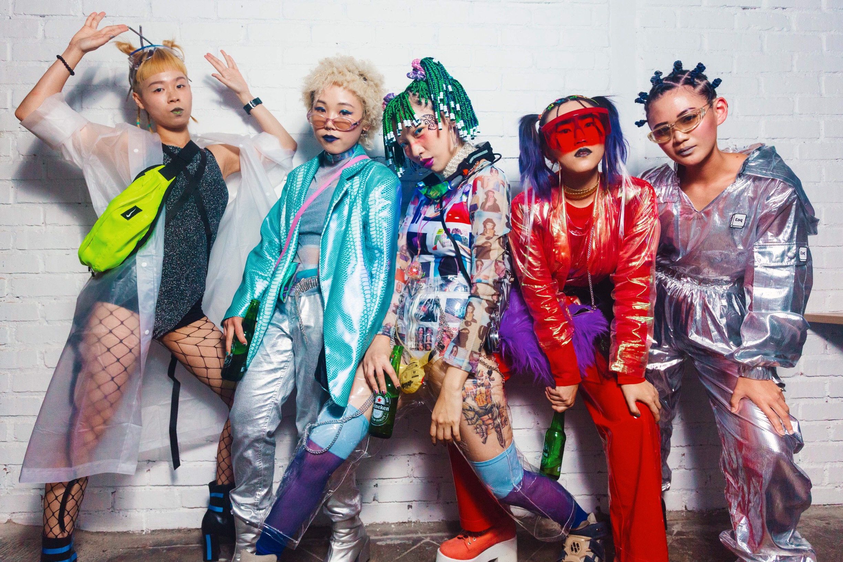
(HeinekenLiveYourMusic2018-14-PhotobyAllIsAmazing.jpg)

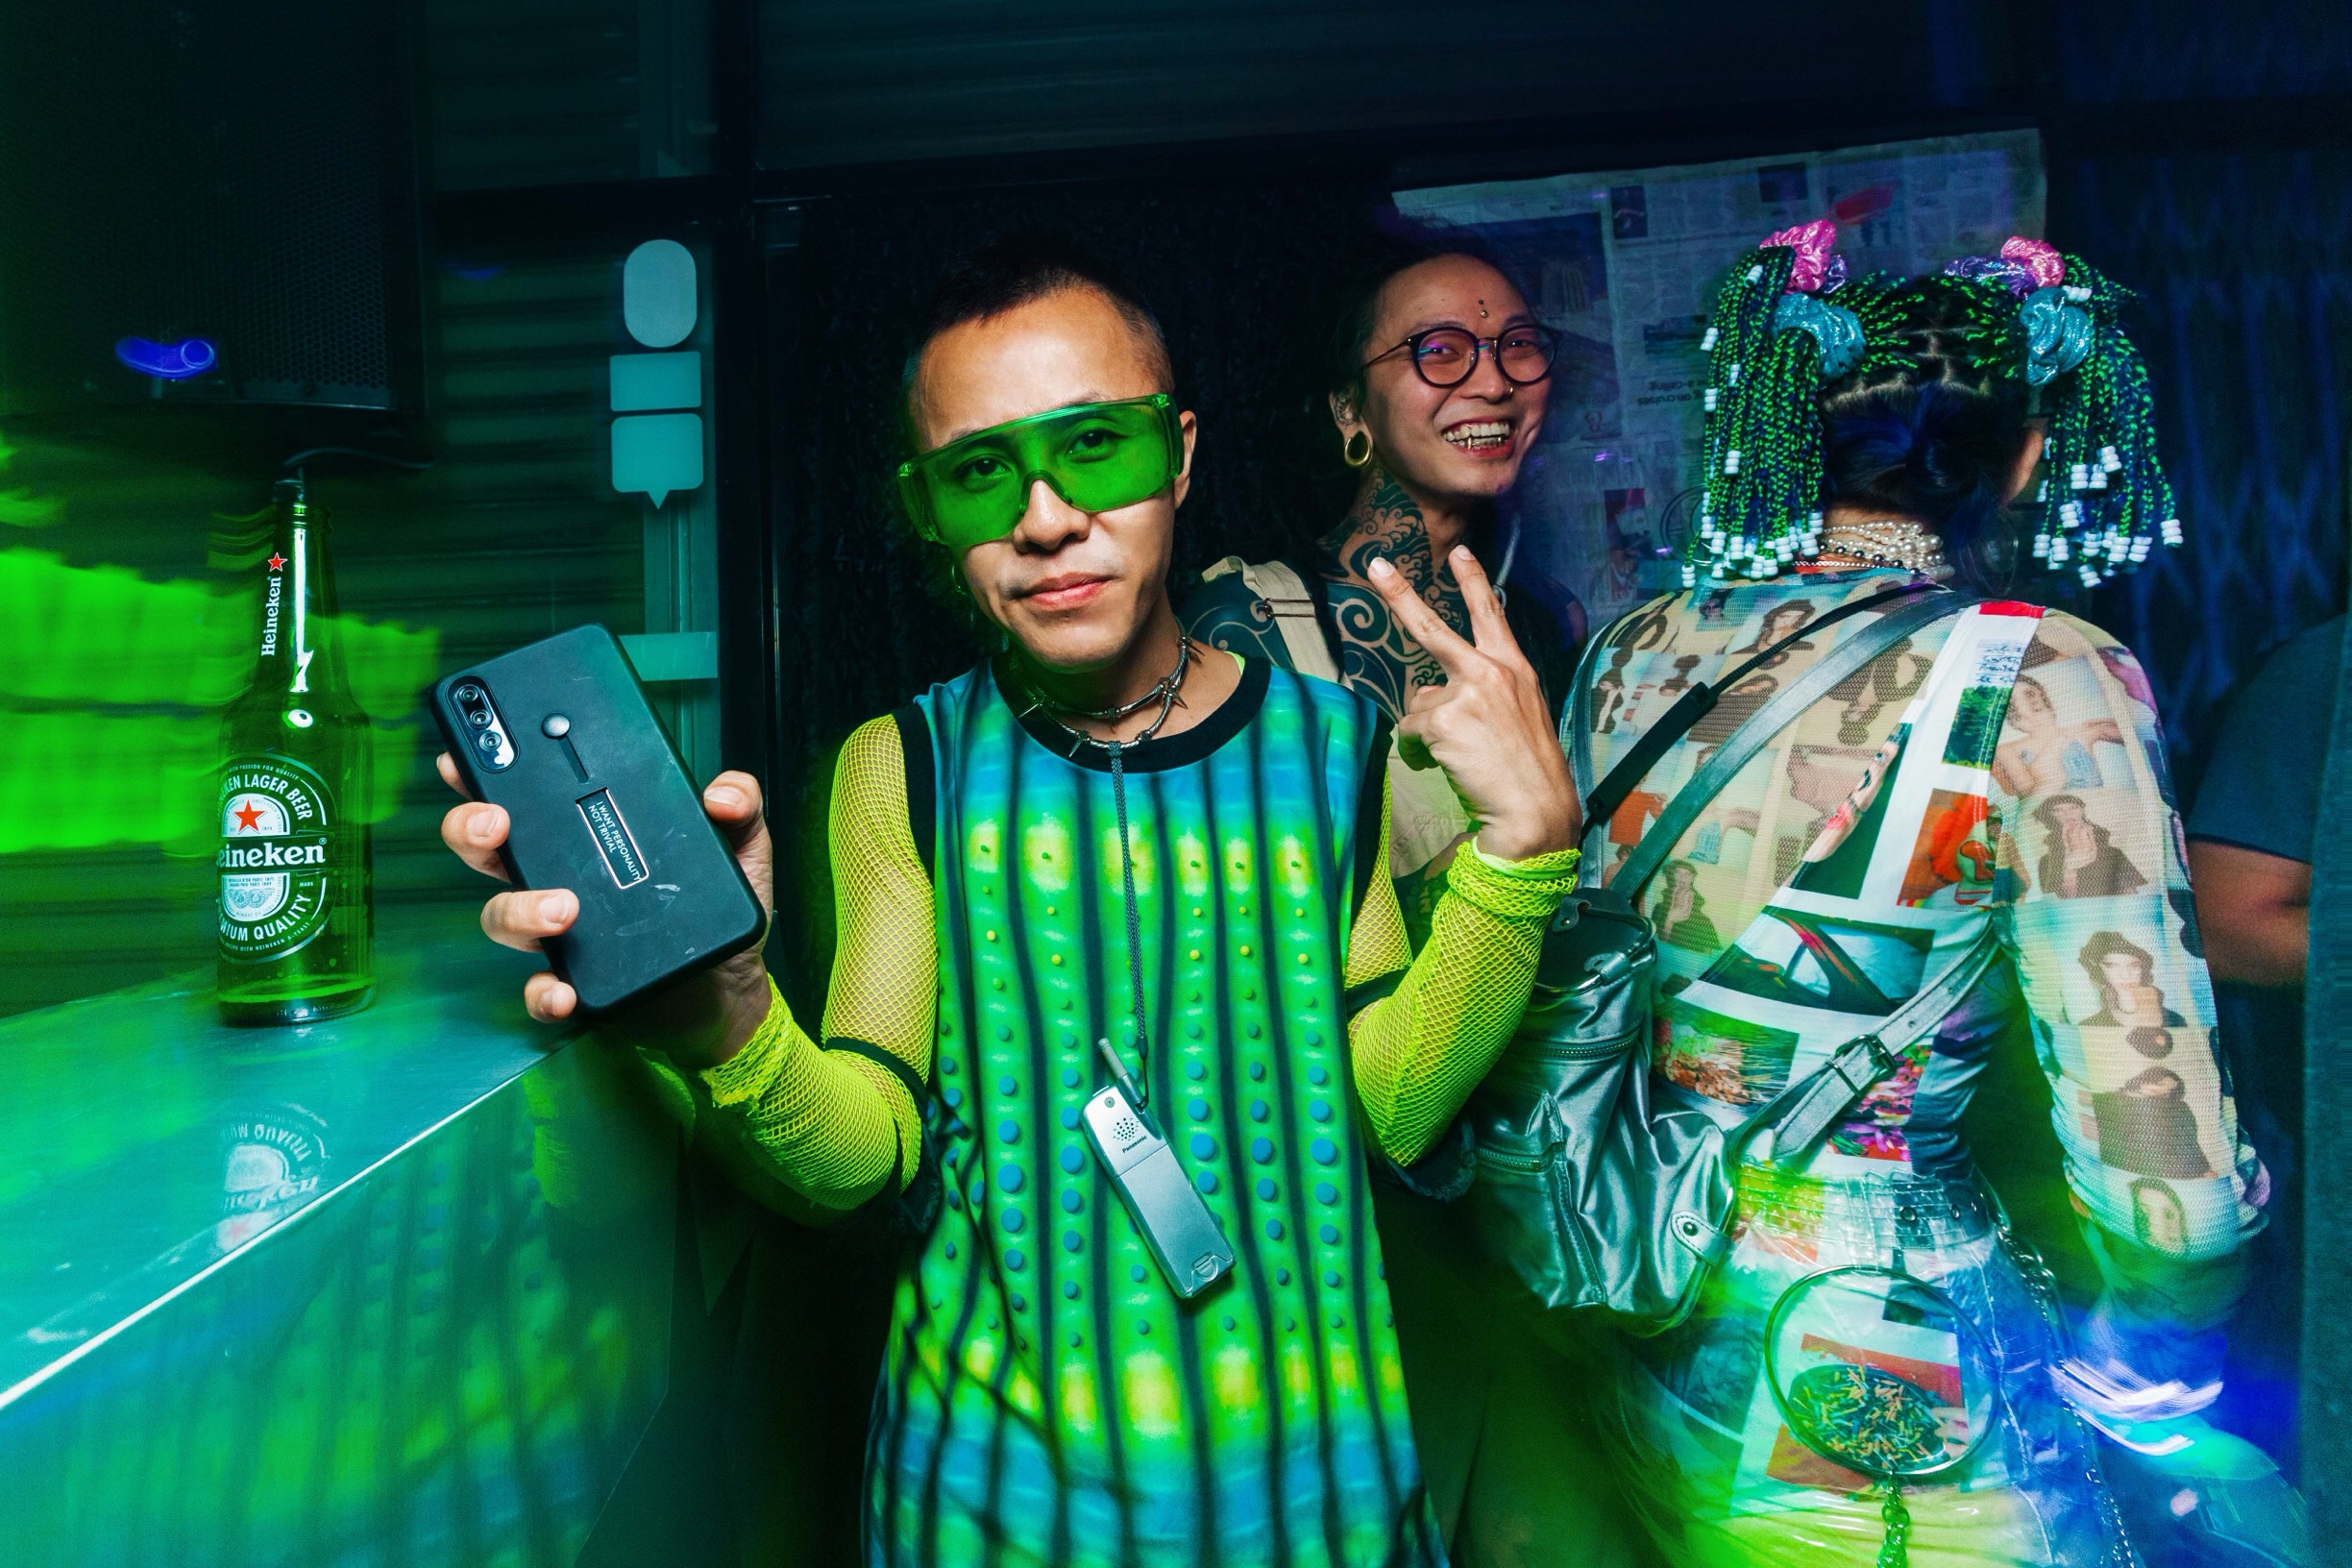
(HeinekenLiveYourMusic2018-15-PhotobyAllIsAmazing.jpg)

This week, join us on a memorable music journey as Heineken® celebrates its last weekend of two weekends back-to-back elevated music experience, featuring international DJs Andrew Rayel and Dyro, supported by homegrown heroes Goldfish & Blink, BATE, Chukiess & Whackboi, Boris Foong, and talents from Goldsounds Academy in Kuala Lumpur, Penang and Johore.

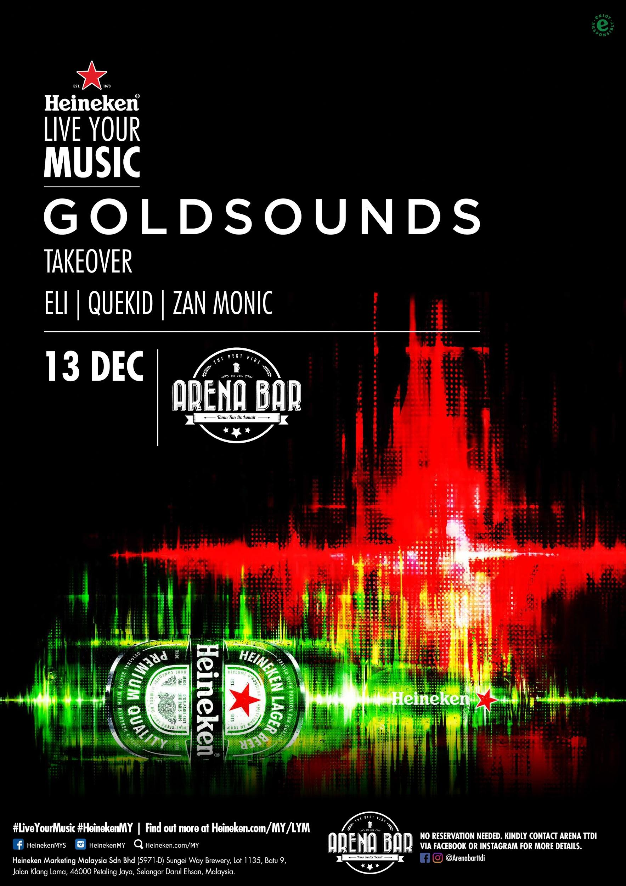 | 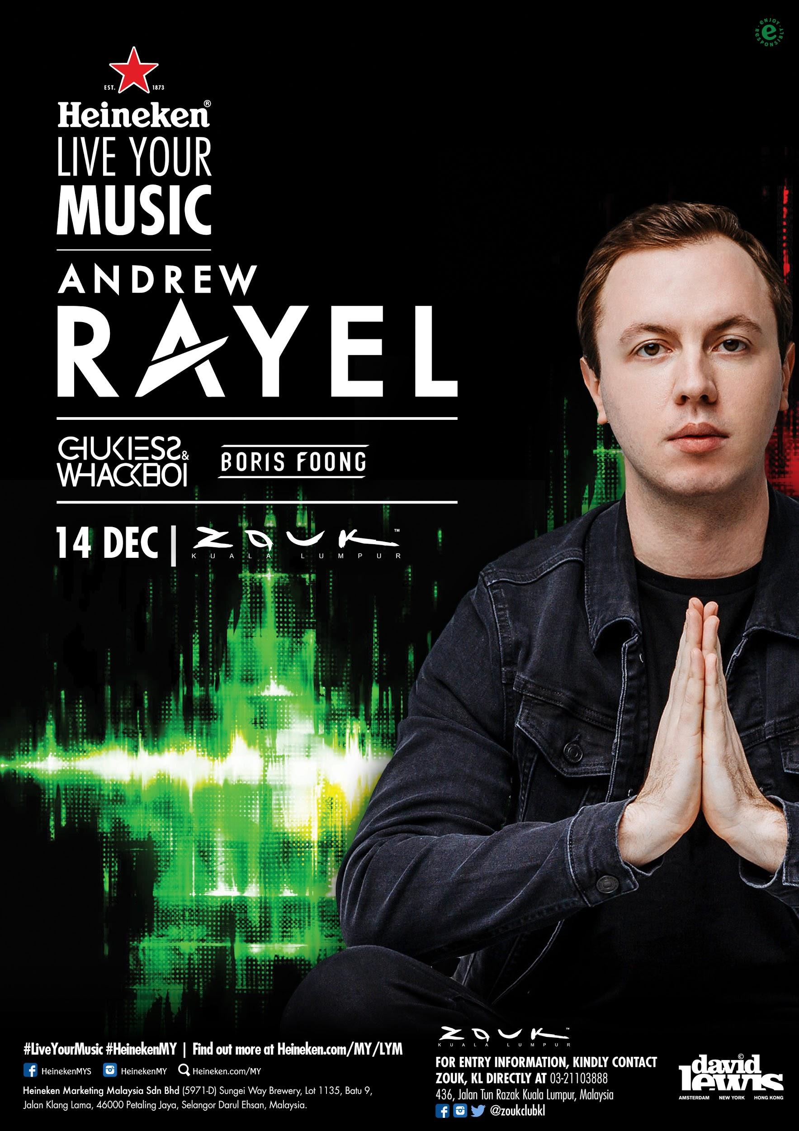
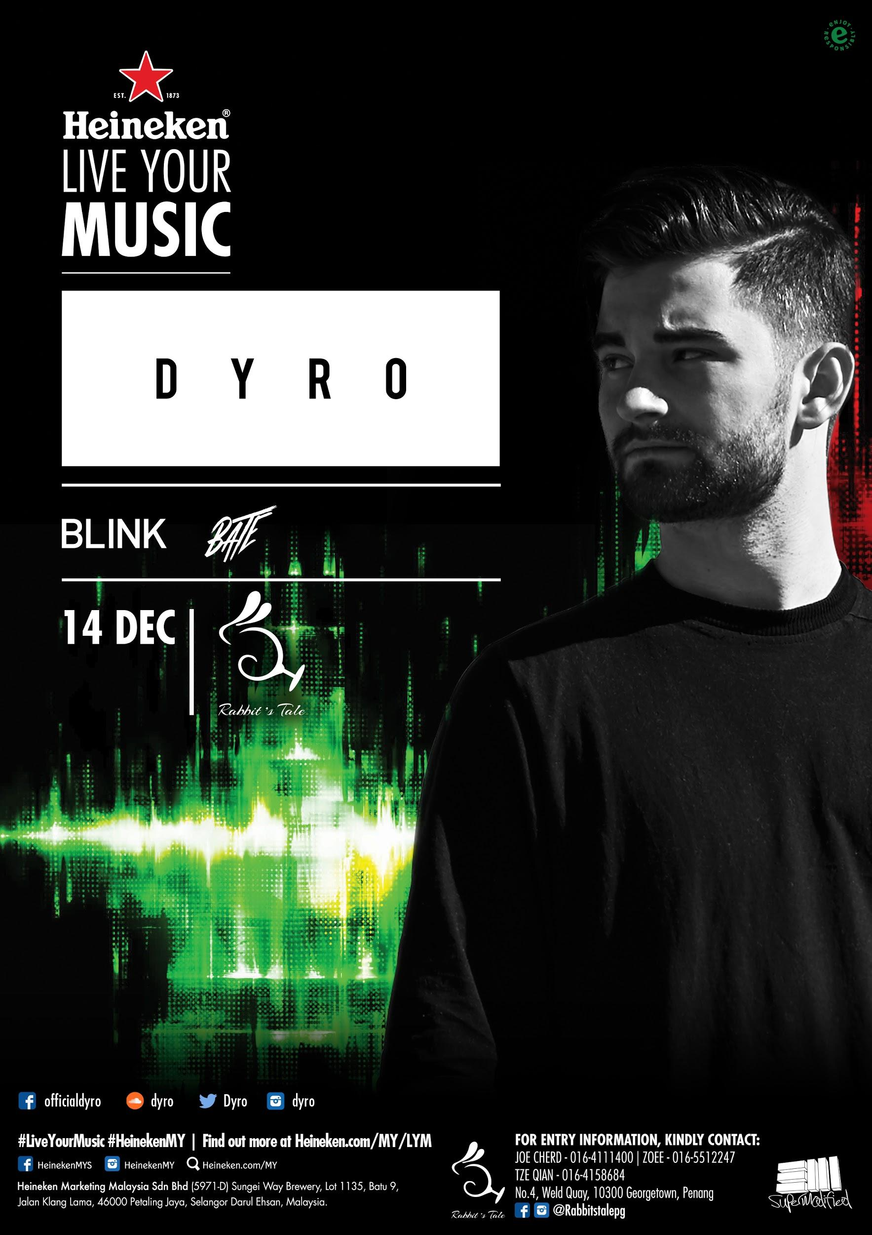 | 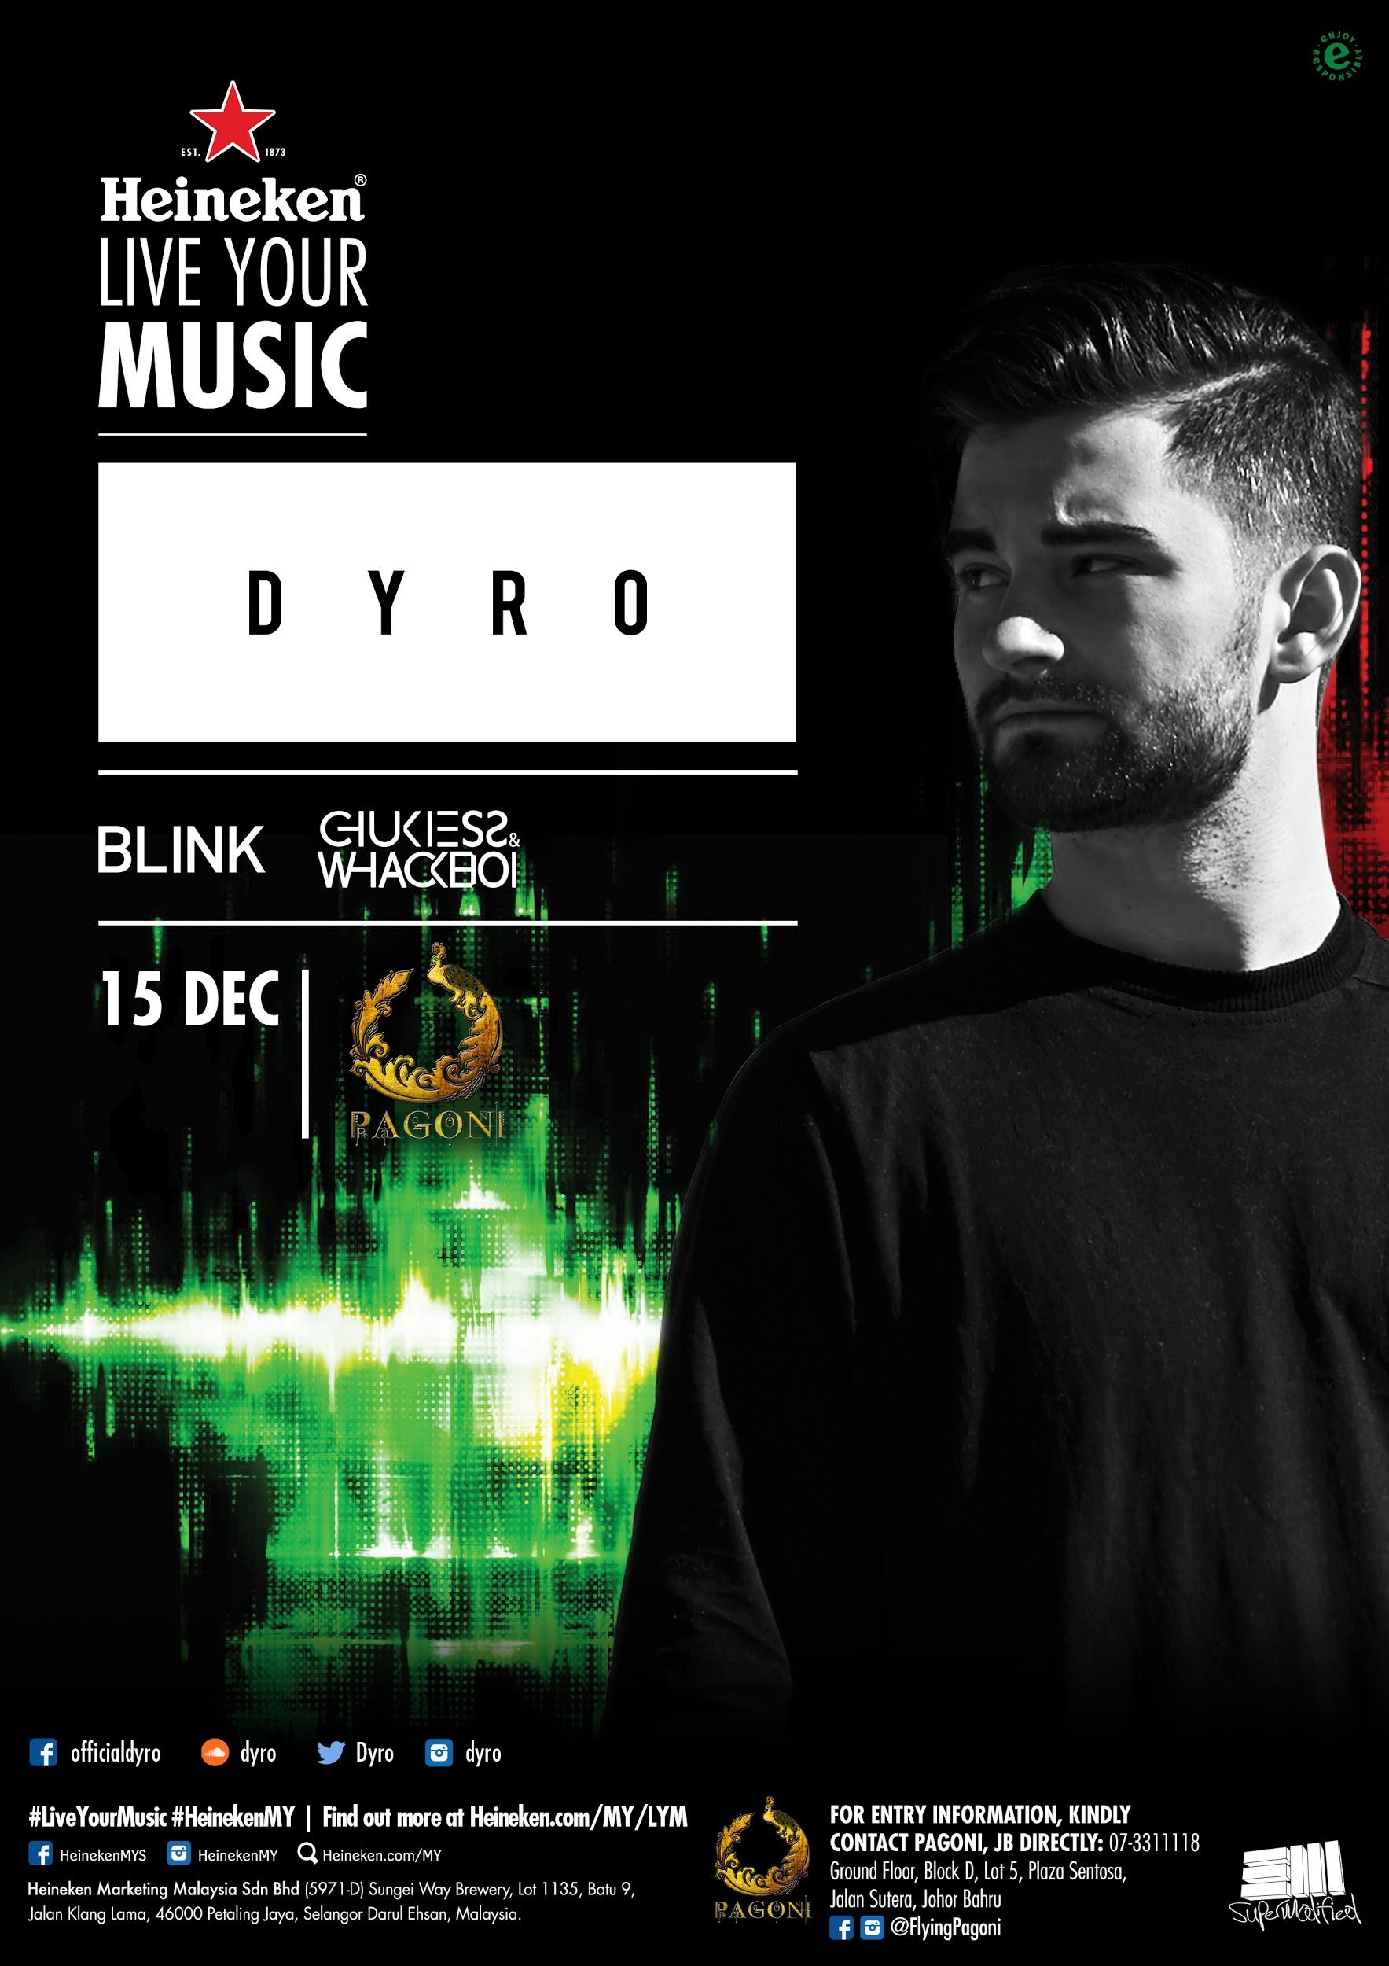

WEEKEND 2

Artist Line Up | Date / Time | Venue | Admission Information
Goldsounds Takeover  Special appearance by DJ Goldfish  Supported by:  Quekid  Zan Monic  Eli | 13 December, Thursday  Doors Open: 10:00 PM | Arena Bar TTDI  (Menara KEN TTDI, R-1 level, Jalan Burhanuddin Helmi, Taman Tun Dr Ismail, 60000 Kuala Lumpur( | Kindly contact Arena Bar TTDI (https://www.facebook.com/Arenabarttdi/) directly. Entry is subject to club rules & regulations.
Andrew Rayel  Supported by:  Chukiess & Whackboi  Boris Foong | 14 December, Friday  Doors Open: 10:00 PM | Zouk Club, Kuala Lumpur  (436, Jalan Tun Razak, Kelab Golf di Raja Selangor, 50400 Kuala Lumpur) | Kindly contact Zouk Club KL (https://www.zoukclub.com.my/) directly at +603 2110 3888. Entry is subject to club rules & regulations.
DYRO  Supported by:  Blink  BATE | 14 December, Friday  Doors Open: 10:00 PM | Rabbit’s Tale, Penang  (No. 4, Weld Quay, 10300, Georgetown, Penang) | Kindly contact Rabbit’s Tale (https://www.facebook.com/rabbitstalepg/) directly at +6016 551 2247 / +6016 415 8684. Entry is subject to club rules & regulations.
DYRO  Supported by:  Blink  Eli | 15 December, Saturday  Doors Open: 10:00 PM | Flying Pagoni, Johor Bahru  (Plaza Sentosa, Ground Floor, Block D, Lot 5, Jalan Sutera, 80150 Johor Bahru, Johor) | Kindly contact Flying Pagoni (https://www.facebook.com/FlyingPagoni/) directly at +607 331 1118. Entry is subject to club rules & regulations.

Admission information is available from the respective clubs and is subject to club rules and regulations. For information on Heineken® Live Your Music, go to www.facebook.com/HeinekenMYS and www.heineken.com/my/LYM.

