

FOR IMMEDIATE RELEASE

“Bergaya with #TeamRayaJD this year!”

Hari Raya Aidilfitri marks the end of Ramadan and is considered the festival of gratitude towards loved ones. An occasion celebrated with family and friends. It is also the time of feasts, homecoming, contemplation, forgiveness and reconciliation. A fresh start is not complete without some new clothes, traditional garments such as the songkok and sampin for men and the baju kurung/kebaya for women. Spending quality time with loved ones is ultimately what truly makes the tradition of raya more meaningful.

While we celebrate traditions that have been around for centuries, we continuously enhance these traditions with a modern flair. This Hari Raya, JD Sports encouraged fashion enthusiasts to switch up their traditional style and be part of #TeamRayaJD. This festive period, JD invited Malaysians to get creative and show how they style their trainers from JD with their traditional raya outfits. Participants stood a chance to win a JD Sports Gift Card worth RM1000. Contest began from the 5th-9th June on JD Sports official Instagram page.

With Undisputed Raya as the theme, JD has enticing in-store promotions available in all JD Outlets. Participating customers were rewarded with two (2) JD Raya vouchers worth RM200 when they spend a minimum of RM500 in store in a single receipt. Customers were also rewarded with four (4) JD Raya vouchers worth RM400 when they spend a minimum of RM800 in store in a single receipt. The promotional period began from 18th May - 9th June. Customers are able to redeem their voucher on the 15th June to 30th June.

Online shoppers also had a chance to receive a discounted purchase with ‘Undisputed Raya Online Promotion 19’. Customers who spent RM800 and above at www.jdsports.my are entitled to enjoy 25% off on their purchase with the promo code “JDRAYA25”.



With Father’s Day just a few days away, JD aims to celebrate fathers nationwide with exclusive Father’s Day Promotions. Drop by any of JD Stores to get a pair of trainers for your “Undisputed King.” Customers who purchase RM499 worth of Mens Products will receive a one of a kind complimentary JD Exclusive Duffle Bag from 14-16 June.

To give you a better idea of what’s popular in JD Sports this year, we’ve highlighted some of the best picks and latest trainers for the month of June.

Image | Gender | Product Description | Brand
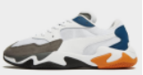 | MENS FOOTWEAR | Puma Storm Origin | PUMA
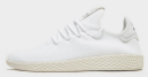 | MENS FOOTWEAR | Adidas Originals x PHARRELL WILLIAMS TENNIS HU | ADIDAS
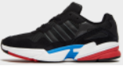 | MENS FOOTWEAR | adidas Originals YUNG 96 | ADIDAS
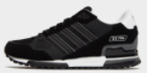 | MENS FOOTWEAR | adidas Originals ZX 750 | ADIDAS
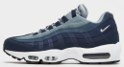 | MENS FOOTWEAR | NIKE AIR MAX 95 | NIKE
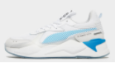 | MENS FOOTWEAR | Puma RS-X Tune | PUMA
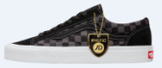 | MENS FOOTWEAR | Vans Style 36 | VANS
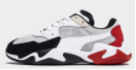 | WOMENS FOOTWEAR | Puma Storm Origin | PUMA
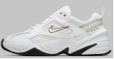 | WOMENS FOOTWEAR | Nike M2K Tekno | NIKE
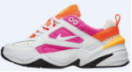 | WOMENS FOOTWEAR | Nike M2K Tekno | NIKE
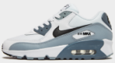 | JUNIOR FOOTWEAR | Nike Air Max 90 | NIKE
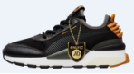 | JUNIOR FOOTWEAR | Puma RS-0 Toys | PUMA
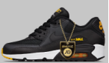 | CHILDREN/INFANT FOOTWEAR | Nike Air Max 90 Mesh | NIKE

To keep up to date with all things JD follow us on: Facebook; JD Sports Malaysia and Instagram; jdsportsmy. JD is also available online at www.jdsports.my.

THE END

For further information, please do not hesitate to contact:
Nicole Aldeth Main Elizabeth Kate Harding
Mad Hat PR Mad Hat PR
T: +6012 5670129 T: +6012 2205703
E: nicole@madhat.asia E: elizabeth@madhat.asia
Note to the Editor:
About JD Sports
JD Sports Fashion Sdn Bhd is part of JD Sports Fashion plc, the leading multichannel retailer of sports fashion and outdoor brands in the UK and Europe. The Group has over 800 stores across a number of retail fascias. For further information visit www.jdplc.com

JD Sports is currently available at the following stores across Malaysia:
- JD Pavilion Elite (Flagship)
- JD Sunway Pyramid
- JD Sunway Velocity
- JD Mid Valley Megamall
- JD IOI City Mall
- JD Setia City Mall
- JD Sunway Carnival Mall
- JD Gurney Plaza
- JD Mahkota Parade
- JD AEON Tebrau City
- JD East Coast Mall
- JD Mid Valley SouthKey, JB

